**Cisco Certified Network Professional certification**

*Lab in reality*

Haoxuan Ge

Newport high school Cisco academy

List

Lab 1 OSPF-signal area

Lab 2 OSPF-multi area

Lab 3 Eternal BGP

Lab 4 Internal BGP

Lab 5 Cisco IP phone

Lab 6 VRF

Lab 7 Amazon aws part

Lab 8 Mpls

Lab 1 signal area OSPF (Open Shortest Path First)

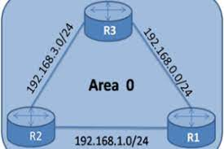

**Config Ospf in single area**

**Diagram**

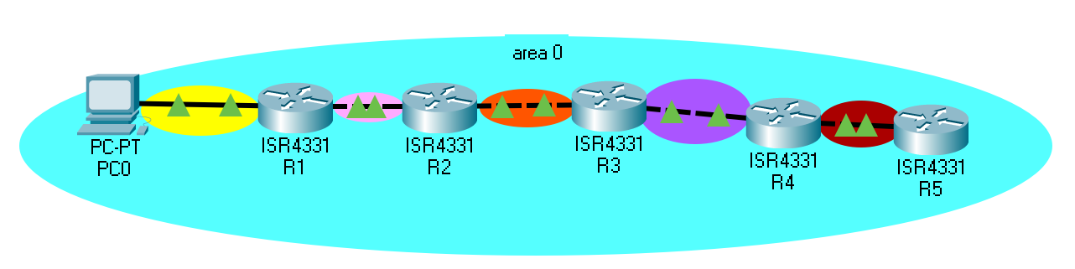

Background: The company network subnet is lack in sometimes, and an efficient way to manage the subnet is urgently needed. Using single-area ospf, Even in different subnets, different devices can still ping each other. And no need to manually set static routes, the devices can identify each other by itself.

In other words of Ospf, OSPF gathers link state information from available routers and constructs a topology map of the network. The topology is presented as a routing table to the Internet Layer for routing packets by their destination IP address. OSPF supports Internet Protocol Version 4 (IPv4) and Internet Protocol Version 6 (IPv6) networks and supports the Classless Inter-Domain Routing (CIDR) addressing model.

Topology: Several routers, multiple PC

Configuration: On below is the configuration of several routers and for one PC

R1:

hostname R1

boot-start-marker

boot-end-marker

vrf definition Mgmt-intf

address-family ipv4

exit-address-family

address-family ipv6

exit-address-family

no aaa new-model

login on-success log

subscriber templating

ipv6 unicast-routing

multilink bundle-name authenticated

crypto pki trustpoint TP-self-signed-3571946550

enrollment selfsigned

subject-name cn=IOS-Self-Signed-Certificate-3571946550

revocation-check none

rsakeypair TP-self-signed-3571946550

crypto pki certificate chain TP-self-signed-3571946550

certificate self-signed 01

30820330 30820218 A0030201 02020101 300D0609 2A864886 F70D0101 05050030

31312F30 2D060355 04031326 494F532D 53656C66 2D536967 6E65642D 43657274

69666963 6174652D 33353731 39343635 3530301E 170D3232 30393036 32303537

33315A17 0D333030 31303130 30303030 305A3031 312F302D 06035504 03132649

4F532D53 656C662D 5369676E 65642D43 65727469 66696361 74652D33 35373139

34363535 30308201 22300D06 092A8648 86F70D01 01010500 0382010F 00308201

0A028201 0100AD1A BE85DD20 31B019CD EFC364A4 9D0DB26B 886C8654 195837B4

64B374DD AF575979 45EEA894 AE519B74 D75ED003 BF49D158 A58642B1 0BFB0D9B

851228F7 ADAA7E47 B53135EB 8427231B 9CFDB38E 13C60140 389C13DA B84EACE5

FFA6C5E0 8EA3B7D1 68B977A9 8E35394F BA3FA97B 9ABD8DBD 581B0AE1 6B272915

1EE4123E 3E7299F0 C3E1DAFA D7E29BA3 131517A5 851D36E6 09D07A3E 4660B6E9

55CB34A5 6D7E0B09 1045D30E 6F502079 E53249AE 9B5F6D96 A5519247 444E8ACE

5232DE0F 0F77346E B5383A0A 88EDFF73 1A30F36E 2DBA2BD2 91FFC65E 0F3F668B

BD88F989 B4ECB6F6 FFD39CAE 7541812E B00E96C9 6E6AE873 62E2D7E2 2F027E97

DB7A1407 06C70203 010001A3 53305130 0F060355 1D130101 FF040530 030101FF

301F0603 551D2304 18301680 145C49CD 1587B484 C7CAF721 181E0093 C7C53ED5

D5301D06 03551D0E 04160414 5C49CD15 87B484C7 CAF72118 1E0093C7 C53ED5D5

300D0609 2A864886 F70D0101 05050003 82010100 082E3107 78489A7F 530BD69B

54DCA277 E2CCBB3F BAF47B14 4532609C C4261BAB 566CB4DF 775B780D AD11A636

3A22A434 234410DD 303E4F27 56FC3FAD 130ACE2A 891F439F B30F14FE 56811A71

511D8B29 77475D58 3093196C 678829F2 172B1DFC 009B0694 C89CBE4B DDFA0BF6

E1BBD448 0DD9E6B6 532EFA2D 2F52454D CF4D4752 8C2784D7 82DC0F25 BA9F82E7

B958FFD2 BDB371E9 894B274C C9D29CA2 C388E7EC 9E006717 9A690D38 927516B3

2476166D 0F7F5C15 FF6DE817 D9634936 26592199 3BE58ADC D788820C DF225BCE

1C34B07E C28AE797 0C853ED0 87961F82 D3F80F0F 31FE66C7 56EFC623 5656CA90

A8F61498 FCA5EFB1 CCC3389F 65076A6C 37E15682

quit

license udi pid ISR4321/K9 sn FDO214420HS

no license smart enable

diagnostic bootup level minimal

spanning-tree extend system-id

redundancy

mode none

interface Loopback0

ip address 1.1.1.1 255.255.255.255

interface GigabitEthernet0/0/0

ip address 192.168.2.1 255.255.255.0

negotiation auto

ipv6 address FE80::1 link-local

ipv6 address 2001:DB8:ACAD:B::1/64

ipv6 ospf 1 area 0

interface GigabitEthernet0/0/1

ip address 192.168.1.1 255.255.255.0

negotiation auto

ipv6 address FE80::1 link-local

ipv6 address 2001:DB8:ACAD:A::2/64

ipv6 ospf 1 area 0

interface Serial0/1/0

no ip address

interface Serial0/1/1

no ip address

interface GigabitEthernet0/2/0

no ip address

negotiation auto

interface GigabitEthernet0/2/1

no ip address

negotiation auto

interface GigabitEthernet0

vrf forwarding Mgmt-intf

no ip address

negotiation auto

router ospfv3 1

router-id 1.1.1.1

address-family ipv6 unicast

exit-address-family

router ospf 1

router-id 1.1.1.1

network 1.1.1.1 0.0.0.0 area 0

network 192.168.0.0 0.0.255.255 area 0

ip forward-protocol nd

no ip http server

ip http secure-server

ip tftp source-interface GigabitEthernet0

ip route 0.0.0.0 0.0.0.0 192.168.2.2

control-plane

line con 0

transport input none

stopbits 1

line aux 0

stopbits 1

line vty 0 4

login

end

Router 2:

hostname R2

boot-start-marker

boot-end-marker

vrf definition Mgmt-intf

address-family ipv4

exit-address-family

address-family ipv6

exit-address-family

no aaa new-model

no ip domain lookup

login on-success log

subscriber templating

ipv6 unicast-routing

multilink bundle-name authenticated

crypto pki trustpoint TP-self-signed-2990358516

enrollment selfsigned

subject-name cn=IOS-Self-Signed-Certificate-2990358516

revocation-check none

rsakeypair TP-self-signed-2990358516

crypto pki certificate chain TP-self-signed-2990358516

certificate self-signed 01

30820330 30820218 A0030201 02020101 300D0609 2A864886 F70D0101 05050030

31312F30 2D060355 04031326 494F532D 53656C66 2D536967 6E65642D 43657274

69666963 6174652D 32393930 33353835 3136301E 170D3232 30393037 31383536

33325A17 0D333030 31303130 30303030 305A3031 312F302D 06035504 03132649

4F532D53 656C662D 5369676E 65642D43 65727469 66696361 74652D32 39393033

35383531 36308201 22300D06 092A8648 86F70D01 01010500 0382010F 00308201

0A028201 01008ABA D79CF944 9FDDA6C1 D5CD0D94 5F5B27B2 E3B43087 0A23FA7A

63ED1A5B E2B97F33 89979F1F E0672A69 2CF0AB5F CD2478FC 9FD9A64F CDEBA6D6

52794E72 6257AA3B 65982A40 70BE2572 FB056AB2 4DB93D1F 102E0F4B 329DB497

0260AE22 7EB5AC11 E2578A49 626DBA89 E45C4112 FD733D85 EE3CF4BF C155F4FB

2DE826C3 96184CD9 1DD2B8AB FF88CE59 2EB5C9FF 55C15E88 6D70A9A7 24207CA2

1593D59B F89E1362 B0288749 3C8BDBBD 025610BB C8BB9404 5F6A4400 D0539E43

9483BF1D 60A93674 8D95B1EB 0437A4C5 BAAE0A2D BE52E1BB BD56B380 8788A2A0

AE03BCF2 DE4A0D6F 7950604D 1A2162CF 81DBE85F E9A8505F 3A068376 C7E0C857

9D855AA9 A6010203 010001A3 53305130 0F060355 1D130101 FF040530 030101FF

301F0603 551D2304 18301680 1499E326 A53EFA5B 1E4DC59A 4E5E45A3 2B4B3E11

07301D06 03551D0E 04160414 99E326A5 3EFA5B1E 4DC59A4E 5E45A32B 4B3E1107

300D0609 2A864886 F70D0101 05050003 82010100 8A3CD9EC D686714D 71F281EC

C8B2DA02 E2278D2C FB05E3AE 7D19F2E8 9A091A4C 9DA1C807 91CE4187 B4D3C09E

CB6DE919 FE96D87C DE83309A 23088520 3264E65C 6CA40117 861E7388 11C21FF8

5FB8EC6B 8163C7F6 7C59861C 11CACCB5 95DCFA71 BD3B222D 7984E9DA DEBC8131

497DEEDC 7D37BFF6 BA89DC45 93DF106C 2737A042 60E1FEF8 1D38754E 88B6D284

C84670DD C02CED01 38C9198C FEF3B504 47447935 58556359 8E74BD31 565D2956

BD85E78E 7EE8349D 199E32E7 1D417384 9F637FCC 09FF0EC0 60898195 41EBBB3D

460C297E 14C6C0FC E90A3EDA 850BFD8D 0815E6D7 F6528513 67DFBEBC A99BE820

75F73BF1 CFFCAAC3 DF1836F1 82D53DFB E6C71EDF

quit

license udi pid ISR4321/K9 sn FDO21441WBL

no license smart enable

diagnostic bootup level minimal

spanning-tree extend system-id

redundancy

mode none

interface GigabitEthernet0/0/0

ip address 192.168.3.1 255.255.255.0

negotiation auto

ipv6 address FE80::1 link-local

ipv6 address 2001:DB8:ACAD:C::1/64

ipv6 ospf 1 area 0

interface GigabitEthernet0/0/1

ip address 192.168.2.2 255.255.255.0

negotiation auto

ipv6 address 2001:DB8:ACAD:B::2/64

ipv6 ospf 1 area 0

interface Serial0/1/0

interface Serial0/1/1

interface GigabitEthernet0/2/0

no ip address

shutdown

negotiation auto

interface GigabitEthernet0/2/1

no ip address

shutdown

negotiation auto

interface GigabitEthernet0

vrf forwarding Mgmt-intf

no ip address

shutdown

negotiation auto

router ospfv3 1

router-id 2.2.2.2

address-family ipv6 unicast

exit-address-family

router ospf 1

router-id 2.2.2.2

network 192.168.0.0 0.0.255.255 area 0

ip forward-protocol nd

ip http server

ip http authentication local

ip http secure-server

ip tftp source-interface GigabitEthernet0

control-plane

line con 0

transport input none

stopbits 1

line aux 0

stopbits 1

line vty 0 4

login

end

Router 3:

hostname R3

boot-start-marker

boot-end-marker

vrf definition Mgmt-intf

address-family ipv4

exit-address-family

address-family ipv6

exit-address-family

no aaa new-model

no ip domain lookup

login on-success log

subscriber templating

vtp domain cisco

vtp mode transparent

ipv6 unicast-routing

multilink bundle-name authenticated

crypto pki trustpoint TP-self-signed-1411542050

enrollment selfsigned

subject-name cn=IOS-Self-Signed-Certificate-1411542050

revocation-check none

rsakeypair TP-self-signed-1411542050

crypto pki certificate chain TP-self-signed-1411542050

certificate self-signed 01

30820330 30820218 A0030201 02020101 300D0609 2A864886 F70D0101 05050030

31312F30 2D060355 04031326 494F532D 53656C66 2D536967 6E65642D 43657274

69666963 6174652D 31343131 35343230 3530301E 170D3232 30393037 31383434

34385A17 0D333030 31303130 30303030 305A3031 312F302D 06035504 03132649

4F532D53 656C662D 5369676E 65642D43 65727469 66696361 74652D31 34313135

34323035 30308201 22300D06 092A8648 86F70D01 01010500 0382010F 00308201

0A028201 0100D0E8 5FEC553C 7D943914 6DF23F38 B45D6D42 D15B7CCE F3591DE5

4A97994A C31C22DD 71422F59 D5FA2935 1A02899E 94A69197 19787A38 4AFB5C9F

728CAE31 112683EF F070C7C4 09AE55AB 6C8EB8DE 14CA9DF4 FFF8568F ECA84AF7

B4411725 514D6F61 9E5BAC96 ACE15C0E F101DB63 5082D665 5A707E7F D4FC39CF

E4923EC3 9451F1A3 7DEF1334 9ED50BF7 66B6FFE7 E7DA2A0A E20516DA 74F1F8FF

81F7628F B1A1A375 FE586EC3 75562425 011089B7 72290DFB 8147025B D2E020E3

AA8FF213 058B7920 80BA5A8A D1461CE0 00339E2F E1472A0A D5610DD3 8D61B88F

BF89FBFD 20B6CE5F A2A9DBEF 30377C76 B084C045 B5EA26BC 40B0740F F86E746B

86174D7A 979F0203 010001A3 53305130 0F060355 1D130101 FF040530 030101FF

301F0603 551D2304 18301680 14550872 37B790FA 74F4B1A3 F0010B37 74946294

A0301D06 03551D0E 04160414 55087237 B790FA74 F4B1A3F0 010B3774 946294A0

300D0609 2A864886 F70D0101 05050003 82010100 72843DE6 F5578A9B 1CB8B366

7C497C78 B5231D0F D85310AC 97764011 137E0F77 89EA69AF 891B7C7E B6D01778

CE60989C 09E91C39 F82D27C1 80AF37B9 20F57845 B3B020B5 BF9C60E4 9A28181E

03FA3D8E 96DE9EF1 A8EA9D75 810975AB F9206CC4 C4E2F229 176B612C 63FE143F

4CFA08AA 62AB2D8F 41688326 5792BE91 D449F09B D9C5D36A E5F10F05 1C77BDE1

132BAE1F DC1FA29C BFB53C31 055837FB 47789562 2493C20F 24E037DB 3E809211

2E5CD444 609167E8 6BC617E5 51B0CA97 1F89C2B8 8CB0B1FD CE5F691F 90DCF943

1C0B7B1A 3FE2FA33 E1A2300C 143D7401 ADF19DD7 532E6B9B 11216D6E 993EB73C

6D62A6C4 499DBC6D 51342042 BB3C888D 641EA5EE

quit

license udi pid ISR4321/K9 sn FDO215009PN

no license smart enable

diagnostic bootup level minimal

spanning-tree extend system-id

redundancy

mode none

interface GigabitEthernet0/0/0

ip address 192.168.4.1 255.255.255.0

negotiation auto

ipv6 address 2001:DB8:ACAD:D::1/64

ipv6 ospf 1 area 0

interface GigabitEthernet0/0/1

ip address 192.168.3.2 255.255.255.0

negotiation auto

ipv6 address 2001:DB8:ACAD:C::2/64

ipv6 ospf 1 area 0

interface Serial0/1/0

no ip address

shutdown

interface Serial0/1/1

no ip address

shutdown

interface GigabitEthernet0/2/0

no ip address

shutdown

negotiation auto

interface GigabitEthernet0/2/1

no ip address

shutdown

negotiation auto

interface GigabitEthernet0

vrf forwarding Mgmt-intf

no ip address

shutdown

negotiation auto

router ospfv3 1

router-id 3.3.3.3

address-family ipv6 unicast

exit-address-family

router ospf 1

router-id 3.3.3.3

network 192.168.0.0 0.0.255.255 area 0

ip forward-protocol nd

ip http server

ip http authentication local

ip http secure-server

ip tftp source-interface GigabitEthernet0

control-plane

line con 0

transport input none

stopbits 1

line aux 0

stopbits 1

line vty 0 4

login

end

Router 4:

hostname R4

boot-start-marker

boot-end-marker

vrf definition Mgmt-intf

address-family ipv4

exit-address-family

address-family ipv6

exit-address-family

no aaa new-model

no ip domain lookup

login on-success log

subscriber templating

ipv6 unicast-routing

multilink bundle-name authenticated

crypto pki trustpoint TP-self-signed-3937601207

enrollment selfsigned

subject-name cn=IOS-Self-Signed-Certificate-3937601207

revocation-check none

rsakeypair TP-self-signed-3937601207

crypto pki certificate chain TP-self-signed-3937601207

certificate self-signed 01

30820330 30820218 A0030201 02020101 300D0609 2A864886 F70D0101 05050030

31312F30 2D060355 04031326 494F532D 53656C66 2D536967 6E65642D 43657274

69666963 6174652D 33393337 36303132 3037301E 170D3232 30393037 31383433

34395A17 0D333030 31303130 30303030 305A3031 312F302D 06035504 03132649

4F532D53 656C662D 5369676E 65642D43 65727469 66696361 74652D33 39333736

30313230 37308201 22300D06 092A8648 86F70D01 01010500 0382010F 00308201

0A028201 0100F18E 54049040 4110BE82 C341496E 7F7A3574 A79F9008 4629B40C

410CA076 9857EDFB 780B1E6B 42B42E87 B5A6A5AC BA93D0CF EEB16B12 CA40A0A8

C5BDA6C8 5D1AD273 3D5751A0 0277FC9F 5EF71A19 4601DE8B E6D54B7A 70C4B4AF

8AC786B6 BFD32E58 E69F332B BE205D5E 637272D6 C76802EF 5F1494A4 C7276D65

93248893 5FBD0D76 117A1D59 26A20477 12A283B3 918E365E D604BA69 55D117EF

783E0082 534EF80B 27930061 D5E0A984 2B369BBE FA940BE5 BC002174 D682BB77

65F7AB49 115B83F3 A8B0050B 987BD395 825360C1 1328F92A 3FD078A5 500C381D

E71E1207 4FCAA460 E8EFD61C 36834BA7 56F41364 D4377147 F0F8DB94 DBA3A5DC

3085DB56 53F10203 010001A3 53305130 0F060355 1D130101 FF040530 030101FF

301F0603 551D2304 18301680 140E8004 CDA0899E 4BAAE52E 416783EF 654EA7B0

7E301D06 03551D0E 04160414 0E8004CD A0899E4B AAE52E41 6783EF65 4EA7B07E

300D0609 2A864886 F70D0101 05050003 82010100 6A475FEE A743A074 C75288C1

870B9805 C05310C7 D5E1015A A3FC44DC 1C54FA31 DB6580AA 4C093742 40D75612

18FCFC05 E76118D3 A49097EF 43B4DFBF E69EF8DE 42D2099A 534AA956 47F59646

5119BF3B C8115E12 9D7D09B6 FCB6A373 F86D9077 2028330B 31A98F3E 97BF6ADA

9C43F97B F7EFE8B4 6E93B3E9 65947D12 3DFE2C4E 91BDC509 5F9723BF F8CCD113

534E16C7 BE5FC9A9 74495F6A 57B146D8 72572535 E776BF15 03E4A5F4 6256AC5A

409279F9 A215B8AB 179B4F74 12DB2CE5 FF485C66 1BBF10F4 B2DA9112 6C29B90D

0D018469 92DB3C74 89AEAED8 CD1CFF14 027C190B D9414FEA ABA47E8B C92E8652

AF728340 CD51B5C3 4A8BC3C7 34597380 6F15FB52

quit

license udi pid ISR4321/K9 sn FDO214421BX

no license smart enable

diagnostic bootup level minimal

spanning-tree extend system-id

redundancy

mode none

interface GigabitEthernet0/0/0

ip address 192.168.5.1 255.255.255.0

negotiation auto

ipv6 address FE80::1 link-local

ipv6 address 2001:DB8:ACAD:E::1/64

ipv6 ospf 1 area 0

interface GigabitEthernet0/0/1

ip address 192.168.4.2 255.255.255.0

negotiation auto

ipv6 address 2001:DB8:ACAD:D::2/64

ipv6 ospf 1 area 0

interface Serial0/1/0

no ip address

shutdown

interface Serial0/1/1

no ip address

shutdown

interface GigabitEthernet0

vrf forwarding Mgmt-intf

no ip address

shutdown

negotiation auto

router ospfv3 1

router-id 4.4.4.4

address-family ipv6 unicast

exit-address-family

router ospf 1

router-id 4.4.4.4

network 192.168.0.0 0.0.255.255 area 0

ip forward-protocol nd

ip http server

ip http authentication local

ip http secure-server

ip tftp source-interface GigabitEthernet0

control-plane

line con 0

transport input none

stopbits 1

line aux 0

stopbits 1

line vty 0 4

login

end

Router 5:

hostname R5

boot-start-marker

boot-end-marker

vrf definition Mgmt-intf

address-family ipv4

exit-address-family

address-family ipv6

exit-address-family

no aaa new-model

no ip domain lookup

login on-success log

subscriber templating

ipv6 unicast-routing

multilink bundle-name authenticated

crypto pki trustpoint TP-self-signed-2100162634

enrollment selfsigned

subject-name cn=IOS-Self-Signed-Certificate-2100162634

revocation-check none

rsakeypair TP-self-signed-2100162634

crypto pki certificate chain TP-self-signed-2100162634

certificate self-signed 01

30820330 30820218 A0030201 02020101 300D0609 2A864886 F70D0101 05050030

31312F30 2D060355 04031326 494F532D 53656C66 2D536967 6E65642D 43657274

69666963 6174652D 32313030 31363236 3334301E 170D3232 30393037 31383539

33385A17 0D333030 31303130 30303030 305A3031 312F302D 06035504 03132649

4F532D53 656C662D 5369676E 65642D43 65727469 66696361 74652D32 31303031

36323633 34308201 22300D06 092A8648 86F70D01 01010500 0382010F 00308201

0A028201 0100ABDE AACF2D1B 3E7E59BA 5FDC9DBB B876C69D 13BE6A14 54A2156D

C85DEE38 A166FF6D ACCCF028 967127B4 E670E369 AE983DCA 52B76BCF 0D32315D

AC074392 595CDFAA 5383FCE2 3855E296 3A84A8BE 1CDE15EF CEE28FC5 946BE98D

A2C1300F 12DA1978 6CB85DA8 CF4754F5 06F8F25C CD384B51 0D1127EA 1A74B6B2

2FDEFBAD 0EE26711 263DB21C 9FD25DEC 9E7FAE01 0900FDFA 2420C3A7 7CBBBB3E

E03BF484 A00CEE7F 6A12D880 5783661F 578BDFC2 8EA5C476 1CE18641 331C3554

1BCBF18B 8C19FFAA 832564B9 E8B7DCF4 B9E6EA74 7432A104 68938D7F 9270CAF9

43F68F49 10A24E09 8E1F6135 8A48C0E8 747087C5 96BAC928 77BA73E2 9690EA7E

C1078D78 270F0203 010001A3 53305130 0F060355 1D130101 FF040530 030101FF

301F0603 551D2304 18301680 14976773 656654FC 62610CE4 D9351661 05C694EE

B7301D06 03551D0E 04160414 97677365 6654FC62 610CE4D9 35166105 C694EEB7

300D0609 2A864886 F70D0101 05050003 82010100 7A9165D7 4AE4D8BD B9D459B5

1303E22F 75F41E43 79886B87 7109F2B6 623056B8 F025238D F83F9A13 4E92E81D

4FD63BEA 549213A7 4376B8CB 1B2B5B14 6F5B70D5 249928DE D3F646FC ADBC2326

1F78323B 0C50B862 4CD8F7E2 05111102 E320CB73 7C47F3A2 33745685 A426E1B7

203BA9A0 63317487 9FD29D2E 257DEB9C CC68EF2E F6773F7D AB001E1B 8A5BCCE3

9C87103F 9D4944F2 5C40023D F36D93AC AA087648 A5F6FAD5 3CAF905F EA238646

24A28113 3EEF7146 39E6B319 29A61B59 75A53130 C04F2A2F 0773003F 3F5FE0AC

4186E535 D9836A94 300D90A3 B3A5DA19 E4466F29 1CC31A45 1C3678DA AD335CF9

9312B7AC 7B84B3C6 2EF45E79 E2B3D674 45D7947E

quit

license udi pid ISR4321/K9 sn FDO21491FBC

no license smart enable

diagnostic bootup level minimal

spanning-tree extend system-id

redundancy

mode none

interface Loopback0

ip address 2.2.2.2 255.255.255.255

interface GigabitEthernet0/0/0

ip address 192.168.6.1 255.255.255.0

negotiation auto

ipv6 address FE80::1 link-local

ipv6 address 2001:DB8:ACAD:F::1/64

ipv6 ospf 1 area 0

interface GigabitEthernet0/0/1

ip address 192.168.5.2 255.255.255.0

negotiation auto

ipv6 address 2001:DB8:ACAD:E::2/64

ipv6 ospf 1 area 0

interface Serial0/1/0

no ip address

shutdown

interface Serial0/1/1

no ip address

shutdown

interface GigabitEthernet0

vrf forwarding Mgmt-intf

no ip address

shutdown

negotiation auto

router ospfv3 1

router-id 5.5.5.5

address-family ipv6 unicast

exit-address-family

router ospf 1

router-id 5.5.5.5

network 2.2.2.2 0.0.0.0 area 0

network 192.168.0.0 0.0.255.255 area 0

ip forward-protocol nd

ip http server

ip http authentication local

ip http secure-server

ip tftp source-interface GigabitEthernet0

ip route 0.0.0.0 0.0.0.0 192.168.5.1

control-plane

line con 0

transport input none

stopbits 1

line aux 0

stopbits 1

line vty 0 4

login

end

PC A:

ip address 192.168.1.1 255.255.255.0

default gateway 192.168.1.2

ipv6 address 2001:db8:acad:a::1/64

link local fe80::1

**Issue:** ipv6 connection will lost in sometime, because the ospf router id are duplicated, although they are unique in the config, manual set the id will not auto refresh the memory of the router, so the router think it is duplicated, just use clear ipv6 ospf process command to update its.

Lab 2

multi area OSPF (Open Shortest Path First)

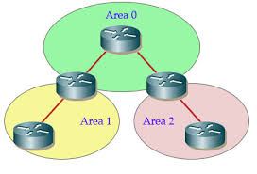

Config ospf in multiple area

**Requirements**

Cisco recommends that you have knowledge of these topics:

**OSPF**

Multi-Area Adjacency

Cisco also recommends that these requirements be met before you attempt the configuration that is described in this document:

The OSPF link state routing protocol must be pre-configured in the network.

Only two OSPF speakers use the interface between which OSPF Multi-Area functionality works. Multi-Area OSPF only works on Point-to-Point network types.

**Components Used**

The information in this document is based on multi-Area OSPF.

The information in this document was created from the devices in a specific lab environment. All of the devices used in this document started with a cleared (default) configuration. If your network is live, ensure that you understand the potential impact of any command

**Background:**

The OSPF link state routing protocol uses the concept of Areas, which are sub-domains within the OSPF domain. A router within an Area maintains the complete topology information of that Area. By default, an interface can only belong to one OSPF Area. This can not only cause sub-optimal routing in the network, but it can also lead to other issues if the network is not designed correctly.

When Multi-Area Adjacency is configured on an interface, the OSPF speakers form more than one Adjacency (ADJ) over that link. The Multi-Area interface is a logical, point-to-point interface over which the ADJ is formed. This document describes a scenario where Multi-Area OSPF ADJ can be used to work around a problem and meet the network requirements.

In other words, when a large OSPF area is divided into smaller areas, this is called multiarea OSPF. Multiarea OSPF is useful in larger network deployments to reduce processing and memory overhead.

Multiarea OSPF requires a hierarchical network design. The main area is called the backbone area (area 0) and all other areas must connect to the backbone area.

Multiarea OSPF have these advantages:

Smaller routing tables – There are fewer routing table entries as network addresses can be summarized between areas.

Reduced frequency of SPF calculations – Localizes impact of a topology change within an area. For instance, it minimizes routing update impact, because LSA flooding stops at the area boundary.

Reduced link-state update overhead – Minimizes processing and memory requirements, because there are fewer routers exchanging LSAs.

Confines network instability to single areas of the network

two-layer area hierarchy:

Backbone (Transit) area – An OSPF area whose primary function is the fast and efficient movement of IP packets. Backbone areas interconnect with other OSPF area types. Generally, end users are not found within a backbone area. The backbone area is also called OSPF area 0. Hierarchical networking defines area 0 as the core to which all other areas directly connect.

Regular (Non-backbone) area – Connects users and resources. Regular areas are usually set up along functional or geographical groupings. By default, a regular area does not allow traffic from another area to use its links to reach other areas. All traffic from other areas must cross a transit area.

Inter-area traffic: All traffic moving from one area to another area must traverse the backbone area. This traffic is referred to as inter-area traffic.

**Diagram:**

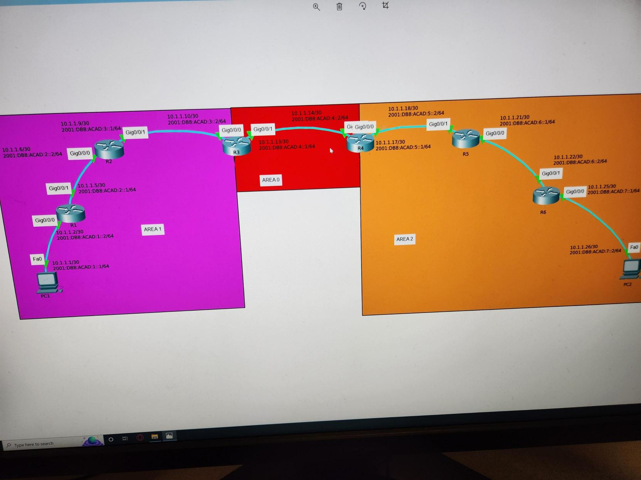

**device:**

6 cisco router, 2 pc

Configuration R1:

hostname R1

boot-start-marker

boot-end-marker

vrf definition Mgmt-intf

address-family ipv4

exit-address-family

address-family ipv6

--More--

*Sep 14 17:47:17.331: %SYS-5-CONFIG_I: Configured from console exit-address-family

enable secret 5 $1$dR.M$VbBdcnIaPUovPBa2y46NC/

no aaa new-model

no ip domain lookup

ipv6 unicast-routing

subscriber templating

multilink bundle-name authenticated

license udi pid ISR4321/K9 sn FDO21482HZX

spanning-tree extend system-id

redundancy

mode none

vlan internal allocation policy ascending

interface GigabitEthernet0/0/0

ip address 10.1.1.2 255.255.255.252

ip ospf 1 area 1

negotiation auto

ipv6 address FE80::1 link-local

ipv6 address 2001:DB8:ACAD:1::1/64

ipv6 address 2001:DB8:ACAD:1::2/64

ipv6 enable

ipv6 ospf 1 area 1

interface GigabitEthernet0/0/1

ip address 10.1.1.5 255.255.255.252

ip ospf 1 area 1

negotiation auto

ipv6 address 2001:DB8:ACAD:2::1/64

ipv6 enable

ipv6 ospf 1 area 1

interface Serial0/1/0

interface Serial0/1/1

interface GigabitEthernet0

vrf forwarding Mgmt-intf

no ip address

shutdown

negotiation auto

interface Vlan1

no ip address

shutdown

router ospf 1

router-id 1.1.1.1

network 10.1.1.0 0.0.0.3 area 1

network 10.1.1.4 0.0.0.3 area 1

ip forward-protocol nd

no ip http server

no ip http secure-server

ip tftp source-interface GigabitEthernet0

ipv6 router ospf 1

router-id 1.1.1.1

control-plane

line con 0

password 7 00071A150754

login

stopbits 1

line aux 0

stopbits 1

line vty 0 4

login

end

R2:

version 15.5

service timestamps debug datetime msec

service timestamps log datetime msec

service password-encryption

no platform punt-keepalive disable-kernel-core

hostname R2

boot-start-marker

boot-end-marker

vrf definition Mgmt-intf

address-family ipv4

exit-address-family

address-family ipv6

exit-address-family

enable secret 5 $1$77i9$1rHfAqo5BOc05xtPGT29//

no aaa new-model

no ip domain lookup

ipv6 unicast-routing

subscriber templating

multilink bundle-name authenticated

license udi pid ISR4321/K9 sn FDO21482DWJ

spanning-tree extend system-id

redundancy

mode none

vlan internal allocation policy ascending

interface GigabitEthernet0/0/0

ip address 10.1.1.6 255.255.255.252

ip ospf 1 area 1

negotiation auto

ipv6 address 2001:DB8:ACAD:2::2/64

ipv6 enable

ipv6 ospf 1 area 1

interface GigabitEthernet0/0/1

ip address 10.1.1.9 255.255.255.252

ip ospf 1 area 1

negotiation auto

ipv6 address FE80::1 link-local

ipv6 address 2001:DB8:ACAD:3::1/64

ipv6 enable

ipv6 ospf 1 area 1

interface Serial0/1/0

no ip address

shutdown

interface Serial0/1/1

no ip address

shutdown

interface GigabitEthernet0

vrf forwarding Mgmt-intf

no ip address

shutdown

negotiation auto

interface Vlan1

no ip address

shutdown

router ospf 1

router-id 2.2.2.2

network 10.1.1.4 0.0.0.3 area 0

network 10.1.1.8 0.0.0.3 area 0

ip forward-protocol nd

no ip http server

no ip http secure-server

ip tftp source-interface GigabitEthernet0

ipv6 router ospf 1

router-id 2.2.2.2

control-plane

line con 0

password 7 045802150C2E

login

stopbits 1

line aux 0

stopbits 1

line vty 0 4

login

end

R3:

Current configuration : 1856 bytes

Last configuration change at 17:39:51 UTC Wed Sep 14 2022

version 15.5

service timestamps debug datetime msec

service timestamps log datetime msec

service password-encryption

no platform punt-keepalive disable-kernel-core

hostname R3

boot-start-marker

boot-end-marker

vrf definition Mgmt-intf

address-family ipv4

exit-address-family

address-family ipv6

exit-address-family

enable secret 5 $1$dR.M$VbBdcnIaPUovPBa2y46NC/

no aaa new-model

no ip domain lookup

ipv6 unicast-routing

subscriber templating

vtp domain cisco

vtp mode transparent

multilink bundle-name authenticated

license udi pid ISR4321/K9 sn FDO214420HW

spanning-tree extend system-id

redundancy

mode none

vlan internal allocation policy ascending

interface GigabitEthernet0/0/0

ip address 10.1.1.10 255.255.255.252

ip ospf 1 area 1

negotiation auto

ipv6 address FE80::1 link-local

ipv6 address 2001:DB8:ACAD:3::2/64

ipv6 enable

ipv6 ospf 1 area 1

interface GigabitEthernet0/0/1

ip address 10.1.1.13 255.255.255.252

ip ospf 1 area 0

negotiation auto

ipv6 address 2001:DB8:ACAD:4::1/64

ipv6 enable

ipv6 ospf 1 area 0

interface Serial0/1/0

no ip address

shutdown

interface Serial0/1/1

no ip address

shutdown

interface GigabitEthernet0

vrf forwarding Mgmt-intf

no ip address

shutdown

negotiation auto

interface Vlan1

no ip address

shutdown

router ospf 1

router-id 3.3.3.3

network 10.1.1.8 0.0.0.3 area 1

network 10.1.1.12 0.0.0.3 area 0

ip forward-protocol nd

no ip http server

no ip http secure-server

ip tftp source-interface GigabitEthernet0

ipv6 router ospf 1

router-id 3.3.3.3

control-plane

line con 0

password 7 00071A150754

login

stopbits 1

line aux 0

stopbits 1

line vty 0 4

login

end

R4:

Current configuration : 1807 bytes

Last configuration change at 17:03:48 UTC Wed Sep 14 2022

version 15.5

service timestamps debug datetime msec

service timestamps log datetime msec

service password-encryption

no platform punt-keepalive disable-kernel-core

hostname R4

boot-start-marker

boot-end-marker

vrf definition Mgmt-intf

address-family ipv4

exit-address-family

address-family ipv6

exit-address-family

enable secret 5 $1$dR.M$VbBdcnIaPUovPBa2y46NC/

no aaa new-model

no ip domain lookup

ipv6 unicast-routing

subscriber templating

vtp domain cisco

vtp mode transparent

multilink bundle-name authenticated

license udi pid ISR4321/K9 sn FDO214421D1

spanning-tree extend system-id

redundancy

mode none

vlan internal allocation policy ascending

interface GigabitEthernet0/0/0

ip address 10.1.1.17 255.255.255.252

ip ospf 1 area 2

negotiation auto

ipv6 address FE80::1 link-local

ipv6 address 2001:DB8:ACAD:5::1/64

ipv6 enable

ipv6 ospf 1 area 2

interface GigabitEthernet0/0/1

ip address 10.1.1.14 255.255.255.252

ip ospf 1 area 0

negotiation auto

ipv6 address 2001:DB8:ACAD:4::2/64

ipv6 enable

ipv6 ospf 1 area 0

interface Serial0/1/0

interface Serial0/1/1

interface GigabitEthernet0

vrf forwarding Mgmt-intf

no ip address

shutdown

negotiation auto

interface Vlan1

no ip address

shutdown

router ospf 1

router-id 4.4.4.4

network 10.1.1.12 0.0.0.3 area 0

network 10.1.1.16 0.0.0.3 area 2

ip forward-protocol nd

no ip http server

no ip http secure-server

ip tftp source-interface GigabitEthernet0

ipv6 router ospf 1

router-id 4.4.4.4

control-plane

line con 0

password 7 00071A150754

login

stopbits 1

line aux 0

stopbits 1

line vty 0 4

login

end

R5:

version 16.9

service timestamps debug datetime msec

service timestamps log datetime msec

service password-encryption

platform qfp utilization monitor load 80

no platform punt-keepalive disable-kernel-core

hostname R5

boot-start-marker

boot-end-marker

vrf definition Mgmt-intf

address-family ipv4

exit-address-family

address-family ipv6

exit-address-family

enable secret 5 $1$dR.M$VbBdcnIaPUovPBa2y46NC/

no aaa new-model

no ip domain lookup

login on-success log

subscriber templating

ipv6 unicast-routing

multilink bundle-name authenticated

crypto pki trustpoint TP-self-signed-859896477

enrollment selfsigned

subject-name cn=IOS-Self-Signed-Certificate-859896477

revocation-check none

rsakeypair TP-self-signed-859896477

crypto pki certificate chain TP-self-signed-859896477

certificate self-signed 01

3082032E 30820216 A0030201 02020101 300D0609 2A864886 F70D0101 05050030

30312E30 2C060355 04031325 494F532D 53656C66 2D536967 6E65642D 43657274

69666963 6174652D 38353938 39363437 37301E17 0D323230 39313431 37303433

345A170D 33303031 30313030 30303030 5A303031 2E302C06 03550403 1325494F

532D5365 6C662D53 69676E65 642D4365 72746966 69636174 652D3835 39383936

34373730 82012230 0D06092A 864886F7 0D010101 05000382 010F0030 82010A02

82010100 A7102733 C3819A1B A4F2E1C3 B9CEFB19 EC1FDE34 60BA1F5B A156313A

F66032D1 39D7CD14 F201114B D18C8B4B 7103E79D 1294D80E 2A650660 A9AE413F

C25A4DDB 436B8A2A D627613D 7BF14743 1AF69DFF D25A05F4 69962FA0 B698126B

7D9C4034 8496C7AA 64FD9B2B B1001BBD 150B070E B2D5319A 25421F25 2FC84619

D3F0FDD5 8EA7CC9D FFB60123 587E7832 F9CE2F63 7A546706 CD91C611 3BD70C95

DDE88518 87D196E6 F557275C A139E4D7 7CEADD2D B2481F55 23F06AC7 5C88BB39

9385503B 3661EFE5 9B37AED5 46357CE0 79FAA167 D517E8D3 D65A830D 4E5E358A

C3F6ADF8 16360273 8895D3D3 B5E86E80 C16F5B90 2CFE8572 92273CCD B4318A69

A17E0FA7 02030100 01A35330 51300F06 03551D13 0101FF04 05300301 01FF301F

0603551D 23041830 16801431 F438937F 21016696 CAAE91BF 8B6833BB 86A6CB30

1D060355 1D0E0416 041431F4 38937F21 016696CA AE91BF8B 6833BB86 A6CB300D

06092A86 4886F70D 01010505 00038201 01003DB0 12436480 79038657 6EDEEFEB

D0401217 F2B8318A C0A140C6 28972D55 D09B4C6D 95FE5B71 E645E9D3 BCB3BB22

B7D20B3B 3285901F 726E9CD5 4BE4EA0E 6870EAE4 C3F7864B EFE34ABF 626D53D6

D615DE6D C12486CB 583DB051 1BA40523 146DE535 140DD9E0 90B60DCC 24FCF2FE

7BBE5900 A3F410C4 955063A4 0B06A2C6 6B485D04 4B66ABA7 27C10D0D BCF3AF21

B17A45E8 B42081E8 D924680E 387FA1A0 3B7FE4E8 90B37AC1 3D7697D1 3ED40BA0

6BF4E970 C478C964 186B04F5 BED97B22 7FDB32EF 9F925A84 C75639BB 200CBA26

7DCD1F37 98072F66 31432093 BE810AB0 EE69547D 94D1AF47 A60C3BD8 12CFE27B

530983E0 73088EB1 01B44D2B 7EF8BDFA D448

quit

license udi pid ISR4321/K9 sn FLM240608PJ

no license smart enable

diagnostic bootup level minimal

spanning-tree extend system-id

redundancy

mode none

interface GigabitEthernet0/0/0

ip address 10.1.1.21 255.255.255.252

ip ospf 1 area 2

negotiation auto

ipv6 address 2001:DB8:ACAD:6::1/64

ipv6 enable

ipv6 ospf 1 area 2

interface GigabitEthernet0/0/1

ip address 10.1.1.18 255.255.255.252

ip ospf 1 area 2

negotiation auto

ipv6 address 2001:DB8:ACAD:5::2/64

ipv6 enable

ipv6 ospf 1 area 2

interface GigabitEthernet0/1/0

no ip address

shutdown

negotiation auto

interface GigabitEthernet0/1/1

no ip address

shutdown

negotiation auto

interface GigabitEthernet0

vrf forwarding Mgmt-intf

no ip address

shutdown

negotiation auto

router ospf 1

router-id 5.5.5.5

network 10.1.1.16 0.0.0.3 area 2

network 10.1.1.20 0.0.0.3 area 2

ip forward-protocol nd

no ip http server

ip http authentication local

no ip http secure-server

ip tftp source-interface GigabitEthernet0

ipv6 router ospf 1

router-id 5.5.5.5

control-plane

line con 0

password 7 00071A150754

login

transport input none

stopbits 1

line aux 0

stopbits 1

line vty 0 4

login

end

R6:

version 16.9

service timestamps debug datetime msec

service timestamps log datetime msec

service password-encryption

platform qfp utilization monitor load 80

no platform punt-keepalive disable-kernel-core

hostname R6

boot-start-marker

boot-end-marker

vrf definition Mgmt-intf

address-family ipv4

exit-address-family

address-family ipv6

exit-address-family

enable secret 5 $1$dR.M$VbBdcnIaPUovPBa2y46NC/

no aaa new-model

no ip domain lookup

login on-success log

subscriber templating

ipv6 unicast-routing

multilink bundle-name authenticate

crypto pki trustpoint TP-self-signed-4288135047

enrollment selfsigned

subject-name cn=IOS-Self-Signed-Certificate-4288135047

revocation-check none

rsakeypair TP-self-signed-4288135047

crypto pki certificate chain TP-self-signed-4288135047

certificate self-signed 01

30820330 30820218 A0030201 02020101 300D0609 2A864886 F70D0101 05050030

31312F30 2D060355 04031326 494F532D 53656C66 2D536967 6E65642D 43657274

69666963 6174652D 34323838 31333530 3437301E 170D3232 30393134 31373033

35395A17 0D333030 31303130 30303030 305A3031 312F302D 06035504 03132649

4F532D53 656C662D 5369676E 65642D43 65727469 66696361 74652D34 32383831

33353034 37308201 22300D06 092A8648 86F70D01 01010500 0382010F 00308201

0A028201 0100C5D8 1A81DD6B A6B7CD0F CE7332B2 EACC2466 01BB56D4 4FD3EF5D

28C5CEB8 BABAEE75 72665F7D 79253D5A 5EA0AE56 334F5DB2 1AB4A541 55409F11

BF03AF1E E87C9C8F 2580B6BF 83903F4A 30E0B5E4 D551E03F A826D9EA DE2BA8BA

3E52B1F6 2760F9D7 AF096DB2 B22AD73D 871E62FD 93ABB072 A6406A37 B2B23CC3

6344B7AA 60FE5B69 D5F5CE02 715A6141 90604451 1D280915 F89876DD 77916473

0FD4781F 85056DBC 2816E189 A3B33E57 79946583 F3A3BBEA C9CADE73 62201D6B

817DBD30 A812FF5D CD7B3B0E C5EDAFEE 85AB93CC E0E2527A 33912F55 FBC71A2F

C2C03435 842D4382 61571103 7C0C9537 31F3AF56 A01D522E BBC4BD7B A21A7FE7

52BF5775 82A50203 010001A3 53305130 0F060355 1D130101 FF040530 030101FF

301F0603 551D2304 18301680 148260BF 39AA075E 8E45C3D2 0E191B9C 4B6BD78D

88301D06 03551D0E 04160414 8260BF39 AA075E8E 45C3D20E 191B9C4B 6BD78D88

300D0609 2A864886 F70D0101 05050003 82010100 B1AEAB52 5DBFD618 64272611

6FFA35DD 785EAEC0 A592E9BE B0F86C27 B5B58D14 83A2B767 A8ACE329 2F097943

2B9E0C57 E46FD2D6 63A90DB5 7E0EE2BD 3FE97EBB AF1BD714 387F4180 B782DFDF

A64281FE FED70404 C96F1959 4E18517D 385099D0 B2B3E770 F32780B6 DBC2DF26

7A8BF5BA C43B2691 C6229D64 FB24CF4C F97E0BBB 2FC36D50 8DBD62D2 C4CBB404

EBFED703 A11E3BB9 33BE4C31 6B7BEA3A 4DB4FF7C 7B91DBF9 95B6FC8C D6C49041

897C1C2F 9576E1EB 8BD311C9 FA7BE334 97BCA4F4 052CA860 4DC9D7B7 FBFBF8F7

F62D0C9A 52F429C9 9231AD27 C06C1922 93176385 FC0FF01B 4B00C179 0DE28C78

96D658D1 3DAD143B D6A6A88C C9021E64 FB9BF2DE

quit

license udi pid ISR4321/K9 sn FLM2406090M

no license smart enable

diagnostic bootup level minimal

spanning-tree extend system-id

redundancy

mode none

interface GigabitEthernet0/0/0

ip address 10.1.1.25 255.255.255.252

ip ospf 1 area 2

negotiation auto

ipv6 address 2001:DB8:ACAD:7::1/64

ipv6 enable

ipv6 ospf 1 area 2

interface GigabitEthernet0/0/1

ip address 10.1.1.22 255.255.255.252

ip ospf 1 area 2

negotiation auto

ipv6 address 2001:DB8:ACAD:6::2/64

ipv6 enable

ipv6 ospf 1 area 2

interface GigabitEthernet0/1/0

no ip address

shutdown

negotiation auto

interface GigabitEthernet0/1/1

no ip address

shutdown

negotiation auto

interface GigabitEthernet0

vrf forwarding Mgmt-intf

no ip address

shutdown

negotiation auto

router ospf 1

router-id 6.6.6.6

network 10.1.1.20 0.0.0.3 area 2

network 10.1.1.24 0.0.0.3 area 2

ip forward-protocol nd

no ip http server

ip http authentication local

no ip http secure-server

ip tftp source-interface GigabitEthernet0

ipv6 router ospf 1

router-id 6.6.6.6

control-plane

line con 0

password 7 00071A150754

login

transport input none

stopbits 1

line aux 0

stopbits 1

line vty 0 4

login

end

**routing**:

The ip route table show that there are all route pass through the whole devices, which means the fine connection are establish between PC1 and PC2

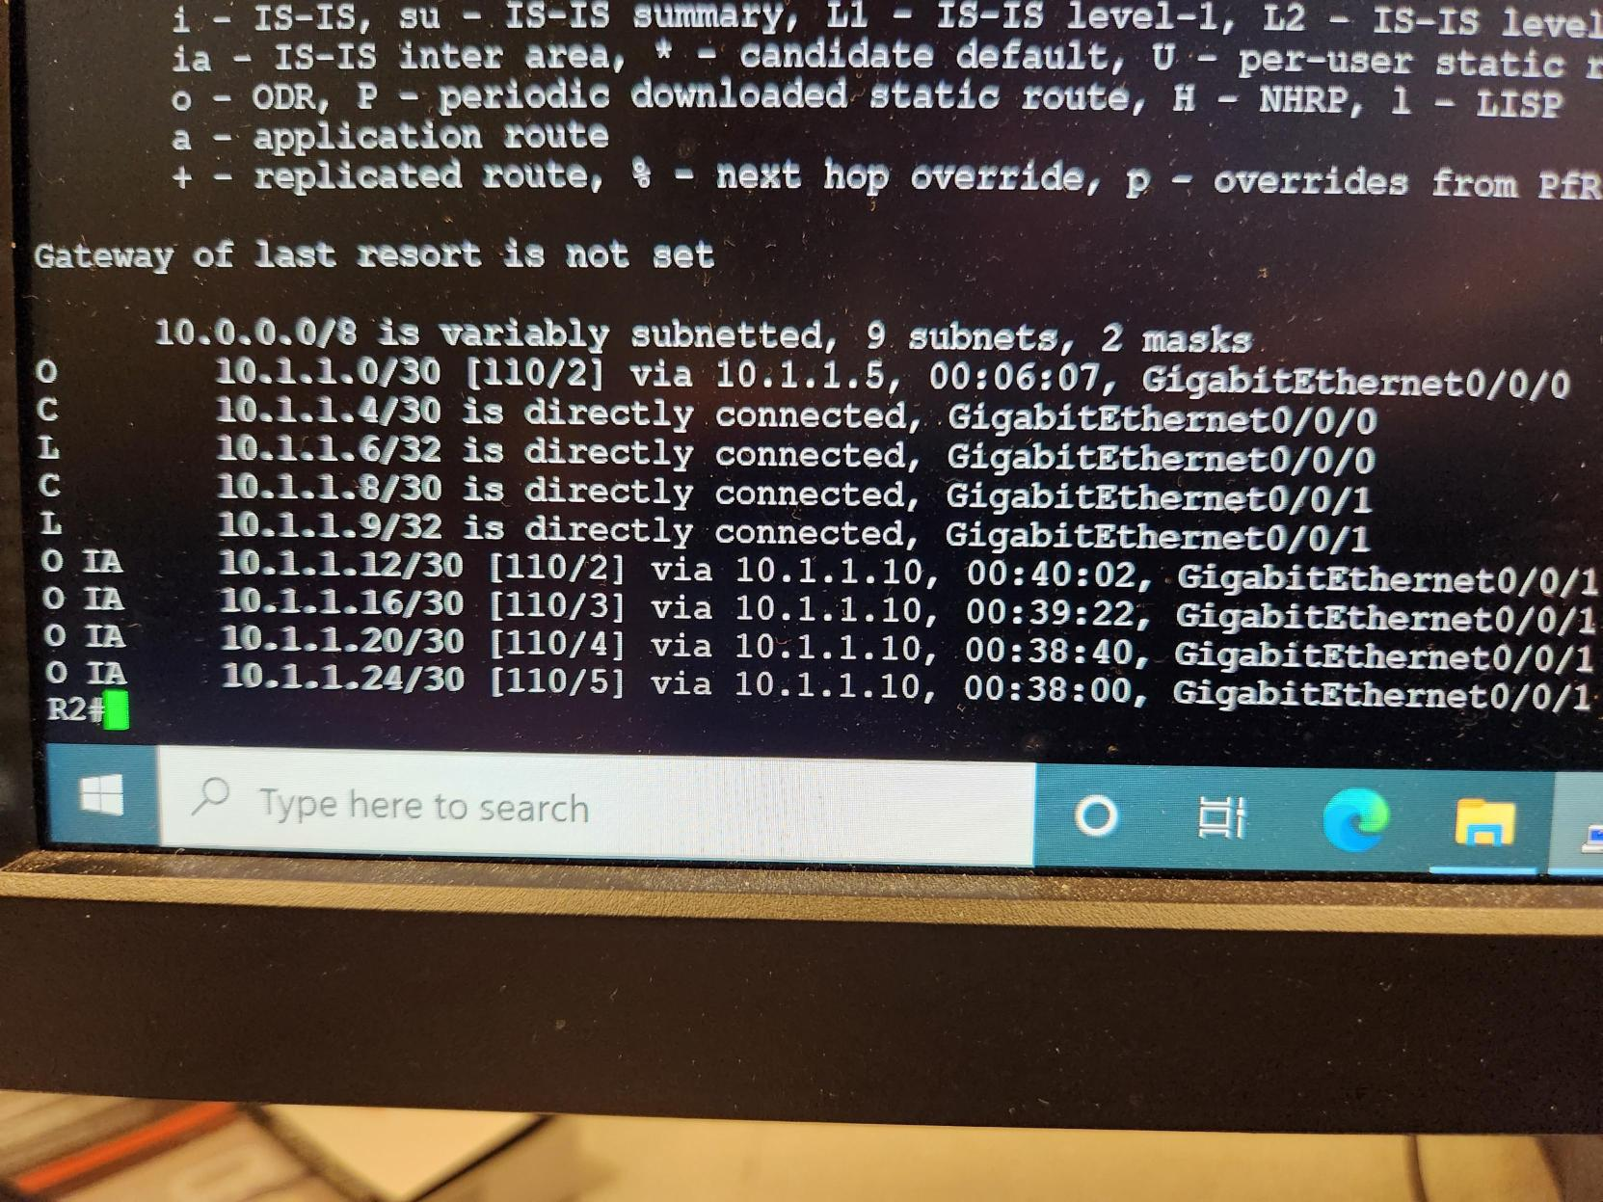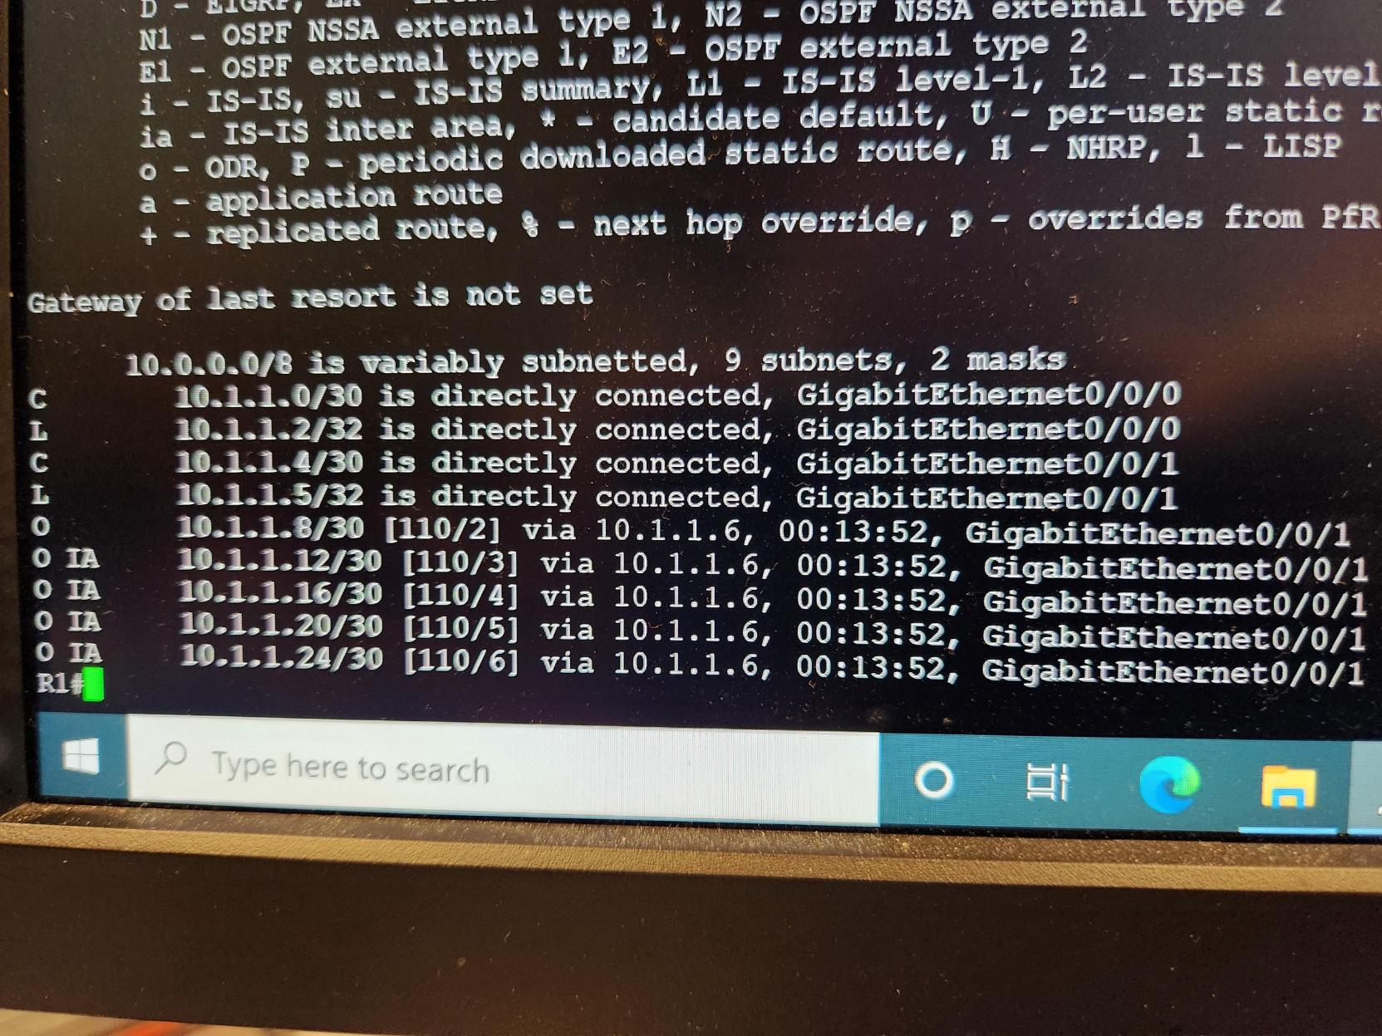

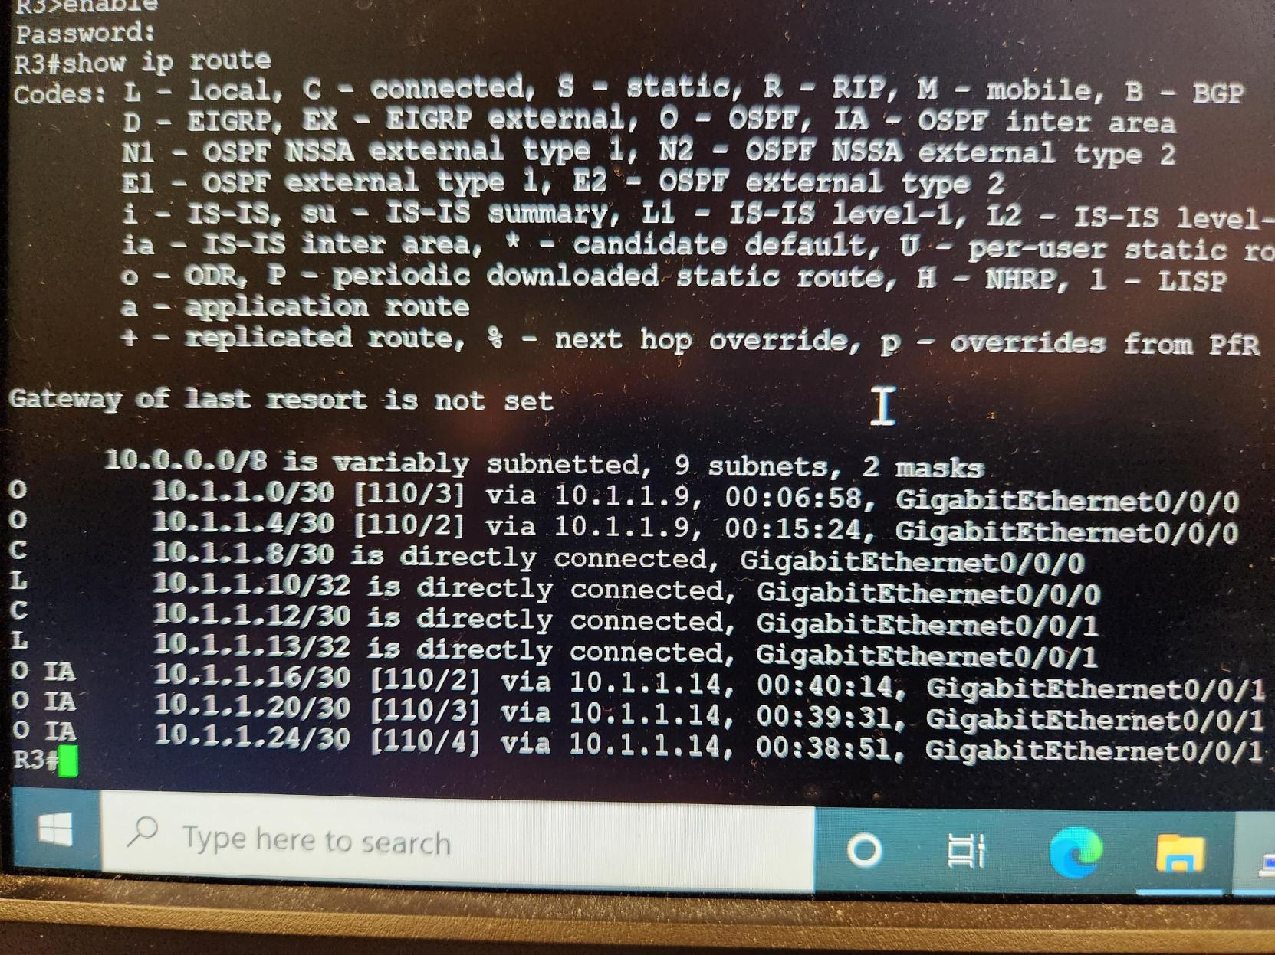

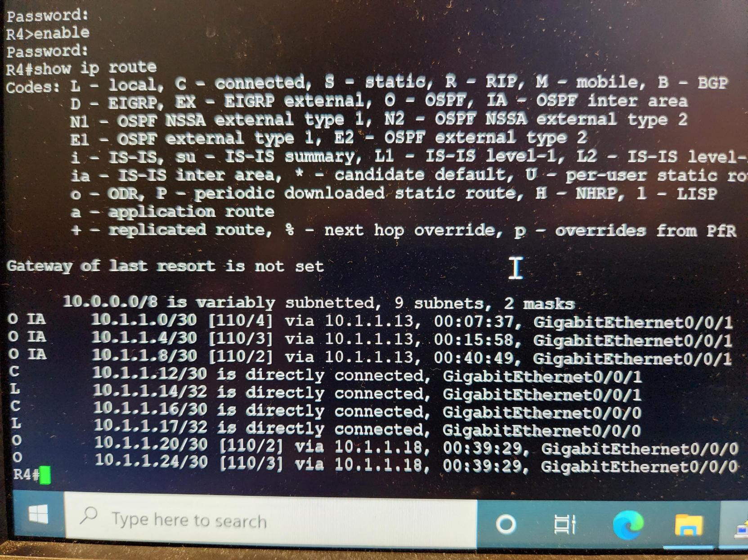

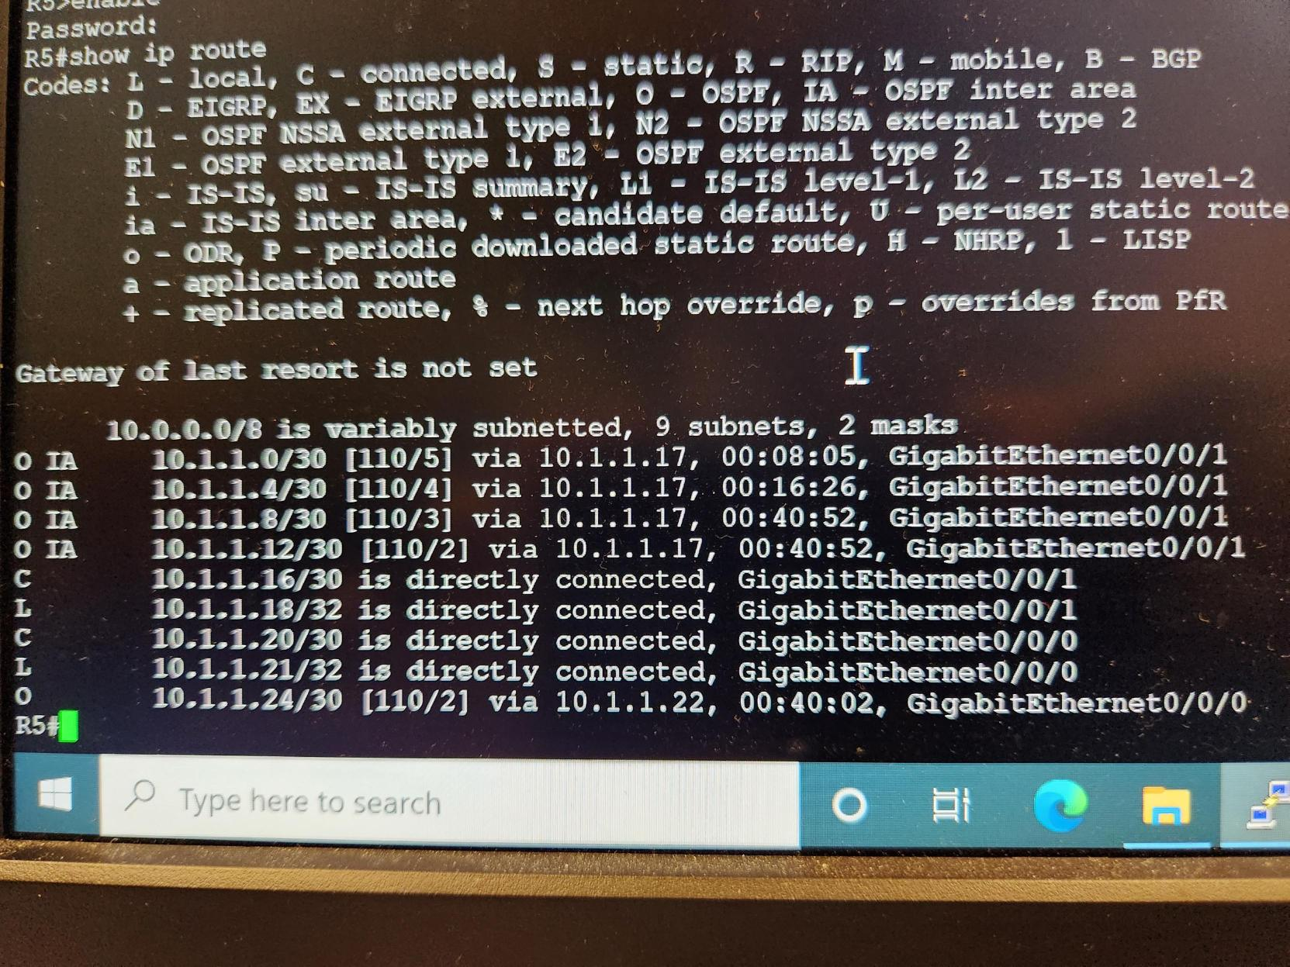

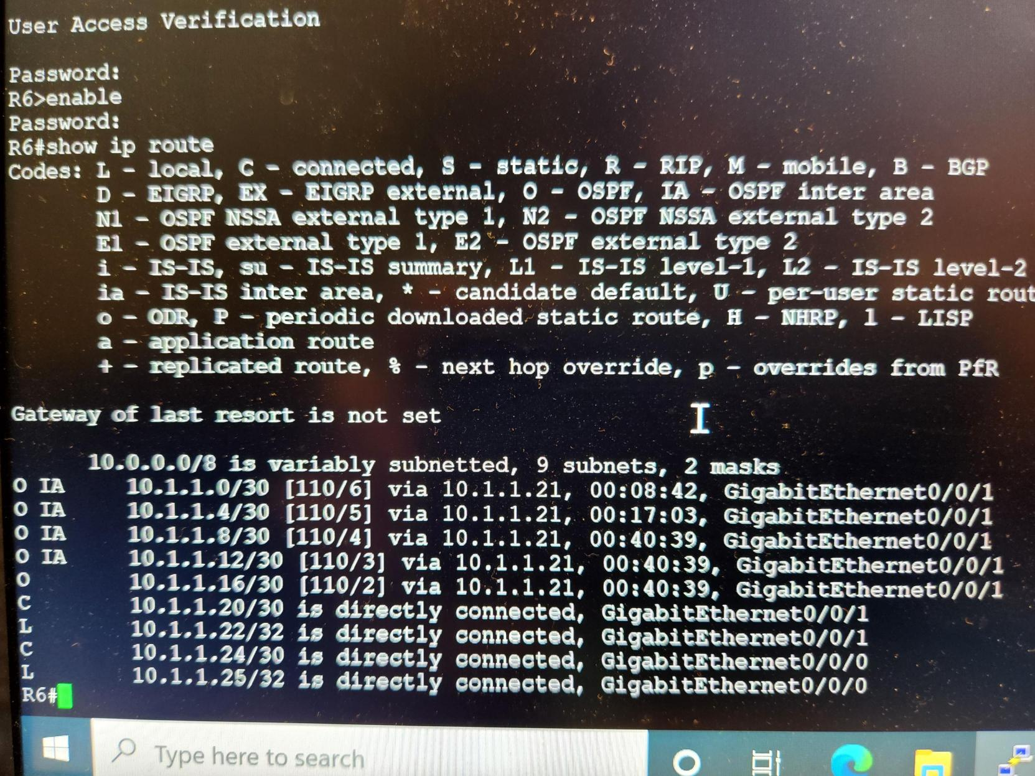

**Problem:**

We didn't run into too many problems, one problem was that any device couldn't ping further to adjacent to that device, we removed Fe80::2 for ipv6, because it is redundant, after removing it I can ping.

Another problem is that in IPv4, R1 can ping to PC1 and PC2, PC2 can ping to PC1, but PC1 cannot connect to routers other than R1, and ipv6 can ping to each other. Restarting the network port of pc1 solves this problem strangely.

Lab 3

Eternal BGP (Border Gateway Protocol)

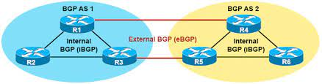

Using BGP makes connection between EIGRP and OSPF

Device:

2 computers, 6 routers

Diagram:

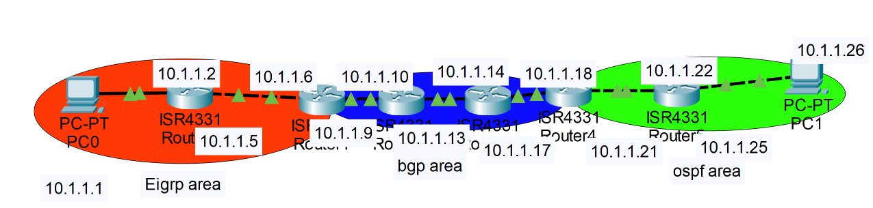

Background:

Border Gateway Protocol (BGP) is a standardized exterior gateway protocol designed to exchange routing and reachability information among autonomous systems (AS) on the Internet. BGP is classified as a path-vector routing protocol, and it makes routing decisions based on paths, network policies, or rule-sets configured by a network administrator. BGP offers network stability that guarantees routers can quickly adapt to send packets through another reconnection if one internet path goes down. BGP makes routing decisions based on paths, rules or network policies configured by a network administrator.

BGP used for routing within an autonomous system is called Interior Border Gateway Protocol, Internal BGP (iBGP). In contrast, the Internet application of the protocol is called Exterior Border Gateway Protocol, External BGP (eBGP).

When BGP runs between two peers in the same autonomous system (AS), it is referred to as Internal BGP (iBGP or Interior Border Gateway Protocol). When it runs between different autonomous systems, it is called External BGP (eBGP or Exterior Border Gateway Protocol). Routers on the boundary of one AS exchanging information with another AS are called border or edge routers or simply eBGP peers and are typically connected directly, while iBGP peers can be interconnected through other intermediate routers. Other deployment topologies are also possible, such as running eBGP peering inside a VPN tunnel, allowing two remote sites to exchange routing information in a secure and isolated manner.

The main difference between iBGP and eBGP peering is in the way routes that were received from one peer are typically propagated by default to other peers:

New routes learned from an eBGP peer are re-advertised to all iBGP and eBGP peers.

New routes learned from an iBGP peer are re-advertised to all eBGP peers only.

we are using EBGP This time, which is one remote only have one router

Configuration:

R1:

hostname R1

boot-start-marker

boot-end-marker

vrf definition Mgmt-intf

address-family ipv4

exit-address-family

address-family ipv6

exit-address-family

enable secret 5 $1$dR.M$VbBdcnIaPUovPBa2y46NC/

no aaa new-model

no ip domain lookup

ipv6 unicast-routing

subscriber templating

multilink bundle-name authenticated

license udi pid ISR4321/K9 sn FDO21482HZX

spanning-tree extend system-id

redundancy

mode none

vlan internal allocation policy ascending

interface GigabitEthernet0/0/0

ip address 10.1.1.2 255.255.255.252

negotiation auto

ipv6 address 2001:DB8:ACAD:1::2/64

ipv6 enable

ipv6 eigrp 1

interface GigabitEthernet0/0/1

ip address 10.1.1.5 255.255.255.252

negotiation auto

ipv6 address 2001:DB8:ACAD:2::1/64

ipv6 enable

ipv6 eigrp 1

interface Serial0/1/0

no ip address

shutdown

interface Serial0/1/1

no ip address

shutdown

interface GigabitEthernet0

vrf forwarding Mgmt-intf

no ip address

shutdown

negotiation auto

interface Vlan1

no ip address

shutdown

router eigrp 1

network 10.1.1.0 0.0.0.3

network 10.1.1.4 0.0.0.3

eigrp router-id 1.1.1.1

ip forward-protocol nd

no ip http server

no ip http secure-server

ip tftp source-interface GigabitEthernet0

ipv6 router eigrp 1

eigrp router-id 1.1.1.1

control-plane

line con 0

password 7 00071A150754

login

stopbits 1

line aux 0

stopbits 1

line vty 0 4

login

end

Router 2:

hostname R2

boot-start-marker

boot-end-marker

vrf definition Mgmt-intf

address-family ipv4

exit-address-family

address-family ipv6

exit-address-family

enable secret 5 $1$77i9$1rHfAqo5BOc05xtPGT29//

no aaa new-model

no ip domain lookup

ipv6 unicast-routing

subscriber templating

multilink bundle-name authenticated

license udi pid ISR4321/K9 sn FDO21482DWJ

spanning-tree extend system-id

redundancy

mode none

vlan internal allocation policy ascending

interface GigabitEthernet0/0/0

ip address 10.1.1.9 255.255.255.252

negotiation auto

ipv6 address 2001:DB8:ACAD:3::1/64

ipv6 enable

ipv6 eigrp 1

interface GigabitEthernet0/0/1

ip address 10.1.1.6 255.255.255.252

negotiation auto

ipv6 address 2001:DB8:ACAD:2::2/64

ipv6 enable

ipv6 eigrp 1

interface Serial0/1/0

no ip address

shutdown

interface Serial0/1/1

no ip address

shutdown

interface GigabitEthernet0

vrf forwarding Mgmt-intf

no ip address

shutdown

negotiation auto

interface Vlan1

no ip address

shutdown

router eigrp 1

network 10.1.1.4 0.0.0.3

network 10.1.1.8 0.0.0.3

eigrp router-id 2.2.2.2

ip forward-protocol nd

no ip http server

no ip http secure-server

ip tftp source-interface GigabitEthernet0

ipv6 router eigrp 1

eigrp router-id 2.2.2.2

control-plane

line con 0

password 7 045802150C2E

login

stopbits 1

line aux 0

stopbits 1

line vty 0 4

login

end

Router 3:

hostname R3

boot-start-marker

boot-end-marker

vrf definition Mgmt-intf

address-family ipv4

exit-address-family

address-family ipv6

exit-address-family

enable secret 5 $1$dR.M$VbBdcnIaPUovPBa2y46NC/

no aaa new-model

no ip domain lookup

ipv6 unicast-routing

subscriber templating

vtp domain cisco

vtp mode transparent

multilink bundle-name authenticated

license udi pid ISR4321/K9 sn FDO214420HW

spanning-tree extend system-id

redundancy

mode none

vlan internal allocation policy ascending

vlan 10,20

interface GigabitEthernet0/0/0

ip address 10.1.1.13 255.255.255.252

negotiation auto

ipv6 address FE80::1 link-local

ipv6 address 2001:DB8:ACAD:4::1/64

ipv6 enable

ipv6 eigrp 1

interface GigabitEthernet0/0/1

ip address 10.1.1.10 255.255.255.252

negotiation auto

ipv6 address 2001:DB8:ACAD:3::2/64

ipv6 enable

ipv6 eigrp 1

interface Serial0/1/0

no ip address

shutdown

interface Serial0/1/1

no ip address

shutdown

interface GigabitEthernet0

vrf forwarding Mgmt-intf

no ip address

shutdown

negotiation auto

interface Vlan1

no ip address

shutdown

router eigrp 1

network 10.1.1.8 0.0.0.3

network 10.1.1.12 0.0.0.3

redistribute static

redistribute bgp 3 metric 10000 100 255 1 1500

eigrp router-id 3.3.3.3

router bgp 3

bgp router-id 3.3.3.3

bgp log-neighbor-changes

no bgp default ipv4-unicast

neighbor 10.1.1.14 remote-as 4

neighbor 2001:DB8:ACAD:4::2 remote-as 4

address-family ipv4

network 10.1.1.8

network 10.1.1.12

redistribute eigrp 1

neighbor 10.1.1.14 activate

exit-address-family

address-family ipv6

redistribute eigrp 1

network 2001:DB8:ACAD:3::/64

network 2001:DB8:ACAD:4::/64

neighbor 2001:DB8:ACAD:4::2 activate

exit-address-family

ip forward-protocol nd

no ip http server

no ip http secure-server

ip tftp source-interface GigabitEthernet0

ipv6 router eigrp 1

eigrp router-id 3.3.3.3

redistribute bgp 3

ipv6 router eigrp 10

redistribute bgp 3 metric 10000 100 255 1 1500

control-plane

line con 0

password 7 00071A150754

login

stopbits 1

line aux 0

stopbits 1

line vty 0 4

login

end

Router 4:

hostname R4

boot-start-marker

boot-end-marker

vrf definition Mgmt-intf

address-family ipv4

exit-address-family

address-family ipv6

exit-address-family

enable secret 5 $1$dR.M$VbBdcnIaPUovPBa2y46NC/

no aaa new-model

no ip domain lookup

ipv6 unicast-routing

subscriber templating

vtp domain cisco

vtp mode transparent

multilink bundle-name authenticated

license udi pid ISR4321/K9 sn FDO214421D1

spanning-tree extend system-id

redundancy

mode none

vlan internal allocation policy ascending

vlan 10,20

interface GigabitEthernet0/0/0

ip address 10.1.1.17 255.255.255.252

ip ospf 1 area 0

negotiation auto

ipv6 address FE80::1 link-local

ipv6 address 2001:DB8:ACAD:5::1/64

ipv6 enable

ipv6 ospf 1 area 0

interface GigabitEthernet0/0/1

ip address 10.1.1.14 255.255.255.252

ip ospf 1 area 0

negotiation auto

ipv6 address FE80::2 link-local

ipv6 address 2001:DB8:ACAD:4::2/64

ipv6 enable

ipv6 ospf 1 area 0

interface Serial0/1/0

no ip address

shutdown

interface Serial0/1/1

no ip address

shutdown

interface GigabitEthernet0

vrf forwarding Mgmt-intf

no ip address

shutdown

negotiation auto

interface Vlan1

no ip address

shutdown

router ospf 1

router-id 4.4.4.4

redistribute bgp 4 subnets

network 10.1.1.12 0.0.0.3 area 0

network 10.1.1.16 0.0.0.3 area 0

router ospf 10

router bgp 4

bgp router-id 4.4.4.4

bgp log-neighbor-changes

no bgp default ipv4-unicast

neighbor 10.1.1.13 remote-as 3

neighbor 2001:DB8:ACAD:4::1 remote-as 3

address-family ipv4

network 10.1.1.12

network 10.1.1.12 mask 255.255.255.252

network 10.1.1.16

network 10.1.1.16 mask 255.255.255.252

redistribute ospf 1

neighbor 10.1.1.13 activate

exit-address-family

address-family ipv6

redistribute ospf 1

network 2001:DB8:ACAD:4::/64

network 2001:DB8:ACAD:5::/64

neighbor 2001:DB8:ACAD:4::1 activate

exit-address-family

ip forward-protocol nd

no ip http server

no ip http secure-server

ip tftp source-interface GigabitEthernet0

ipv6 router ospf 1

router-id 4.4.4.4

redistribute bgp 4 metric 10000

control-plane

line con 0

password 7 00071A150754

login

stopbits 1

line aux 0

stopbits 1

line vty 0 4

login

end

Router 5:

hostname R5

boot-start-marker

boot system flash:isr4300-universalk9.16.09.08.SPA.bin

boot-end-marker

vrf definition Mgmt-intf

address-family ipv4

exit-address-family

address-family ipv6

exit-address-family

enable secret 5 $1$dR.M$VbBdcnIaPUovPBa2y46NC/

no aaa new-model

no ip domain lookup

subscriber templating

vtp domain cisco

vtp mode transparent

ipv6 unicast-routing

multilink bundle-name authenticated

crypto pki trustpoint TP-self-signed-859896477

enrollment selfsigned

subject-name cn=IOS-Self-Signed-Certificate-859896477

revocation-check none

rsakeypair TP-self-signed-859896477

crypto pki certificate chain TP-self-signed-859896477

certificate self-signed 01

3082032E 30820216 A0030201 02020101 300D0609 2A864886 F70D0101 05050030

30312E30 2C060355 04031325 494F532D 53656C66 2D536967 6E65642D 43657274

69666963 6174652D 38353938 39363437 37301E17 0D323231 30313731 38323635

385A170D 33303031 30313030 30303030 5A303031 2E302C06 03550403 1325494F

532D5365 6C662D53 69676E65 642D4365 72746966 69636174 652D3835 39383936

34373730 82012230 0D06092A 864886F7 0D010101 05000382 010F0030 82010A02

82010100 CA31EE51 C97FF58C 76C72B4E 2B6CD51B 98CBA177 7EEF8D11 DAAB7CA8

47B3AA97 3B815AD1 09F637AE B1D98BB8 A2CAA1A9 0AFAF87A 3AFBFF9E 34875D72

0BD5EE8D E40F4D4A 3B4A38A7 09F1940D 013C18AE F29F2BEA 07085EB5 982E9BC8

F99C8CA7 1C7DD58E 67B89FCB 951C3C4C 6D11B8C7 8D24BF5C 973A32BF E16A3094

99E8DB22 7FEA5A30 6E9457F6 90485336 E953F3D2 942824E3 87D8DE52 E00336AC

09CA85F0 0BD105FA B4078F96 9A2EA846 C147AD42 B08CD3D2 16A06EB1 CC54E167

8F4677E9 2663D37D 7B1C3891 9ABF4B5B 83ECE428 AD426108 357B992E 792C850D

84C67187 BF0E10B5 B1D23A97 F2F1372F 7D0FA8C8 80E947DE 5E0FA234 7FA6A487

24A0DB83 02030100 01A35330 51300F06 03551D13 0101FF04 05300301 01FF301F

0603551D 23041830 168014E7 C71AF39E FCC743E7 C7395603 DBBCA771 4C734E30

1D060355 1D0E0416 0414E7C7 1AF39EFC C743E7C7 395603DB BCA7714C 734E300D

06092A86 4886F70D 01010505 00038201 010029B2 769B6033 C71585B8 DD1EE596

BDB3F81C 5C58921E AF7FBE2F A95F447D 7B870BCD B9AE5E5D 46FCE0E1 667295B7

4668DACB F848F91A 207FC6CD 203E64BF 6747B9E7 6FF304F1 491442EA 56EEBEE6

DE79EC87 F5BE7B9C B2482264 A58FAC1B 827F66C7 F16C0292 815AD1ED 86F2E167

9568FC20 9E2ADCB6 311B34E4 E93EC128 2DD25078 4F27E1F1 4DD309BA B2A0248A

C41F66C8 4A81C2B8 9D0E8A62 4E0443F6 F28B3203 28A14D43 0E06A98B 06DAB16D

66E0616A DB63132A 8FB53D9B 88A28660 F84CD05D EC8653F6 C3FC6446 94977DAC

0ED87E1C 9C0B372A 6E25729B FAD2B249 6FDF7BC6 3218B110 D167D3D5 AEACB17D

6E8CB48E ED168D18 8D9104DE BA9F3515 5662

quit

license udi pid ISR4321/K9 sn FLM240608PJ

no license smart enable

diagnostic bootup level minimal

spanning-tree extend system-id

redundancy

mode none

interface GigabitEthernet0/0/0

ip address 10.1.1.21 255.255.255.252

ip ospf 1 area 0

negotiation auto

ipv6 address FE80::1 link-local

ipv6 address 2001:DB8:ACAD:6::1/64

ipv6 enable

ipv6 ospf 1 area 0

interface GigabitEthernet0/0/1

ip address 10.1.1.18 255.255.255.252

ip ospf 1 area 0

negotiation auto

ipv6 address FE80::2 link-local

ipv6 address 2001:DB8:ACAD:5::2/64

ipv6 enable

ipv6 ospf 1 area 0

interface GigabitEthernet0/1/0

no ip address

shutdown

negotiation auto

interface GigabitEthernet0/1/1

no ip address

shutdown

negotiation auto

interface GigabitEthernet0

vrf forwarding Mgmt-intf

no ip address

shutdown

negotiation auto

router ospf 1

router-id 5.5.5.5

network 10.1.1.16 0.0.0.3 area 0

network 10.1.1.20 0.0.0.3 area 0

ip forward-protocol nd

no ip http server

ip http authentication local

no ip http secure-server

ip tftp source-interface GigabitEthernet0

ipv6 router ospf 1

router-id 5.5.5.5

control-plane

line con 0

password 7 00071A150754

login

transport input none

stopbits 1

line aux 0

stopbits 1

line vty 0 4

login

end

Router 6:

hostname R6

boot-start-marker

boot-end-marker

vrf definition Mgmt-intf

address-family ipv4

exit-address-family

address-family ipv6

exit-address-family

enable secret 5 $1$dR.M$VbBdcnIaPUovPBa2y46NC/

no aaa new-model

no ip domain lookup

login on-success log

subscriber templating

ipv6 unicast-routing

multilink bundle-name authenticated

crypto pki trustpoint TP-self-signed-4288135047

enrollment selfsigned

subject-name cn=IOS-Self-Signed-Certificate-4288135047

revocation-check none

rsakeypair TP-self-signed-4288135047

crypto pki certificate chain TP-self-signed-4288135047

certificate self-signed 01

30820330 30820218 A0030201 02020101 300D0609 2A864886 F70D0101 05050030

31312F30 2D060355 04031326 494F532D 53656C66 2D536967 6E65642D 43657274

69666963 6174652D 34323838 31333530 3437301E 170D3232 31303138 31373132

35315A17 0D333030 31303130 30303030 305A3031 312F302D 06035504 03132649

4F532D53 656C662D 5369676E 65642D43 65727469 66696361 74652D34 32383831

33353034 37308201 22300D06 092A8648 86F70D01 01010500 0382010F 00308201

0A028201 0100B495 9E257FF6 673D15D2 869C1617 50F21A68 8E428FEC FE307231

65CA7B01 9029C78E F78217E5 1EFEA53D A47BB776 B62143FD 8AE2D798 6C0DC976

D61FE69C 19AAE979 2D967496 5078182F E022788B F62FF714 179123D5 16C2DC97

6228B9F5 FF9BB180 D12EB5CD 527B9A71 8003318D B87B1250 2A1FFE21 254F9704

09E65928 7DB5745C F836610A 9E07208A 2DBF93EC 9A931BC4 08601F4A 12D17DCA

936E15EA FEFE1483 77548E8E 623FAC7A 5323B838 8777E9D5 12E0363E 76CAE4CC

159D051C 3095B17A 552007F7 60C9C647 886F5796 B13CDE0A E8ECCDA4 1576EFD1

89DAE800 1F4C5179 129C5DF5 BBEF7EFD B614A1C8 58D739A0 85481FE2 2A167C9D

F1763C47 25CF0203 010001A3 53305130 0F060355 1D130101 FF040530 030101FF

301F0603 551D2304 18301680 1406874A 4386F012 C8C332BB 8AA17C9D BA2302B9

CB301D06 03551D0E 04160414 06874A43 86F012C8 C332BB8A A17C9DBA 2302B9CB

300D0609 2A864886 F70D0101 05050003 82010100 596D712B 318F3855 E327FDB4

082E3C70 B3065E30 D9423085 21AC02CE 19CF91CE F116F82C 88D0D363 9E2DECFE

0B5183C8 04EDFF92 34A6CC58 A1405F4F 1962E32E 12B6B583 BC9AF375 1FF02283

AFF03622 10B1CD3B 43A54AD1 ED94CA21 A47BA1F9 BE976EBF 0D45C9DE 85B7AA84

423C3B48 DBD0FBAD 8FBA77ED 71BC90DA D9EB07BC D69873D4 67DB6370 03C0CC0C

9FC86391 BC9C5F15 F81A31DF FE7AE3BD DC5BEC5F 2C367326 7ECB7A73 6C1DA1E4

00BDB7BC 5449AD37 9B166929 8B1939D2 568385EE 6C7017E8 6DF1FFA0 2E090842

041D84CC 47415EA0 0162F4C4 EA423A52 7E7D1C50 90CCBE91 88F99334 D41ECD95

3B202683 B0B6D465 6ACF683B 9991C5E5 424F89C2

quit

license udi pid ISR4321/K9 sn FLM2406090M

no license smart enable

diagnostic bootup level minimal

spanning-tree extend system-id

redundancy

mode none

interface GigabitEthernet0/0/0

ip address 10.1.1.22 255.255.255.252

ip ospf 1 area 0

negotiation auto

ipv6 address 2001:DB8:ACAD:6::2/64

ipv6 enable

ipv6 ospf 1 area 0

interface GigabitEthernet0/0/1

ip address 10.1.1.25 255.255.255.252

ip ospf 1 area 0

negotiation auto

ipv6 address 2001:DB8:ACAD:7::1/64

ipv6 enable

ipv6 ospf 1 area 0

interface GigabitEthernet0/1/0

no ip address

shutdown

negotiation auto

interface GigabitEthernet0/1/1

no ip address

shutdown

negotiation auto

interface GigabitEthernet0

vrf forwarding Mgmt-intf

no ip address

shutdown

negotiation auto

router ospf 1

router-id 6.6.6.6

network 10.1.1.20 0.0.0.3 area 0

network 10.1.1.24 0.0.0.3 area 0

ip forward-protocol nd

no ip http server

ip http authentication local

no ip http secure-server

ip tftp source-interface GigabitEthernet0

ipv6 router ospf 1

router-id 6.6.6.6

control-plane

line con 0

password 7 00071A150754

login

transport input none

stopbits 1

line aux 0

stopbits 1

line vty 0 4

login

end

Ping from PC1 to PC2:

C:/users/user>ping 10.1.1.1

Pinging 10.1.1.26 with 32 bytes of data:

Reply from 10.1.1.26: bytes=32 time<1ms TTL=128

Reply from 10.1.1.26: bytes=32 time<1ms TTL=128

Reply from 10.1.1.26: bytes=32 time<1ms TTL=128

Reply from 10.1.1.26: bytes=32 time<1ms TTL=128

Ping statistics for 10.1.1.26:

Packets: Sent = 4, Received = 4, Lost = 0 (0% loss)

approximate round trip times in milli-seconds:

minimum - 0ms, maximum = 0ms, Average = 0ms

C:/users/user>ping 2001:db8:acad:7::2

Pinging 2001:db8:acad:7::2 with 32 bytes of data:

Reply from 2001:db8:acad:7::2: time<1ms

Reply from 2001:db8:acad:7::2: time<1ms

Reply from 2001:db8:acad:7::2: time<1ms

Reply from 2001:db8:acad:7::2: time<1ms

Ping statistics for 2001:db8:acad:7::2:

Packets: Sent = 4, Received = 4, Lost = 0 (0% loss)

approximate round trip times in milli-seconds:

minimum - 0ms, maximum = 0ms, Average = 0ms

Ping from PC2 to PC1:

C:/users/user>ping 10.1.1.1

Pinging 10.1.1.1 with 32 bytes of data:

Reply from 10.1.1.1: bytes=32 time<1ms TTL=128

Reply from 10.1.1.1: bytes=32 time<1ms TTL=128

Reply from 10.1.1.1: bytes=32 time<1ms TTL=128

Reply from 10.1.1.1: bytes=32 time<1ms TTL=128

Ping statistics for 10.1.1.1:

Packets: Sent = 4, Received = 4, Lost = 0 (0% loss)

approximate round trip times in milli-seconds:

minimum - 0ms, maximum = 0ms, Average = 0ms

C:/users/user>ping 2001:db8:acad:1::1

Pinging 2001:db8:acad:1::1 with 32 bytes of data:

Reply from 2001:db8:acad:1::1: time<1ms

Reply from 2001:db8:acad:1::1: time<1ms

Reply from 2001:db8:acad:1::1: time<1ms

Reply from 2001:db8:acad:1::1: time<1ms

Ping statistics for 2001:db8:acad:1::1:

Packets: Sent = 4, Received = 4, Lost = 0 (0% loss)

approximate round trip times in milli-seconds:

minimum - 0ms, maximum = 0ms, Average = 0ms

Connections and routing table: all in work

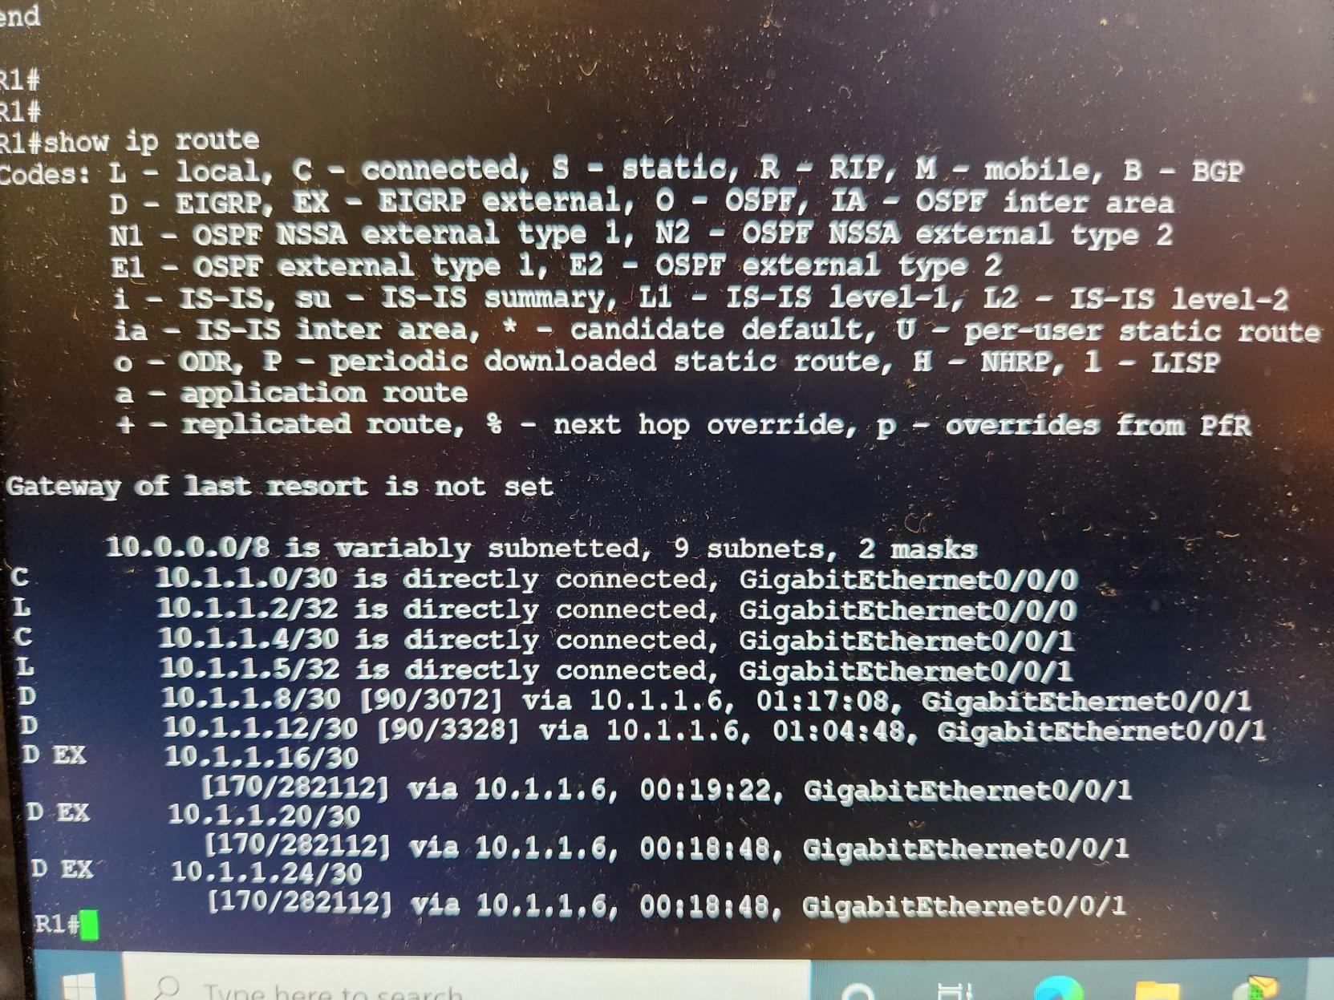

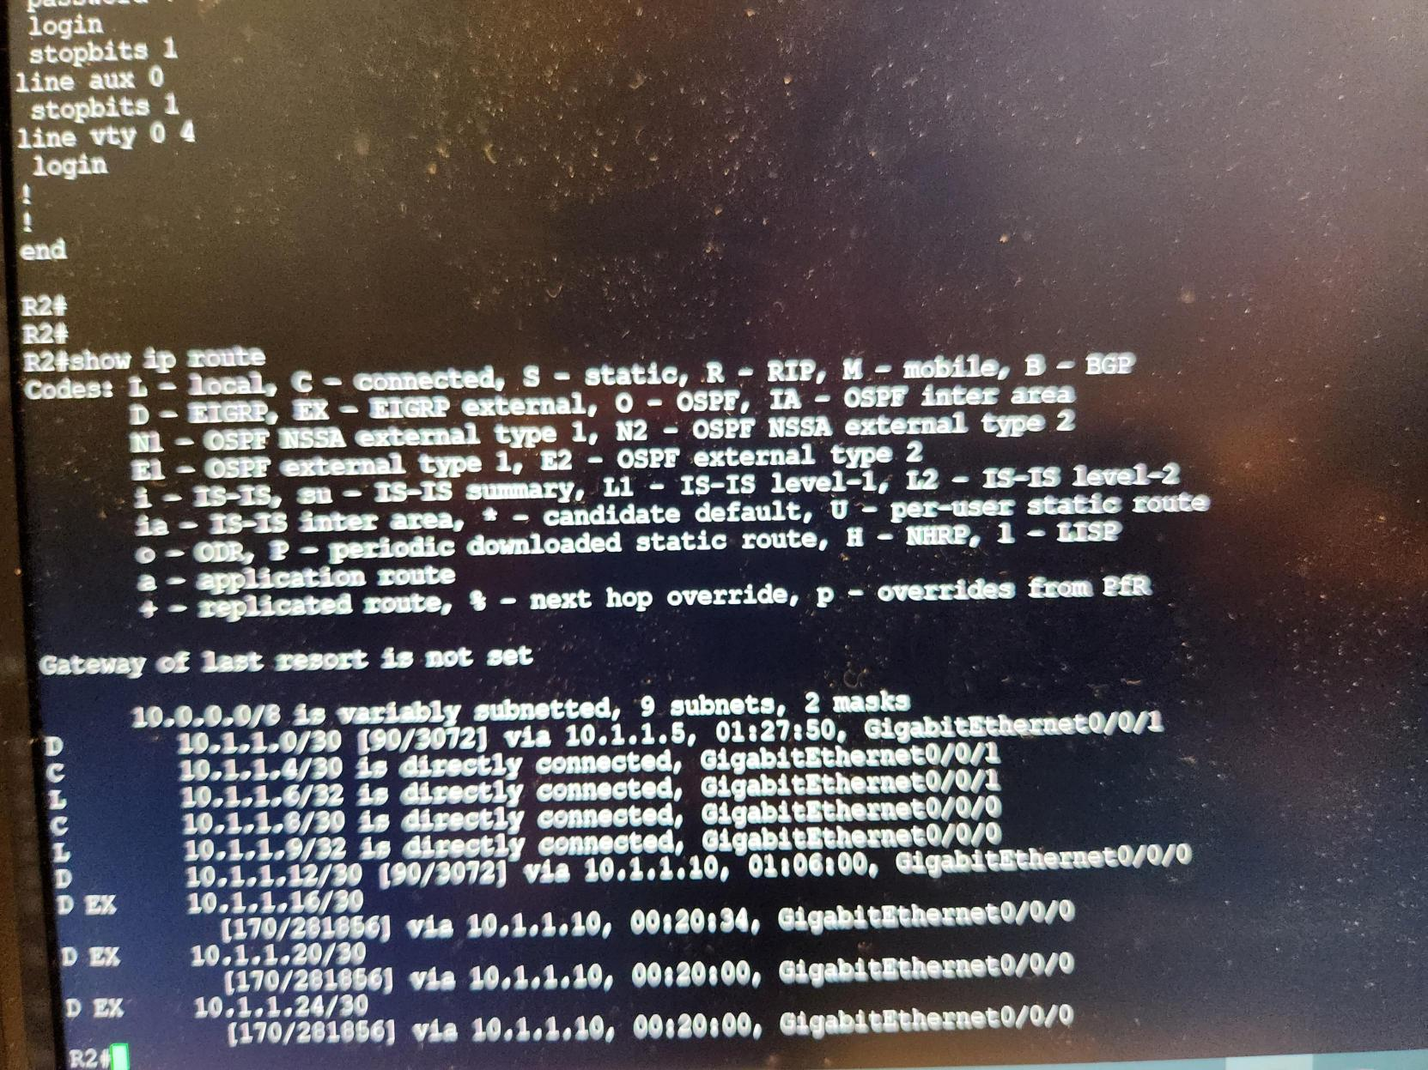

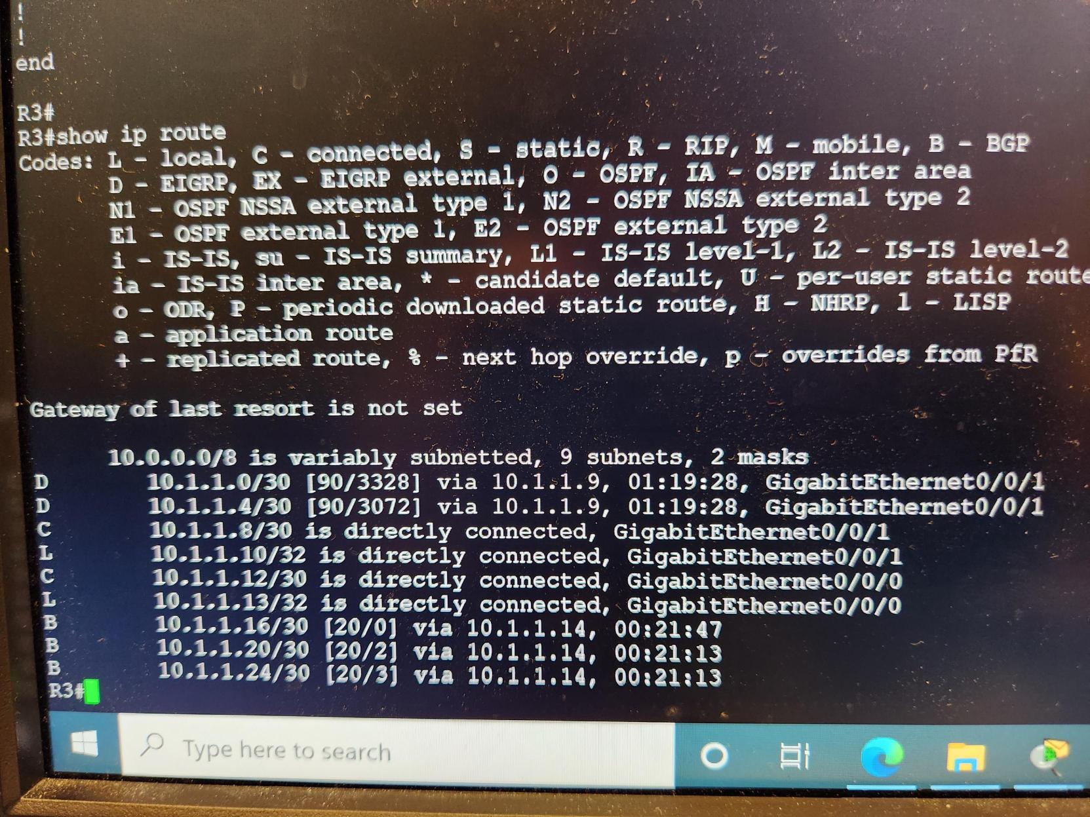

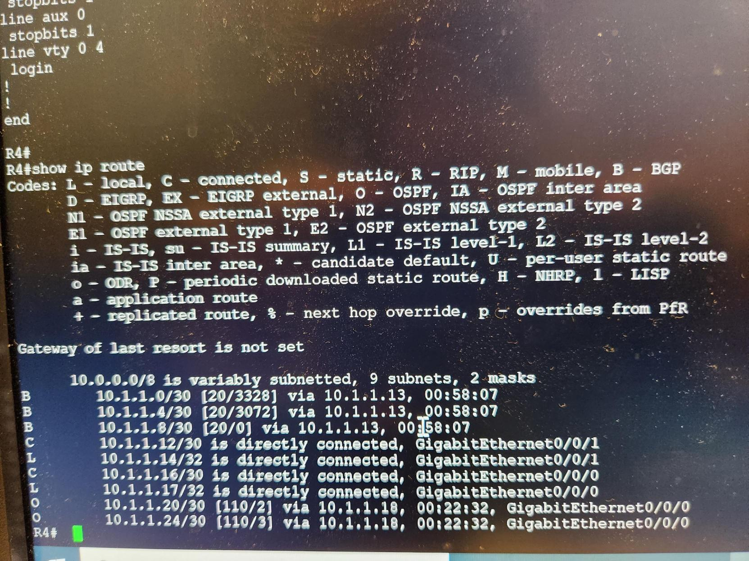

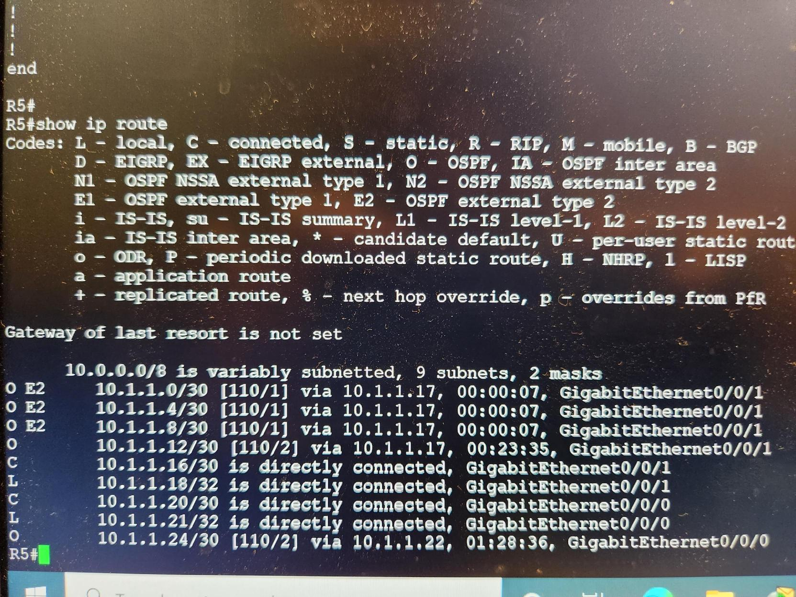

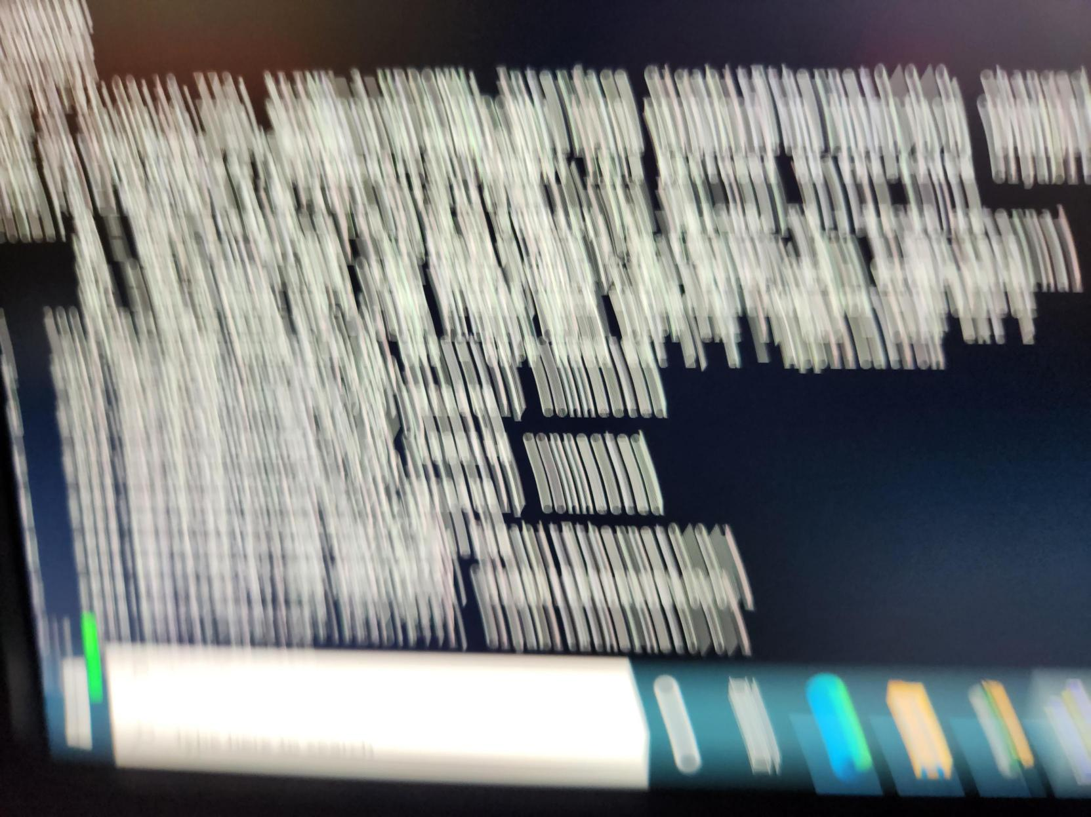

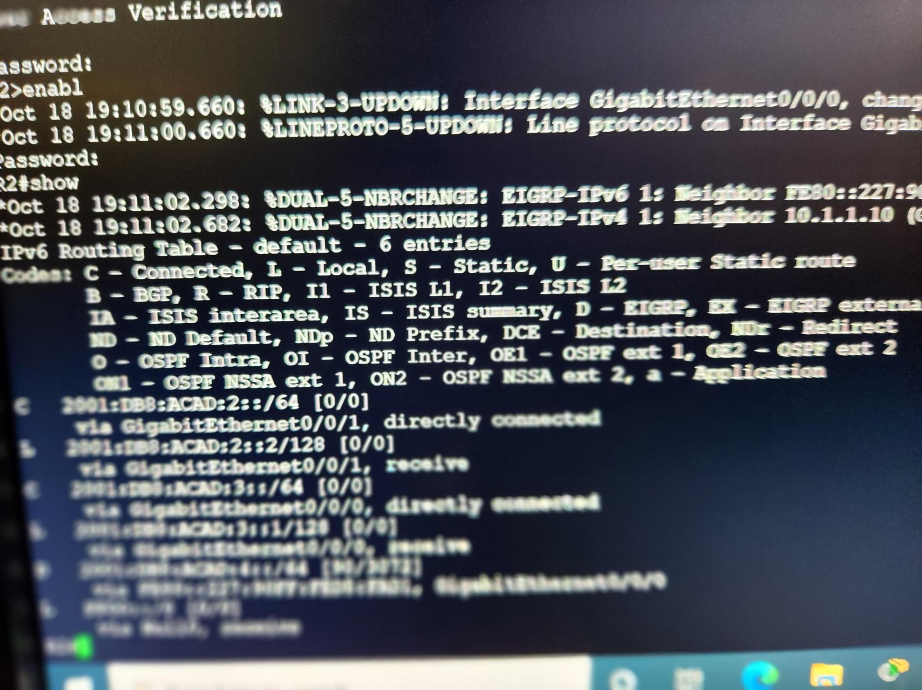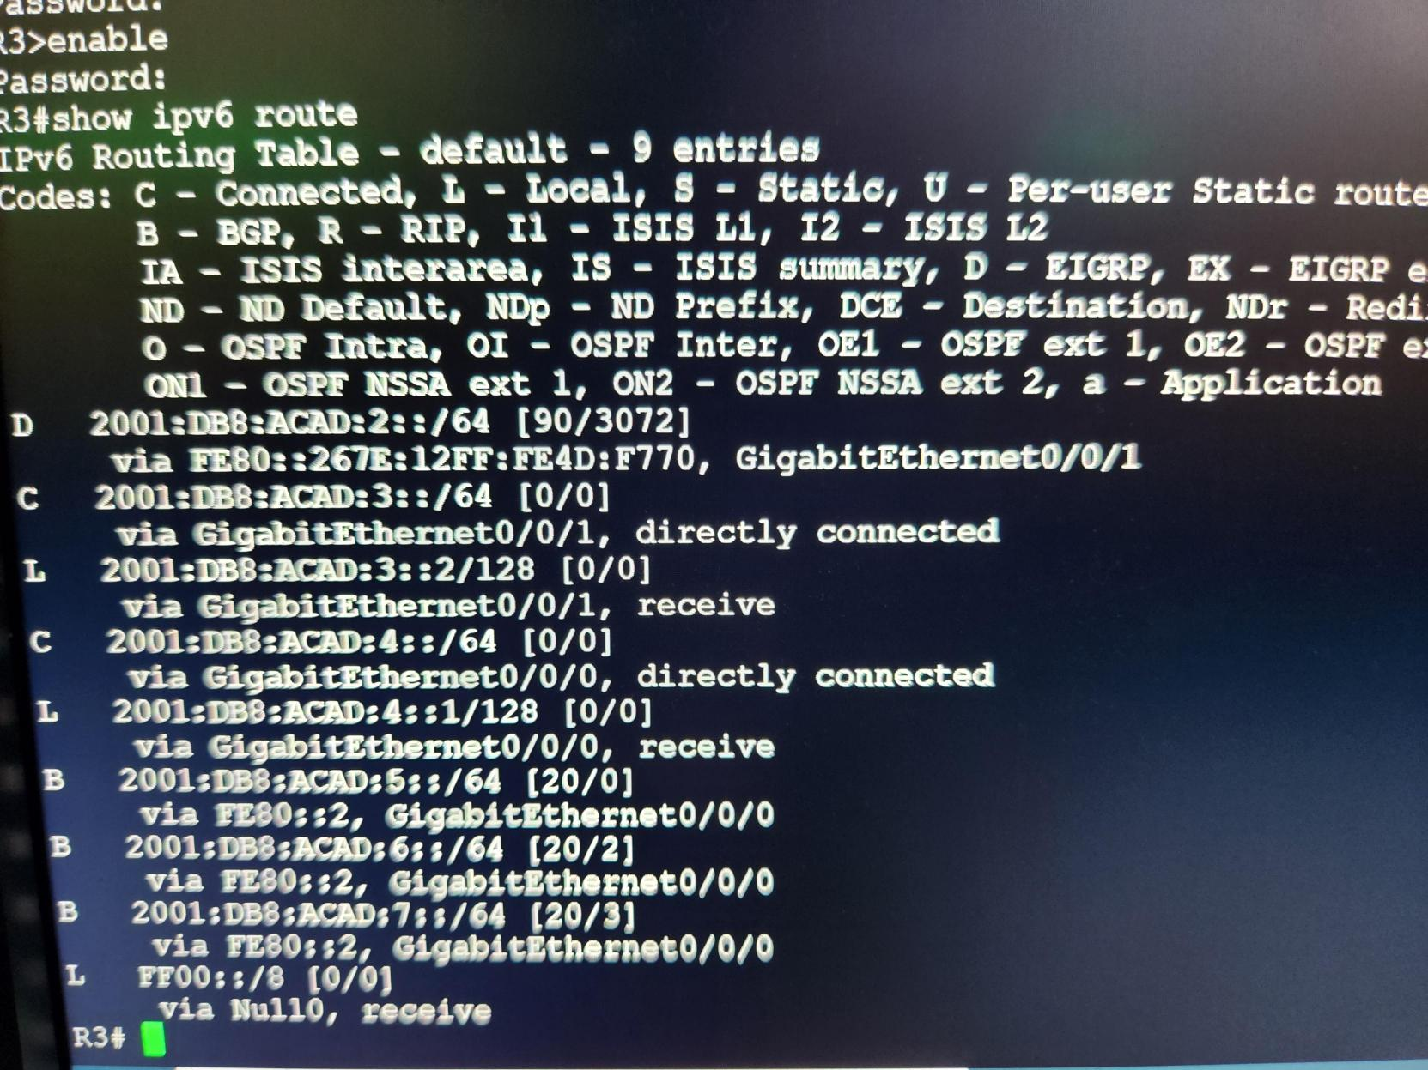

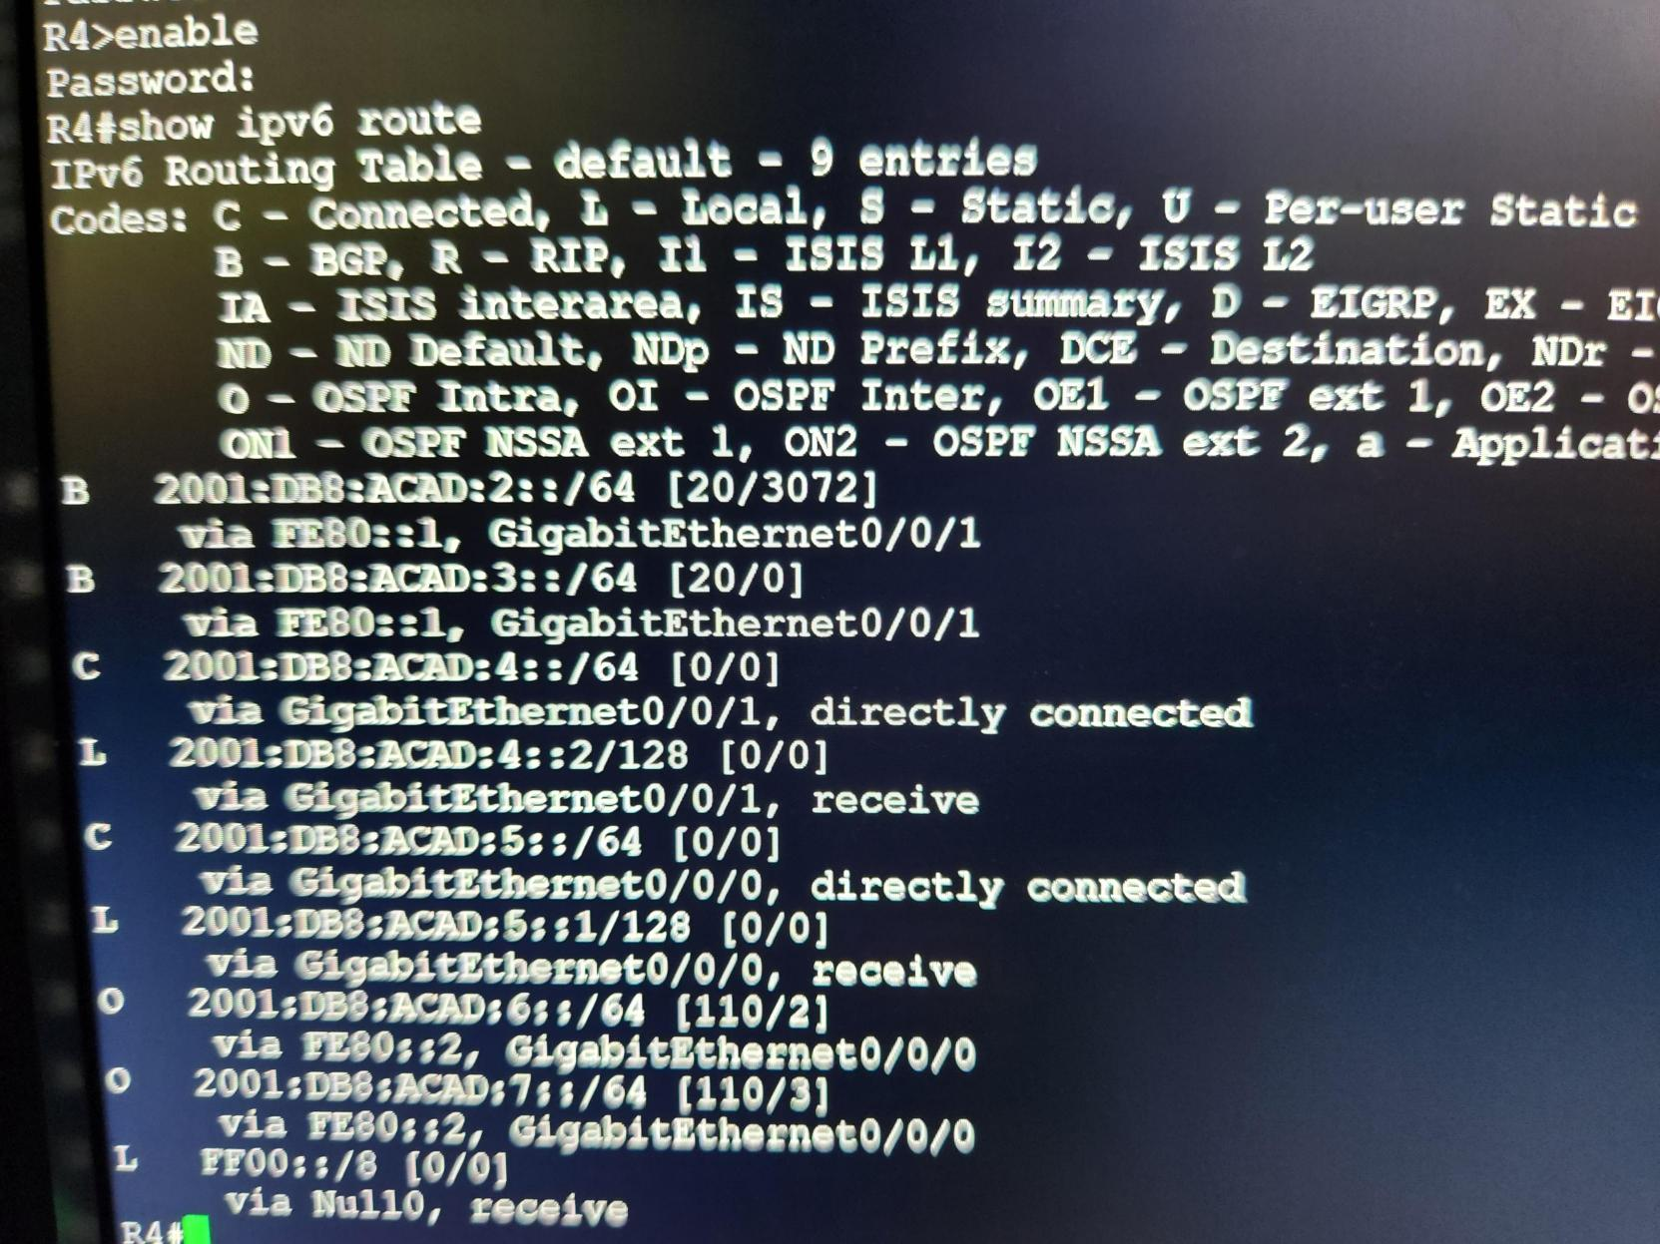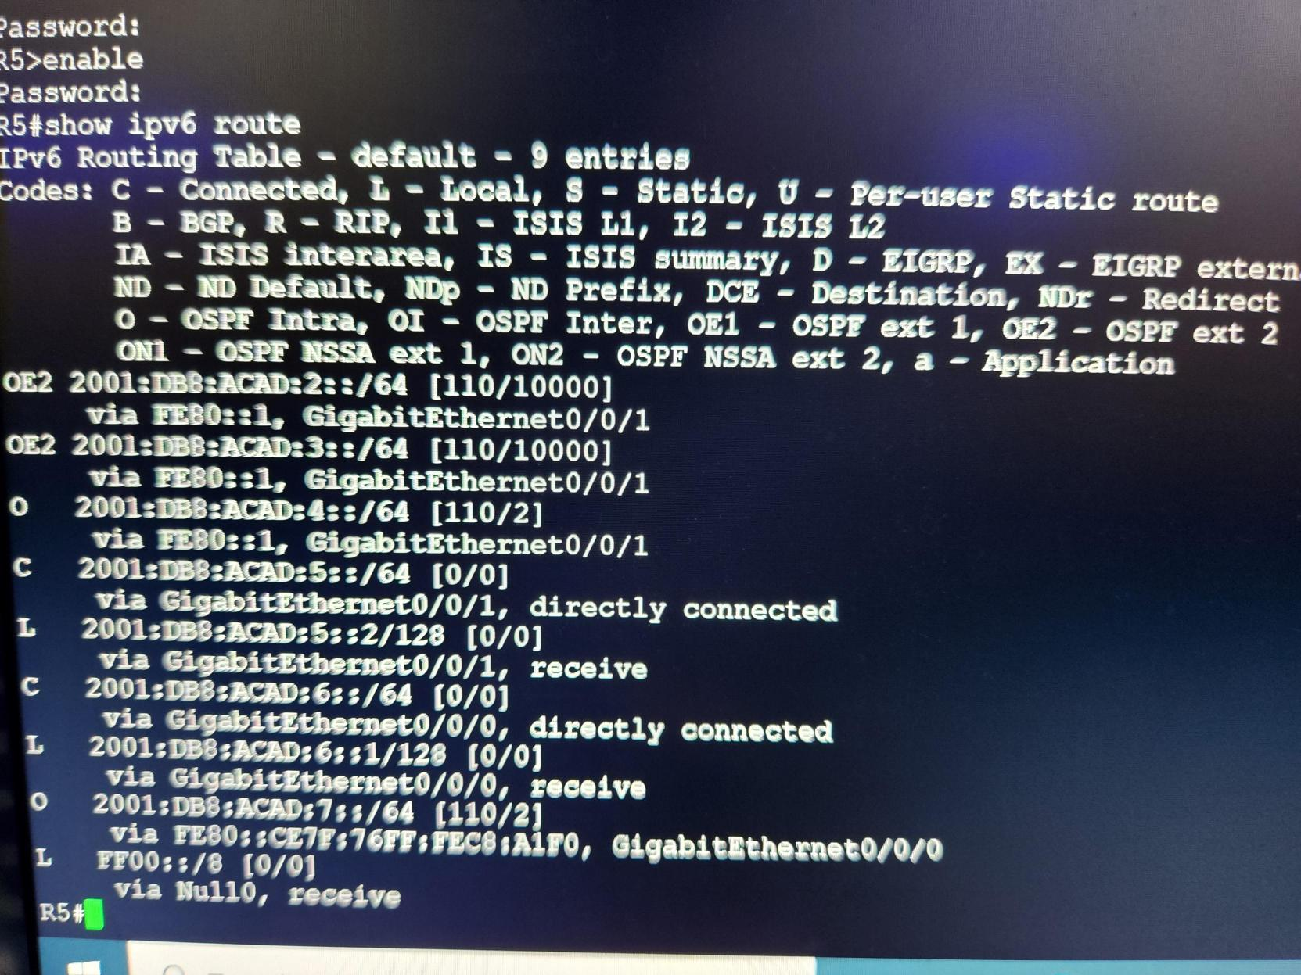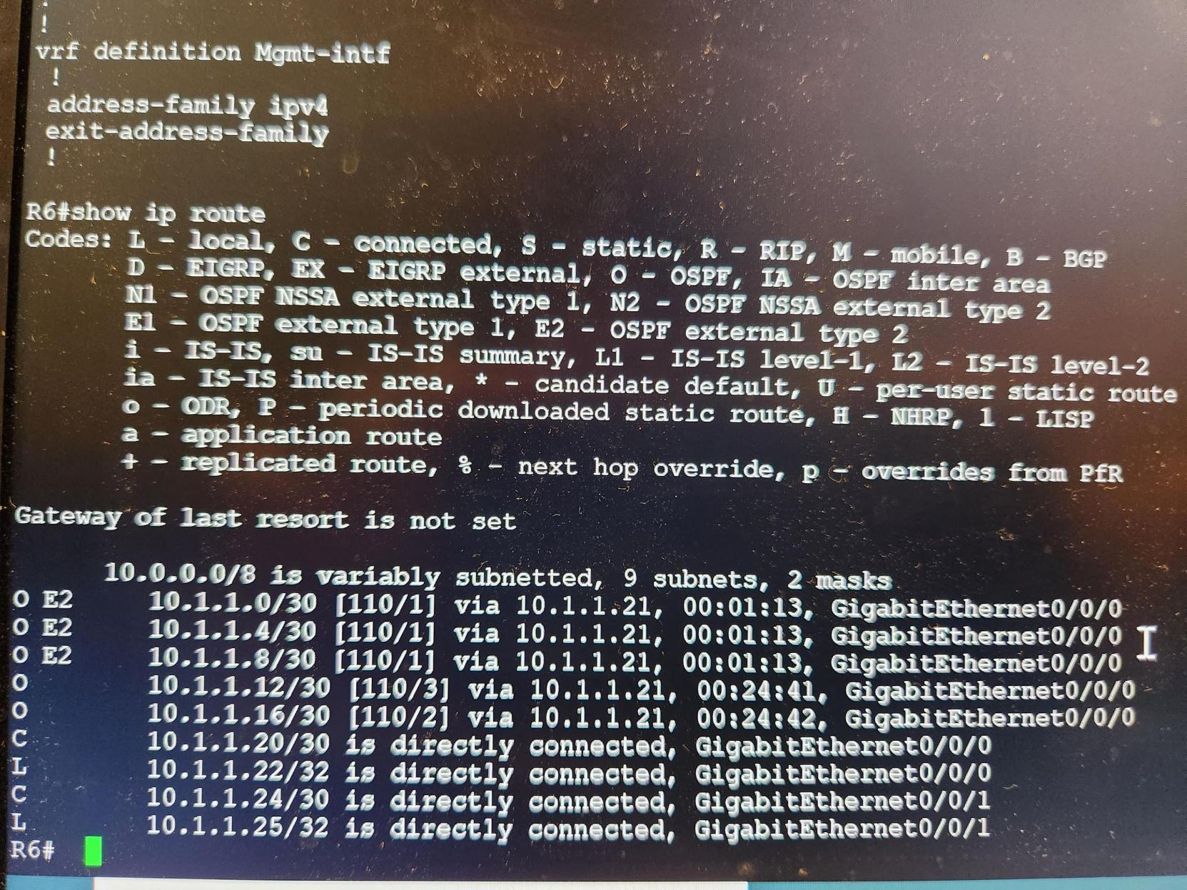

Issue we meet:

BGP area can’t communicate with OSPF area, we did not solve this problem, and the configuration is almost the same as the one on the Internet. Derek came over and entered some commands and then it was solved.

Lab 4

IBGP (Border Gateway Protocol)

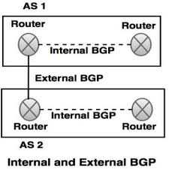

Config IBGP with using EBGP connect with EIGRP

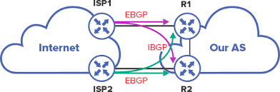

Diagram

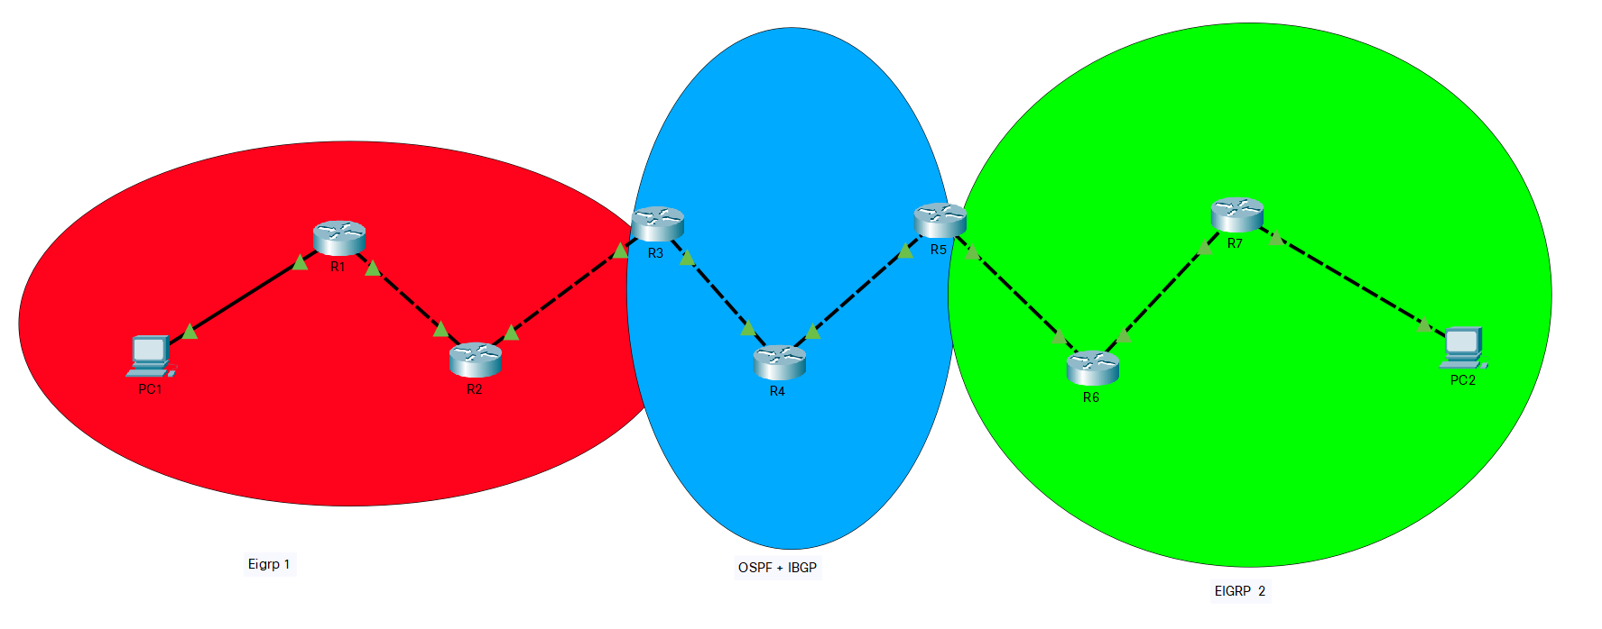

Topologies:

7 routers, 2 PC

Background:

Basic information:

IBGP (Interior Border Gateway Protocol) is a type of bgp (Border Gateway Protocol) protocol, BGP is a standardized exterior gateway protocol designed to exchange routing and reachability information among autonomous systems (AS) on the Internet. BGP is classified as a path-vector routing protocol, and it makes routing decisions based on paths, network policies, or rule-sets configured by a network administrator.

BGP used for routing within an autonomous system is called Interior Border Gateway Protocol, Internal BGP (iBGP). In contrast, the Internet application of the protocol is called Exterior Border Gateway Protocol, External BGP (eBGP).

The BGP protocol helps find the best route for network traffic seeking to reach an autonomous system (AS). An AS can be an Internet Service Provider or a large organization that controls a network prefix, representing a range of IP addresses. An autonomous system has a unique number called an ASN. BGP determines the best path to the ASN, depending on the topology of network nodes and current network conditions.

To use an analogy, an AS is like a city with many streets. A network prefix is one street, and an IP address is one particular house. Network packets are like cars traveling from one house to another, and BGP is like a navigation app that helps them take the best possible route.

IBGP vs EBGP:

Just as the concepts of stub and transit (core) autonomous systems were introduced in EGP, that pioneering protocol also introduced the concepts of interior and exterior neighbors. That is, if an EGP process peers with a neighbor in the same AS, the neighbor is interior; if the neighbor is in a different AS, the neighbor is exterior.

BGP uses the same concept: If a BGP session is established between two neighbors in different autonomous systems, the session is external BGP (EBGP), and if the session is established between two neighbors in the same AS, the session is internal BGP (IBGP).

All in all, ibgp is a better protocol than ebgp in the same AS number, unless you want to use a different AS number for each device, and then make it like ospf multi-area, Of course, ibgp does not conflict with other network protocols. For example, ibgp works with ospf here, and we use ebgp to connect three different areas, and use eigrp in two sub-areas

Configuration:

hostname R1

boot-start-marker

boot system flash:isr4300-universalk9.16.09.08.SPA.bin

boot-end-marker

vrf definition Mgmt-intf

address-family ipv4

exit-address-family

address-family ipv6

exit-address-family

enable secret 5 $1$dR.M$VbBdcnIaPUovPBa2y46NC/

no aaa new-model

no ip domain lookup

login on-success log

subscriber templating

vtp domain cisco

vtp mode transparent

ipv6 unicast-routing

multilink bundle-name authenticated

license udi pid ISR4321/K9 sn FDO21482HZX

no license smart enable

diagnostic bootup level minimal

spanning-tree extend system-id

redundancy

mode none

interface GigabitEthernet0/0/0

ip address 10.1.1.5 255.255.255.252

negotiation auto

ipv6 address FE80::1 link-local

ipv6 address 2001:DB8:ACAD:2::1/64

ipv6 enable

ipv6 eigrp 10

interface GigabitEthernet0/0/1

ip address 10.1.1.2 255.255.255.252

negotiation auto

ipv6 address FE80::2 link-local

ipv6 address 2001:DB8:ACAD:1::2/64

ipv6 enable

ipv6 eigrp 10

interface Serial0/1/0

no ip address

shutdown

interface Serial0/1/1

no ip address

shutdown

interface GigabitEthernet0

vrf forwarding Mgmt-intf

no ip address

shutdown

negotiation auto

router eigrp 10

network 10.1.1.0 0.0.0.3

network 10.1.1.4 0.0.0.3

eigrp router-id 1.1.1.1

ip forward-protocol nd

no ip http server

ip http authentication local

no ip http secure-server

ip tftp source-interface GigabitEthernet0

ipv6 router eigrp 10

eigrp router-id 1.1.1.1

redistribute bgp 10 metric 10000 100 255 1 1500

control-plane

line con 0

password 7 00071A150754

login

transport input none

stopbits 1

line aux 0

stopbits 1

line vty 0 4

login

end

hostname R2

boot-start-marker

boot-end-marker

vrf definition Mgmt-intf

address-family ipv4

exit-address-family

address-family ipv6

exit-address-family

enable secret 5 $1$77i9$1rHfAqo5BOc05xtPGT29//

no aaa new-model

no ip domain lookup

login on-success log

subscriber templating

ipv6 unicast-routing

multilink bundle-name authenticated

crypto pki trustpoint TP-self-signed-2105456491

enrollment selfsigned

subject-name cn=IOS-Self-Signed-Certificate-2105456491

revocation-check none

rsakeypair TP-self-signed-2105456491

crypto pki certificate chain TP-self-signed-2105456491

certificate self-signed 01

30820330 30820218 A0030201 02020101 300D0609 2A864886 F70D0101 05050030

31312F30 2D060355 04031326 494F532D 53656C66 2D536967 6E65642D 43657274

69666963 6174652D 32313035 34353634 3931301E 170D3232 31313239 31383336

35315A17 0D333030 31303130 30303030 305A3031 312F302D 06035504 03132649

4F532D53 656C662D 5369676E 65642D43 65727469 66696361 74652D32 31303534

35363439 31308201 22300D06 092A8648 86F70D01 01010500 0382010F 00308201

0A028201 0100C873 0201A31F E3109525 58231A63 5C8DFA48 4B3F6931 483568AD

F0E48A84 19F963AB F42761AC 1FBA1EEA F7849BF0 B1C75540 67ED10C0 9F3A75B4

1AE62B78 D17E8957 42AEEDA1 7EAACE8E 2FD0156A 0CB199A9 0173DED6 CA6B1CA0

3A2EE25E 37600A9C F1B4F7F7 54E61BC4 F8905243 795E5C59 C08C2293 6A897DB0

95EE98CA 8E75E79F D017B735 2396D5DB 3904CEC8 0B96F60C 95749603 A21A83FB

176B8DEA A83FFCD3 9BA23577 AF98E853 BDC18CC6 8AB5BC99 158ECF27 D94FE2E6

C975EBD8 CCF18C97 4F2E694D BFBA7970 BB3C7B8B 004E5C67 9F11CDC5 A528FEFA

269C10E2 A9659F24 DF16B68C 28E1A9F5 07FD9482 B6DC8F3B 577C4567 448D5807

060CAF94 F3B90203 010001A3 53305130 0F060355 1D130101 FF040530 030101FF

301F0603 551D2304 18301680 14773369 7C1A29A6 380183C5 9CCBBE99 25CF0935

65301D06 03551D0E 04160414 7733697C 1A29A638 0183C59C CBBE9925 CF093565

300D0609 2A864886 F70D0101 05050003 82010100 2A092386 CF7EFDB7 499B591E

222ACDBA 8494EDE0 8470A22D B0AE81E2 928EA6C0 50C23C6C DF071625 44BA16C4

AE41EF2E 6BEB0AA2 56B9C5D1 BFE4BAE6 921278DB 133616B7 139DD0B5 AF6E1A1A

01C0DAE6 B9EC527E AEA23A34 FE60C8FE 7C89BCF6 979E6D2A 626A6095 64F0E449

783E9914 EA949236 6FEE43E0 4A6BBCCB 86F90532 EDD12FCF 7DC64935 443EFAA5

5A33529B D8F5406A FF661AEA 012F2B65 B5239915 758F690C 09F72ED8 94127A3D

DA187975 8181E885 3135A832 AA21632C 7500467B 1E13DAB4 E9A62179 114ADCB9

B715017A 8FB57741 10435D7D 69A8E979 9D401303 BE01E8CD 78D27816 3FBE148A

7B0843FB 4183BA5D B9CEF94F E164C8BB 2CB165E5

quit

license udi pid ISR4321/K9 sn FDO21482DWJ

no license smart enable

diagnostic bootup level minimal

spanning-tree extend system-id

redundancy

mode none

interface GigabitEthernet0/0/0

ip address 10.1.1.9 255.255.255.252

negotiation auto

ipv6 address FE80::1 link-local

ipv6 address 2001:DB8:ACAD:3::1/64

ipv6 enable

ipv6 eigrp 10

interface GigabitEthernet0/0/1

ip address 10.1.1.6 255.255.255.252

negotiation auto

ipv6 address FE80::2 link-local

ipv6 address 2001:DB8:ACAD:2::2/64

ipv6 enable

ipv6 eigrp 10

interface Serial0/1/0

no ip address

shutdown

interface Serial0/1/1

no ip address

shutdown

interface GigabitEthernet0

vrf forwarding Mgmt-intf

no ip address

shutdown

negotiation auto

router eigrp 10

network 10.1.1.4 0.0.0.3

network 10.1.1.8 0.0.0.3

redistribute bgp 10 metric 10000 100 255 1 1500

eigrp router-id 2.2.2.2

router bgp 10

bgp router-id 2.2.2.2

no bgp log-neighbor-changes

no bgp default ipv4-unicast

neighbor 10.1.1.10 remote-as 5

neighbor 2001:DB8:ACAD:3::2 remote-as 5

address-family ipv4

network 10.1.1.8 mask 255.255.255.252

redistribute eigrp 10

neighbor 10.1.1.10 activate

exit-address-family

address-family ipv6

redistribute eigrp 10

network 2001:DB8:ACAD:2::/64

network 2001:DB8:ACAD:3::/64

neighbor 2001:DB8:ACAD:3::2 activate

exit-address-family

ip forward-protocol nd

no ip http server

ip http authentication local

no ip http secure-server

ip tftp source-interface GigabitEthernet0

ipv6 router eigrp 10

eigrp router-id 2.2.2.2

redistribute bgp 10 metric 10000 100 255 1 1500

control-plane

line con 0

password 7 045802150C2E

login

transport input none

stopbits 1

line aux 0

stopbits 1

line vty 0 4

login

end

hostname R3

boot-start-marker

boot-end-marker

vrf definition Mgmt-intf

address-family ipv4

exit-address-family

address-family ipv6

exit-address-family

enable secret 5 $1$dR.M$VbBdcnIaPUovPBa2y46NC/

no aaa new-model

no ip domain lookup

login on-success log

subscriber templating

vtp domain cisco

vtp mode transparent

ipv6 unicast-routing

multilink bundle-name authenticated

crypto pki trustpoint TP-self-signed-2949602955

enrollment selfsigned

subject-name cn=IOS-Self-Signed-Certificate-2949602955

revocation-check none

rsakeypair TP-self-signed-2949602955

crypto pki certificate chain TP-self-signed-2949602955

certificate self-signed 01

30820330 30820218 A0030201 02020101 300D0609 2A864886 F70D0101 05050030

31312F30 2D060355 04031326 494F532D 53656C66 2D536967 6E65642D 43657274

69666963 6174652D 32393439 36303239 3535301E 170D3232 31313239 31393238

34365A17 0D333030 31303130 30303030 305A3031 312F302D 06035504 03132649

4F532D53 656C662D 5369676E 65642D43 65727469 66696361 74652D32 39343936

30323935 35308201 22300D06 092A8648 86F70D01 01010500 0382010F 00308201

0A028201 0100CD95 F89EF9B0 3B0E0EA4 55660F03 C59623BD D17AB017 105D3FE8

75B3EBAE 0ED835EB 94B5AA1A 66D62C67 A7288906 481204B7 D2FBB082 9E9ACE2F

CE3E266B 247B5CA1 EE800D9C 24A162B5 126F8563 332D37DE B6A0E6C7 8294F405

6ABFB18A 4B2AFF03 35E61AFE 1FE47913 0CA6C277 93124EBC 9DDD39FC 0D7D5AB2

FE1CBE72 4A05531F D53AAF1A D9C131A7 248C8100 0E26D1FD 94D7740A 01210E37

174BFD1D A7A9A9C8 3C644BFF 2F5FB1D0 56F16C8F 797306BD 94300054 F17EBB96

69CE0553 D1562270 4FEDF0F1 D39FCB0C 1BC9FC25 B2CCAF36 16996640 001BCD39

6686657B 5CCFCE22 AB73BC2D 1D82710B 54BE4395 93DB4429 108A522D CDC7CA2D

0D82BBDB B6610203 010001A3 53305130 0F060355 1D130101 FF040530 030101FF

301F0603 551D2304 18301680 14DDD9A8 E661104F E219A44E 125B6B0A D218C24B

57301D06 03551D0E 04160414 DDD9A8E6 61104FE2 19A44E12 5B6B0AD2 18C24B57

300D0609 2A864886 F70D0101 05050003 82010100 894AEAC9 EADF6736 58C16054

2FAE5C99 038D01DB F9F836F6 57F2FF77 894A405D 2D788619 FCBA65F8 3EA8BB78

724463E6 7B7AB16F 03B062F3 35463389 E205695F 355411E2 997C8F68 78371CC0

EB77D2A1 CD7FA29D EC4F9462 4CB41324 4D15E792 059789DD B52F3348 52FA5877

14EB046A A3C93DBF F3CE0085 EE18E4A9 4FD84180 844FC774 41992C06 F3D94A8C

4D8760F2 9A30F9C3 2EF16EC5 4F0B8CB2 FAE7D460 BE6F8869 290FEDF6 7420FB2F

3E5A54B7 0F774A36 F7AF58F5 F31A5941 C0787246 F1D5023B 344E0A7C 3EC07775

B8056666 5CE5233C 4EF763D9 63BBED0D 58F33B6E 379B991E EA5B8E18 94DCA726

5812080B 6FF15591 C8A7CF92 5ED0382D DC1A3EE6

quit

license udi pid ISR4321/K9 sn FDO214420HW

no license smart enable

diagnostic bootup level minimal

spanning-tree extend system-id

redundancy

mode none

interface GigabitEthernet0/0/0

ip address 10.1.1.13 255.255.255.252

ip ospf 1 area 0

negotiation auto

ipv6 address FE80::1 link-local

ipv6 address 2001:DB8:ACAD:4::1/64

ipv6 enable

interface GigabitEthernet0/0/1

ip address 10.1.1.10 255.255.255.252

ip ospf 1 area 0

negotiation auto

ipv6 address FE80::2 link-local

ipv6 address 2001:DB8:ACAD:3::2/64

ipv6 enable

interface Serial0/1/0

no ip address

shutdown

interface Serial0/1/1

no ip address

shutdown

interface GigabitEthernet0

vrf forwarding Mgmt-intf

no ip address

shutdown

negotiation auto

router ospf 1

router-id 3.3.3.3

redistribute bgp 5 subnets

network 10.1.1.8 0.0.0.3 area 0

network 10.1.1.12 0.0.0.3 area 0

router bgp 5

bgp router-id 3.3.3.3

no bgp log-neighbor-changes

no bgp default ipv4-unicast

neighbor 10.1.1.9 remote-as 10

neighbor 10.1.1.14 remote-as 5

neighbor 10.1.1.18 remote-as 5

neighbor 2001:DB8:ACAD:3::1 remote-as 10

neighbor 2001:DB8:ACAD:4::2 remote-as 5

neighbor 2001:DB8:ACAD:5::2 remote-as 5

address-family ipv4

netw ▒

address-family ipv6

network 2001:DB8:ACAD:3::/64

network 2001:DB8:ACAD:4::/64

neighbor 2001:DB8:ACAD:3::1 activate

neighbor 2001:DB8:ACAD:4::2 activate

neighbor 2001:DB8:ACAD:5::2 activate

neighbor 2001:DB8:ACAD:5::2 next-hop-self

exit-address-family

ip forward-protocol nd

no ip http server

ip http authentication local

no ip http secure-server

ip tftp source-interface GigabitEthernet0

ipv6 router ospf 1

router-id 3.3.3.3

redistribute bgp 5 metric 10000

control-plane

line con 0

password 7 00071A150754

login

transport input none

stopbits 1

line aux 0

stopbits 1

line vty 0 4

login

end

hostname R4

boot-start-marker

boot-end-marker

vrf definition Mgmt-intf

address-family ipv4

exit-address-family

address-family ipv6

exit-address-family

no aaa new-model

login on-success log

subscriber templating

vtp domain cisco

vtp mode transparent

ipv6 unicast-routing

multilink bundle-name authenticated

crypto pki trustpoint TP-self-signed-262078645

enrollment selfsigned

subject-name cn=IOS-Self-Signed-Certificate-262078645

revocation-check none

rsakeypair TP-self-signed-262078645

crypto pki certificate chain TP-self-signed-262078645

certificate self-signed 01

3082032E 30820216 A0030201 02020101 300D0609 2A864886 F70D0101 05050030

30312E30 2C060355 04031325 494F532D 53656C66 2D536967 6E65642D 43657274

69666963 6174652D 32363230 37383634 35301E17 0D323231 31323931 39323230

345A170D 33303031 30313030 30303030 5A303031 2E302C06 03550403 1325494F

532D5365 6C662D53 69676E65 642D4365 72746966 69636174 652D3236 32303738

36343530 82012230 0D06092A 864886F7 0D010101 05000382 010F0030 82010A02

82010100 96D6CB8D 01472715 B47121ED 39589F70 6C2401C0 10EF24CF 0D67543E

AF629A4E 2D7C6089 1D51B7B2 573C25D0 128FDE7D 5D3C96E9 100079D0 3405F0B6

3A973944 A37A686A 8F848482 111AE521 6D5F44F2 7999D0FC D7BFE242 49304847

3B0F03BA D8132691 337F2C64 CEBACA7D 729AA924 BA60E332 2BBB1979 EB96CB73

23C770CC 6F1BCE11 F3AF1F74 3148BECC CFD92C75 37AB8045 9F03E9F1 BCAC8AE3

8226BD8D A7D36466 660C1697 CE2B234B 3743A74F 95D1CA88 E1D1A6BE 0D82829A

808CA9AE 7C4DB5AD 88C83050 F861F8A0 FD362A0C 270753C0 EEB1251C 0377ED5C

C7915508 FD1B53D5 D774148D EBB062EF 6841B082 ACA73157 6DA7FC4F 548F2181

0D736197 02030100 01A35330 51300F06 03551D13 0101FF04 05300301 01FF301F

0603551D 23041830 16801419 E240F965 F78096AD EECBEA7D 6C6DB50F 071B6030

1D060355 1D0E0416 041419E2 40F965F7 8096ADEE CBEA7D6C 6DB50F07 1B60300D

06092A86 4886F70D 01010505 00038201 01005A54 D28E26C2 9144C63A A123130E

C6386168 8E15CFE2 EA732A78 87F013F1 359B8734 6E791A26 6BD8F080 3D2A1E91

E237FBF9 771FC29E 9E9CF27C 6EC04A2F DEBDC287 76FA769B 603BEA5C E42562A6

240FD37C CF0B8581 A49F0B25 B7ACA0A2 2AE6C673 4C557EBB 101376B7 D5A77A64

FDFA90D4 4F6D039E 5C27D948 0B6F19AD 02E88A2D 3043149F BD723330 29486C5A

C71BC741 D53F2E2C 8B9D95D4 99AAD379 71A3FD62 0156094F FC6F217D 60BCA7F3

BCDB503D 536FFF75 FEEA7C7B 2A32DA25 91FFB5D0 80D7BE7F 324C8230 ED344652

37F62616 31C680D1 84697620 04F530E2 E46431A9 AAAB3FDC 1799075D 19421731

F0B2E966 87E5BD73 4BCDF348 0D45A717 8E4A

quit

license udi pid ISR4321/K9 sn FDO214421D1

no license smart enable

diagnostic bootup level minimal

spanning-tree extend system-id

redundancy

mode none

interface GigabitEthernet0/0/0

ip address 10.1.1.17 255.255.255.252

ip ospf 1 area 0

negotiation auto

ipv6 address FE80::1 link-local

ipv6 address 2001:DB8:ACAD:5::1/64

ipv6 enable

ipv6 ospf 1 area 0

interface GigabitEthernet0/0/1

ip address 10.1.1.14 255.255.255.252

ip ospf 1 area 0

negotiation auto

ipv6 address FE80::2 link-local

ipv6 address 2001:DB8:ACAD:4::2/64

ipv6 enable

ipv6 ospf 1 area 0

interface Serial0/1/0

interface Serial0/1/1

interface GigabitEthernet0

vrf forwarding Mgmt-intf

no ip address

shutdown

negotiation auto

router ospf 1

router-id 4.4.4.4

redistribute bgp 5 subnets

network 10.1.1.12 0.0.0.3 area 0

network 10.1.1.16 0.0.0.3 area 0

router bgp 5

bgp router-id 5.5.5.5

no bgp log-neighbor-changes

no bgp default ipv4-unicast

neighbor 10.1.1.13 remote-as 5

neighbor 10.1.1.18 remote-as 5

neighbor 2001:DB8:ACAD:4::1 remote-as 5

neighbor 2001:DB8:ACAD:5::2 remote-as 5

address-family ipv4

network 10.1.1.12 mask 255.255.255.252

network 10.1.1.16 mask 255.255.255.252

redistribute ospf 1

neighbor 10.1.1.13 activate

neighbor 10.1.1.18 activate

exit-address-family

address-family ipv6

redistribute ospf 1

network 2001:DB8:ACAD:4::/64

network 2001:DB8:ACAD:5::/64

neighbor 2001:DB8:ACAD:4::1 activate

neighbor 2001:DB8:ACAD:5::2 activate

exit-address-family

ip forward-protocol nd

no ip http server

ip http authentication local

no ip http secure-server

ip tftp source-interface GigabitEthernet0

ipv6 router ospf 1

router-id 4.4.4.4

redistribute bgp 5

control-plane

line con 0

transport input none

stopbits 1

line aux 0

stopbits 1

line vty 0 4

login

end

hostname R5

boot-start-marker

boot system flash:isr4300-universalk9.16.09.08.SPA.bin

boot-end-marker

vrf definition Mgmt-intf

address-family ipv4

exit-address-family

address-family ipv6

exit-address-family

no aaa new-model

no ip domain lookup

login on-success log

subscriber templating

vtp domain cisco

vtp mode transparent

ipv6 unicast-routing

multilink bundle-name authenticated

crypto pki trustpoint TP-self-signed-859896477

enrollment selfsigned

subject-name cn=IOS-Self-Signed-Certificate-859896477

revocation-check none

rsakeypair TP-self-signed-859896477

crypto pki certificate chain TP-self-signed-859896477

certificate self-signed 01

3082032E 30820216 A0030201 02020101 300D0609 2A864886 F70D0101 05050030

30312E30 2C060355 04031325 494F532D 53656C66 2D536967 6E65642D 43657274

69666963 6174652D 38353938 39363437 37301E17 0D323231 30313731 38323635

385A170D 33303031 30313030 30303030 5A303031 2E302C06 03550403 1325494F

532D5365 6C662D53 69676E65 642D4365 72746966 69636174 652D3835 39383936

34373730 82012230 0D06092A 864886F7 0D010101 05000382 010F0030 82010A02

82010100 CA31EE51 C97FF58C 76C72B4E 2B6CD51B 98CBA177 7EEF8D11 DAAB7CA8

47B3AA97 3B815AD1 09F637AE B1D98BB8 A2CAA1A9 0AFAF87A 3AFBFF9E 34875D72

0BD5EE8D E40F4D4A 3B4A38A7 09F1940D 013C18AE F29F2BEA 07085EB5 982E9BC8

F99C8CA7 1C7DD58E 67B89FCB 951C3C4C 6D11B8C7 8D24BF5C 973A32BF E16A3094

99E8DB22 7FEA5A30 6E9457F6 90485336 E953F3D2 942824E3 87D8DE52 E00336AC

09CA85F0 0BD105FA B4078F96 9A2EA846 C147AD42 B08CD3D2 16A06EB1 CC54E167

8F4677E9 2663D37D 7B1C3891 9ABF4B5B 83ECE428 AD426108 357B992E 792C850D

84C67187 BF0E10B5 B1D23A97 F2F1372F 7D0FA8C8 80E947DE 5E0FA234 7FA6A487

24A0DB83 02030100 01A35330 51300F06 03551D13 0101FF04 05300301 01FF301F

0603551D 23041830 168014E7 C71AF39E FCC743E7 C7395603 DBBCA771 4C734E30

1D060355 1D0E0416 0414E7C7 1AF39EFC C743E7C7 395603DB BCA7714C 734E300D

06092A86 4886F70D 01010505 00038201 010029B2 769B6033 C71585B8 DD1EE596

BDB3F81C 5C58921E AF7FBE2F A95F447D 7B870BCD B9AE5E5D 46FCE0E1 667295B7

4668DACB F848F91A 207FC6CD 203E64BF 6747B9E7 6FF304F1 491442EA 56EEBEE6

DE79EC87 F5BE7B9C B2482264 A58FAC1B 827F66C7 F16C0292 815AD1ED 86F2E167

9568FC20 9E2ADCB6 311B34E4 E93EC128 2DD25078 4F27E1F1 4DD309BA B2A0248A

C41F66C8 4A81C2B8 9D0E8A62 4E0443F6 F28B3203 28A14D43 0E06A98B 06DAB16D

66E0616A DB63132A 8FB53D9B 88A28660 F84CD05D EC8653F6 C3FC6446 94977DAC

0ED87E1C 9C0B372A 6E25729B FAD2B249 6FDF7BC6 3218B110 D167D3D5 AEACB17D

6E8CB48E ED168D18 8D9104DE BA9F3515 5662

quit

license udi pid ISR4321/K9 sn FLM240608PJ

no license smart enable

diagnostic bootup level minimal

spanning-tree extend system-id

redundancy

mode none

interface GigabitEthernet0/0/0

ip address 10.1.1.21 255.255.255.252

ip ospf 1 area 0

negotiation auto

ipv6 address FE80::1 link-local

ipv6 address 2001:DB8:ACAD:6::1/64

ipv6 enable

ipv6 ospf 1 area 0

interface GigabitEthernet0/0/1

ip address 10.1.1.18 255.255.255.252

ip ospf 1 area 0

negotiation auto

ipv6 address FE80::2 link-local

ipv6 address 2001:DB8:ACAD:5::2/64

ipv6 enable

ipv6 ospf 1 area 0

interface GigabitEthernet0/1/0

no ip address

shutdown

negotiation auto

interface GigabitEthernet0/1/1

no ip address

shutdown

negotiation auto

interface GigabitEthernet0

vrf forwarding Mgmt-intf

no ip address

shutdown

negotiation auto

router eigrp 5

network 10.1.1.20 0.0.0.3

redistribute bgp 5 metric 1000 1 255 255 1

router ospf 1

router-id 5.5.5.5

redistribute bgp 5 subnets

network 10.1.1.16 0.0.0.3 area 0

router bgp 5

bgp router-id 5.5.5.5

no bgp log-neighbor-changes

no bgp default ipv4-unicast

neighbor 10.1.1.13 remote-as 5

neighbor 10.1.1.17 remote-as 5

neighbor 10.1.1.22 remote-as 1

neighbor 2001:DB8:ACAD:4::1 remote-as 5

neighbor 2001:DB8:ACAD:5::1 remote-as 5

neighbor 2001:DB8:ACAD:6::2 remote-as 1

address-family ipv4

network 10.1.1.16 mask 255.255.255.252

network 10.1.1.20 mask 255.255.255.252

redistribute ospf 1

neighbor 10.1.1.13 activate

neighbor 10.1.1.13 next-hop-self

neighbor 10.1.1.17 activate

neighbor 10.1.1.22 activate

exit-address-family

address-family ipv6

redistribute ospf 1

network 2001:DB8:ACAD:4::/64

network 2001:DB8:ACAD:5::/64

network 2001:DB8:ACAD:6::/64

network 2001:DB8:ACAD:7::/64

neighbor 2001:DB8:ACAD:4::1 activate

neighbor 2001:DB8:ACAD:5::1 activate

neighbor 2001:DB8:ACAD:6::2 activate

exit-address-family

ip forward-protocol nd

ip http server

ip http authentication local

ip http secure-server

ip tftp source-interface GigabitEthernet0

ipv6 router eigrp 5

eigrp router-id 5.5.5.5

ipv6 router ospf 1

router-id 5.5.5.5

redistribute bgp 5 metric 10000

control-plane

line con 0

transport input none

stopbits 1

line aux 0

stopbits 1

line vty 0 4

login

end

hostname R6

boot-start-marker

boot-end-marker

vrf definition Mgmt-intf

address-family ipv4

exit-address-family

address-family ipv6

exit-address-family

no aaa new-model

login on-success log

subscriber templating

vtp domain cisco

vtp mode transparent

ipv6 unicast-routing

multilink bundle-name authenticated

crypto pki trustpoint TP-self-signed-4288135047

enrollment selfsigned

subject-name cn=IOS-Self-Signed-Certificate-4288135047

revocation-check none

rsakeypair TP-self-signed-4288135047

crypto pki certificate chain TP-self-signed-4288135047

certificate self-signed 01

30820330 30820218 A0030201 02020101 300D0609 2A864886 F70D0101 05050030

31312F30 2D060355 04031326 494F532D 53656C66 2D536967 6E65642D 43657274

69666963 6174652D 34323838 31333530 3437301E 170D3232 31313239 31383338

33365A17 0D333030 31303130 30303030 305A3031 312F302D 06035504 03132649

4F532D53 656C662D 5369676E 65642D43 65727469 66696361 74652D34 32383831

33353034 37308201 22300D06 092A8648 86F70D01 01010500 0382010F 00308201

0A028201 0100986B 99D1EC6A FD6A4D9B 3980B9D3 F6C8B533 A37CAB3B D86EABF3

4E414D0F 56A36421 4EC7F444 CB7062D0 04131347 ED5A8CBD B035A688 BFE4F174

80C1835D 263EFEFB 1A6D63B4 F93FCA17 F51FD61B 730D1704 474BF648 07400A44

3AFC8EF9 A8FFE960 E91BDA29 1020F0B3 BA1AF551 DFF51B9D 9250DB1D FC722960

8B35E828 1E7717B2 830BE47D 7E85E5DF 36C17914 A86729B4 F6072BC4 460A985D

49D9FBF8 D36813EF ED3BD95F 519488EE 8ADCC6AA 75AA4C51 6CD606A6 58471F2B

E572CBAA F314DDF6 00766853 EE7B49AB 2FCF1E3B 4B22E9ED D1D6281B AC9BB4B9

2531983A 31521305 840B394E 5CB4D5FB D8FEB8C5 44A1927C 71F50DC9 0D6A41FF

DDF6AF2A 01850203 010001A3 53305130 0F060355 1D130101 FF040530 030101FF

301F0603 551D2304 18301680 140B6093 DD116B8E D9956601 6117C033 BE98CF3E

81301D06 03551D0E 04160414 0B6093DD 116B8ED9 95660161 17C033BE 98CF3E81

300D0609 2A864886 F70D0101 05050003 82010100 68530267 D8448B9C 3F196F9D

5A5FE60A EE461E3A A90B0911 30A13348 AC79E114 65A9B5A4 96E7D77E C88F0101

4C5D5262 B769C31E 5BF419FE C4FACAD8 9F9BB611 3D28220E 738B6BE9 1290C9D2

2C32C96B 42FE4881 361AB3C5 93CF999C 12F9E008 608F045A 12F9D079 38D59A7C

E6531B6A 7D366449 DF08288A 291008BC 15D7510B E782103C 717E28CE 1913EBB0

433BA9A0 E1A17646 6C682729 0744BD74 0C8084E8 9DB808CF B3F73160 2F8D4D51

2612ADE3 53A5C26F 3D01014A 2C784AD3 44C07533 A445E758 AE4590D0 B8659E82

6044EE99 D33489A2 580301F3 23001CE8 2FA6427D 90A280F9 872994B8 BF770B8A

0F8B9264 1FE30CCC 187978A8 49614E50 95C6D167

quit

license udi pid ISR4321/K9 sn FLM2406090M

no license smart enable

diagnostic bootup level minimal

spanning-tree extend system-id

redundancy

mode none

interface GigabitEthernet0/0/0

ip address 10.1.1.25 255.255.255.252

negotiation auto

ipv6 address FE80::1 link-local

ipv6 address 2001:DB8:ACAD:7::1/64

ipv6 enable

ipv6 eigrp 1

interface GigabitEthernet0/0/1

ip address 10.1.1.22 255.255.255.252

negotiation auto

ipv6 address FE80::2 link-local

ipv6 address 2001:DB8:ACAD:6::2/64

ipv6 enable

ipv6 eigrp 1

interface GigabitEthernet0/1/0

no ip address

shutdown

negotiation auto

interface GigabitEthernet0/1/1

no ip address

shutdown

negotiation auto

interface GigabitEthernet0

vrf forwarding Mgmt-intf

no ip address

shutdown

negotiation auto

router eigrp 1

network 10.1.1.20 0.0.0.3

network 10.1.1.24 0.0.0.3

network 10.1.1.28 0.0.0.3

redistribute bgp 1 metric 10000 100 255 1 1500

eigrp router-id 6.6.6.6

router bgp 1

bgp router-id 6.6.6.6

no bgp log-neighbor-changes

no bgp default ipv4-unicast

neighbor 10.1.1.21 remote-as 5

neighbor 2001:DB8:ACAD:6::1 remote-as 5

address-family ipv4

network 10.1.1.20 mask 255.255.255.252

redistribute eigrp 1

neighbor 10.1.1.21 activate

exit-address-family

address-family ipv6

redistribute eigrp 1

network 2001:DB8:ACAD:6::/64

network 2001:DB8:ACAD:7::/64

neighbor 2001:DB8:ACAD:6::1 activate

exit-address-family

ip forward-protocol nd

ip http server

ip http authentication local

ip http secure-server

ip tftp source-interface GigabitEthernet0

ipv6 router eigrp 1

eigrp router-id 6.6.6.6

redistribute bgp 1 metric 10000 100 255 1 1500

control-plane

line con 0

transport input none

stopbits 1

line aux 0

stopbits 1

line vty 0 4

login

end

hostname R7

boot-start-marker

boot-end-marker

vrf definition Mgmt-intf

address-family ipv4

exit-address-family

address-family ipv6

exit-address-family

no aaa new-model

login on-success log

subscriber templating

ipv6 unicast-routing

multilink bundle-name authenticated

crypto pki trustpoint TP-self-signed-2667303412

enrollment selfsigned

subject-name cn=IOS-Self-Signed-Certificate-2667303412

revocation-check none

rsakeypair TP-self-signed-2667303412

crypto pki certificate chain TP-self-signed-2667303412

certificate self-signed 01

30820330 30820218 A0030201 02020101 300D0609 2A864886 F70D0101 05050030

31312F30 2D060355 04031326 494F532D 53656C66 2D536967 6E65642D 43657274

69666963 6174652D 32363637 33303334 3132301E 170D3232 31313239 31383334

32305A17 0D333030 31303130 30303030 305A3031 312F302D 06035504 03132649

4F532D53 656C662D 5369676E 65642D43 65727469 66696361 74652D32 36363733

30333431 32308201 22300D06 092A8648 86F70D01 01010500 0382010F 00308201

0A028201 0100B602 282785DC 333C9156 8F19980B FC203726 90BD9008 C1F8D1D9

7E27F6D7 F91EF1AD DE149049 A3AE688A 92C6B38B 2AAF1FEF AAEA443E DB993376

67D0D4E6 C14C9252 9018A38B 79BDBCF1 693E0BF6 9D9DE3BF E86F60C6 D20A76BE

74AAAA19 CE154B71 4C7C21A9 8C547B74 6A4328CF 19889025 27A296DB FC8723AF

C2A612B7 412E33CF 924F5F36 A3EDBC33 CF4F916C 34AC08B2 3653E5B1 A46315BE

E3B266C4 031621B2 6ECC43B1 C6E2839E 8B291734 56413044 0497163C C8CDC2B9

FFA6F0D6 EF1D73A3 DCEF0F54 0696F4A8 F92843E0 B33DA2D5 4DD0F49E 682E2017

FF90D42B 16759D4E 94DE75F4 583BFEB6 B2B441E1 721AA6C2 45E8D0F4 CF115199

D4C85830 10F70203 010001A3 53305130 0F060355 1D130101 FF040530 030101FF

301F0603 551D2304 18301680 144CC41B 57EB781D 5E2DF844 083A2518 FDF97E61

27301D06 03551D0E 04160414 4CC41B57 EB781D5E 2DF84408 3A2518FD F97E6127

300D0609 2A864886 F70D0101 05050003 82010100 019075DE 9D80D15E E569E1BE

3789D2AF 2AF53760 AEF19C1F C3020462 2BC60DF4 4EE2939C 07876353 D16D8919

908B3A25 9AD225D4 AD0DFF05 DDBE65D6 5F9178B9 B6F468C3 2AADB02D 1386FA5C

355E4B1B C2980538 A2F678CA 1EDC559A D931B092 7DB4B1F4 9A811456 A48B0090

D1CC6648 E74EA549 D1F4A912 07600A37 3C8A6652 C6FD78D2 C00D8120 232EF810

D62EEDC9 7D9CB654 0914424D F8FADCE7 72A27A2E A5548692 FD203A54 07146BC6

D6A99AF5 9B6FF098 B0E069F5 A7448509 3CBD7AE0 26D6AEC3 59C34700 D18314F6

AE0CE09F 7E9EB51F 7247C5DE B70D7519 95CC99BB 134D936D 21C77C60 15AD977A

C3D3108A EC08F054 45A370EE B4970424 151D3C69

quit

license udi pid ISR4321/K9 sn FLM2407011F

no license smart enable

diagnostic bootup level minimal

spanning-tree extend system-id

redundancy

mode none

interface GigabitEthernet0/0/0

ip address 10.1.1.29 255.255.255.252

negotiation auto

ipv6 address FE80::1 link-local

ipv6 address 2001:DB8:ACAD:8::1/64

ipv6 enable

ipv6 eigrp 1

interface GigabitEthernet0/0/1

ip address 10.1.1.26 255.255.255.252

negotiation auto

ipv6 address FE80::2 link-local

ipv6 address 2001:DB8:ACAD:7::2/64

ipv6 enable

ipv6 eigrp 1

interface GigabitEthernet0/1/0

no ip address

shutdown

negotiation auto

interface GigabitEthernet0/1/1

no ip address

shutdown

negotiation auto

interface GigabitEthernet0

vrf forwarding Mgmt-intf

no ip address

shutdown

negotiation auto

router eigrp 1

network 10.1.1.20 0.0.0.3

network 10.1.1.24 0.0.0.3

network 10.1.1.28 0.0.0.3

eigrp router-id 7.7.7.7

ip forward-protocol nd

ip http server

ip http authentication local

ip http secure-server

ip tftp source-interface GigabitEthernet0

ipv6 router eigrp 1

eigrp router-id 7.7.7.7

redistribute bgp 1 metric 10000 100 255 1 1500

control-plane

line con 0

transport input none

stopbits 1

line aux 0

stopbits 1

line vty 0 4

login

end

Ping and routing table:

C:\Users\user>ping 10.1.1.26

Pinging 10.1.1.26 with 32 bytes of data:

Reply from 10.1.1.26: bytes=32 time=1ms TTL=249

Reply from 10.1.1.26: bytes=32 time=1ms TTL=249

Reply from 10.1.1.26: bytes=32 time=1ms TTL=249

Reply from 10.1.1.26: bytes=32 time=1ms TTL=249

Ping statistics for 10.1.1.26:

    Packets: Sent = 4, Received = 4, Lost = 0 (0% loss),

Approximate round trip times in milli-seconds:

    Minimum = 1ms, Maximum = 1ms, Average = 1ms

R1#show ip route

Codes: L - local, C - connected, S - static, R - RIP, M - mobile, B - BGP

D - EIGRP, EX - EIGRP external, O - OSPF, IA - OSPF inter area

N1 - OSPF NSSA external type 1, N2 - OSPF NSSA external type 2

E1 - OSPF external type 1, E2 - OSPF external type 2

i - IS-IS, su - IS-IS summary, L1 - IS-IS level-1, L2 - IS-IS level-2

ia - IS-IS inter area, * - candidate default, U - per-user static route

o - ODR, P - periodic downloaded static route, H - NHRP, l - LISP

a - application route

+ - replicated route, % - next hop override, p - overrides from PfR

Gateway of last resort is not set

10.0.0.0/8 is variably subnetted, 10 subnets, 2 masks

C 10.1.1.0/30 is directly connected, GigabitEthernet0/0/1

L 10.1.1.2/32 is directly connected, GigabitEthernet0/0/1

C 10.1.1.4/30 is directly connected, GigabitEthernet0/0/0

L 10.1.1.5/32 is directly connected, GigabitEthernet0/0/0

D 10.1.1.8/30 [90/3072] via 10.1.1.6, 00:25:31, GigabitEthernet0/0/0

D EX 10.1.1.12/30

[170/281856] via 10.1.1.6, 00:24:33, GigabitEthernet0/0/0

D EX 10.1.1.16/30

[170/281856] via 10.1.1.6, 00:24:33, GigabitEthernet0/0/0

D EX 10.1.1.20/30

[170/281856] via 10.1.1.6, 00:24:33, GigabitEthernet0/0/0

D EX 10.1.1.24/30

[170/281856] via 10.1.1.6, 00:15:27, GigabitEthernet0/0/0

D EX 10.1.1.28/30

[170/281856] via 10.1.1.6, 00:15:27, GigabitEthernet0/0/0

R1#show ipv6 route

IPv6 Routing Table - default - 11 entries

Codes: C - Connected, L - Local, S - Static, U - Per-user Static route

B - BGP, R - RIP, I1 - ISIS L1, I2 - ISIS L2

IA - ISIS interarea, IS - ISIS summary, D - EIGRP, EX - EIGRP external

ND - ND Default, NDp - ND Prefix, DCE - Destination, NDr - Redirect

O - OSPF Intra, OI - OSPF Inter, OE1 - OSPF ext 1, OE2 - OSPF ext 2

ON1 - OSPF NSSA ext 1, ON2 - OSPF NSSA ext 2, a - Application

C 2001:DB8:ACAD:1::/64 [0/0]

via GigabitEthernet0/0/1, directly connected

L 2001:DB8:ACAD:1::2/128 [0/0]

via GigabitEthernet0/0/1, receive

C 2001:DB8:ACAD:2::/64 [0/0]

via GigabitEthernet0/0/0, directly connected

L 2001:DB8:ACAD:2::1/128 [0/0]

via GigabitEthernet0/0/0, receive

D 2001:DB8:ACAD:3::/64 [90/3072]

via FE80::2, GigabitEthernet0/0/0

EX 2001:DB8:ACAD:4::/64 [170/281856]

via FE80::2, GigabitEthernet0/0/0

EX 2001:DB8:ACAD:5::/64 [170/281856]

via FE80::2, GigabitEthernet0/0/0

EX 2001:DB8:ACAD:6::/64 [170/281856]

via FE80::2, GigabitEthernet0/0/0

EX 2001:DB8:ACAD:7::/64 [170/281856]

via FE80::2, GigabitEthernet0/0/0

EX 2001:DB8:ACAD:8::/64 [170/281856]

via FE80::2, GigabitEthernet0/0/0

L FF00::/8 [0/0]

via Null0, receive

R2#show ip route

Codes: L - local, C - connected, S - static, R - RIP, M - mobile, B - BGP

D - EIGRP, EX - EIGRP external, O - OSPF, IA - OSPF inter area

N1 - OSPF NSSA external type 1, N2 - OSPF NSSA external type 2

E1 - OSPF external type 1, E2 - OSPF external type 2

i - IS-IS, su - IS-IS summary, L1 - IS-IS level-1, L2 - IS-IS level-2

ia - IS-IS inter area, * - candidate default, U - per-user static route

o - ODR, P - periodic downloaded static route, H - NHRP, l - LISP

a - application route

+ - replicated route, % - next hop override, p - overrides from PfR

Gateway of last resort is not set

10.0.0.0/8 is variably subnetted, 10 subnets, 2 masks

D 10.1.1.0/30 [90/3072] via 10.1.1.5, 01:25:03, GigabitEthernet0/0/1

C 10.1.1.4/30 is directly connected, GigabitEthernet0/0/1

L 10.1.1.6/32 is directly connected, GigabitEthernet0/0/1

C 10.1.1.8/30 is directly connected, GigabitEthernet0/0/0

L 10.1.1.9/32 is directly connected, GigabitEthernet0/0/0

B 10.1.1.12/30 [20/0] via 10.1.1.10, 00:27:49

B 10.1.1.16/30 [20/2] via 10.1.1.10, 00:27:49

B 10.1.1.20/30 [20/3] via 10.1.1.10, 00:27:49

B 10.1.1.24/30 [20/0] via 10.1.1.10, 00:18:42

B 10.1.1.28/30 [20/0] via 10.1.1.10, 00:18:42

R2#show ipv6 route

IPv6 Routing Table - default - 11 entries

Codes: C - Connected, L - Local, S - Static, U - Per-user Static route

B - BGP, R - RIP, I1 - ISIS L1, I2 - ISIS L2

IA - ISIS interarea, IS - ISIS summary, D - EIGRP, EX - EIGRP external

ND - ND Default, NDp - ND Prefix, DCE - Destination, NDr - Redirect

O - OSPF Intra, OI - OSPF Inter, OE1 - OSPF ext 1, OE2 - OSPF ext 2

ON1 - OSPF NSSA ext 1, ON2 - OSPF NSSA ext 2, a - Application

D 2001:DB8:ACAD:1::/64 [90/3072]

via FE80::1, GigabitEthernet0/0/1

C 2001:DB8:ACAD:2::/64 [0/0]

via GigabitEthernet0/0/1, directly connected

L 2001:DB8:ACAD:2::2/128 [0/0]

via GigabitEthernet0/0/1, receive

C 2001:DB8:ACAD:3::/64 [0/0]

via GigabitEthernet0/0/0, directly connected

L 2001:DB8:ACAD:3::1/128 [0/0]

via GigabitEthernet0/0/0, receive

B 2001:DB8:ACAD:4::/64 [20/0]

via FE80::2, GigabitEthernet0/0/0

B 2001:DB8:ACAD:5::/64 [20/0]

via FE80::2, GigabitEthernet0/0/0

B 2001:DB8:ACAD:6::/64 [20/0]

via FE80::2, GigabitEthernet0/0/0

B 2001:DB8:ACAD:7::/64 [20/0]

via FE80::2, GigabitEthernet0/0/0

B 2001:DB8:ACAD:8::/64 [20/0]

via FE80::2, GigabitEthernet0/0/0

L FF00::/8 [0/0]

via Null0, receive

R3#show ip route

Codes: L - local, C - connected, S - static, R - RIP, M - mobile, B - BGP

D - EIGRP, EX - EIGRP external, O - OSPF, IA - OSPF inter area

N1 - OSPF NSSA external type 1, N2 - OSPF NSSA external type 2

E1 - OSPF external type 1, E2 - OSPF external type 2

i - IS-IS, su - IS-IS summary, L1 - IS-IS level-1, L2 - IS-IS level-2

ia - IS-IS inter area, * - candidate default, U - per-user static route

o - ODR, P - periodic downloaded static route, H - NHRP, l - LISP

a - application route

+ - replicated route, % - next hop override, p - overrides from PfR

Gateway of last resort is not set

10.0.0.0/8 is variably subnetted, 10 subnets, 2 masks

B 10.1.1.0/30 [20/3072] via 10.1.1.9, 00:32:41

B 10.1.1.4/30 [20/0] via 10.1.1.9, 00:32:41

C 10.1.1.8/30 is directly connected, GigabitEthernet0/0/1

L 10.1.1.10/32 is directly connected, GigabitEthernet0/0/1

C 10.1.1.12/30 is directly connected, GigabitEthernet0/0/0

L 10.1.1.13/32 is directly connected, GigabitEthernet0/0/0

O 10.1.1.16/30 [110/2] via 10.1.1.14, 00:32:58, GigabitEthernet0/0/0

O 10.1.1.20/30 [110/3] via 10.1.1.14, 00:23:53, GigabitEthernet0/0/0

O E2 10.1.1.24/30 [110/1] via 10.1.1.14, 00:23:52, GigabitEthernet0/0/0

O E2 10.1.1.28/30 [110/1] via 10.1.1.14, 00:23:52, GigabitEthernet0/0/0

R3#show ipv6 route

IPv6 Routing Table - default - 11 entries

Codes: C - Connected, L - Local, S - Static, U - Per-user Static route

B - BGP, R - RIP, I1 - ISIS L1, I2 - ISIS L2

IA - ISIS interarea, IS - ISIS summary, D - EIGRP, EX - EIGRP external

ND - ND Default, NDp - ND Prefix, DCE - Destination, NDr - Redirect

O - OSPF Intra, OI - OSPF Inter, OE1 - OSPF ext 1, OE2 - OSPF ext 2

ON1 - OSPF NSSA ext 1, ON2 - OSPF NSSA ext 2, a - Application

B 2001:DB8:ACAD:1::/64 [20/3072]

via FE80::1, GigabitEthernet0/0/1

B 2001:DB8:ACAD:2::/64 [20/0]

via FE80::1, GigabitEthernet0/0/1

C 2001:DB8:ACAD:3::/64 [0/0]

via GigabitEthernet0/0/1, directly connected

L 2001:DB8:ACAD:3::2/128 [0/0]

via GigabitEthernet0/0/1, receive

C 2001:DB8:ACAD:4::/64 [0/0]

via GigabitEthernet0/0/0, directly connected

L 2001:DB8:ACAD:4::1/128 [0/0]

via GigabitEthernet0/0/0, receive

B 2001:DB8:ACAD:5::/64 [200/0]

via 2001:DB8:ACAD:4::2

B 2001:DB8:ACAD:6::/64 [200/0]

via 2001:DB8:ACAD:5::2

B 2001:DB8:ACAD:7::/64 [200/0]

via 2001:DB8:ACAD:6::2

B 2001:DB8:ACAD:8::/64 [200/3072]

via 2001:DB8:ACAD:6::2

L FF00::/8 [0/0]

via Null0, receive

R4#show ip route

Codes: L - local, C - connected, S - static, R - RIP, M - mobile, B - BGP

D - EIGRP, EX - EIGRP external, O - OSPF, IA - OSPF inter area

N1 - OSPF NSSA external type 1, N2 - OSPF NSSA external type 2

E1 - OSPF external type 1, E2 - OSPF external type 2

i - IS-IS, su - IS-IS summary, L1 - IS-IS level-1, L2 - IS-IS level-2

ia - IS-IS inter area, * - candidate default, U - per-user static route

o - ODR, P - periodic downloaded static route, H - NHRP, l - LISP

a - application route

+ - replicated route, % - next hop override, p - overrides from PfR

Gateway of last resort is not set

10.0.0.0/8 is variably subnetted, 10 subnets, 2 masks

O E2 10.1.1.0/30 [110/1] via 10.1.1.13, 00:29:13, GigabitEthernet0/0/1

O E2 10.1.1.4/30 [110/1] via 10.1.1.13, 00:29:13, GigabitEthernet0/0/1

O 10.1.1.8/30 [110/2] via 10.1.1.13, 00:29:31, GigabitEthernet0/0/1

C 10.1.1.12/30 is directly connected, GigabitEthernet0/0/1

L 10.1.1.14/32 is directly connected, GigabitEthernet0/0/1

C 10.1.1.16/30 is directly connected, GigabitEthernet0/0/0

L 10.1.1.17/32 is directly connected, GigabitEthernet0/0/0

O 10.1.1.20/30 [110/2] via 10.1.1.18, 00:20:26, GigabitEthernet0/0/0

O E2 10.1.1.24/30 [110/1] via 10.1.1.18, 00:20:24, GigabitEthernet0/0/0

O E2 10.1.1.28/30 [110/1] via 10.1.1.18, 00:20:24, GigabitEthernet0/0/0

R4#show ipv6 route

IPv6 Routing Table - default - 11 entries

Codes: C - Connected, L - Local, S - Static, U - Per-user Static route

B - BGP, R - RIP, I1 - ISIS L1, I2 - ISIS L2

IA - ISIS interarea, IS - ISIS summary, D - EIGRP, EX - EIGRP external

ND - ND Default, NDp - ND Prefix, DCE - Destination, NDr - Redirect

O - OSPF Intra, OI - OSPF Inter, OE1 - OSPF ext 1, OE2 - OSPF ext 2

ON1 - OSPF NSSA ext 1, ON2 - OSPF NSSA ext 2, a - Application

B 2001:DB8:ACAD:1::/64 [200/3072]

via 2001:DB8:ACAD:3::1

B 2001:DB8:ACAD:2::/64 [200/0]

via 2001:DB8:ACAD:3::1

B 2001:DB8:ACAD:3::/64 [200/0]

via 2001:DB8:ACAD:4::1

C 2001:DB8:ACAD:4::/64 [0/0]

via GigabitEthernet0/0/1, directly connected

L 2001:DB8:ACAD:4::2/128 [0/0]

via GigabitEthernet0/0/1, receive

C 2001:DB8:ACAD:5::/64 [0/0]

via GigabitEthernet0/0/0, directly connected

L 2001:DB8:ACAD:5::1/128 [0/0]

via GigabitEthernet0/0/0, receive

O 2001:DB8:ACAD:6::/64 [110/2]

via FE80::2, GigabitEthernet0/0/0

OE2 2001:DB8:ACAD:7::/64 [110/10000]

via FE80::2, GigabitEthernet0/0/0

OE2 2001:DB8:ACAD:8::/64 [110/10000]

via FE80::2, GigabitEthernet0/0/0

L FF00::/8 [0/0]

via Null0, receive

R5#show ip route

Codes: L - local, C - connected, S - static, R - RIP, M - mobile, B - BGP

D - EIGRP, EX - EIGRP external, O - OSPF, IA - OSPF inter area

N1 - OSPF NSSA external type 1, N2 - OSPF NSSA external type 2

E1 - OSPF external type 1, E2 - OSPF external type 2

i - IS-IS, su - IS-IS summary, L1 - IS-IS level-1, L2 - IS-IS level-2

ia - IS-IS inter area, * - candidate default, U - per-user static route

o - ODR, P - periodic downloaded static route, H - NHRP, l - LISP

a - application route

+ - replicated route, % - next hop override, p - overrides from PfR

Gateway of last resort is not set

10.0.0.0/8 is variably subnetted, 9 subnets, 2 masks

O E2 10.1.1.4/30 [110/1] via 10.1.1.17, 00:34:26, GigabitEthernet0/0/1

O 10.1.1.8/30 [110/3] via 10.1.1.17, 00:34:43, GigabitEthernet0/0/1

O 10.1.1.12/30 [110/2] via 10.1.1.17, 00:34:59, GigabitEthernet0/0/1

C 10.1.1.16/30 is directly connected, GigabitEthernet0/0/1

L 10.1.1.18/32 is directly connected, GigabitEthernet0/0/1

C 10.1.1.20/30 is directly connected, GigabitEthernet0/0/0

L 10.1.1.21/32 is directly connected, GigabitEthernet0/0/0

B 10.1.1.24/30 [20/0] via 10.1.1.22, 00:25:37

B 10.1.1.28/30 [20/3072] via 10.1.1.22, 00:25:37

R5#show ipv6 route

IPv6 Routing Table - default - 10 entries

Codes: C - Connected, L - Local, S - Static, U - Per-user Static route

B - BGP, R - RIP, I1 - ISIS L1, I2 - ISIS L2

IA - ISIS interarea, IS - ISIS summary, D - EIGRP, EX - EIGRP external

ND - ND Default, NDp - ND Prefix, DCE - Destination, NDr - Redirect

O - OSPF Intra, OI - OSPF Inter, OE1 - OSPF ext 1, OE2 - OSPF ext 2

ON1 - OSPF NSSA ext 1, ON2 - OSPF NSSA ext 2, a - Application

B 2001:DB8:ACAD:2::/64 [200/0]

via 2001:DB8:ACAD:4::1

B 2001:DB8:ACAD:3::/64 [200/0]

via 2001:DB8:ACAD:4::1

O 2001:DB8:ACAD:4::/64 [110/2]

via FE80::1, GigabitEthernet0/0/1

C 2001:DB8:ACAD:5::/64 [0/0]

via GigabitEthernet0/0/1, directly connected

L 2001:DB8:ACAD:5::2/128 [0/0]

via GigabitEthernet0/0/1, receive

C 2001:DB8:ACAD:6::/64 [0/0]

via GigabitEthernet0/0/0, directly connected

L 2001:DB8:ACAD:6::1/128 [0/0]

via GigabitEthernet0/0/0, receive

B 2001:DB8:ACAD:7::/64 [20/0]

via FE80::2, GigabitEthernet0/0/0

B 2001:DB8:ACAD:8::/64 [20/3072]

via FE80::2, GigabitEthernet0/0/0

L FF00::/8 [0/0]

via Null0, receive

R6#show ip route

Codes: L - local, C - connected, S - static, R - RIP, M - mobile, B - BGP

D - EIGRP, EX - EIGRP external, O - OSPF, IA - OSPF inter area

N1 - OSPF NSSA external type 1, N2 - OSPF NSSA external type 2

E1 - OSPF external type 1, E2 - OSPF external type 2

i - IS-IS, su - IS-IS summary, L1 - IS-IS level-1, L2 - IS-IS level-2

ia - IS-IS inter area, * - candidate default, U - per-user static route

o - ODR, P - periodic downloaded static route, H - NHRP, l - LISP

a - application route

+ - replicated route, % - next hop override, p - overrides from PfR

Gateway of last resort is not set

10.0.0.0/8 is variably subnetted, 10 subnets, 2 masks

B 10.1.1.0/30 [20/0] via 10.1.1.21, 00:01:52

B 10.1.1.4/30 [20/0] via 10.1.1.21, 00:28:51

B 10.1.1.8/30 [20/3] via 10.1.1.21, 00:28:51

B 10.1.1.12/30 [20/2] via 10.1.1.21, 00:28:51

B 10.1.1.16/30 [20/0] via 10.1.1.21, 00:28:51

C 10.1.1.20/30 is directly connected, GigabitEthernet0/0/1

L 10.1.1.22/32 is directly connected, GigabitEthernet0/0/1

C 10.1.1.24/30 is directly connected, GigabitEthernet0/0/0

L 10.1.1.25/32 is directly connected, GigabitEthernet0/0/0

D 10.1.1.28/30 [90/3072] via 10.1.1.26, 00:51:40, GigabitEthernet0/0/0

R6#show ipv6 route

IPv6 Routing Table - default - 11 entries

Codes: C - Connected, L - Local, S - Static, U - Per-user Static route

B - BGP, R - RIP, I1 - ISIS L1, I2 - ISIS L2

IA - ISIS interarea, IS - ISIS summary, D - EIGRP, EX - EIGRP external

ND - ND Default, NDp - ND Prefix, DCE - Destination, NDr - Redirect

O - OSPF Intra, OI - OSPF Inter, OE1 - OSPF ext 1, OE2 - OSPF ext 2

ON1 - OSPF NSSA ext 1, ON2 - OSPF NSSA ext 2, a - Application

B 2001:DB8:ACAD:1::/64 [20/0]

via FE80::1, GigabitEthernet0/0/1

B 2001:DB8:ACAD:2::/64 [20/0]

via FE80::1, GigabitEthernet0/0/1

B 2001:DB8:ACAD:3::/64 [20/0]

via FE80::1, GigabitEthernet0/0/1

B 2001:DB8:ACAD:4::/64 [20/2]

via FE80::1, GigabitEthernet0/0/1

B 2001:DB8:ACAD:5::/64 [20/0]

via FE80::1, GigabitEthernet0/0/1

C 2001:DB8:ACAD:6::/64 [0/0]

via GigabitEthernet0/0/1, directly connected

L 2001:DB8:ACAD:6::2/128 [0/0]

via GigabitEthernet0/0/1, receive

C 2001:DB8:ACAD:7::/64 [0/0]

via GigabitEthernet0/0/0, directly connected

L 2001:DB8:ACAD:7::1/128 [0/0]

via GigabitEthernet0/0/0, receive

D 2001:DB8:ACAD:8::/64 [90/3072]

via FE80::2, GigabitEthernet0/0/0

L FF00::/8 [0/0]

via Null0, receive

R7#show ipv6 route

IPv6 Routing Table - default - 11 entries

Codes: C - Connected, L - Local, S - Static, U - Per-user Static route

B - BGP, R - RIP, I1 - ISIS L1, I2 - ISIS L2

IA - ISIS interarea, IS - ISIS summary, D - EIGRP, EX - EIGRP external

ND - ND Default, NDp - ND Prefix, DCE - Destination, NDr - Redirect

O - OSPF Intra, OI - OSPF Inter, OE1 - OSPF ext 1, OE2 - OSPF ext 2

ON1 - OSPF NSSA ext 1, ON2 - OSPF NSSA ext 2, a - Application

EX 2001:DB8:ACAD:1::/64 [170/281856]

via FE80::1, GigabitEthernet0/0/1

EX 2001:DB8:ACAD:2::/64 [170/281856]

via FE80::1, GigabitEthernet0/0/1

EX 2001:DB8:ACAD:3::/64 [170/281856]

via FE80::1, GigabitEthernet0/0/1

EX 2001:DB8:ACAD:4::/64 [170/281856]

via FE80::1, GigabitEthernet0/0/1

EX 2001:DB8:ACAD:5::/64 [170/281856]

via FE80::1, GigabitEthernet0/0/1

D 2001:DB8:ACAD:6::/64 [90/3072]

via FE80::1, GigabitEthernet0/0/1

C 2001:DB8:ACAD:7::/64 [0/0]

via GigabitEthernet0/0/1, directly connected

L 2001:DB8:ACAD:7::2/128 [0/0]

via GigabitEthernet0/0/1, receive

C 2001:DB8:ACAD:8::/64 [0/0]

via GigabitEthernet0/0/0, directly connected

L 2001:DB8:ACAD:8::1/128 [0/0]

via GigabitEthernet0/0/0, receive

L FF00::/8 [0/0]

via Null0, receive

Evidence of IBGP but not EBGP

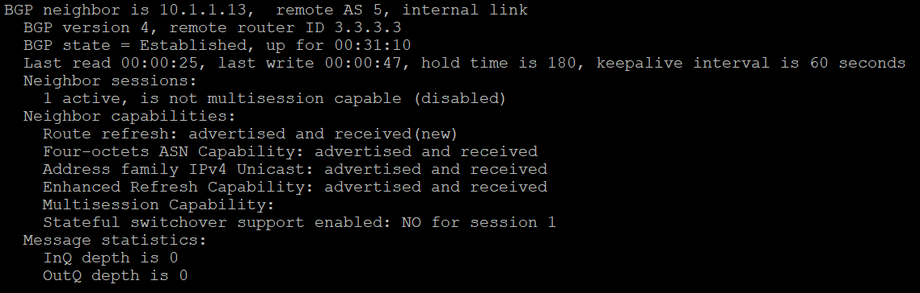

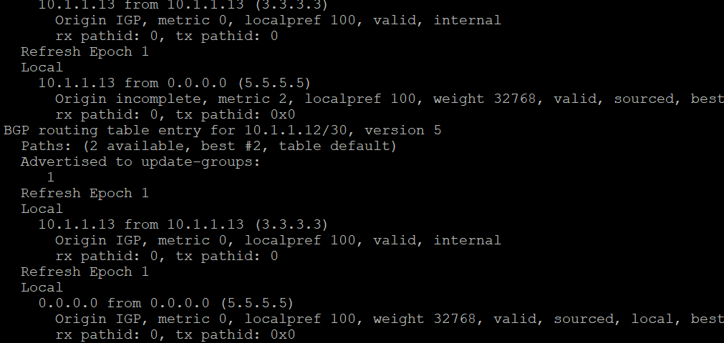

Problem:

We encountered a very strange problem; all the configurations should be there but cannot connect between different regions, I don't know why this problem is solved automatically

The same problem as last time, ipv6 cannot be worked, because Cayman has added an extra link local on each router

I'm not sure what the difference is between config in the address family vs. typing directly, but...they seem to be worked the same

There are also commands from the Internet that I haven't seen, which seem to have no effect (I also feel very strange)

Lab 5

Cisco IP phone

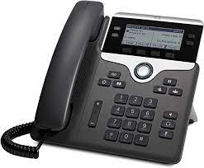

Cisco IP phone

Diagram:

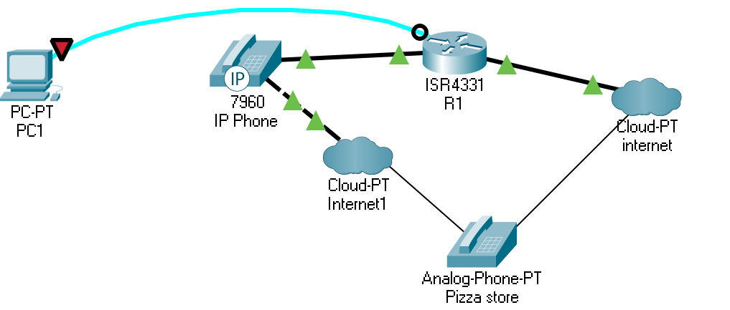

Topologies:

1PC, 1Cisco IP phone, 1router, and patience to solve infinity problems

Background:

Voice over Internet Protocol (VoIP), also known as IP telephony, is a group of methods and technologies for delivering voice communications and multimedia sessions over Internet Protocol (IP) networks such as the Internet.

The steps and principles for initiating a VoIP telephone call are similar to those of traditional digital telephony, involving signaling, channel setup, digitization of analog voice signals, and encoding. Instead of transmitting over circuit-switched networks, digital messages are packetized and transmitted as IP packets over packet-switched networks. They transmit media streams using special media transport protocols that use audio codecs and video codecs to encode audio and video. Various codecs exist to optimize media streams based on application requirements and network bandwidth; some implementations rely on narrowband and compressed voice, while others support high-fidelity stereo codecs.

Because VoIP technology offers bandwidth efficiency and low cost, enterprises are migrating from traditional copper wire phone systems to VoIP systems to reduce monthly phone costs. In 2008, 80 percent of all new private branch exchange (PBX) lines installed internationally were VoIP. In the United States, for example, the Social Security Administration is converting its 63,000-employee field office from traditional telephony equipment to a VoIP infrastructure hosted on its existing data network.

VoIP allows voice and data communications to run on a single network, which can significantly reduce infrastructure costs. VoIP extensions are less expensive than PBXs and critical systems. VoIP switches can run on commercial hardware, such as personal computers. These devices are not closed architectures but rely on standard interfaces. VoIP devices have a simple, intuitive user interface, so users can often make simple system configuration changes. Dual-mode phones allow users to continue to talk while moving between external cellular services and internal Wi-Fi networks, so there is no longer a need to carry both a desktop phone and a cell phone. Maintenance becomes easier because fewer devices need to be supervised

Cisco IP phone is a kind of VoIP phone, The value of Cisco VoIP telephony or voice clarity in the enterprise is paramount compared to traditional phone systems (probably not)

The main advantage of using Cisco VoIP is that you can use a large number of voice data channels over regular phone lines. Plus VoIP also unifies backwards to the traditional phone system so you can call anyone anywhere in the world in real time.

With the popularity of Voice over IP (VoIP) telephony technology, Cisco phones have become a popular choice because they are available in a variety of models to meet a wide range of needs. While they feature features unique to Cisco VoIP servers, these phones can also be used with "open source" VoIP technology

Configuration:

Router and phone:

hostname R1

boot-start-marker

boot-end-marker

logging message-counter syslog

no aaa new-model

memory-size iomem 10

no network-clock-participate slot 1

dot11 syslog

ip source-route

no ip cef

ip dhcp excluded-address 192.168.10.1 192.168.10.5

ip dhcp excluded-address 192.168.20.1 192.168.20.5

ip dhcp pool VOICE20

network 192.168.20.0 255.255.255.0

default-router 192.168.20.1

option 150 ip 192.168.20.1

no ipv6 cef

multilink bundle-name authenticated

voice-card 0

no dspfarm

voice-card 1

no dspfarm

vtp domain cisco

vtp mode transparent

archive

log config

hidekeys

vlan 2,10,20

vlan 996

name CUSTOMER_NATIVE

interface FastEthernet0/0

ip address dhcp

duplex auto

speed auto

interface FastEthernet0/0.20

encapsulation dot1Q 20

ip address 192.168.20.1 255.255.255.0

interface FastEthernet0/0.50

encapsulation dot1Q 50 native

interface FastEthernet0/1

no ip address

shutdown

duplex auto

speed auto

interface FastEthernet0/0/0

interface FastEthernet0/0/1

interface FastEthernet0/0/2

interface FastEthernet0/0/3

interface Serial0/1/0

no ip address

shutdown

interface Serial0/2/0

no ip address

shutdown

clock rate 2000000

interface Serial0/2/1

no ip address

shutdown

clock rate 2000000

interface Serial0/3/0

no ip address

shutdown

clock rate 2000000

interface Serial0/3/1

no ip address

shutdown

clock rate 2000000

interface Vlan1

no ip address

shutdown

ip forward-protocol nd

ip route 0.0.0.0 0.0.0.0 FastEthernet0/1

no ip http server

no ip http secure-server

ip flow-export version 9

tftp-server P00308000500.sbn

tftp-server P00308000500.loads

tftp-server flash:P00308000500.bin alias P00308000500

tftp-server flash:P00308000500.sb2

control-plane

voice-port 1/0/0

ring number 3

connection plar opx 1010

caller-id enable

voice-port 1/0/1

voice-port 1/0/2

voice-port 1/0/3

voice-port 1/1/0

voice-port 1/1/1

dial-peer voice 82 pots

destination-pattern 9[2-9]..[2-9]......

port 1/0/0

forward-digits 10

dial-peer voice 83 pots

destination-pattern 91[2-9]..[2-9]......

port 1/0/0

forward-digits all

dial-peer voice 81 pots

destination-pattern 9[469]11

port 1/0/0

forward-digits 3

telephony-service

max-ephones 3

max-dn 2

ip source-address 192.167.20.1 port 2000

auto assign 1 to 2

system message akshat is smelly

max-conferences 8 gain -6

transfer-system full-consult

create cnf-files version-stamp Jan 01 2002 00:00:00

ephone-dn 1

number 1010

ephone-dn 2

number 1020

ephone 1

device-security-mode none

mac-address 001D.A219.FA62

type 7940

button 1:2

ephone 2

device-security-mode none

mac-address 0015.2B47.6685

type 7960

button 1:1

ephone 3

device-security-mode none

mac-address 001D.A219.F562

type 7940

line con 0

line aux 0

line vty 0 4

login

scheduler allocate 20000 1000

end

SWITCH BELOW

hostname Switch

boot-start-marker

boot-end-marker

no aaa new-model

system mtu routing 1500

vtp domain CCNP

vtp mode transparent

authentication mac-move permit

ip subnet-zero

spanning-tree mode pvst

spanning-tree etherchannel guard misconfig

spanning-tree extend system-id

vlan internal allocation policy ascending

vlan 10

name DATA

vlan 20

name VOICE

vlan 30

name MGT

vlan 40

name MISC

vlan 50

name NATIVE

vlan 99

name MANAGEMENT

interface FastEthernet0/1

switchport trunk encapsulation dot1q

switchport trunk native vlan 50

switchport mode trunk

interface FastEthernet0/2

switchport mode access

switchport voice vlan 20

spanning-tree portfast

interface FastEthernet0/3

switchport mode access

switchport voice vlan 20

spanning-tree portfast

interface FastEthernet0/4

interface FastEthernet0/5

interface FastEthernet0/6

interface FastEthernet0/7

interface FastEthernet0/8

interface FastEthernet0/9

interface FastEthernet0/10

interface FastEthernet0/11

interface FastEthernet0/12

interface FastEthernet0/13

interface FastEthernet0/14

interface FastEthernet0/15

interface FastEthernet0/16

interface FastEthernet0/17

interface FastEthernet0/18

interface FastEthernet0/19

interface FastEthernet0/20

interface FastEthernet0/21

interface FastEthernet0/22

interface FastEthernet0/23

interface FastEthernet0/24

interface GigabitEthernet0/1

interface GigabitEthernet0/2

interface Vlan1

no ip address

shutdown

ip classless

ip http server

ip sla enable reaction-alerts

line con 0

line vty 0 4

login

line vty 5 15

login

end

Problems:

Countless…Can’t remember all of them

The phone doesn't actually have power supply, it needs to be connected to other devices

The phone didn't have direct access to the external internet at first, I don’t know why it need connect both internet and a router connected to internet, we have a cable was connected later

some routers lacked a certificate, and we try to install it later, and then found that the router did not have that much memory, and had to change the drive...

Can make calls to another phone inside of the room but not outside, it's torture, because we copied many commands from the Internet, but nothing seems to work

We told the person who answered the phone at the pizza store only need 1, but for unknown reasons, darn employee actually orders more, and need paid more.

I record a video, but it’s too large

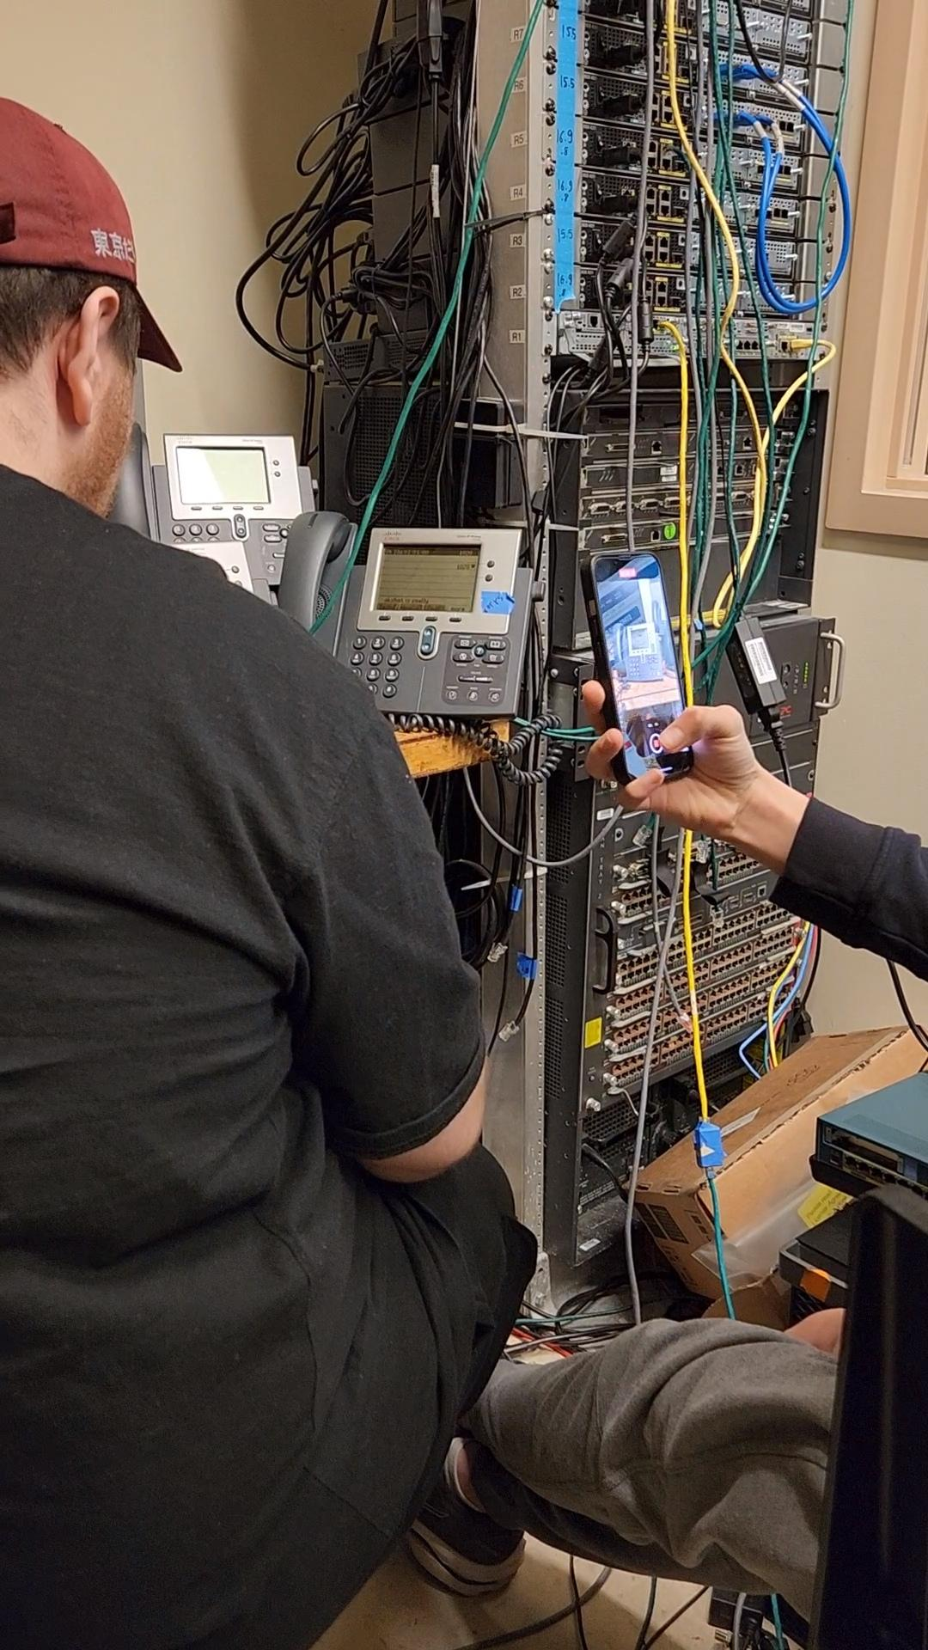

Lab 6

VRF (Virtual routing and forwarding)

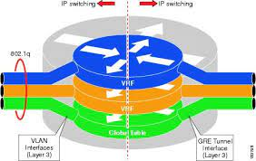

**VRF**

Diagram:

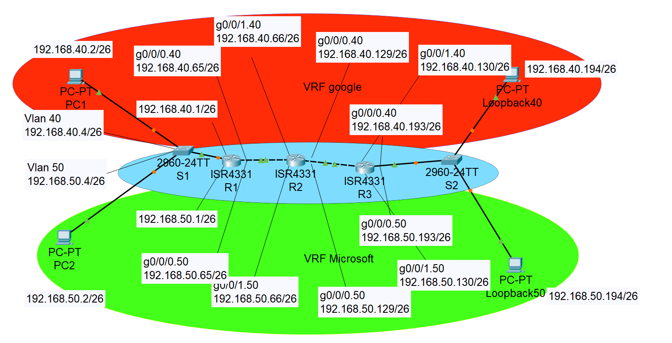

Background:

VRF (Virtual Routing and Forwarding) is a technology that allows multiple routing tables on a single router. The concept of VRF on a router is similar to VLAN on a switch. VRF is usually used in conjunction with MPLS VPN. A VRF without MPLS is called a VRF lite.

Multiple routing instances can be made to traverse different paths (i.e., with different outgoing interfaces).

If we need isolated IP networks because they are used by different companies, departments, or organizations, we typically deploy multiple IP networks that consist of separate physical routers that are not connected to each other. They may still be using a shared Layer 2 or Layer 1 infrastructure, but at Layer 3 they are unconnected and do not form a network.

Network virtualization allows a single physical router to have multiple routing tables. The global table contains all IP interfaces that do not belong to a particular virtual network, and the routing table is used for each unique virtual network assigned to an IP interface.

In its basic form, this allows the FastEthernet 0/0 IP interface to be located in virtual network 10 and the FastEthernet 0/1 IP interface to be located in virtual network 20. Packets arriving at FastEthernet 0/0 are only forwarded to other interfaces in virtual network 10 and FastEthernet 0/1 is not used because it is not in its virtual network: virtual network 10 does not have routing information for other virtual networks.

Additional virtualization can be provided by allowing multiple virtual networks per physical connection. This is accomplished by using Layer 2 logical connections. For FastEthernet physical ports, the use of multiple virtual LANs (VLANs) allows each VLAN to use a different virtual network.

Virtual Route Forwarding (VRF) is a technique for creating multiple virtual networks within a single network entity (Figure 1). Within a single network component, multiple VRF resources create isolation between virtual networks.

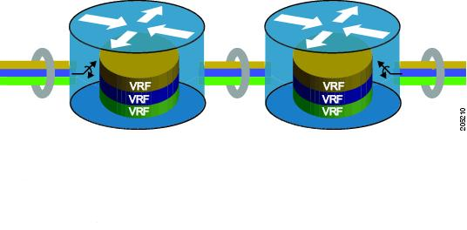

VRF is the same method of network isolation/virtualization as VLAN.

VRFs are to routing tables what VLANs are to LANs.

Using virtual routing and forwarding, we virtualize the routing table into multiple routing tables, similar to the VLANs used to virtualize the LAN.

You can say that VLANs are performing L2 virtualization and VRFs are performing L3 virtualization. VLANs make a single switch look like multiple switches; virtual routing and forwarding makes a single router look like multiple routers.

Configuration:

R1:

hostname R1

boot-start-marker

boot-end-marker

vrf definition Mgmt-intf

address-family ipv4

exit-address-family

address-family ipv6

exit-address-family

no aaa new-model

ip vrf GOOGLE

ip vrf MICROSOFT

no ip domain lookup

login on-success log

subscriber templating

multilink bundle-name authenticated

crypto pki trustpoint TP-self-signed-2667303412

enrollment selfsigned

subject-name cn=IOS-Self-Signed-Certificate-2667303412

revocation-check none

rsakeypair TP-self-signed-2667303412

crypto pki certificate chain TP-self-signed-2667303412

license udi pid ISR4321/K9 sn FLM2407011F

no license smart enable

diagnostic bootup level minimal

spanning-tree extend system-id

redundancy

mode none

interface GigabitEthernet0/0/0

no ip address

negotiation auto

interface GigabitEthernet0/0/0.40

encapsulation dot1Q 40

ip vrf forwarding MICROSOFT

ip address 192.168.40.1 255.255.255.192

interface GigabitEthernet0/0/0.50

encapsulation dot1Q 50

ip vrf forwarding GOOGLE

ip address 192.168.50.1 255.255.255.192

interface GigabitEthernet0/0/1

no ip address

negotiation auto

interface GigabitEthernet0/0/1.40

encapsulation dot1Q 40

ip vrf forwarding MICROSOFT

ip address 192.168.40.65 255.255.255.192

interface GigabitEthernet0/0/1.50

encapsulation dot1Q 50

ip vrf forwarding GOOGLE

ip address 192.168.50.65 255.255.255.192

interface GigabitEthernet0/1/0

no ip address

shutdown

negotiation auto

interface GigabitEthernet0/1/1

no ip address

shutdown

negotiation auto

interface GigabitEthernet0

vrf forwarding Mgmt-intf

no ip address

shutdown

negotiation auto

router ospf 1 vrf MICROSOFT

network 192.168.40.0 0.0.0.63 area 0

network 192.168.40.64 0.0.0.63 area 0

router ospf 2 vrf GOOGLE

network 192.168.50.0 0.0.0.63 area 0

network 192.168.50.64 0.0.0.63 area 0

ip forward-protocol nd

ip http server

ip http authentication local

ip http secure-server

ip tftp source-interface GigabitEthernet0

control-plane

line con 0

transport input none

stopbits 1

line aux 0

stopbits 1

line vty 0 4

login

End

R2:

hostname R2

boot-start-marker

boot-end-marker

vrf definition Mgmt-intf

address-family ipv4

exit-address-family

address-family ipv6

exit-address-family

no aaa new-model

ip vrf GOOGLE

ip vrf MICROSOFT

no ip domain lookup

login on-success log

subscriber templating

vtp domain cisco

vtp mode transparent

multilink bundle-name authenticated

crypto pki trustpoint TP-self-signed-4288135047

enrollment selfsigned

subject-name cn=IOS-Self-Signed-Certificate-4288135047

revocation-check none

rsakeypair TP-self-signed-4288135047

crypto pki certificate chain TP-self-signed-4288135047

license udi pid ISR4321/K9 sn FLM2406090M

no license smart enable

diagnostic bootup level minimal

spanning-tree extend system-id

redundancy

mode none

interface GigabitEthernet0/0/0

no ip address

negotiation auto

interface GigabitEthernet0/0/0.40

encapsulation dot1Q 40

ip vrf forwarding MICROSOFT

ip address 192.168.40.66 255.255.255.192

interface GigabitEthernet0/0/0.50

encapsulation dot1Q 50

ip vrf forwarding GOOGLE

ip address 192.168.50.66 255.255.255.192

interface GigabitEthernet0/0/1

no ip address

negotiation auto

interface GigabitEthernet0/0/1.40

encapsulation dot1Q 40

ip vrf forwarding MICROSOFT

ip address 192.168.40.129 255.255.255.192

interface GigabitEthernet0/0/1.50

encapsulation dot1Q 50

ip vrf forwarding GOOGLE

ip address 192.168.50.129 255.255.255.192

interface GigabitEthernet0/1/0

no ip address

shutdown

negotiation auto

interface GigabitEthernet0/1/1

no ip address

shutdown

negotiation auto

interface GigabitEthernet0

vrf forwarding Mgmt-intf

no ip address

shutdown

negotiation auto

router ospf 1 vrf MICROSOFT

network 192.168.40.64 0.0.0.63 area 0

network 192.168.40.128 0.0.0.63 area 0

router ospf 2 vrf GOOGLE

network 192.168.50.64 0.0.0.63 area 0

network 192.168.50.128 0.0.0.63 area 0

ip forward-protocol nd

ip http server

ip http authentication local

ip http secure-server

ip tftp source-interface GigabitEthernet0

ip route vrf GOOGLE 0.0.0.0 0.0.0.0 192.168.40.65

ip route vrf GOOGLE 0.0.0.0 0.0.0.0 192.168.40.130

ip route vrf MICROSOFT 0.0.0.0 0.0.0.0 192.168.50.65

ip route vrf MICROSOFT 0.0.0.0 0.0.0.0 192.168.50.130

control-plane

line con 0

transport input none

stopbits 1

line aux 0

stopbits 1

line vty 0 4

login

End

R3:

hostname R3

boot-start-marker

boot-end-marker

vrf definition Mgmt-intf

address-family ipv4

exit-address-family

address-family ipv6

exit-address-family

no aaa new-model

ip vrf GOOGLE

ip vrf MICROSOFT

no ip domain lookup

login on-success log

subscriber templating

vtp domain cisco

vtp mode transparent

multilink bundle-name authenticated

crypto pki trustpoint TP-self-signed-859896477

enrollment selfsigned

subject-name cn=IOS-Self-Signed-Certificate-859896477

revocation-check none

rsakeypair TP-self-signed-859896477

crypto pki certificate chain TP-self-signed-859896477

certificate self-signed 01

3082032E 30820216 A0030201 02020101 300D0609 2A864886 F70D0101 05050030

30312E30 2C060355 04031325 494F532D 53656C66 2D536967 6E65642D 43657274

69666963 6174652D 38353938 39363437 37301E17 0D323231 30313731 38323635

385A170D 33303031 30313030 30303030 5A303031 2E302C06 03550403 1325494F

532D5365 6C662D53 69676E65 642D4365 72746966 69636174 652D3835 39383936

34373730 82012230 0D06092A 864886F7 0D010101 05000382 010F0030 82010A02

82010100 CA31EE51 C97FF58C 76C72B4E 2B6CD51B 98CBA177 7EEF8D11 DAAB7CA8

47B3AA97 3B815AD1 09F637AE B1D98BB8 A2CAA1A9 0AFAF87A 3AFBFF9E 34875D72

0BD5EE8D E40F4D4A 3B4A38A7 09F1940D 013C18AE F29F2BEA 07085EB5 982E9BC8

F99C8CA7 1C7DD58E 67B89FCB 951C3C4C 6D11B8C7 8D24BF5C 973A32BF E16A3094

99E8DB22 7FEA5A30 6E9457F6 90485336 E953F3D2 942824E3 87D8DE52 E00336AC

09CA85F0 0BD105FA B4078F96 9A2EA846 C147AD42 B08CD3D2 16A06EB1 CC54E167

8F4677E9 2663D37D 7B1C3891 9ABF4B5B 83ECE428 AD426108 357B992E 792C850D

84C67187 BF0E10B5 B1D23A97 F2F1372F 7D0FA8C8 80E947DE 5E0FA234 7FA6A487

24A0DB83 02030100 01A35330 51300F06 03551D13 0101FF04 05300301 01FF301F

0603551D 23041830 168014E7 C71AF39E FCC743E7 C7395603 DBBCA771 4C734E30

1D060355 1D0E0416 0414E7C7 1AF39EFC C743E7C7 395603DB BCA7714C 734E300D

06092A86 4886F70D 01010505 00038201 010029B2 769B6033 C71585B8 DD1EE596

BDB3F81C 5C58921E AF7FBE2F A95F447D 7B870BCD B9AE5E5D 46FCE0E1 667295B7

4668DACB F848F91A 207FC6CD 203E64BF 6747B9E7 6FF304F1 491442EA 56EEBEE6

DE79EC87 F5BE7B9C B2482264 A58FAC1B 827F66C7 F16C0292 815AD1ED 86F2E167

9568FC20 9E2ADCB6 311B34E4 E93EC128 2DD25078 4F27E1F1 4DD309BA B2A0248A

C41F66C8 4A81C2B8 9D0E8A62 4E0443F6 F28B3203 28A14D43 0E06A98B 06DAB16D

66E0616A DB63132A 8FB53D9B 88A28660 F84CD05D EC8653F6 C3FC6446 94977DAC

0ED87E1C 9C0B372A 6E25729B FAD2B249 6FDF7BC6 3218B110 D167D3D5 AEACB17D

6E8CB48E ED168D18 8D9104DE BA9F3515 5662

quit

license udi pid ISR4321/K9 sn FLM240608PJ

no license smart enable

diagnostic bootup level minimal

spanning-tree extend system-id

redundancy

mode none

interface Loopback0

no ip address

interface Loopback40

ip vrf forwarding MICROSOFT

ip address 192.168.40.194 255.255.255.192

interface Loopback50

ip vrf forwarding GOOGLE

ip address 192.168.50.194 255.255.255.192

interface GigabitEthernet0/0/0

no ip address

negotiation auto

interface GigabitEthernet0/0/0.40

encapsulation dot1Q 40

ip vrf forwarding MICROSOFT

ip address 192.168.40.130 255.255.255.192

interface GigabitEthernet0/0/0.50

encapsulation dot1Q 50

ip vrf forwarding GOOGLE

ip address 192.168.50.130 255.255.255.192

interface GigabitEthernet0/0/1

no ip address

shutdown

negotiation auto

interface GigabitEthernet0/1/0

no ip address

shutdown

negotiation auto

interface GigabitEthernet0/1/1

no ip address

shutdown

negotiation auto

interface GigabitEthernet0

vrf forwarding Mgmt-intf

no ip address

shutdown

negotiation auto

router ospf 1 vrf MICROSOFT

network 192.168.40.128 0.0.0.63 area 0

network 192.168.40.192 0.0.0.63 area 0

router ospf 2 vrf GOOGLE

network 192.168.50.128 0.0.0.63 area 0

network 192.168.50.192 0.0.0.63 area 0

ip forward-protocol nd

ip http server

ip http authentication local

ip http secure-server

ip tftp source-interface GigabitEthernet0

ip route vrf GOOGLE 0.0.0.0 0.0.0.0 192.168.40.129

ip route vrf MICROSOFT 0.0.0.0 0.0.0.0 192.168.50.129

control-plane

line con 0

transport input none

stopbits 1

line aux 0

stopbits 1

line vty 0 4

login

end

S1:

hostname S1

boot-start-marker

boot-end-marker

no aaa new-model

system mtu routing 1500

vtp domain CCNP

vtp mode transparent

crypto pki trustpoint TP-self-signed-1670285312

enrollment selfsigned

subject-name cn=IOS-Self-Signed-Certificate-1670285312

revocation-check none

rsakeypair TP-self-signed-1670285312

crypto pki certificate chain TP-self-signed-1670285312

certificate self-signed 01

3082023A 308201A3 A0030201 02020101 300D0609 2A864886 F70D0101 04050030

31312F30 2D060355 04031326 494F532D 53656C66 2D536967 6E65642D 43657274

69666963 6174652D 31363730 32383533 3132301E 170D3933 30333031 30333034

32325A17 0D323030 31303130 30303030 305A3031 312F302D 06035504 03132649

4F532D53 656C662D 5369676E 65642D43 65727469 66696361 74652D31 36373032

38353331 3230819F 300D0609 2A864886 F70D0101 01050003 818D0030 81890281

8100EB46 8671730D 021D58ED 3413BF61 9EB68969 97AAFC04 7A39EC84 B0B0A5FB

8A14889C 4C8C589B E7031D3D 6FD3E662 3FB2930C 4E775ECB A9A8D734 183D958E

3C1D6DC0 326A3001 3E0CF4B1 1943F496 60DA532F 34BA9441 2ECA2324 0E30F6C5

E0CBBE4D 3F1BEA58 ECE8962C AF1A7025 4361E5E0 30D3164E AC9A1E4F 2388EEE0

8FED0203 010001A3 62306030 0F060355 1D130101 FF040530 030101FF 300D0603

551D1104 06300482 02533130 1F060355 1D230418 30168014 7442AFD2 ACA520DE

FD99C215 36F3B04B 3D7195A3 301D0603 551D0E04 16041474 42AFD2AC A520DEFD

99C21536 F3B04B3D 7195A330 0D06092A 864886F7 0D010104 05000381 81001A74

829F3FB7 FB7C5ECA 9B96493C E4A61D33 9BF78B7E AE7FD484 02FEAF77 8A7933B6

A0C76DB2 1EB4D082 D6F47FD8 78E48955 3C736A21 62B5DB69 7949F7AD DE4CC897

FB3456DE 98DEC347 B204650C 5FF3EE08 4E83AB03 71A98895 59FF8462 8CD37291

2D416C50 D79BEACC 412A8E45 359E1DD5 EE6EA864 AD1DA61A D1D57394 DC44

quit

spanning-tree mode pvst

spanning-tree extend system-id

vlan internal allocation policy ascending

vlan 2

name data

vlan 3

name voice

vlan 4

name management

vlan 5

name Phoneline

vlan 6

name native

vlan 10

name Trivago

vlan 20

name Data

vlan 30

name Expedia

vlan 40

name google

vlan 50

name Microsoft

vlan 100

name Voice

vlan 400,707

vlan 996

name CUSTOMER_NATIVE

vlan 999

interface FastEthernet1/0/1

switchport trunk encapsulation dot1q

switchport trunk allowed vlan 40,50

switchport mode trunk

interface FastEthernet1/0/2

interface FastEthernet1/0/3

switchport access vlan 40

switchport mode access

interface FastEthernet1/0/4

switchport access vlan 50

switchport mode access

interface FastEthernet1/0/5

interface FastEthernet1/0/6

interface FastEthernet1/0/7

interface FastEthernet1/0/8

interface FastEthernet1/0/9

interface FastEthernet1/0/10

interface FastEthernet1/0/11

interface FastEthernet1/0/12

interface FastEthernet1/0/13

interface FastEthernet1/0/14

interface FastEthernet1/0/15

interface FastEthernet1/0/16

interface FastEthernet1/0/17

interface FastEthernet1/0/18

interface FastEthernet1/0/19

interface FastEthernet1/0/20

interface FastEthernet1/0/21

interface FastEthernet1/0/22

interface FastEthernet1/0/23

interface FastEthernet1/0/24

interface GigabitEthernet1/0/1

interface GigabitEthernet1/0/2

interface GigabitEthernet1/1/1

interface GigabitEthernet1/1/2

interface Vlan1

no ip address

interface Vlan40

no ip address

interface Vlan50

no ip address

ip http server

ip http secure-server

logging esm config

line con 0

line vty 5 15

End

Routing table and ping situation:

R1#show ip route vrf GOOGLE

Routing Table: GOOGLE

Codes: L - local, C - connected, S - static, R - RIP, M - mobile, B - BGP

D - EIGRP, EX - EIGRP external, O - OSPF, IA - OSPF inter area

N1 - OSPF NSSA external type 1, N2 - OSPF NSSA external type 2

E1 - OSPF external type 1, E2 - OSPF external type 2

i - IS-IS, su - IS-IS summary, L1 - IS-IS level-1, L2 - IS-IS level-2

ia - IS-IS inter area, * - candidate default, U - per-user static route

o - ODR, P - periodic downloaded static route, H - NHRP, l - LISP

a - application route

+ - replicated route, % - next hop override, p - overrides from PfR

Gateway of last resort is not set

192.168.50.0/24 is variably subnetted, 6 subnets, 2 masks

C 192.168.50.0/26 is directly connected, GigabitEthernet0/0/0.50

L 192.168.50.1/32 is directly connected, GigabitEthernet0/0/0.50

C 192.168.50.64/26 is directly connected, GigabitEthernet0/0/1.50

L 192.168.50.65/32 is directly connected, GigabitEthernet0/0/1.50

O 192.168.50.128/26

[110/2] via 192.168.50.66, 00:21:46, GigabitEthernet0/0/1.50

O 192.168.50.194/32

[110/3] via 192.168.50.66, 00:21:46, GigabitEthernet0/0/1.50

R1#show ip route vrf MICROSOFT

Routing Table: MICROSOFT

Codes: L - local, C - connected, S - static, R - RIP, M - mobile, B - BGP

D - EIGRP, EX - EIGRP external, O - OSPF, IA - OSPF inter area

N1 - OSPF NSSA external type 1, N2 - OSPF NSSA external type 2

E1 - OSPF external type 1, E2 - OSPF external type 2

i - IS-IS, su - IS-IS summary, L1 - IS-IS level-1, L2 - IS-IS level-2

ia - IS-IS inter area, * - candidate default, U - per-user static route

o - ODR, P - periodic downloaded static route, H - NHRP, l - LISP

a - application route

+ - replicated route, % - next hop override, p - overrides from PfR

Gateway of last resort is not set

192.168.40.0/24 is variably subnetted, 6 subnets, 2 masks

C 192.168.40.0/26 is directly connected, GigabitEthernet0/0/0.40

L 192.168.40.1/32 is directly connected, GigabitEthernet0/0/0.40

C 192.168.40.64/26 is directly connected, GigabitEthernet0/0/1.40

L 192.168.40.65/32 is directly connected, GigabitEthernet0/0/1.40

O 192.168.40.128/26

[110/2] via 192.168.40.66, 00:22:14, GigabitEthernet0/0/1.40

O 192.168.40.194/32

[110/3] via 192.168.40.66, 00:22:14, GigabitEthernet0/0/1.40

R2#show ip route vrf GOOGLE

Routing Table: GOOGLE

Codes: L - local, C - connected, S - static, R - RIP, M - mobile, B - BGP

D - EIGRP, EX - EIGRP external, O - OSPF, IA - OSPF inter area

N1 - OSPF NSSA external type 1, N2 - OSPF NSSA external type 2

E1 - OSPF external type 1, E2 - OSPF external type 2

i - IS-IS, su - IS-IS summary, L1 - IS-IS level-1, L2 - IS-IS level-2

ia - IS-IS inter area, * - candidate default, U - per-user static route

o - ODR, P - periodic downloaded static route, H - NHRP, l - LISP

a - application route

+ - replicated route, % - next hop override, p - overrides from PfR

Gateway of last resort is not set

192.168.50.0/24 is variably subnetted, 6 subnets, 2 masks

O 192.168.50.0/26

[110/2] via 192.168.50.65, 00:19:58, GigabitEthernet0/0/0.50

C 192.168.50.64/26 is directly connected, GigabitEthernet0/0/0.50

L 192.168.50.66/32 is directly connected, GigabitEthernet0/0/0.50

C 192.168.50.128/26 is directly connected, GigabitEthernet0/0/1.50

L 192.168.50.129/32 is directly connected, GigabitEthernet0/0/1.50

O 192.168.50.194/32

[110/2] via 192.168.50.130, 01:35:08, GigabitEthernet0/0/1.50

R2#show ip route vrf MICROSOFT

Routing Table: MICROSOFT

Codes: L - local, C - connected, S - static, R - RIP, M - mobile, B - BGP

D - EIGRP, EX - EIGRP external, O - OSPF, IA - OSPF inter area

N1 - OSPF NSSA external type 1, N2 - OSPF NSSA external type 2

E1 - OSPF external type 1, E2 - OSPF external type 2

i - IS-IS, su - IS-IS summary, L1 - IS-IS level-1, L2 - IS-IS level-2

ia - IS-IS inter area, * - candidate default, U - per-user static route

o - ODR, P - periodic downloaded static route, H - NHRP, l - LISP

a - application route

+ - replicated route, % - next hop override, p - overrides from PfR

Gateway of last resort is not set

192.168.40.0/24 is variably subnetted, 6 subnets, 2 masks

O 192.168.40.0/26

[110/2] via 192.168.40.65, 00:20:27, GigabitEthernet0/0/0.40

C 192.168.40.64/26 is directly connected, GigabitEthernet0/0/0.40

L 192.168.40.66/32 is directly connected, GigabitEthernet0/0/0.40

C 192.168.40.128/26 is directly connected, GigabitEthernet0/0/1.40

L 192.168.40.129/32 is directly connected, GigabitEthernet0/0/1.40

O 192.168.40.194/32

[110/2] via 192.168.40.130, 01:35:24, GigabitEthernet0/0/1.40

R3#show ip route vrf GOOGLE

Routing Table: GOOGLE

Codes: L - local, C - connected, S - static, R - RIP, M - mobile, B - BGP

D - EIGRP, EX - EIGRP external, O - OSPF, IA - OSPF inter area

N1 - OSPF NSSA external type 1, N2 - OSPF NSSA external type 2

E1 - OSPF external type 1, E2 - OSPF external type 2

i - IS-IS, su - IS-IS summary, L1 - IS-IS level-1, L2 - IS-IS level-2

ia - IS-IS inter area, * - candidate default, U - per-user static route

o - ODR, P - periodic downloaded static route, H - NHRP, l - LISP

a - application route

+ - replicated route, % - next hop override, p - overrides from PfR

Gateway of last resort is not set

192.168.50.0/24 is variably subnetted, 6 subnets, 2 masks

O 192.168.50.0/26

[110/3] via 192.168.50.129, 00:18:18, GigabitEthernet0/0/0.50

O 192.168.50.64/26

[110/2] via 192.168.50.129, 00:35:07, GigabitEthernet0/0/0.50

C 192.168.50.128/26 is directly connected, GigabitEthernet0/0/0.50

L 192.168.50.130/32 is directly connected, GigabitEthernet0/0/0.50

C 192.168.50.192/26 is directly connected, Loopback50

L 192.168.50.194/32 is directly connected, Loopback50

R3#show ip route vrf MICROSOFT

Routing Table: MICROSOFT

Codes: L - local, C - connected, S - static, R - RIP, M - mobile, B - BGP

D - EIGRP, EX - EIGRP external, O - OSPF, IA - OSPF inter area

N1 - OSPF NSSA external type 1, N2 - OSPF NSSA external type 2

E1 - OSPF external type 1, E2 - OSPF external type 2

i - IS-IS, su - IS-IS summary, L1 - IS-IS level-1, L2 - IS-IS level-2

ia - IS-IS inter area, * - candidate default, U - per-user static route

o - ODR, P - periodic downloaded static route, H - NHRP, l - LISP

a - application route

+ - replicated route, % - next hop override, p - overrides from PfR

Gateway of last resort is not set

192.168.40.0/24 is variably subnetted, 6 subnets, 2 masks

O 192.168.40.0/26

[110/3] via 192.168.40.129, 00:19:15, GigabitEthernet0/0/0.40

O 192.168.40.64/26

[110/2] via 192.168.40.129, 00:35:51, GigabitEthernet0/0/0.40

C 192.168.40.128/26 is directly connected, GigabitEthernet0/0/0.40

L 192.168.40.130/32 is directly connected, GigabitEthernet0/0/0.40

C 192.168.40.192/26 is directly connected, Loopback40

L 192.168.40.194/32 is directly connected, Loopback40

PC1:

C:\Users\user>ping 192.168.40.194

Pinging 192.168.40.194 with 32 bytes of data:  
Reply from 192.168.40.194: bytes=32 time=1ms TTL=253  
Reply from 192.168.40.194: bytes=32 time=1ms TTL=253  
Reply from 192.168.40.194: bytes=32 time=1ms TTL=253  
Reply from 192.168.40.194: bytes=32 time=1ms TTL=253

Ping statistics for 192.168.40.194:  
    Packets: Sent = 4, Received = 4, Lost = 0 (0% loss),  
Approximate round trip times in milli-seconds:  
    Minimum = 1ms, Maximum = 1ms, Average = 1ms

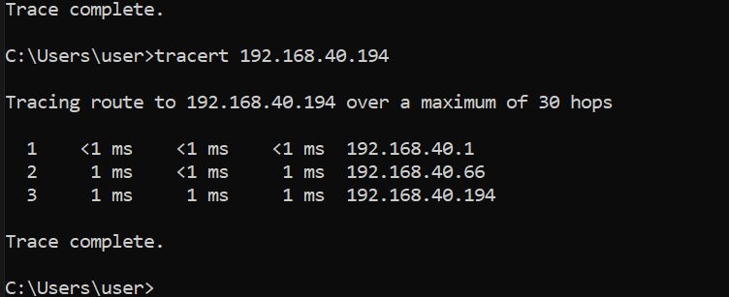PC2:

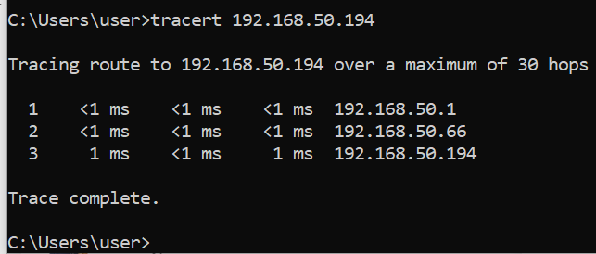

PC2 Ping to a different vrf subnet but fail: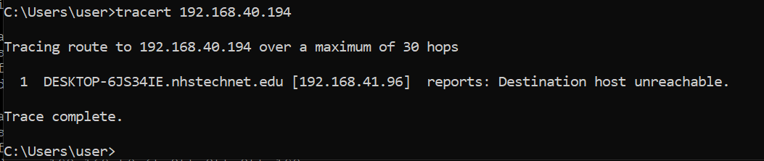

Problem:

Our ping cannot pass the router 2, I add some dedicated static default route for vrf then it gonna work.

Lab 7

Amazon aws cloud services



There are 6 concepts, combine into 1

AWS lab 1-3

Background:

Amazon Web Services, Inc. (AWS), a subsidiary of Amazon, provides on-demand cloud computing platforms and APIs to individuals, companies and governments on a pay-as-you-go basis.

Typically, customers use them in conjunction with autoscaling (a process that allows clients to use more compute when application usage is high and then scale down to reduce costs when traffic is low). These cloud web services offer a variety of services related to networking, compute, storage, middleware, IoT and other processing power, as well as software tools available through AWS server farms. This eliminates the need for customers to manage, scale and patch hardware and operating systems. One of these foundational services is Amazon Elastic Compute Cloud (EC2), which allows users to have a virtual cluster of computers with extremely high availability that can be interacted with via a REST API, CLI or AWS over the Internet Comfort. AWS' virtual computers emulate most of the attributes of real computers, including hardware central processing units (CPUs) and graphics processors (GPUs) for processing; local/RAM memory; hard drive/SSD storage; choice of operating systems; networking; and pre-loaded applications such as Web servers, databases, and customer relationship management (CRM).

AWS offers a wide range of cloud computing products and services, with more than 200 offerings across computing, storage, databases, analytics, networking, mobile, development tools, management, IoT, security, and enterprise applications. AWS also has a global presence, with data centers located in multiple regions worldwide. This allows customers to host their applications and data closer to their end-users, resulting in lower latency and better performance.

AWS also provide Flexibility, Reliability, and Security service

Steps:

Lab 1

Explored pre-created IAM users and groups

Inspected IAM policies as applied to the pre-created groups

Followed a real-world scenario, adding users to groups with specific capabilities enabled

Located and used the IAM sign-in URL

Experimented with the effects of policies on service access

Check in

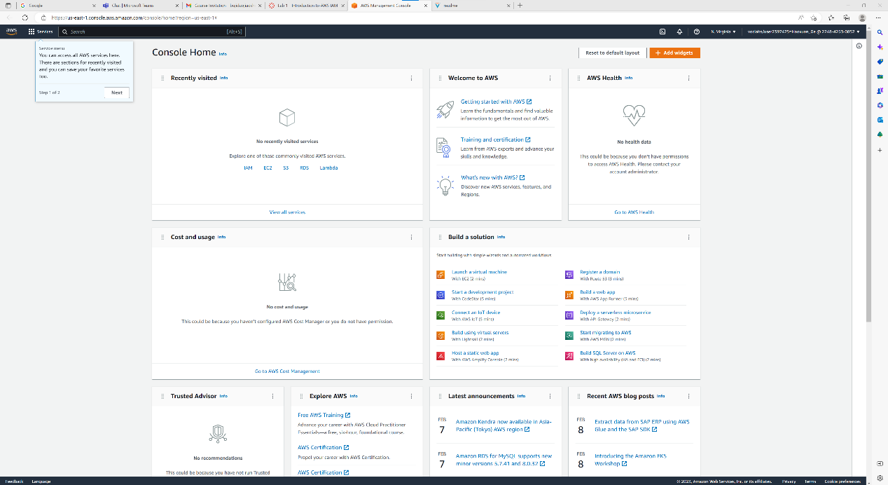

Explore the IAM and add each user (1-3) to each group

1 - S3-Support

2 - EC2-Support

3 - EC2-Admin

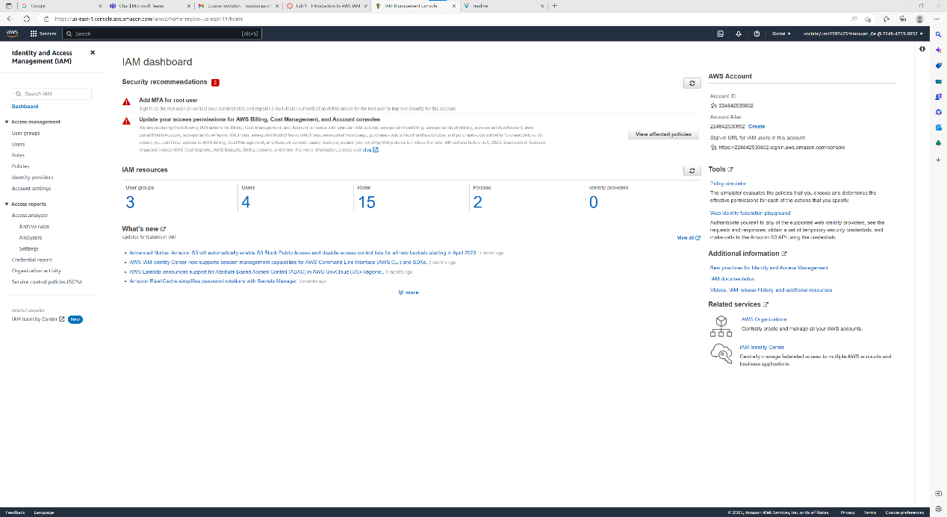

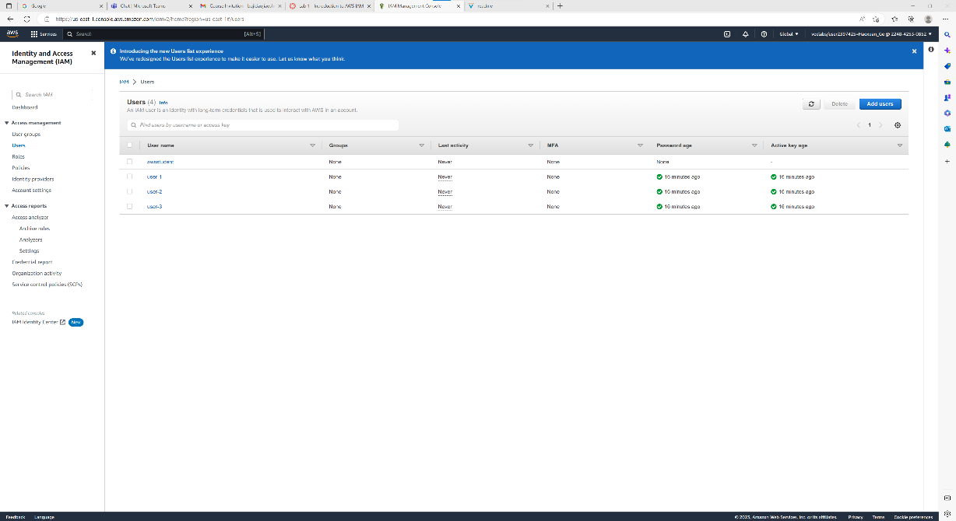

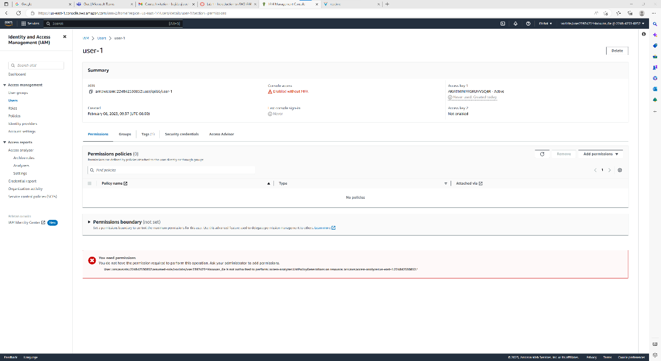

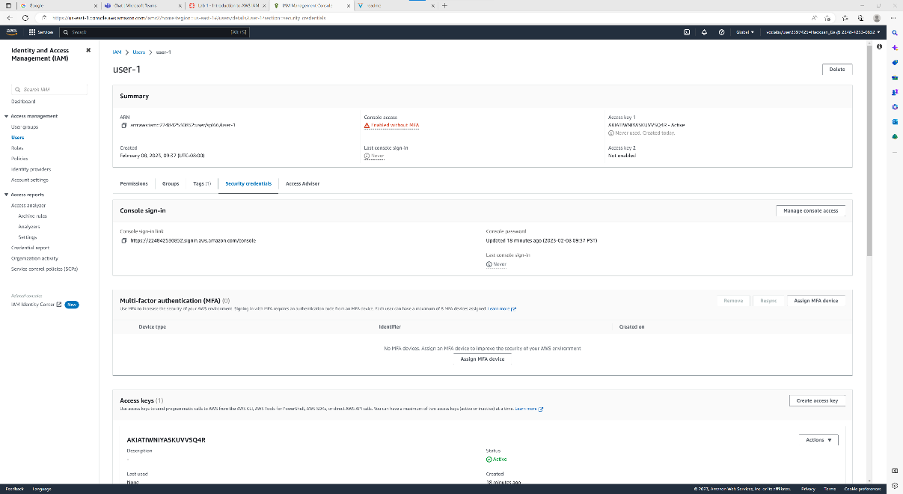

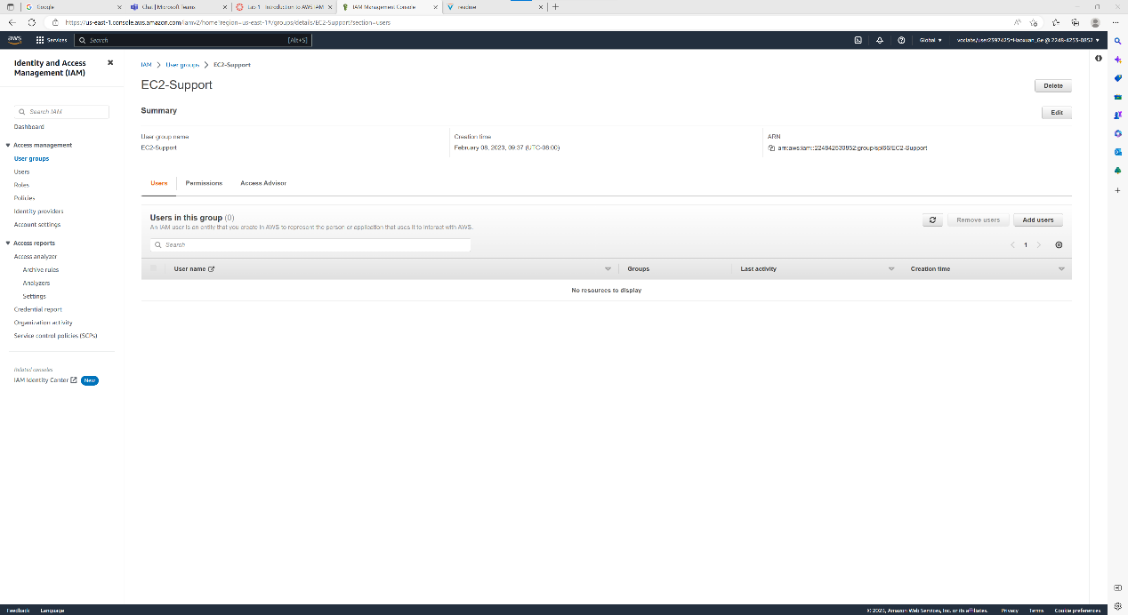

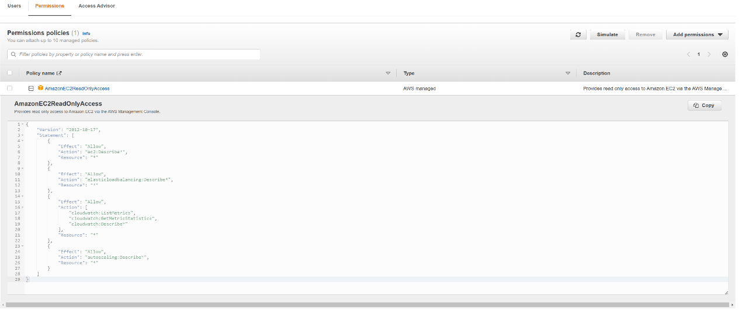

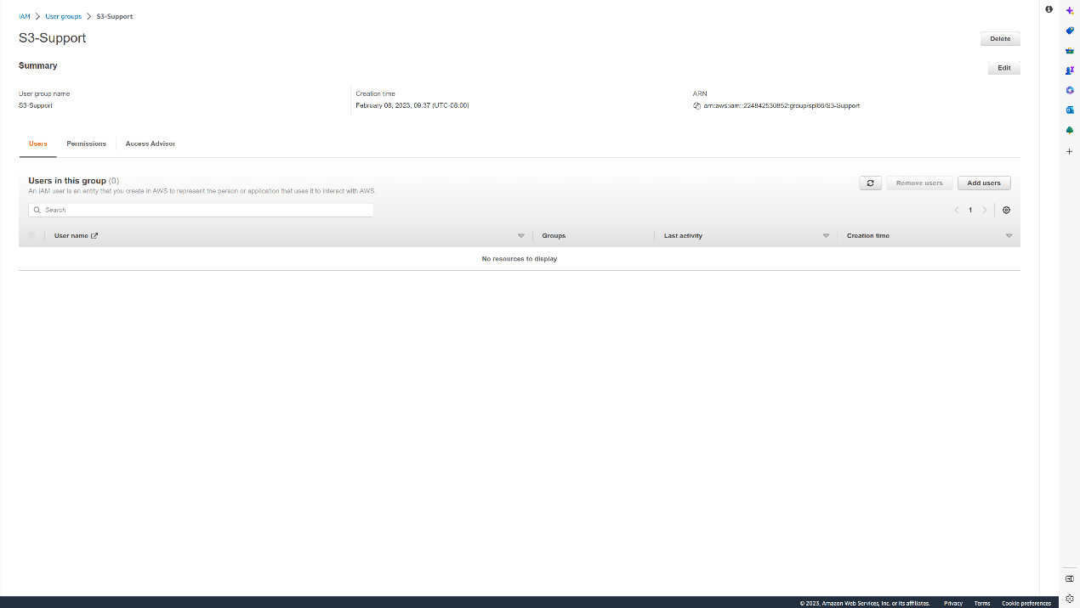

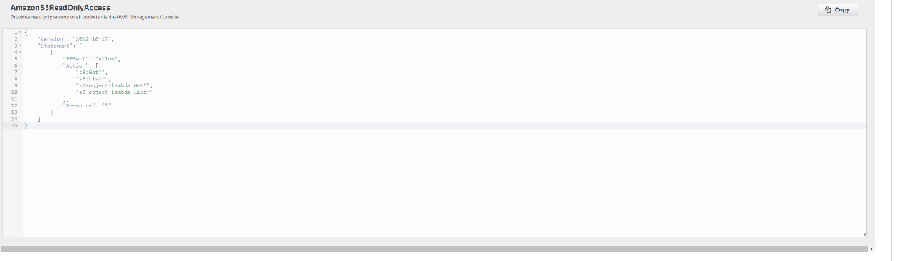

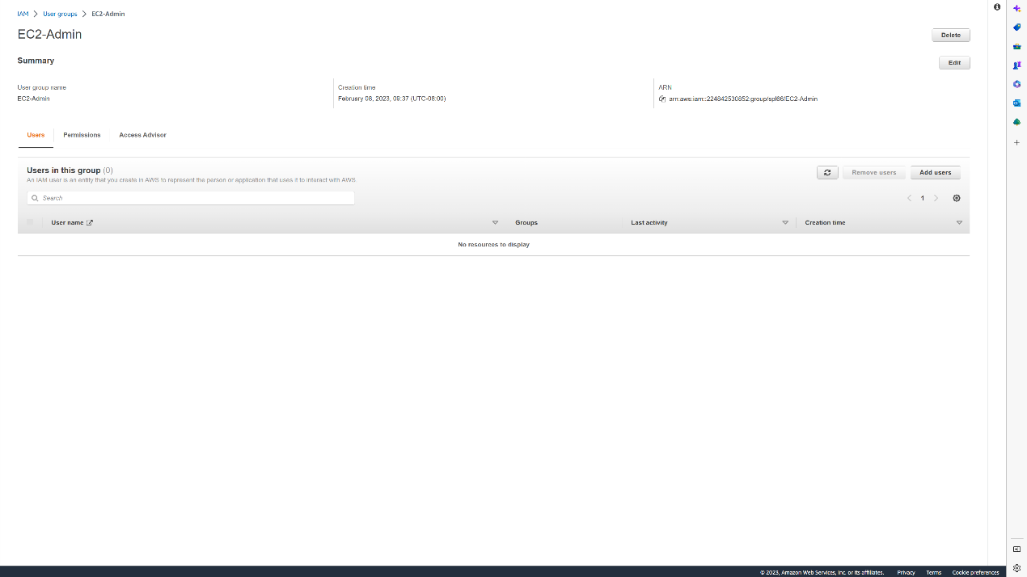

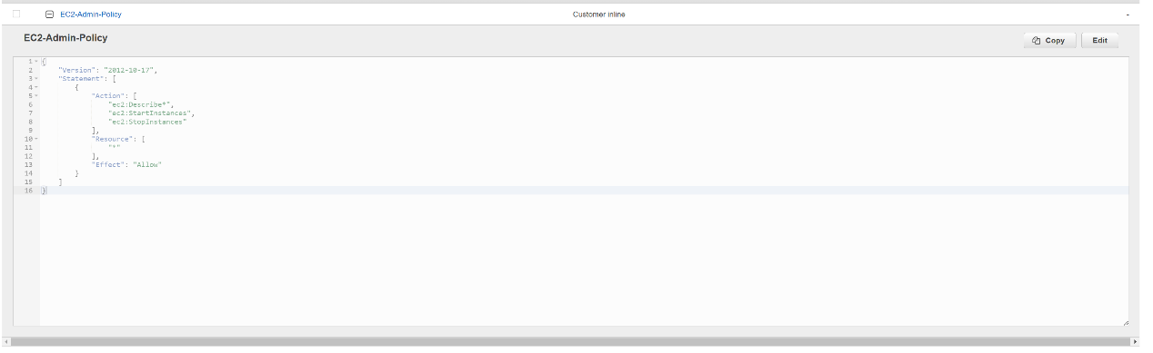

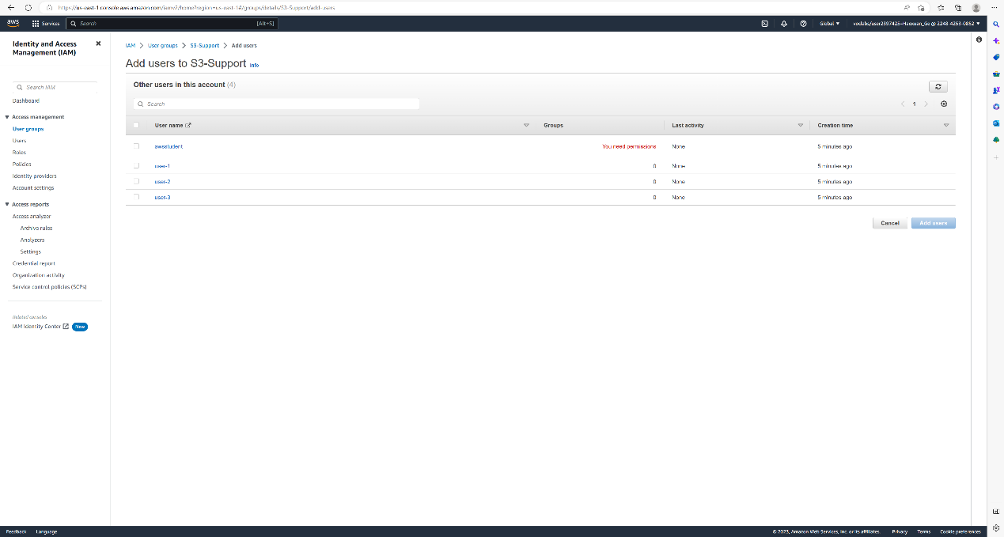

~~~ sorry I then use my home PC therefore it is Chinese~~~

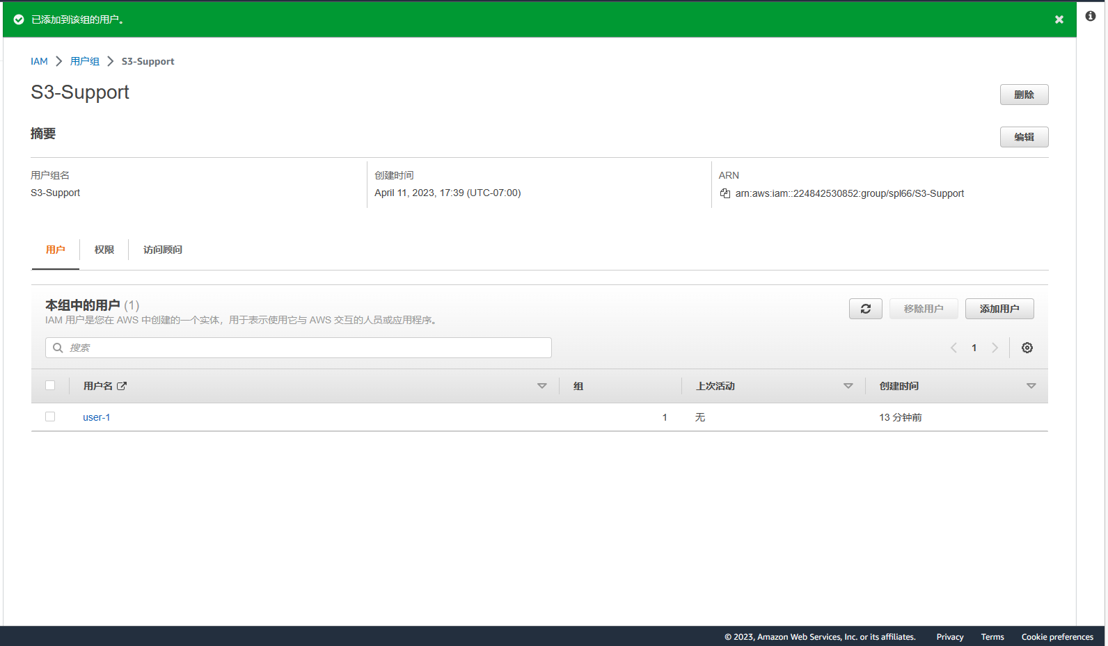

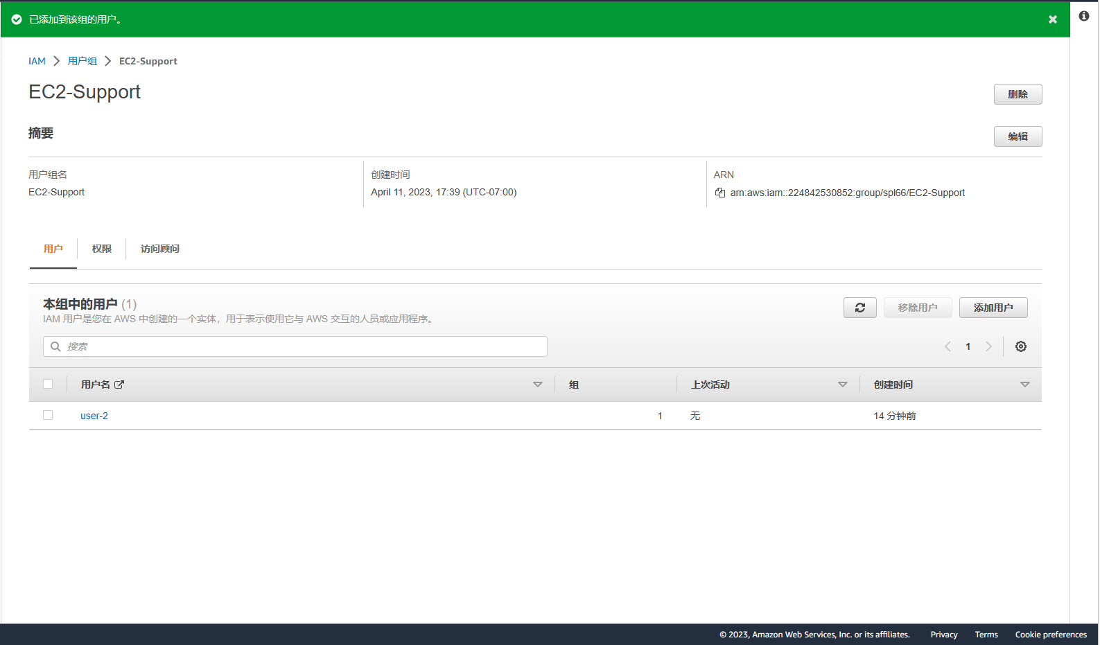

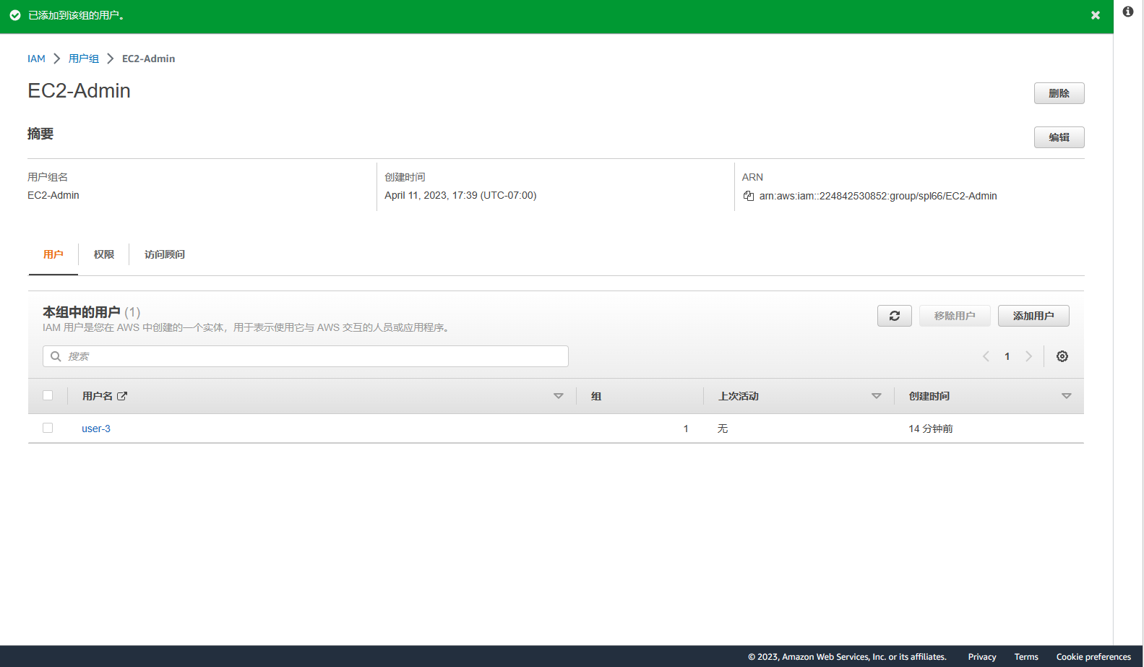

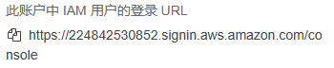

Copy URL, login in user-1

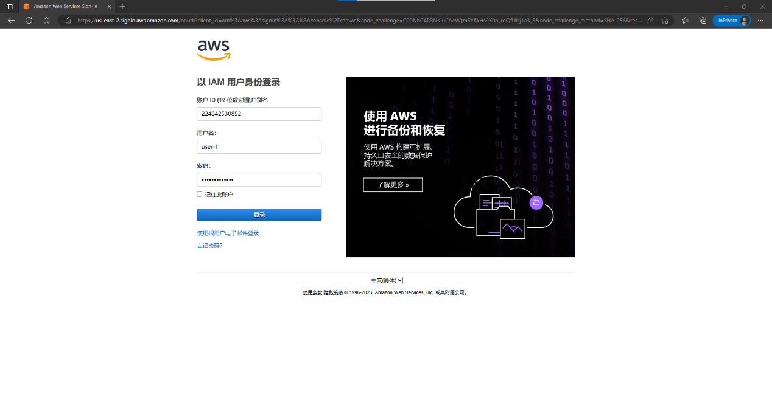

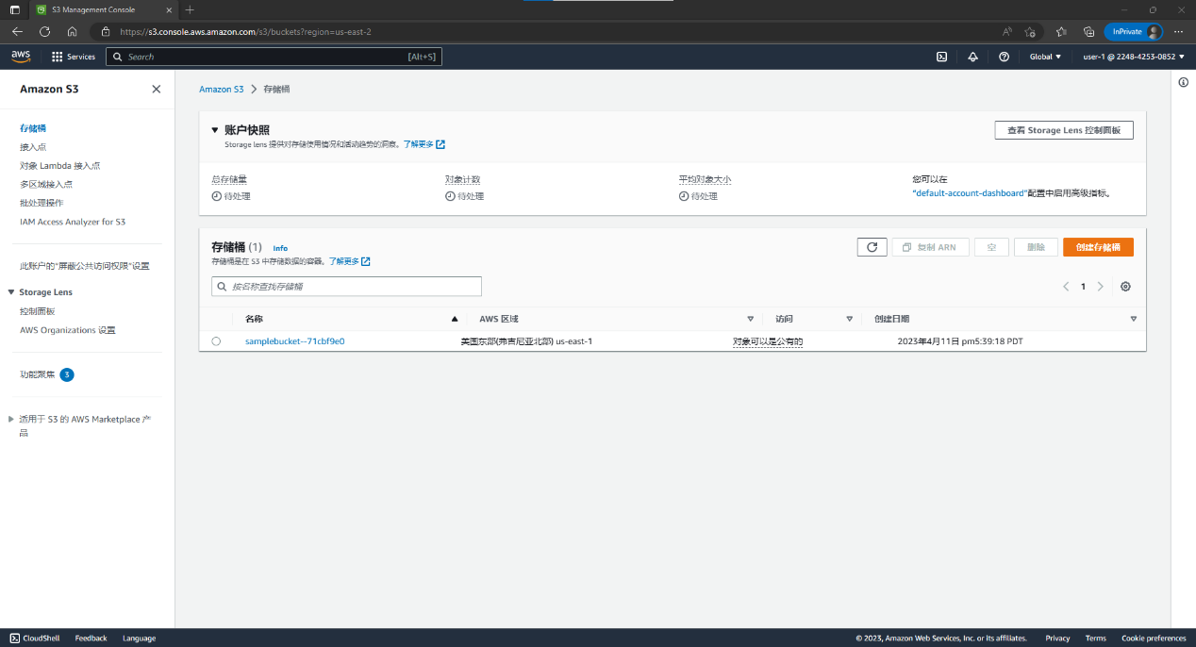

Try to manage instance and finding that no authorized~

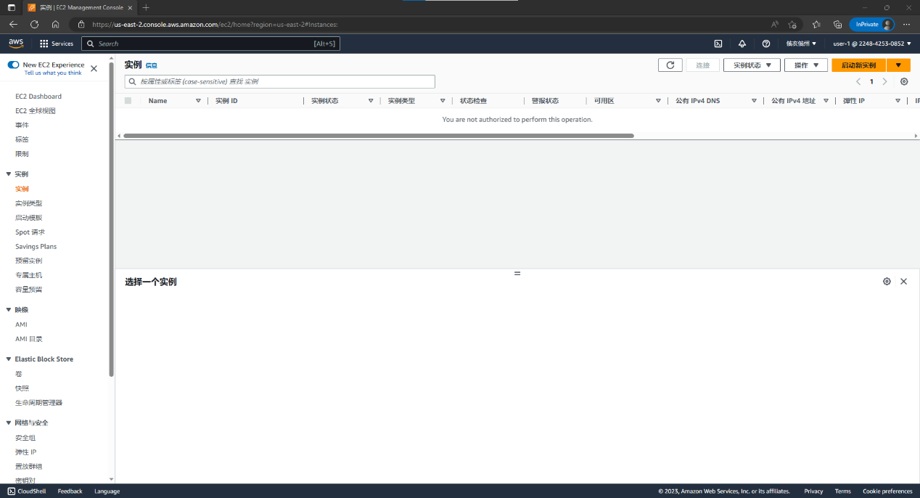

Switch to user 2

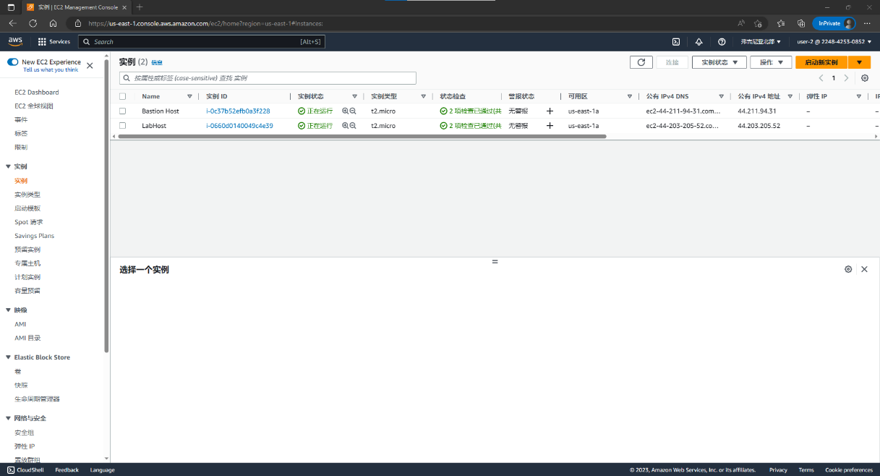

User 2 can see instances but can’t change anythings

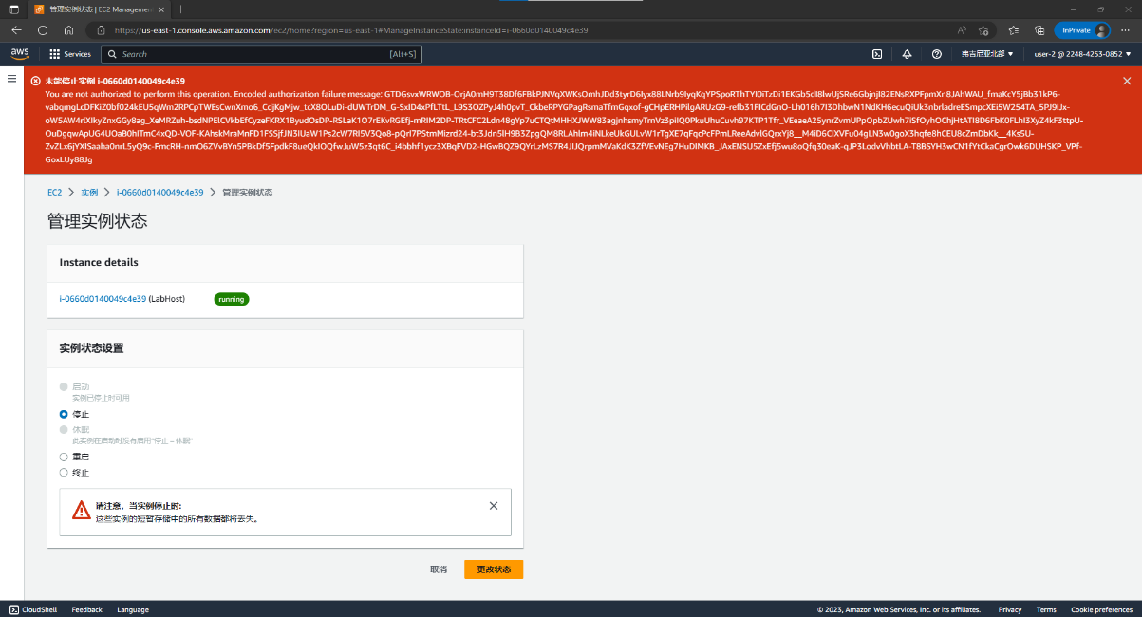

Switch to user 3

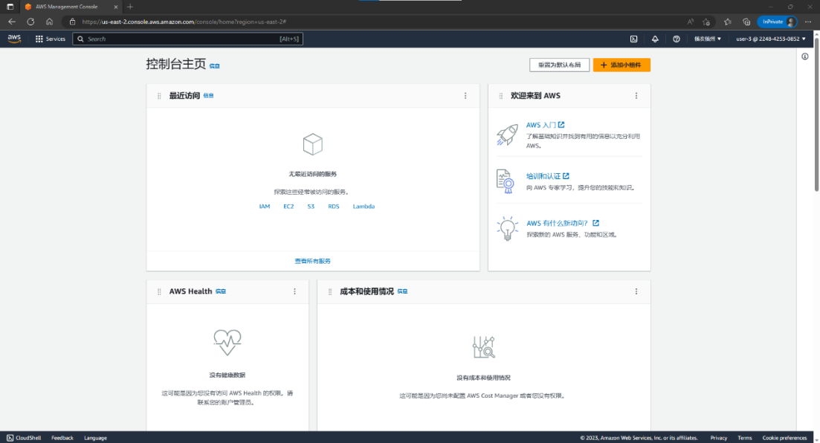

Finally stop the instance

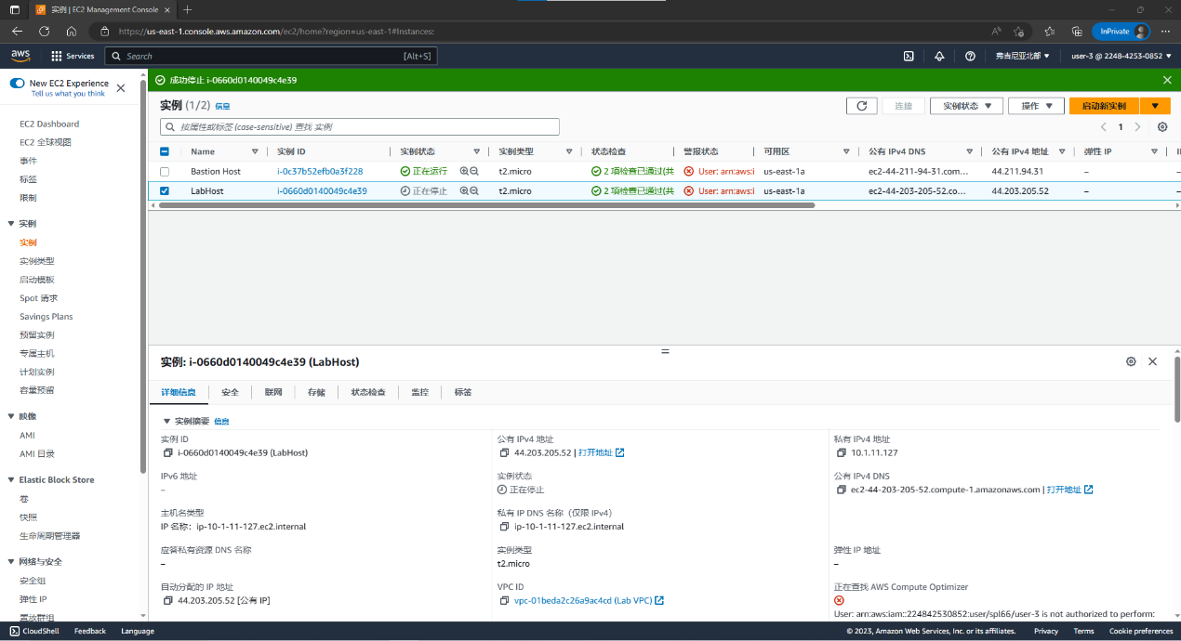

Lab 1 end~~

Lab 2

Create a VPC.

Create subnets.

Configure a security group.

Launch an EC2 instance into a VPC.

Check in

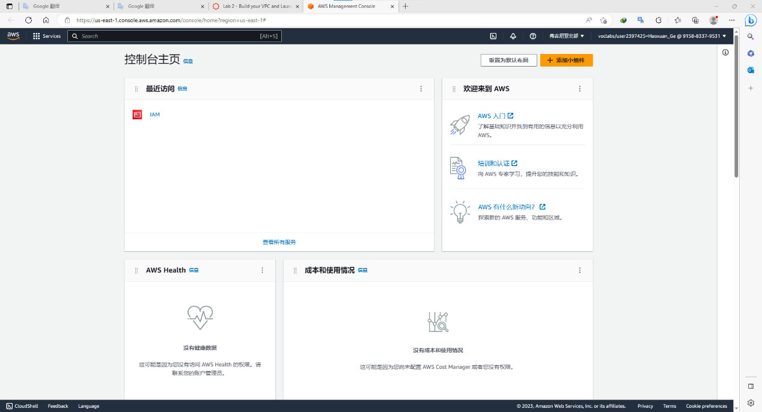

Create vpc

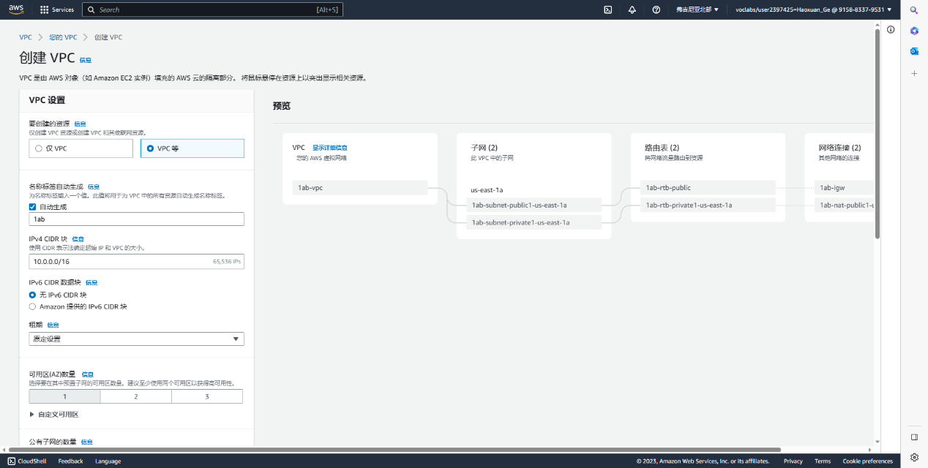

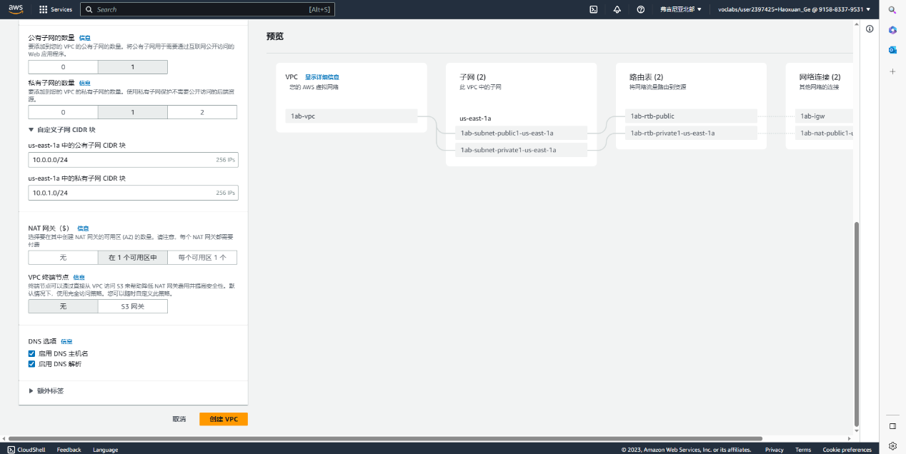

Creating…

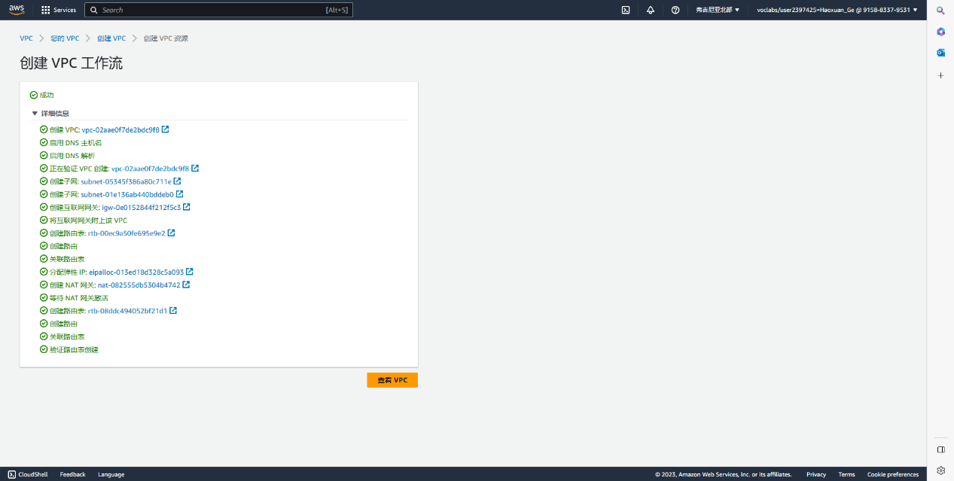

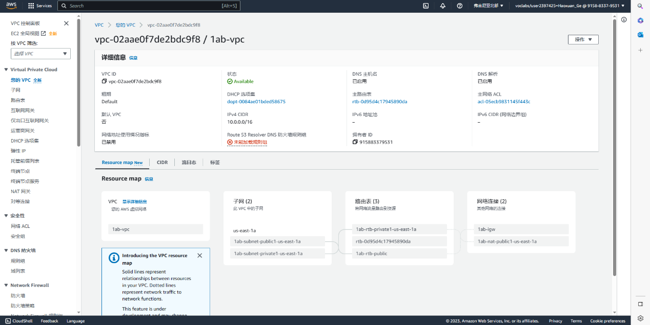

Check subnet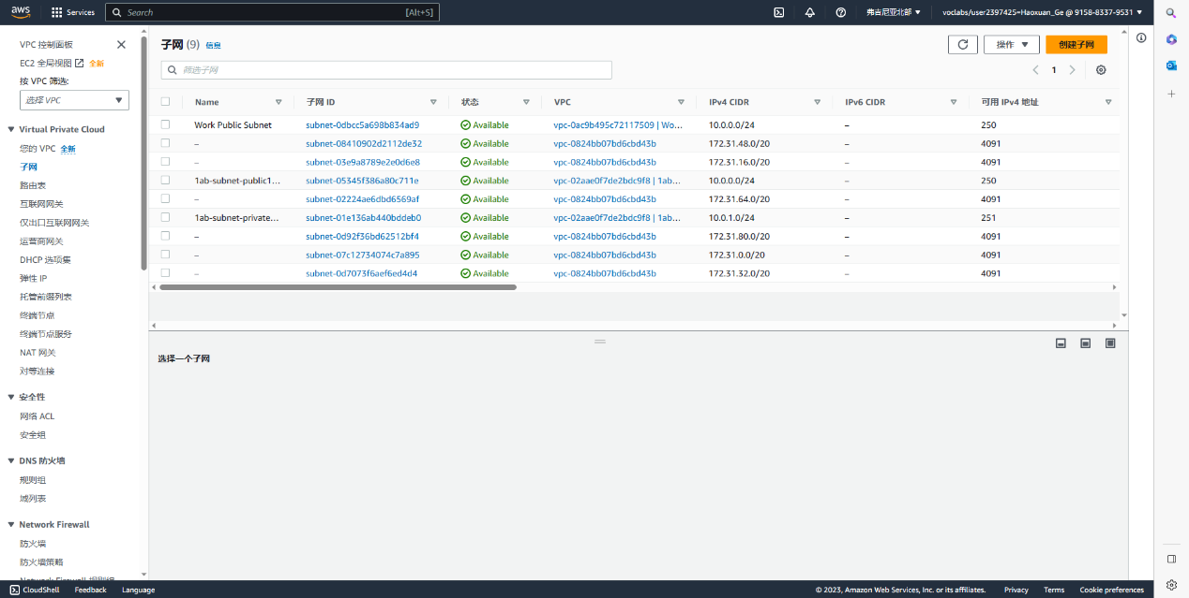

Create a new subnet

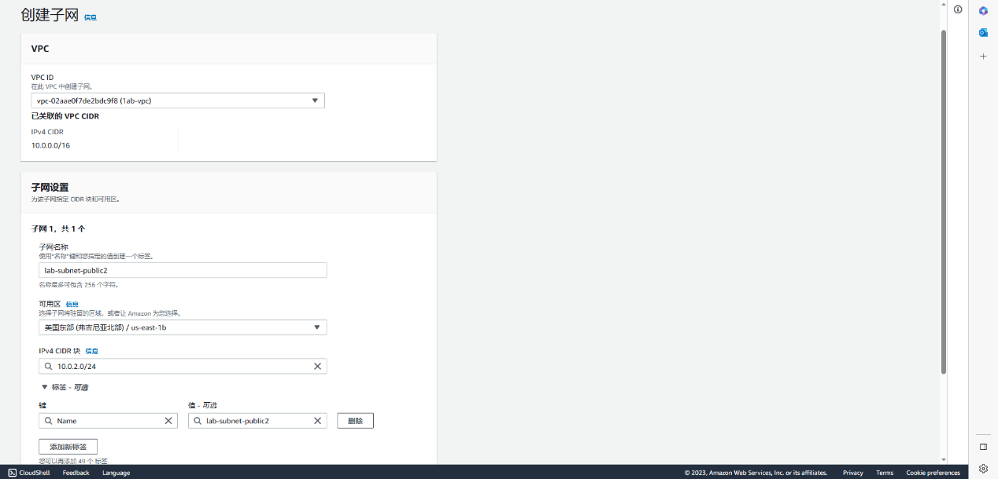

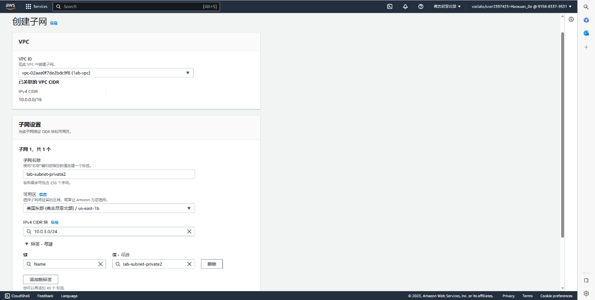

Check route table

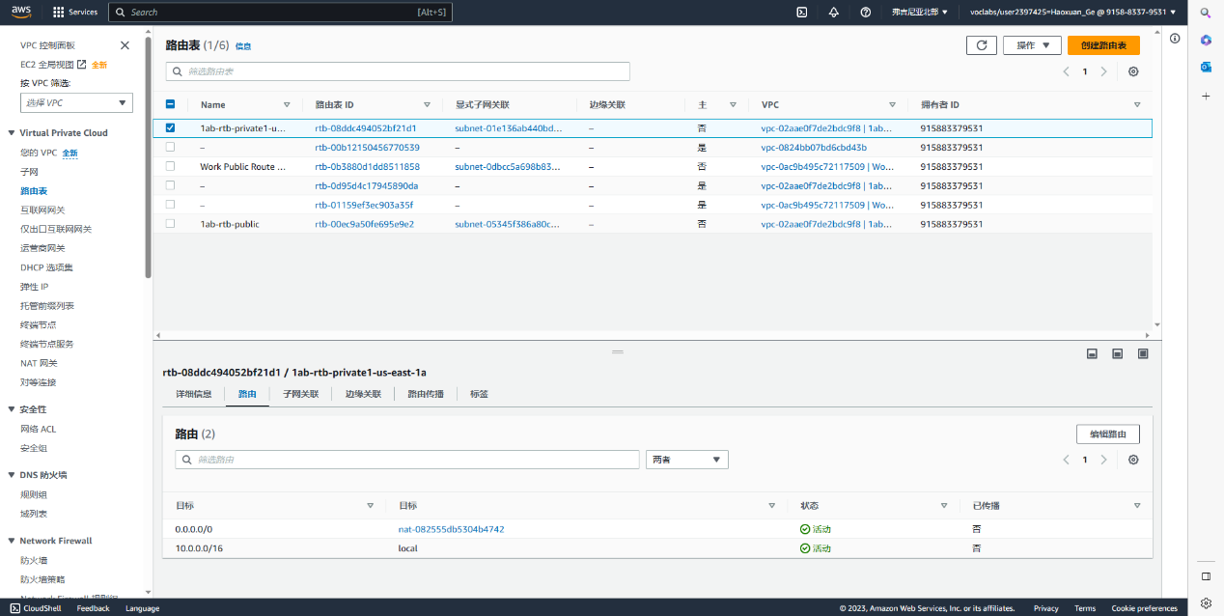

Edit subnet relationship: add 2 new just created subnet to the route table

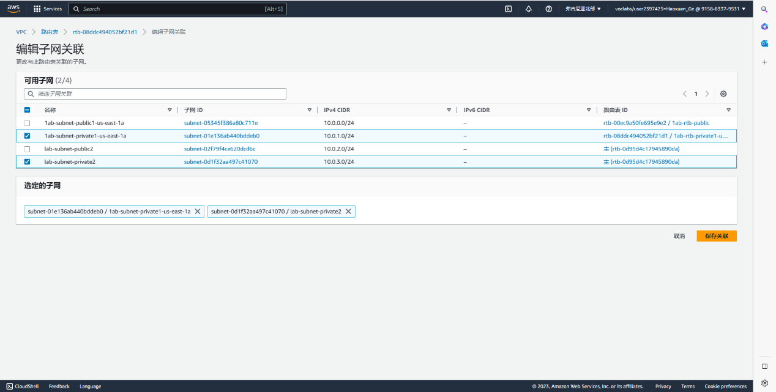

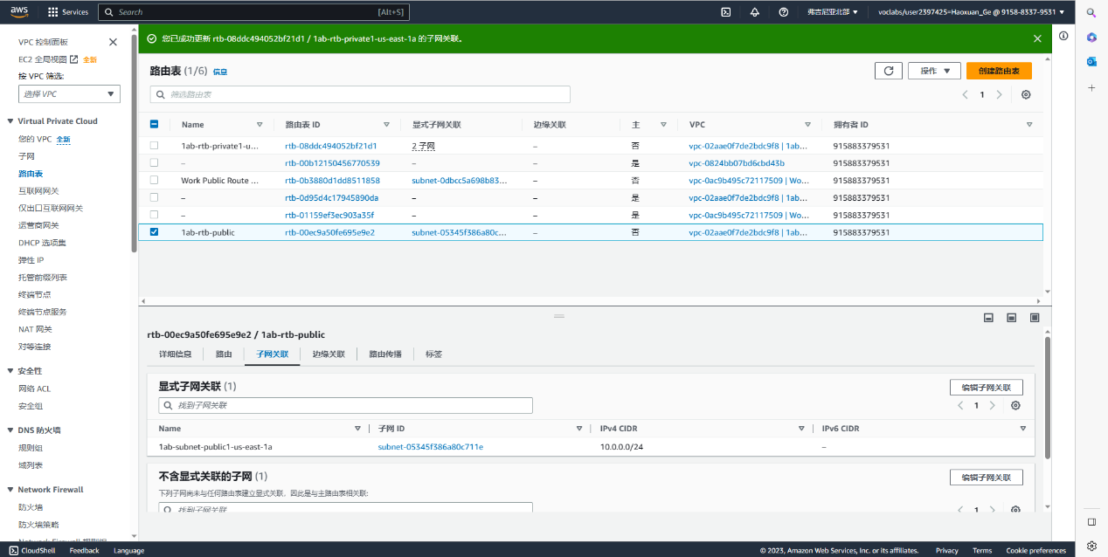

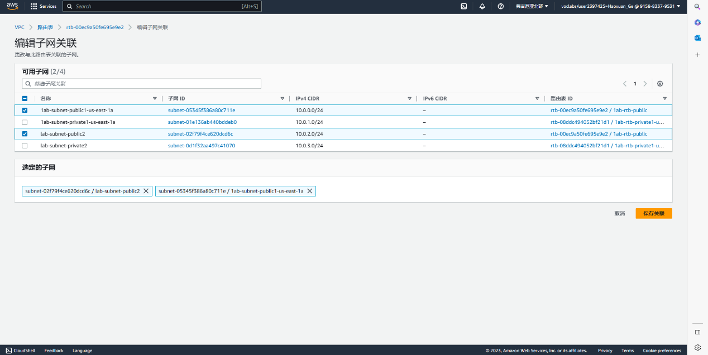

Check security group

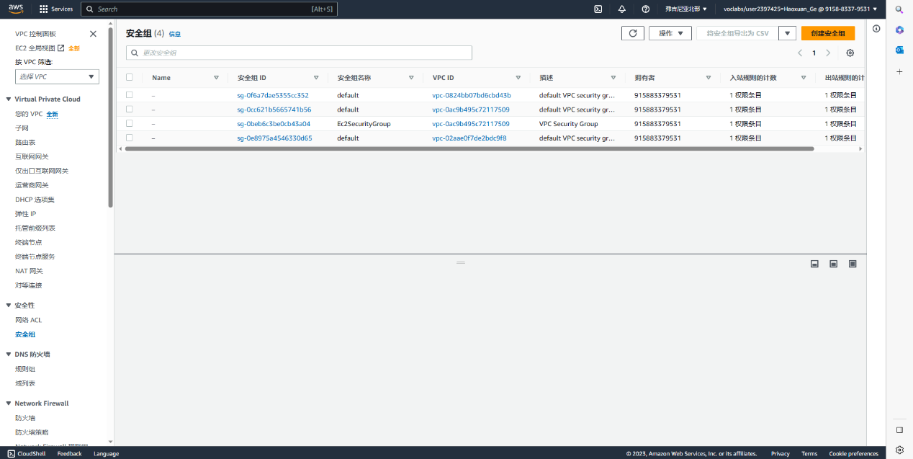

Create a new one~

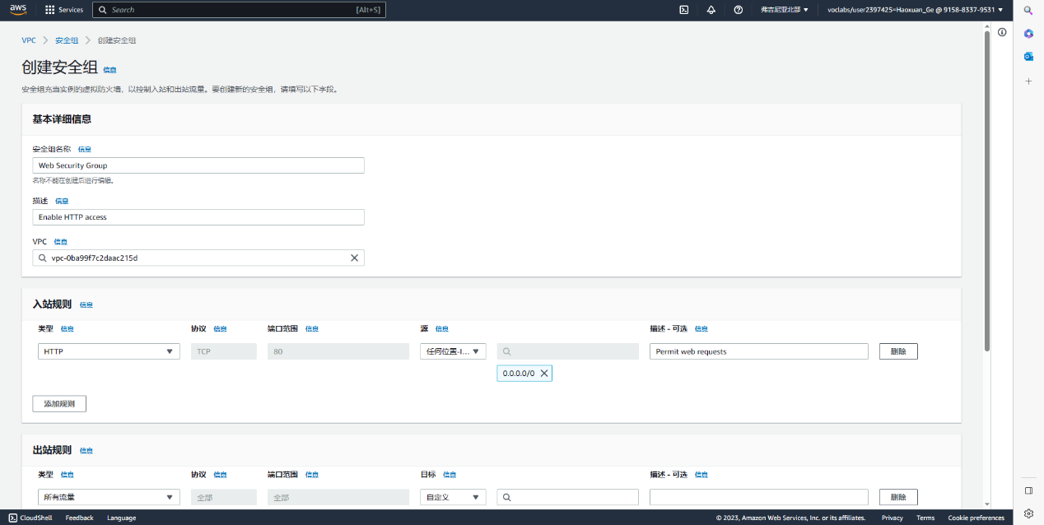

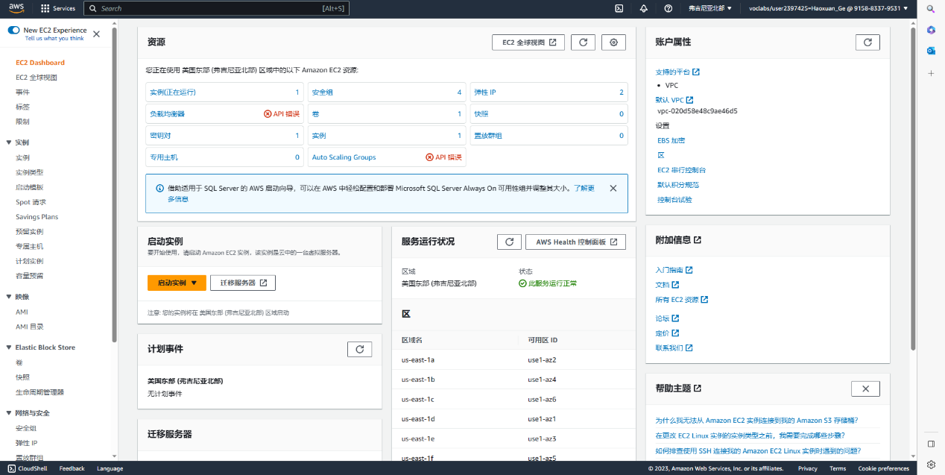

Launch instance(create a new one)

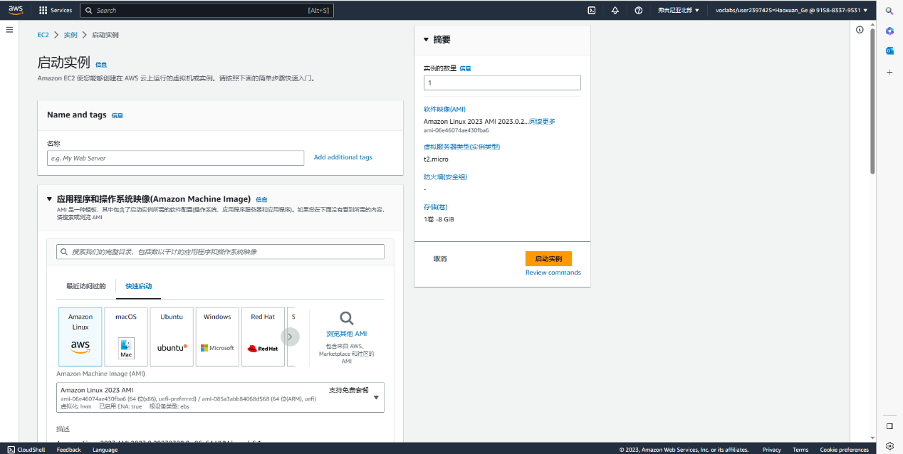

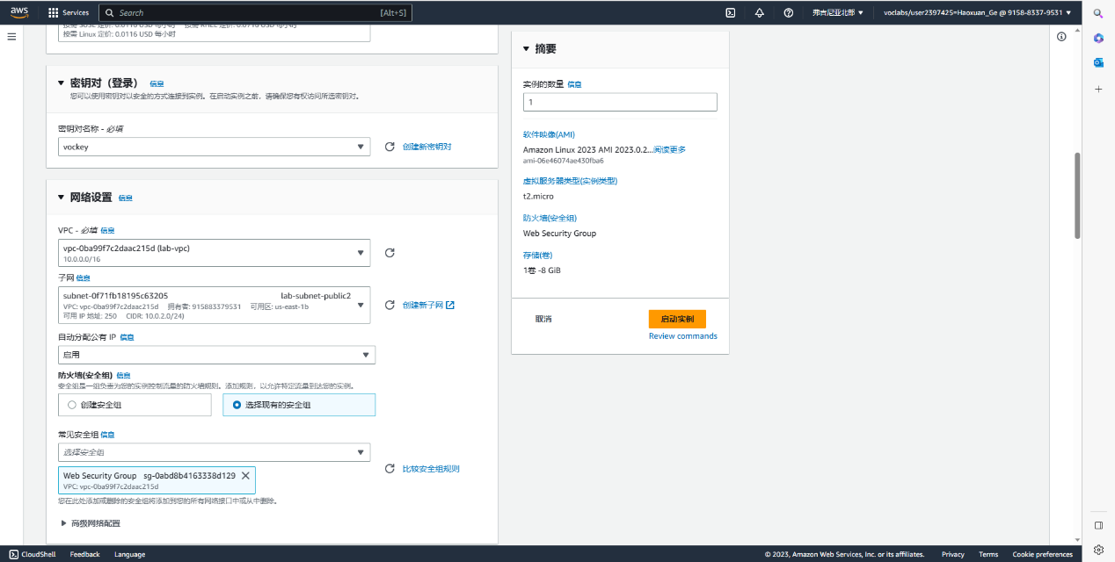

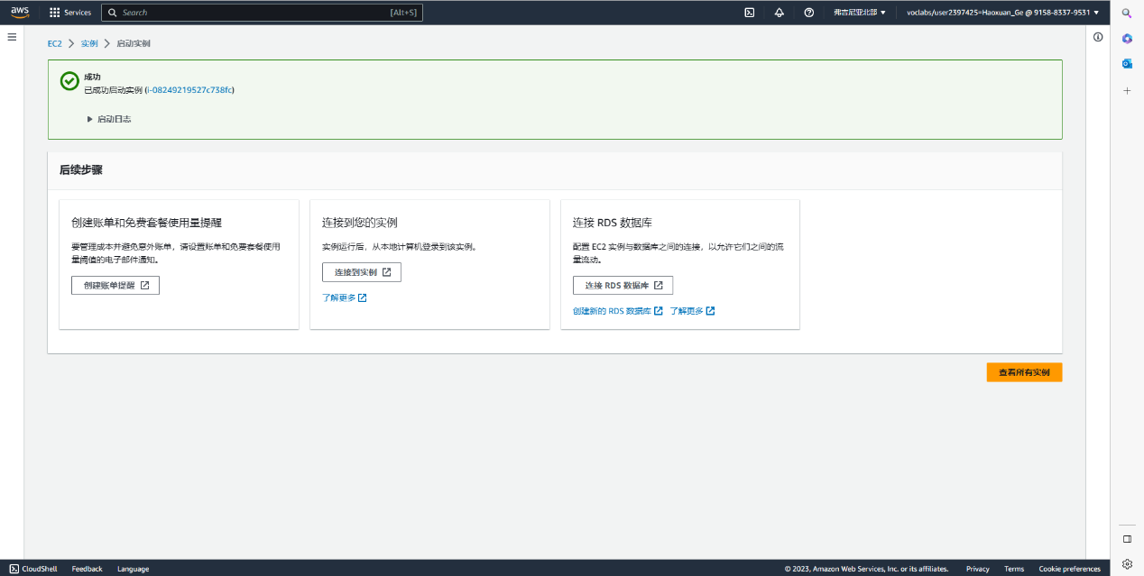

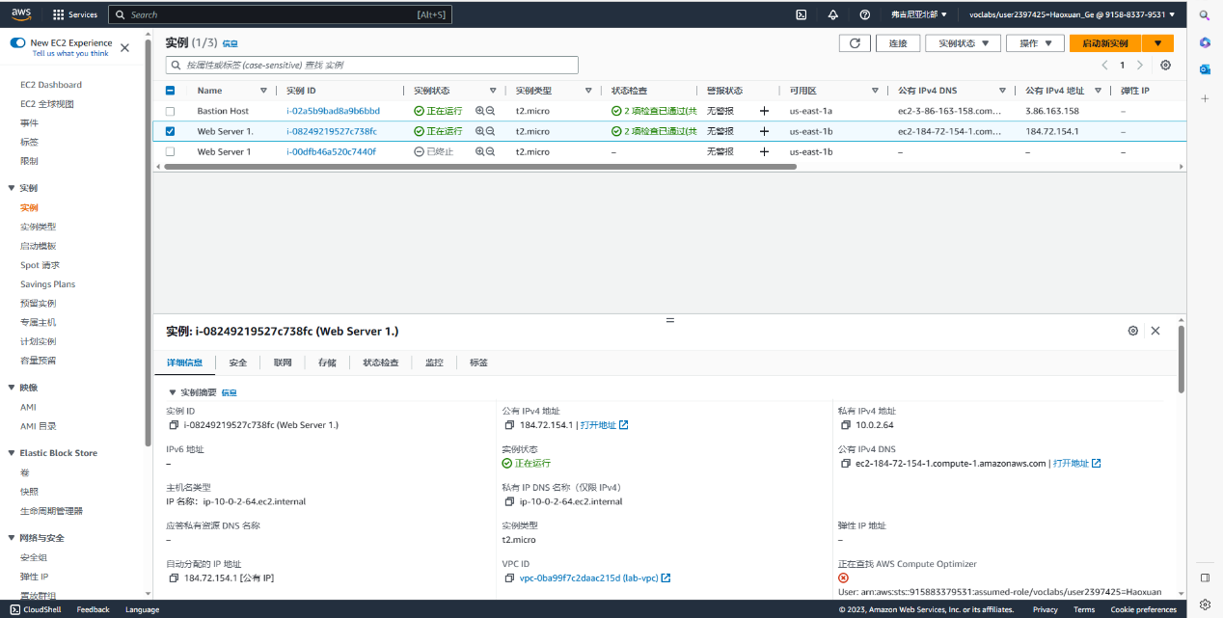

…, I don’t know why it not working though, they say it should be something like this:

And whenever I start the lab, everything getting reset

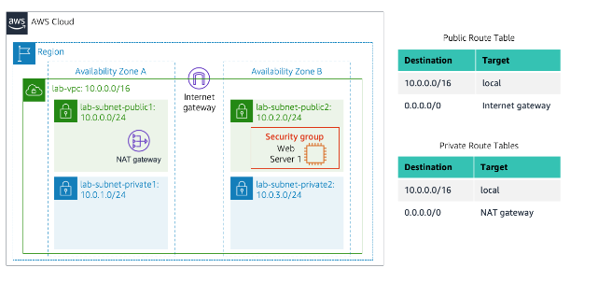

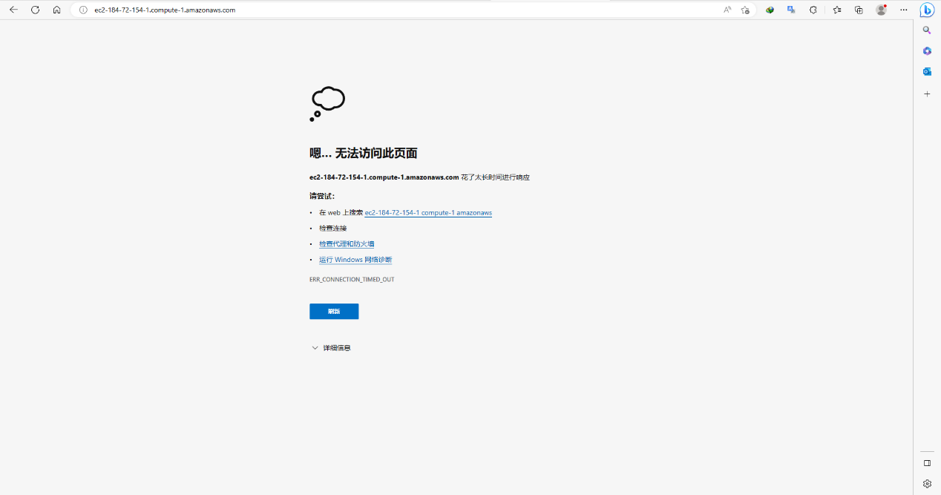

Lab 2 end

Lab 3

Launch a web server with termination protection enabled

Monitor Your EC2 instance

Modify the security group that your web server is using to allow HTTP access

Resize your Amazon EC2 instance to scale

Explore EC2 limits

Test termination protection

Terminate your EC2 instance

Check in

Create a new instance

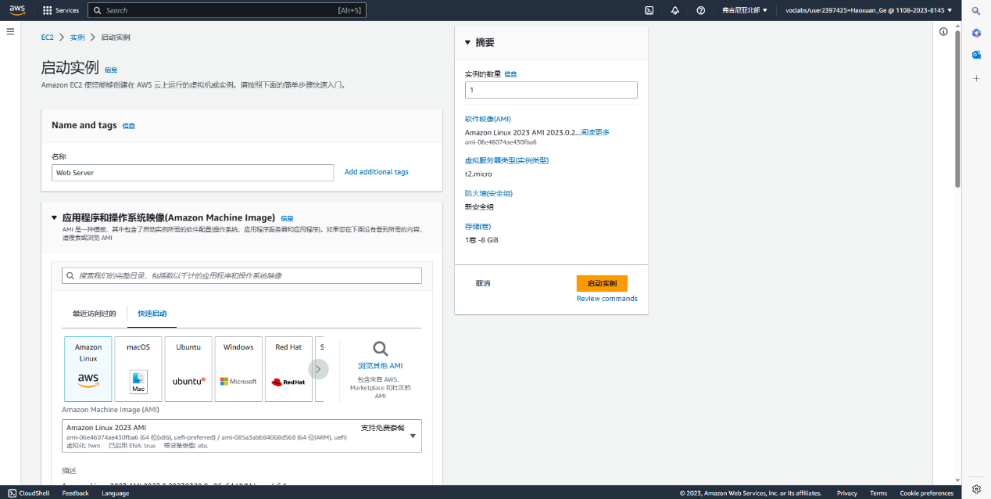

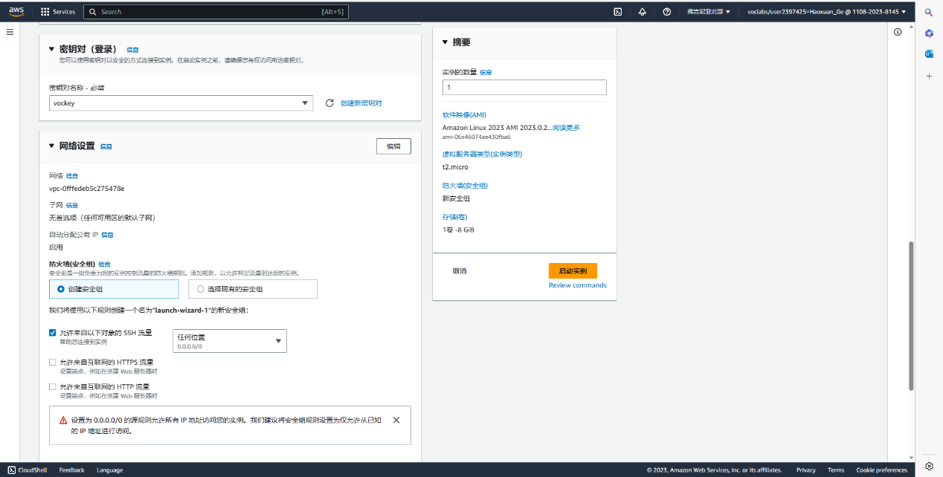

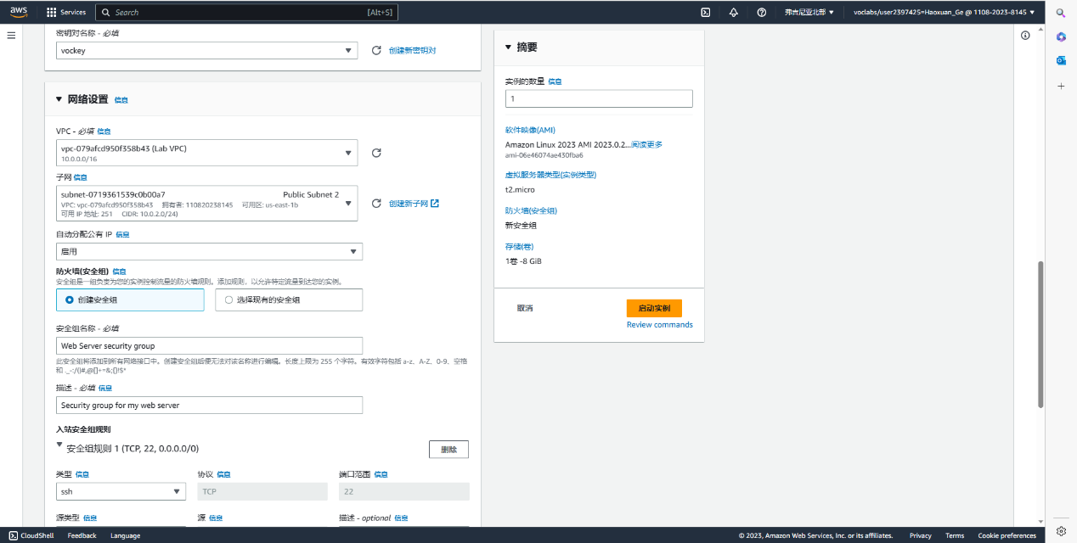

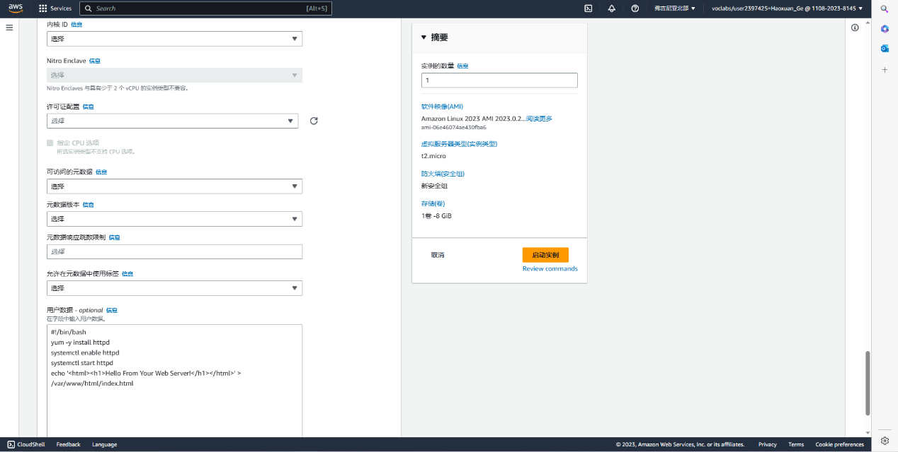

monitoring data

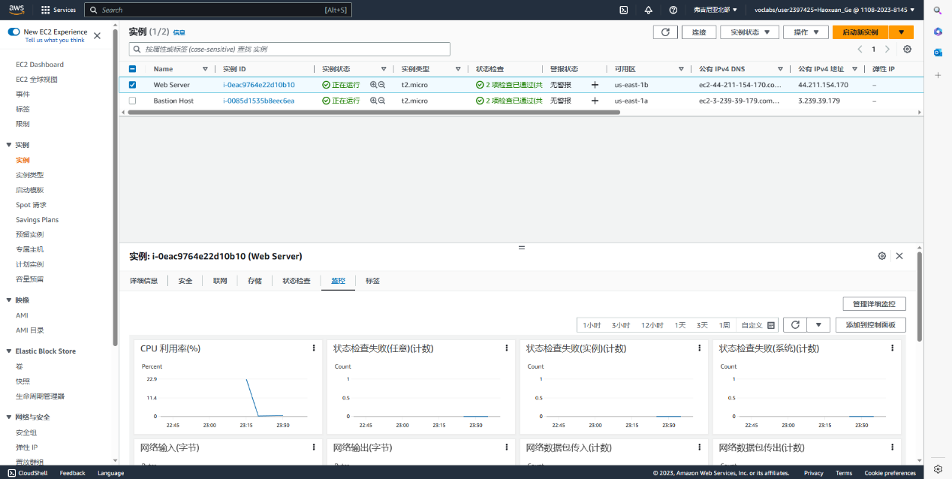

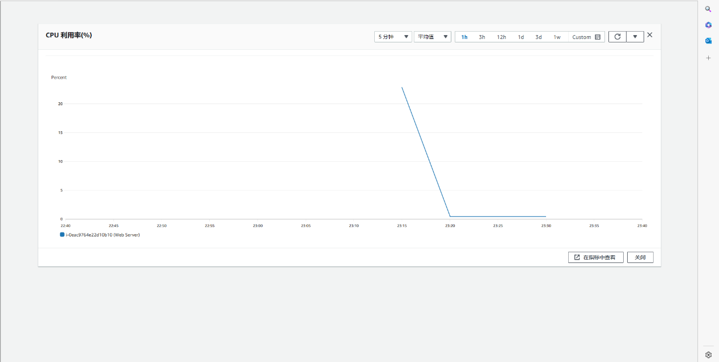

Get system log and instance screenshot

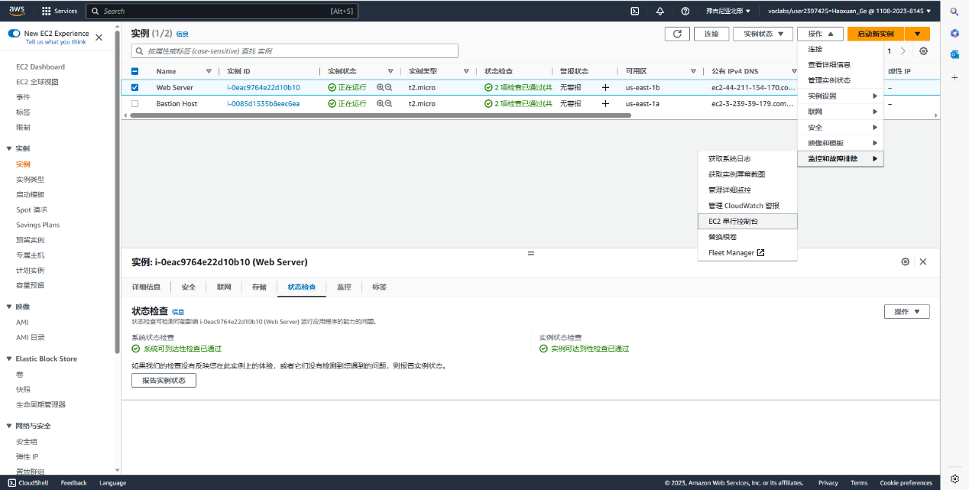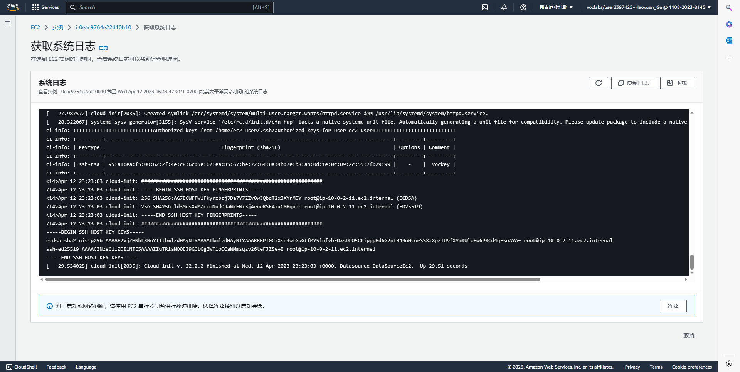

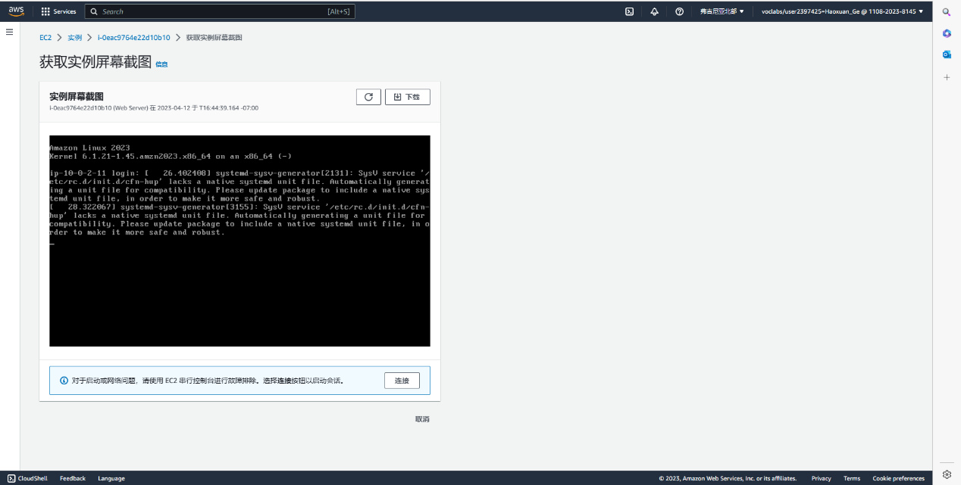

Fail to access the address, the reason is lack inbound rule

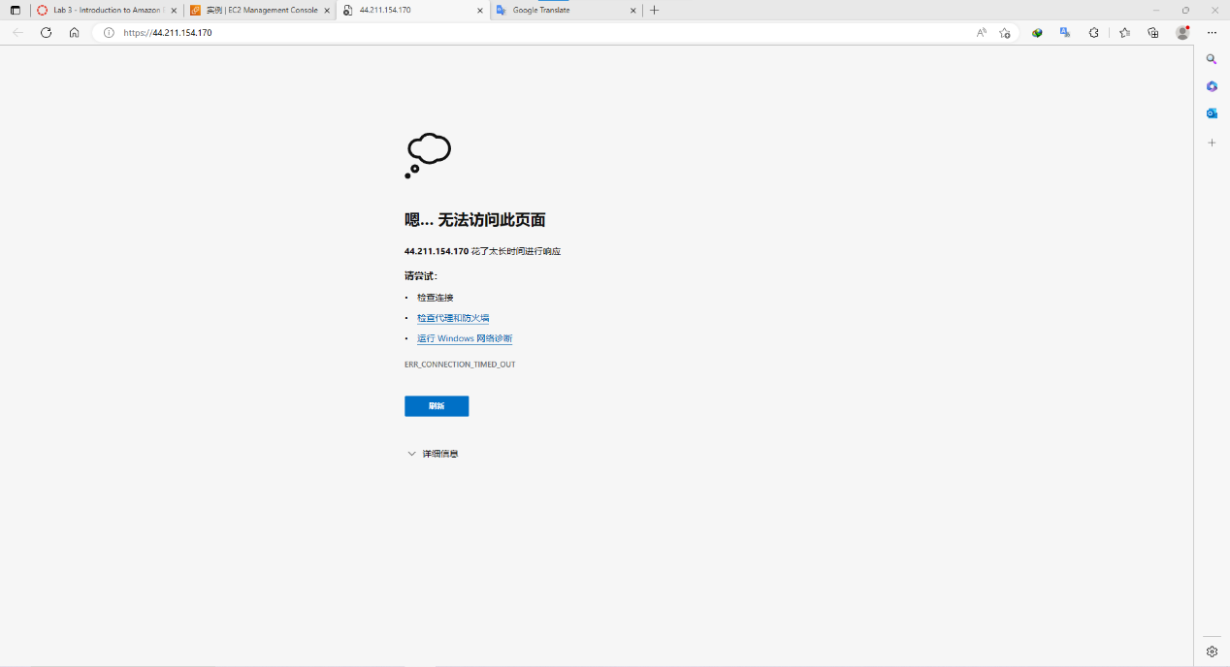

Create inbound rule

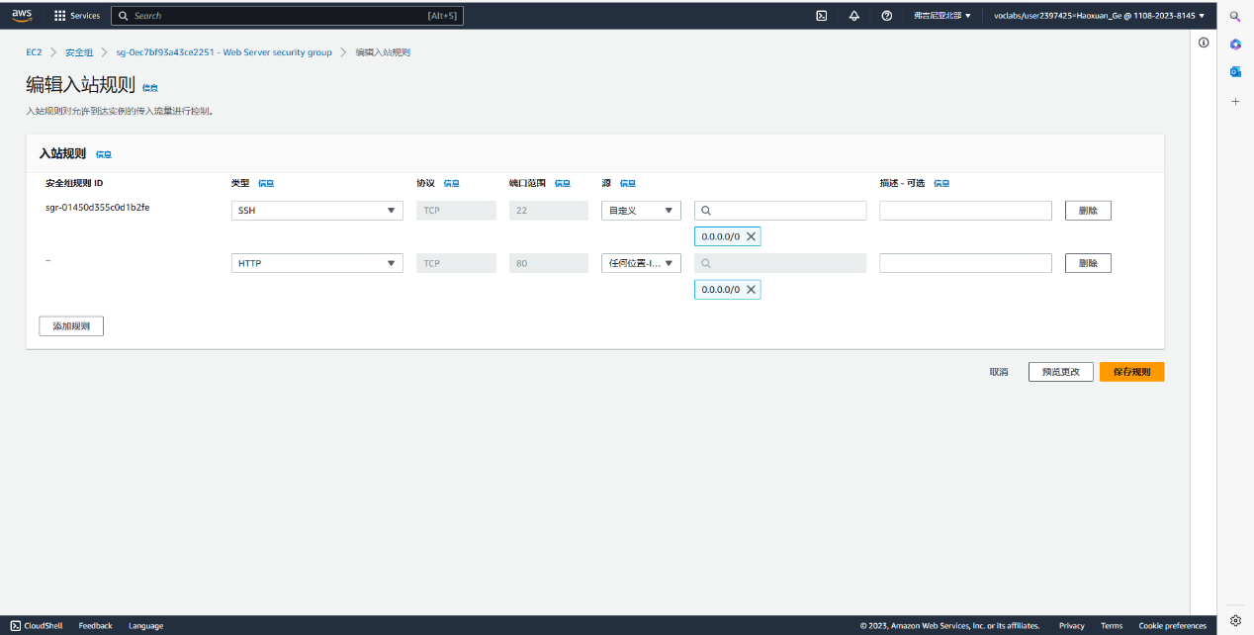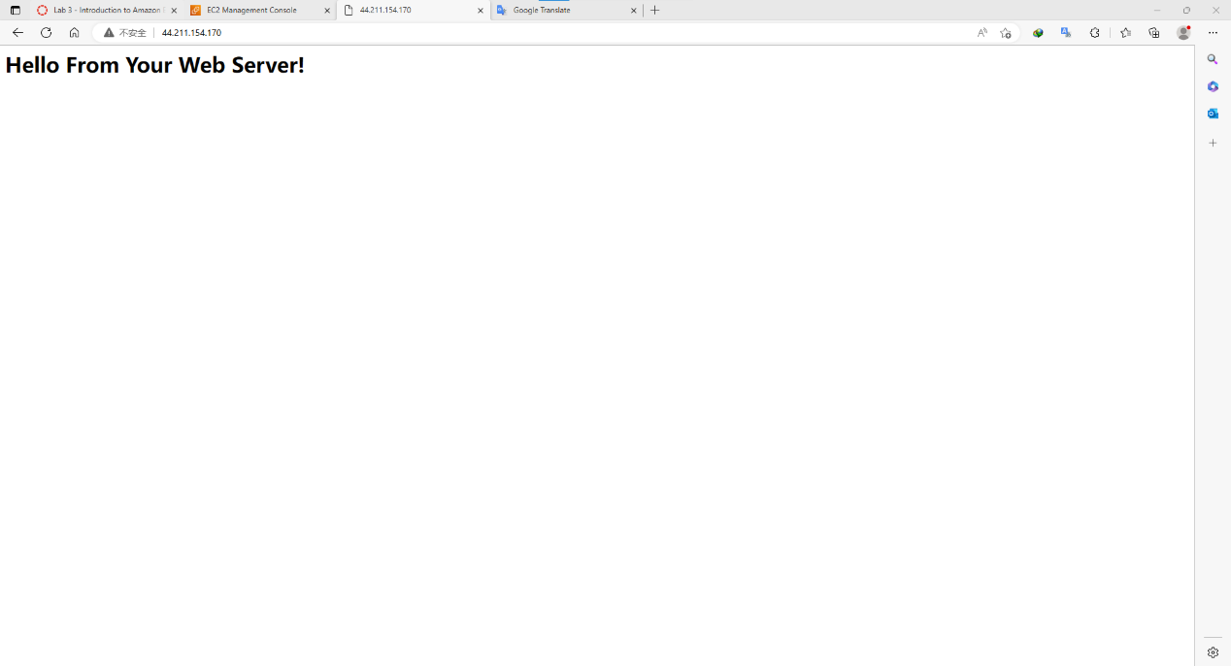

Stop the instance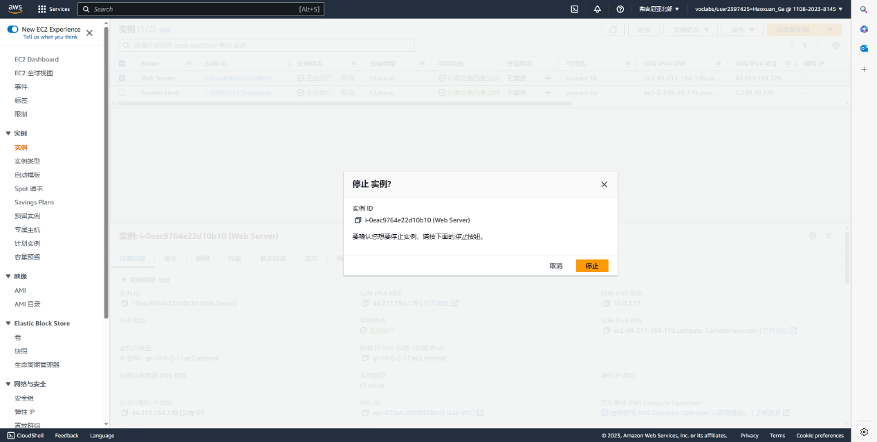

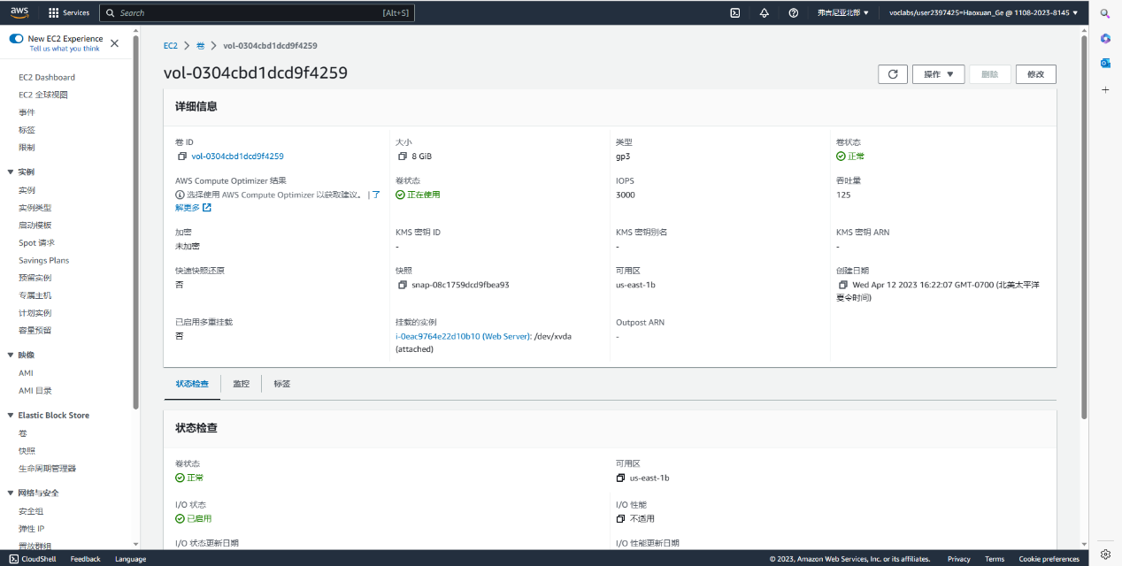

Resize the EBS Volume to 10gb

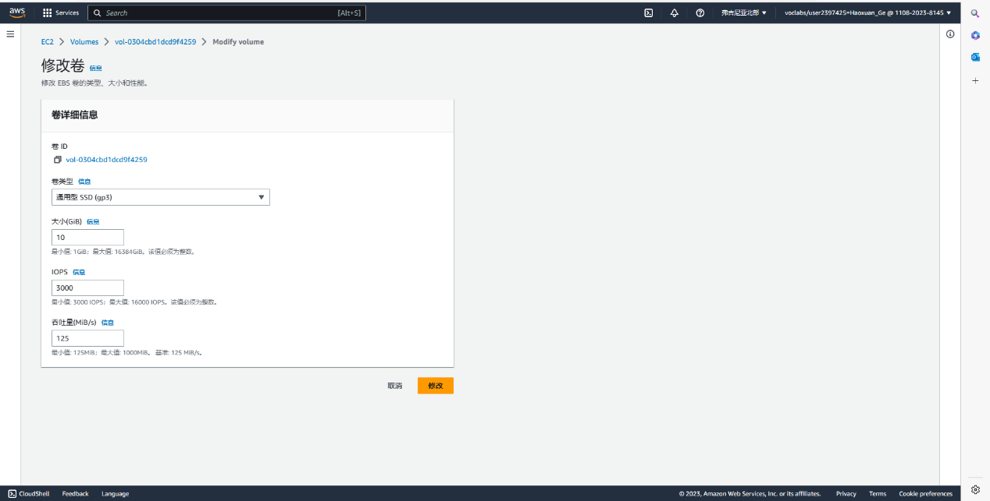

Launch instance again

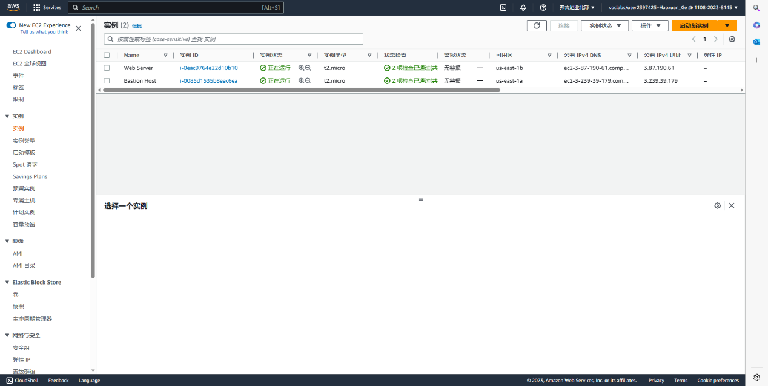

Check limit of Running instances.

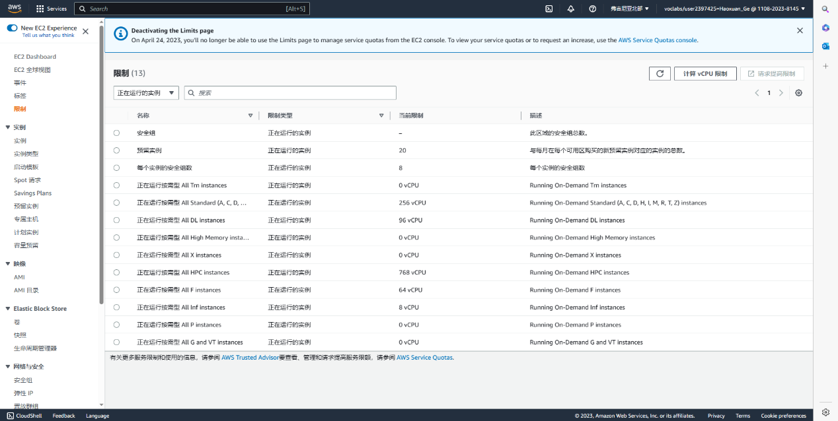

Try to terminate instance but failing

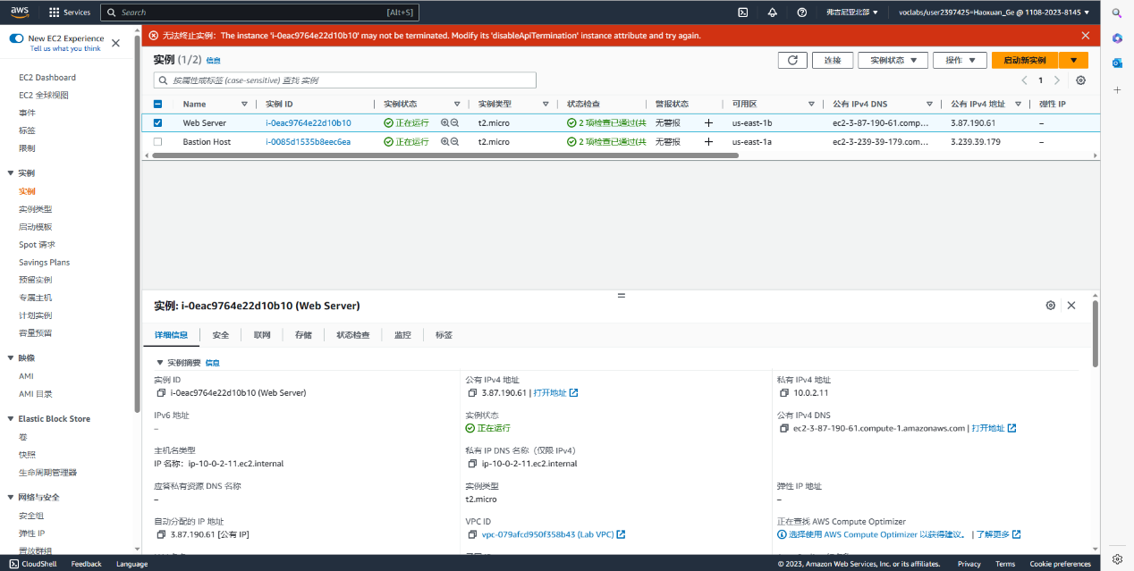

Disable the setting of Change termination protection.

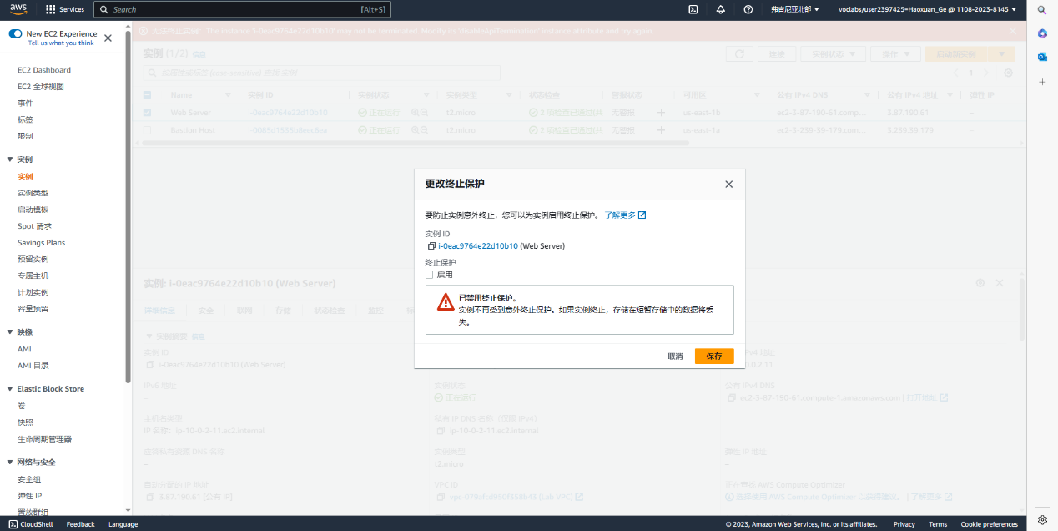

Successfully terminate instance

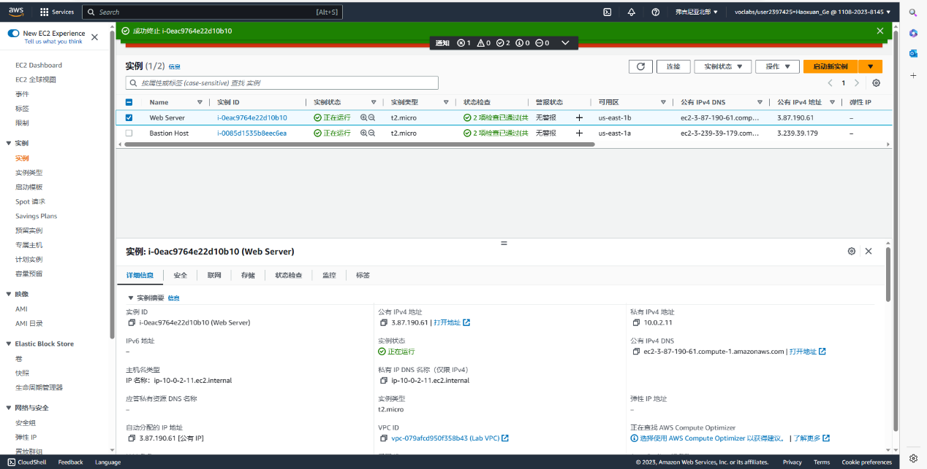

Lab 3 end

Problem:

In some cases, the restarted lab did not inherit the previous data due to time expiration

Copying the network address to the browser will automatically recognize the network protocol as https instead of the set http, which is I suspected to be the source of the problem in the last part of lab 2

AWS lab 4-6

Background:

Amazon Web Services, Inc. (AWS), a subsidiary of Amazon, provides on-demand cloud computing platforms and APIs to individuals, companies and governments on a pay-as-you-go basis.

Typically, customers use them in conjunction with autoscaling (a process that allows clients to use more compute when application usage is high and then scale down to reduce costs when traffic is low). These cloud web services offer a variety of services related to networking, compute, storage, middleware, IoT and other processing power, as well as software tools available through AWS server farms. This eliminates the need for customers to manage, scale and patch hardware and operating systems. One of these foundational services is Amazon Elastic Compute Cloud (EC2), which allows users to have a virtual cluster of computers with extremely high availability that can be interacted with via a REST API, CLI or AWS over the Internet Comfort. AWS' virtual computers emulate most of the attributes of real computers, including hardware central processing units (CPUs) and graphics processors (GPUs) for processing; local/RAM memory; hard drive/SSD storage; choice of operating systems; networking; and pre-loaded applications such as Web servers, databases, and customer relationship management (CRM).

AWS offers a wide range of cloud computing products and services, with more than 200 offerings across computing, storage, databases, analytics, networking, mobile, development tools, management, IoT, security, and enterprise applications. AWS also has a global presence, with data centers located in multiple regions worldwide. This allows customers to host their applications and data closer to their end-users, resulting in lower latency and better performance.

AWS also provide Flexibility, Reliability, and Security service

EBS, known as Elastic Block Store, is a high-performance, persistent block storage service provided by Amazon Web Services (AWS). Designed for use with Amazon Elastic Compute Cloud (EC2) instances, it provides block-level storage volumes for use with EC2 instances. EBS volumes are highly available, persistent, and can be attached to a single EC2 instance at a time. They are ideal for storing data that requires frequent access and low latency, such as transactional databases, applications, and log files. EBS also offers different types of storage options to meet different performance and cost requirements.

A database server is a computer program that provides database services to other programs or computers. It is a special type of server designed to store and manage databases, which are organized collections of data. Database servers can store data in a variety of formats and structures, such as tables, graphs, or trees, and it can be used to store data for a wide range of applications, such as websites, financial systems, or inventory management systems. Some popular database servers include Microsoft SQL Server, Oracle Database, MySQL, and PostgreSQL.

Architecture in cloud services refers to the design and organization of computing resources and infrastructure to support a specific application or workload in the cloud. It involves the use of various cloud computing technologies and services to create a reliable, scalable and cost-effective environment to host applications and data.

Steps:

Lab 4:

Create an Amazon EBS volume

Attach and mount your volume to an EC2 instance

Create a snapshot of your volume

Create a new volume from your snapshot

Attach and mount the new volume to your EC2 instance

Check in

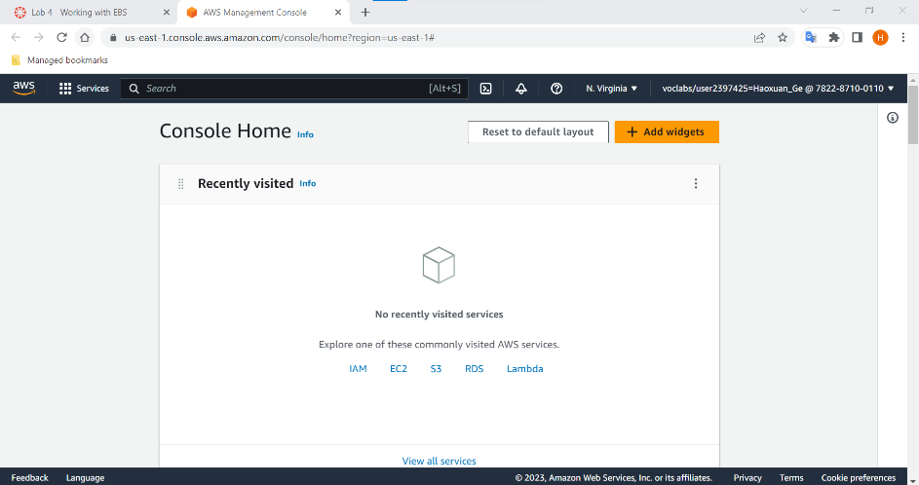

Enter instance

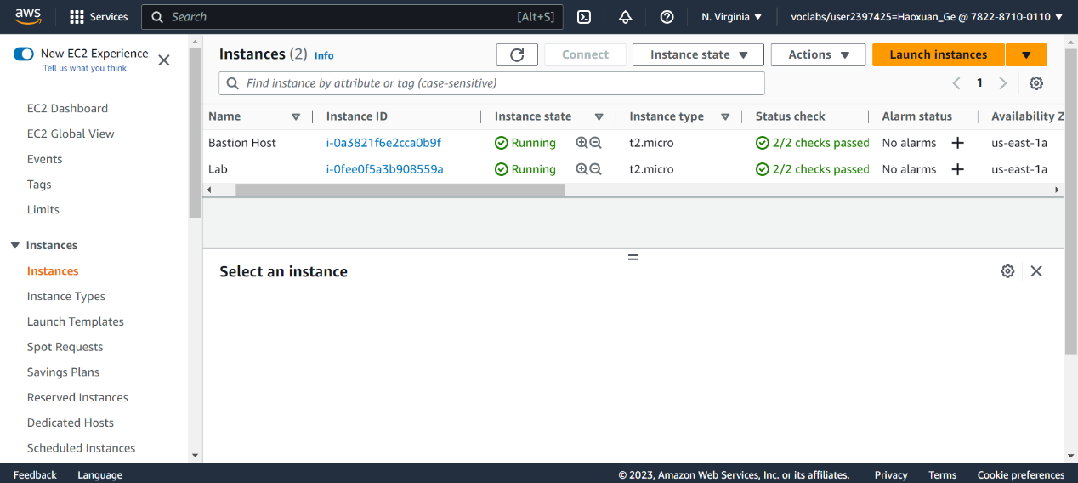

Enter volume

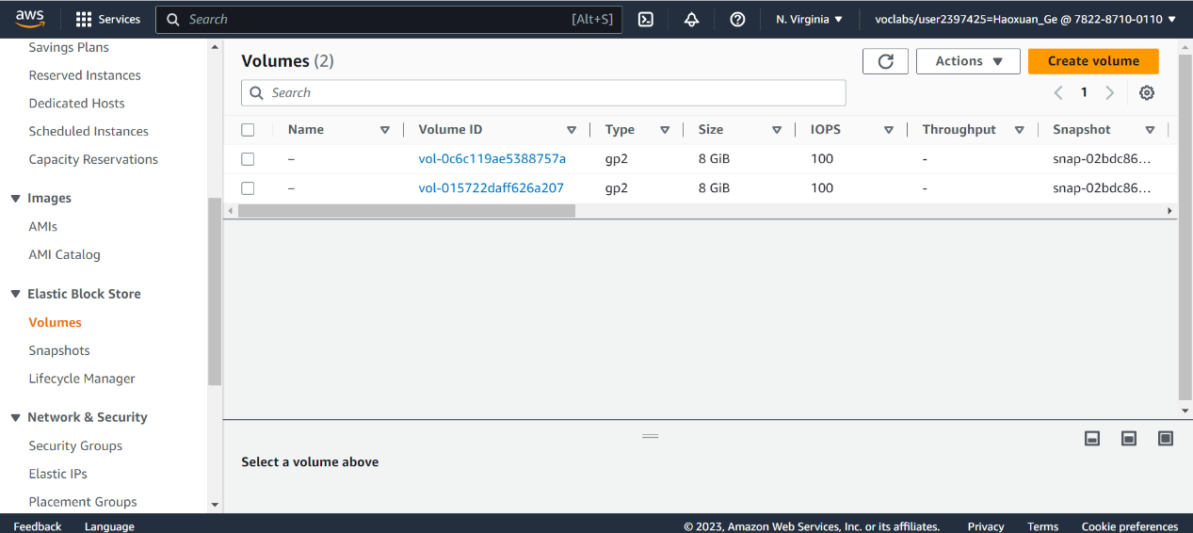create a new one

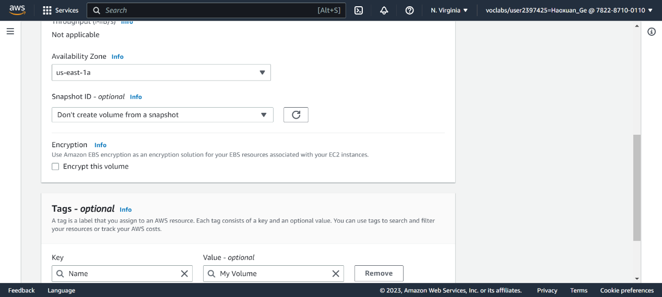attach it

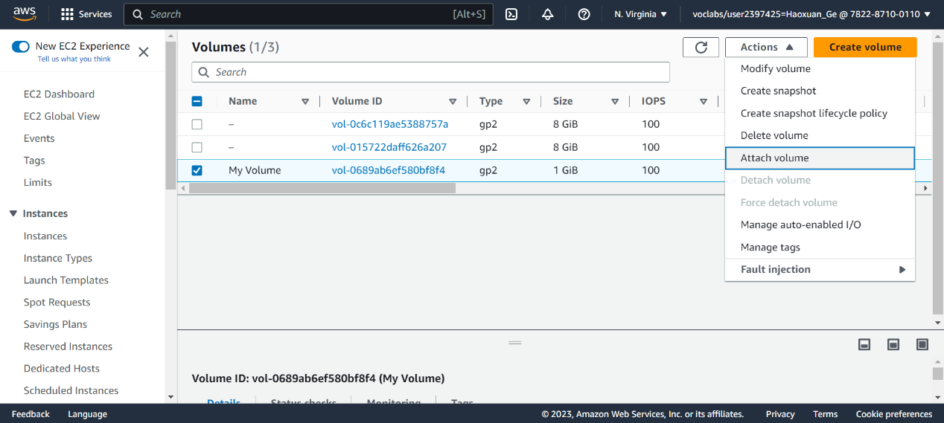 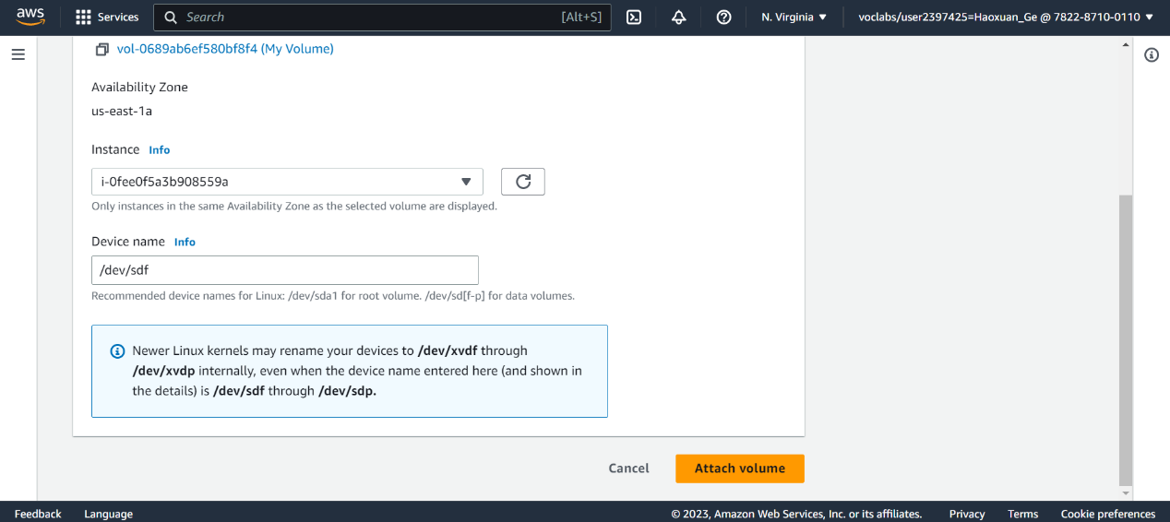

Download ppk in detail in lab detail…(no image)

District laptop can’t download putty…anyway, download the putty <https://the.earth.li/~sgtatham/putty/latest/w64/putty.exe>

Copy instance public address

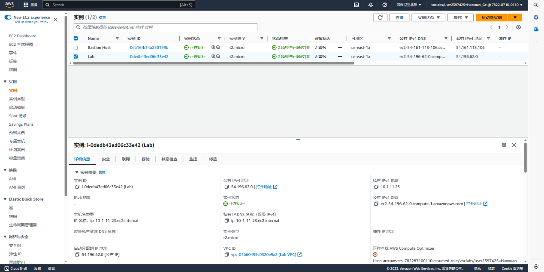

Enter the ppk in putty just downloaded

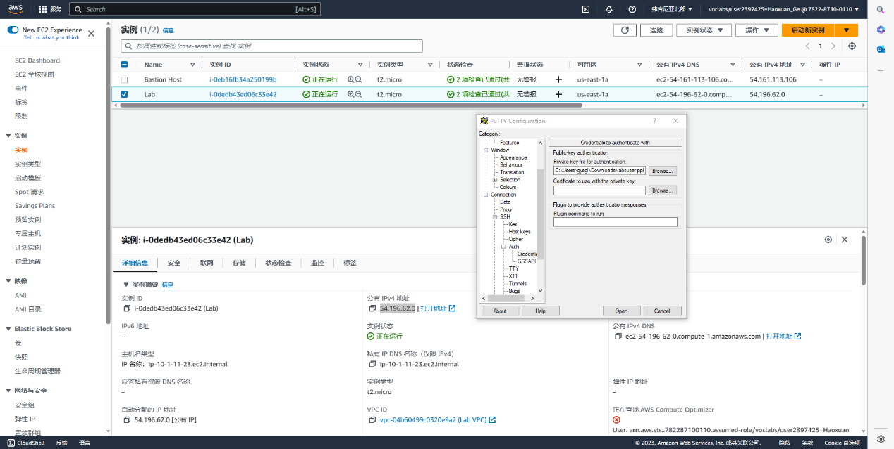

It seems works, instances is here and also create several things(ext3 file system…)

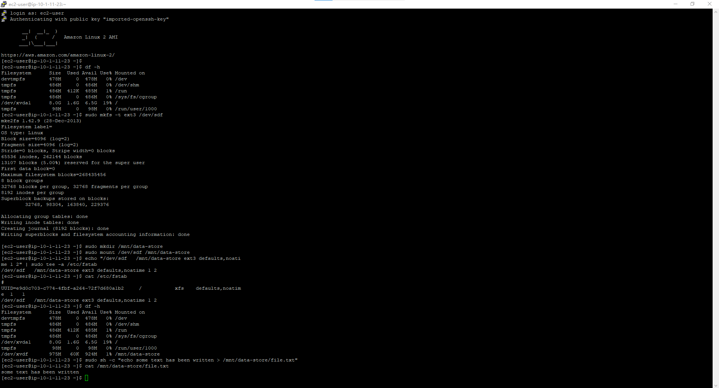

Create snapshot

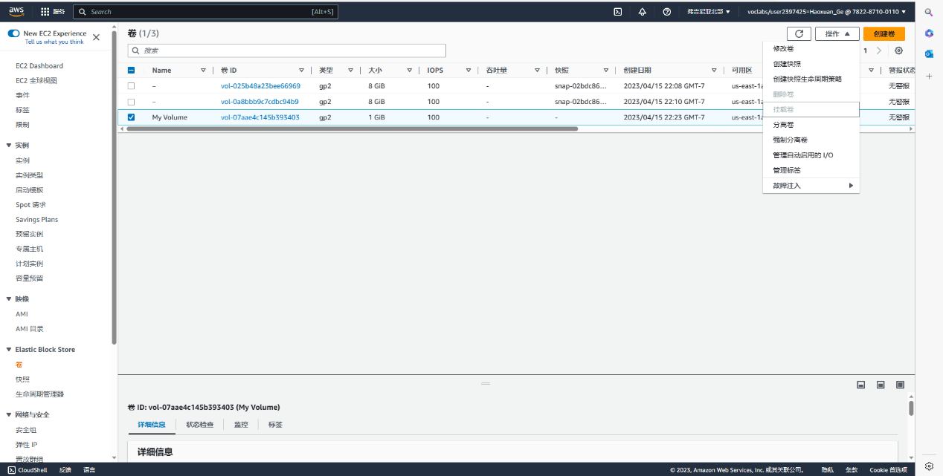

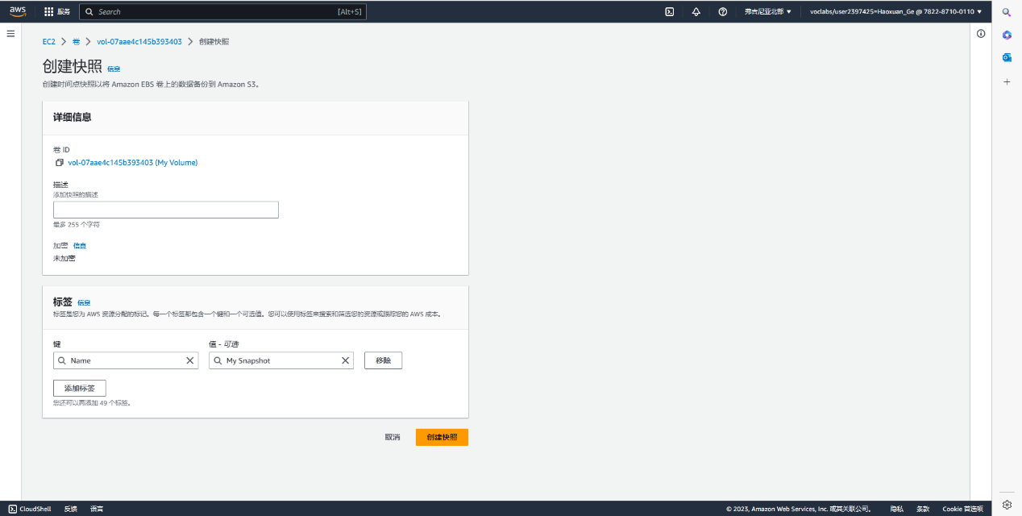

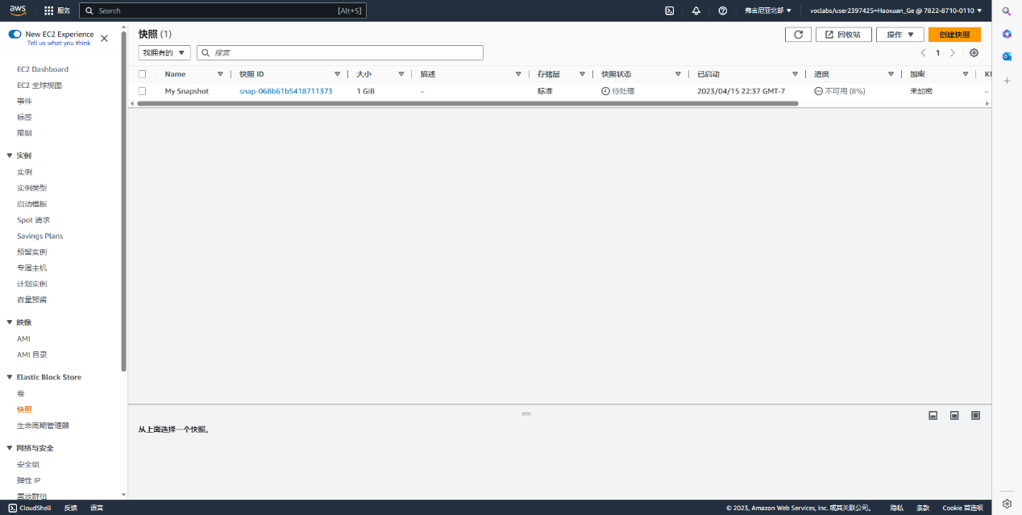

Create volume from snapshot.

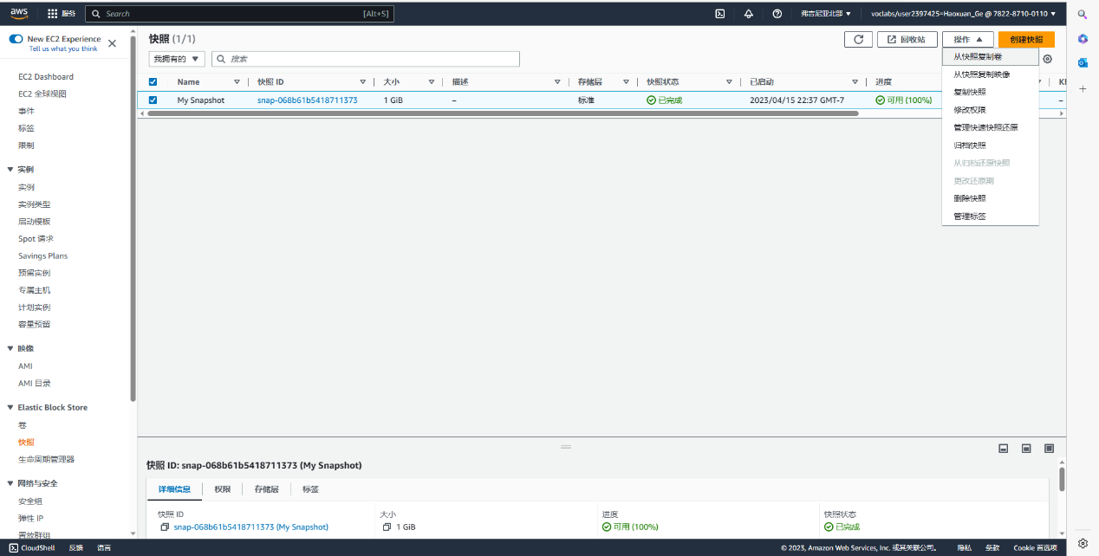 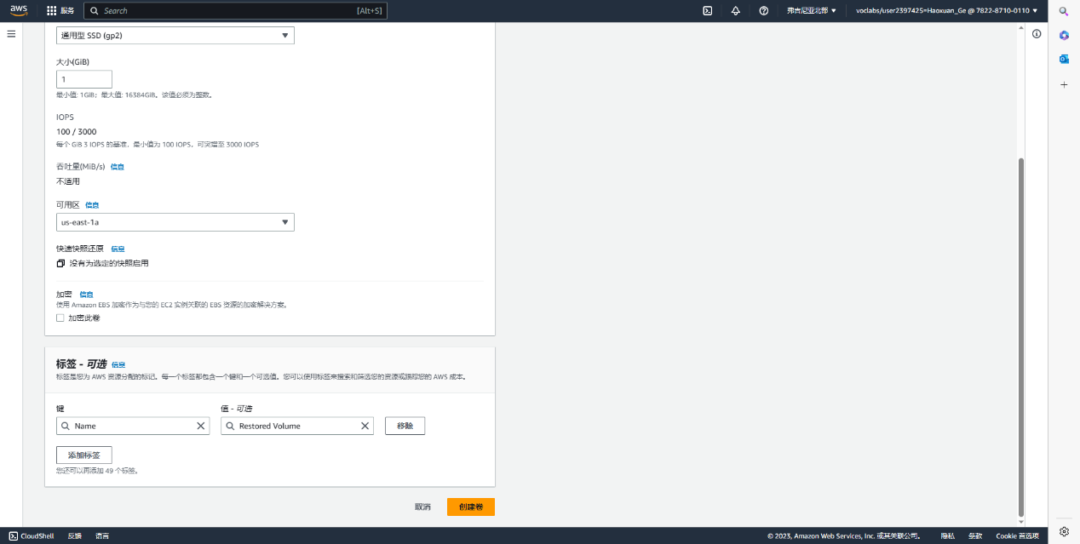

Attach it

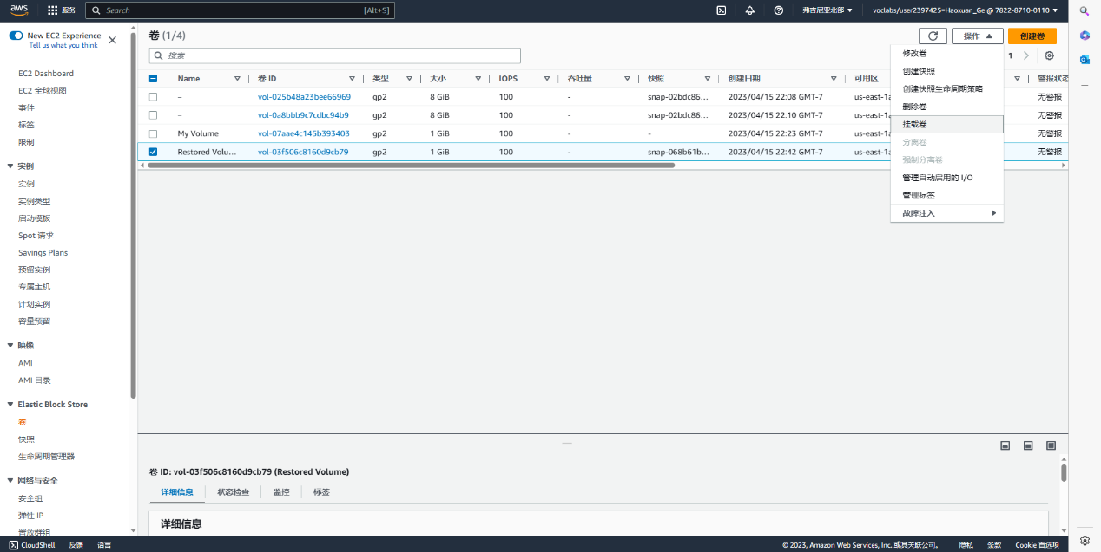

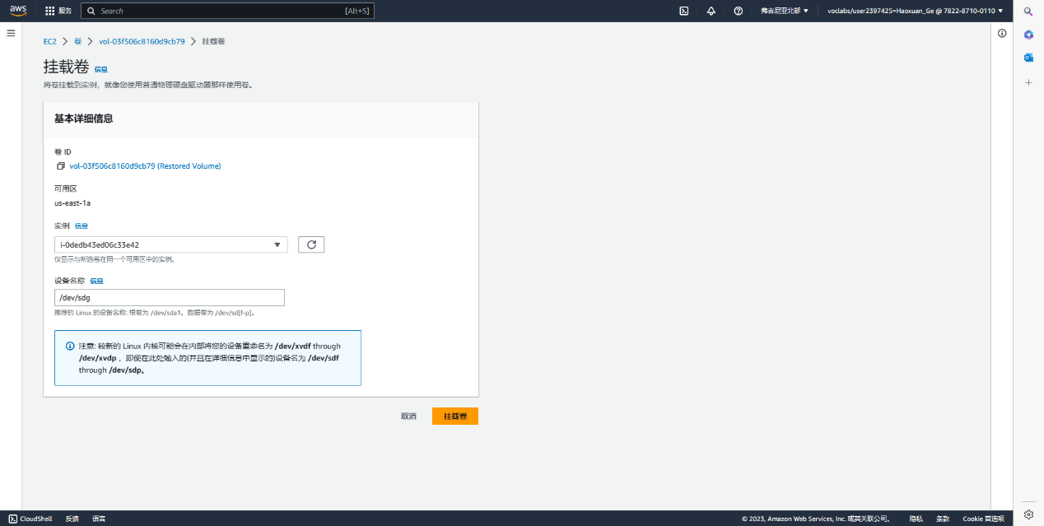

It works, successfully verify that volume you mounted has the file that created earlier

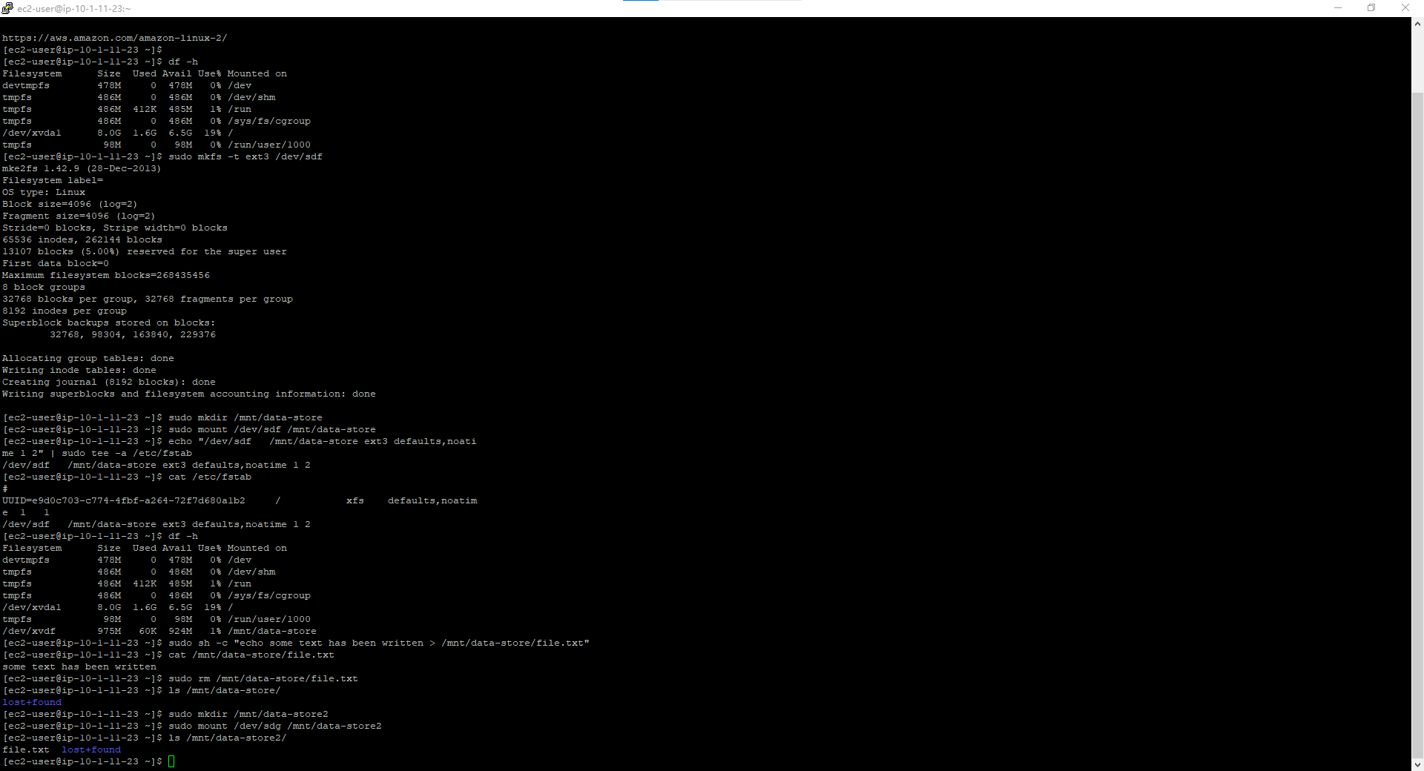

Lab 4 end ~

Lab 5:

Launch an Amazon RDS DB instance with high availability.

Configure the DB instance to permit connections from your web server.

Open a web application and interact with your database.

Enter vpc

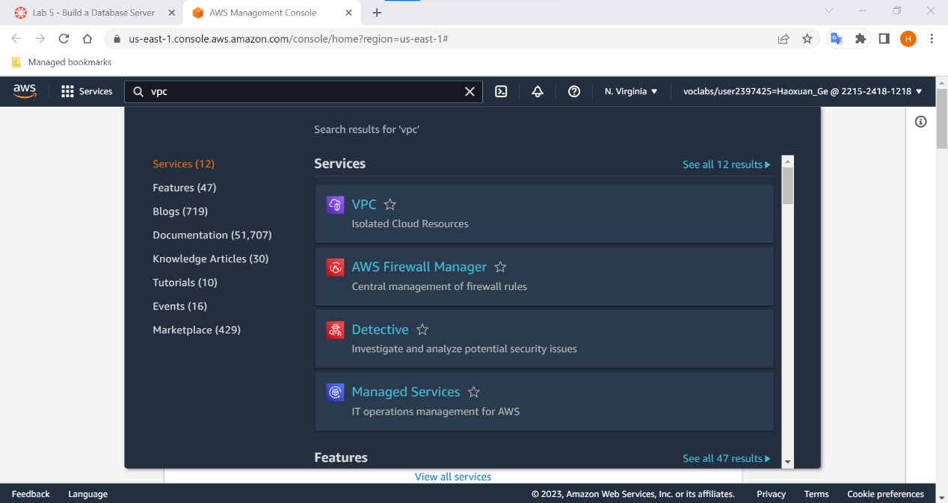

Create a new security group

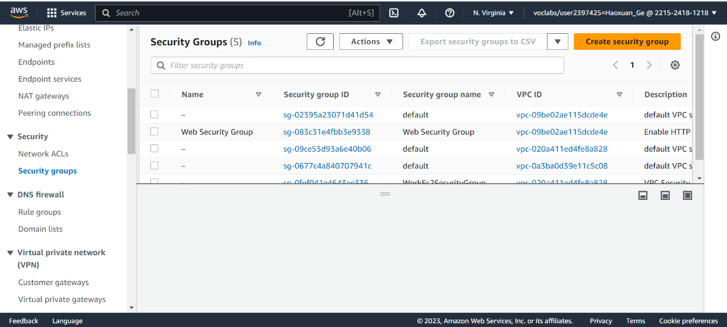

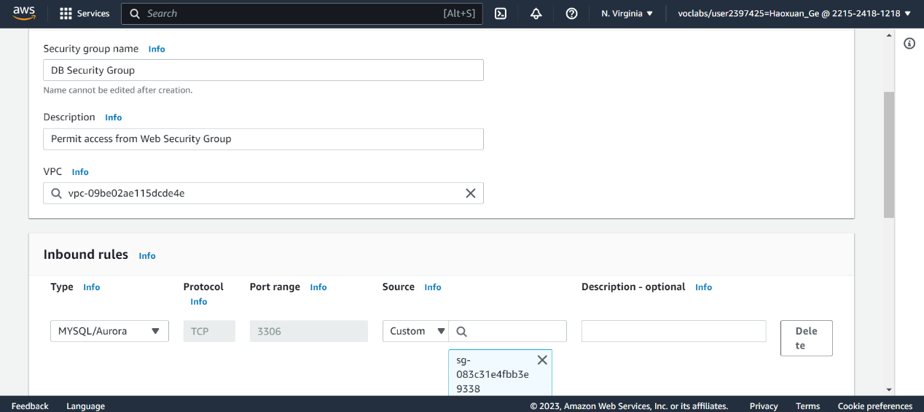

Enter RDS server

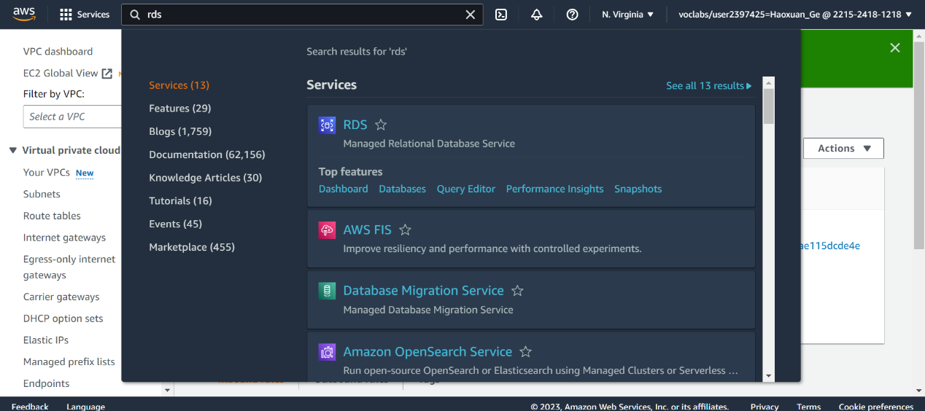

Enter subnet group and create a new one

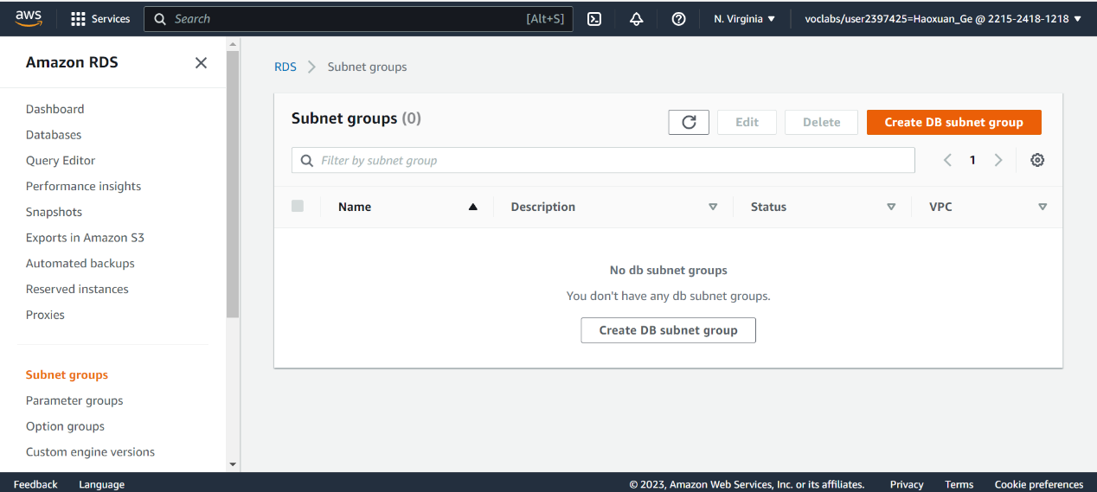

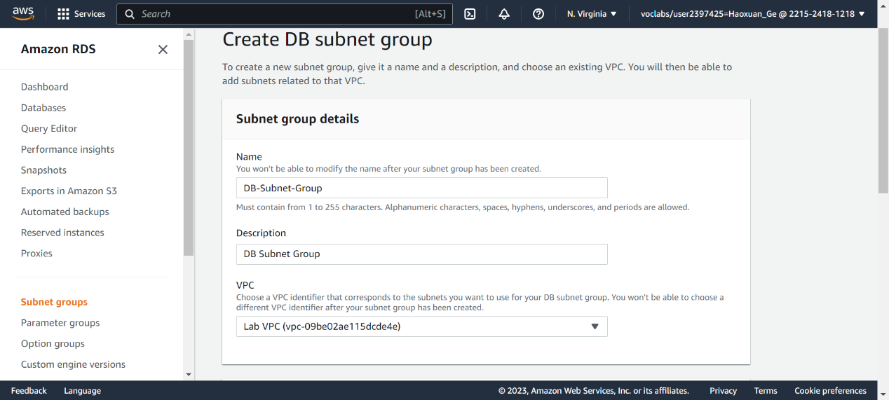

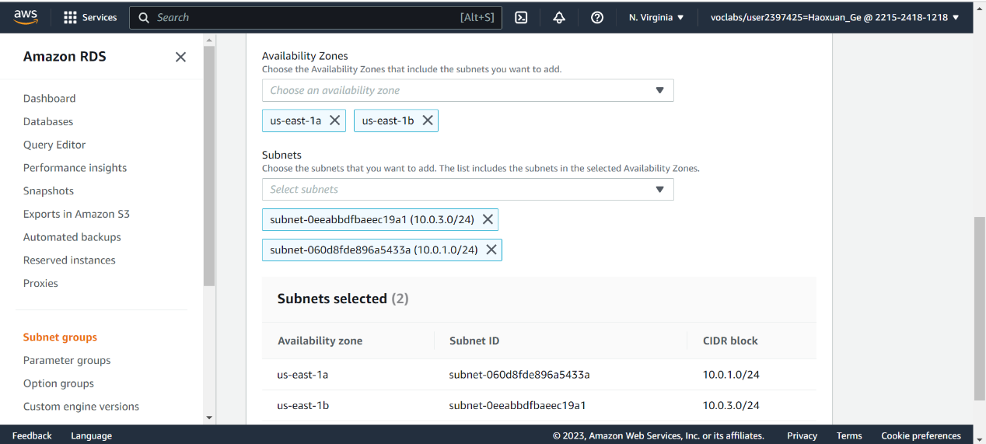

Create a new database

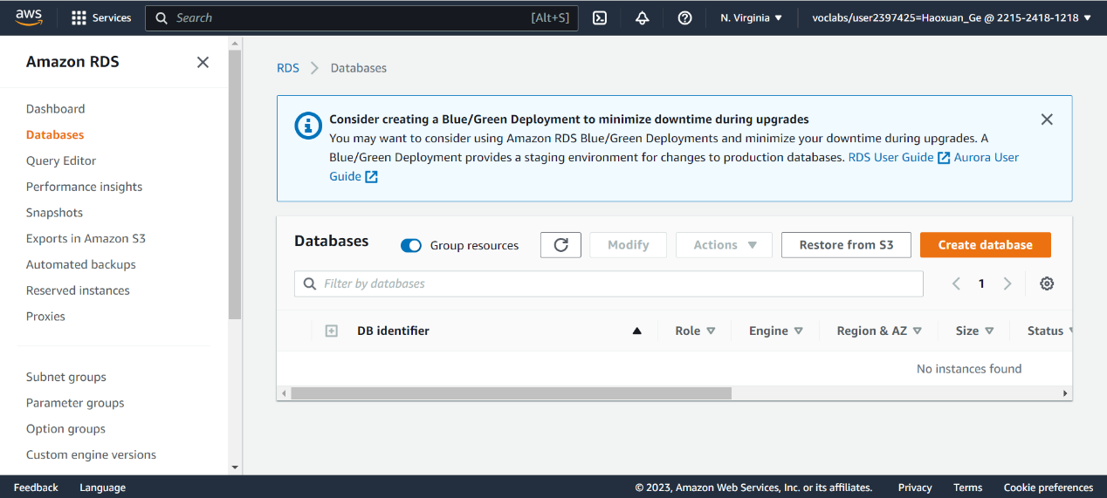

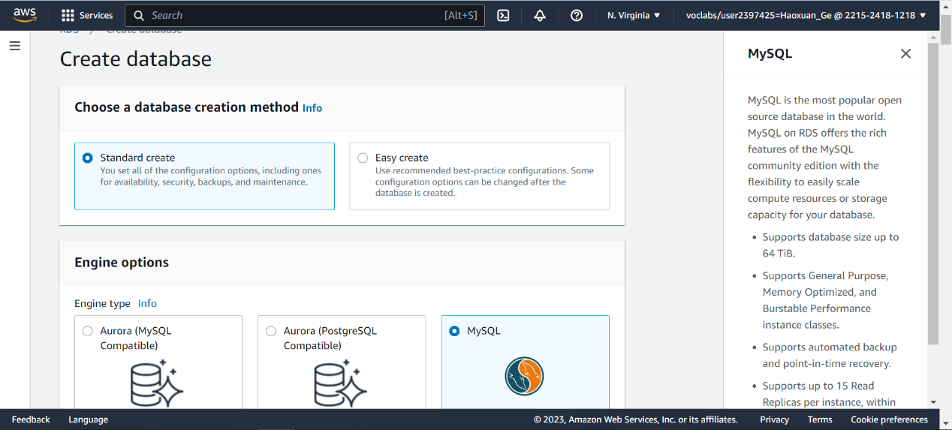

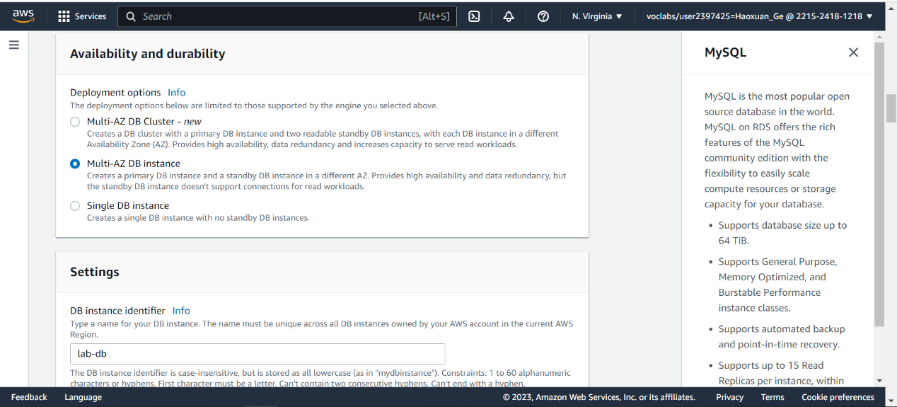

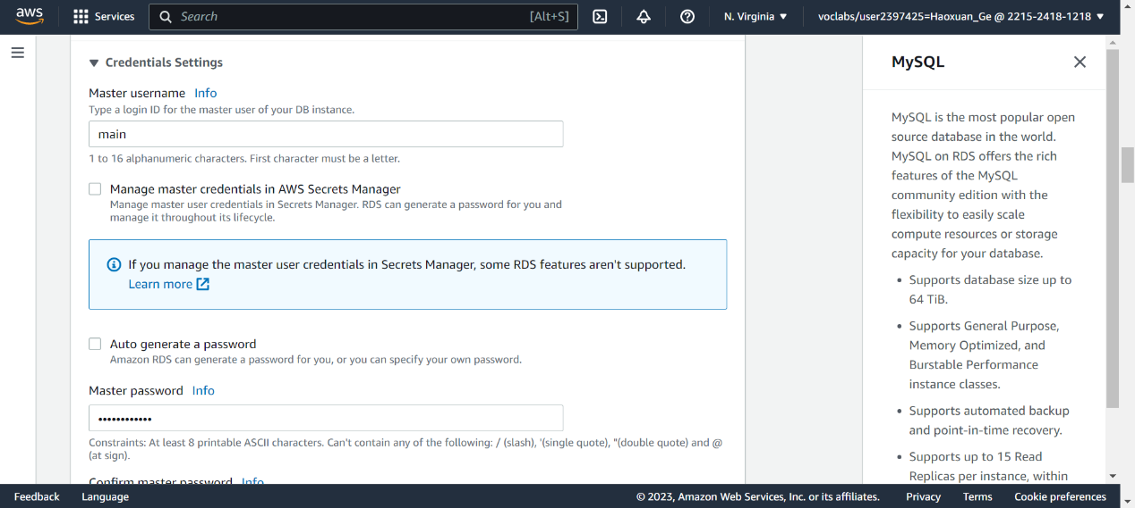

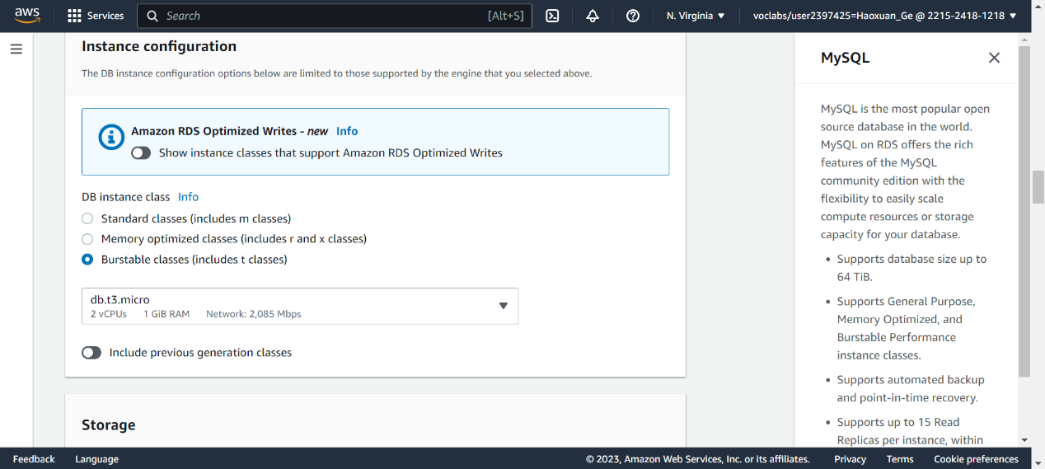

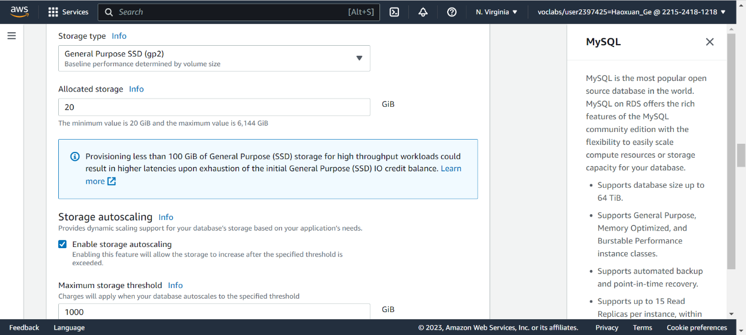 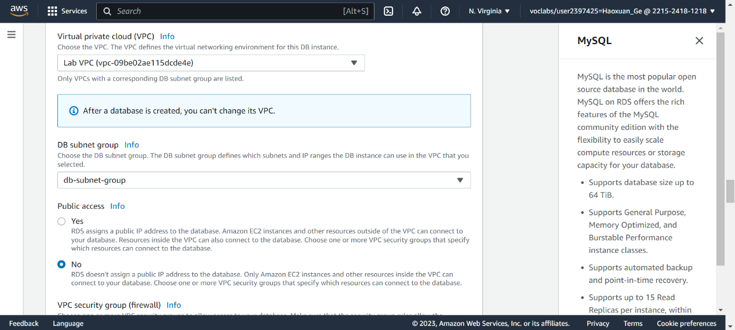

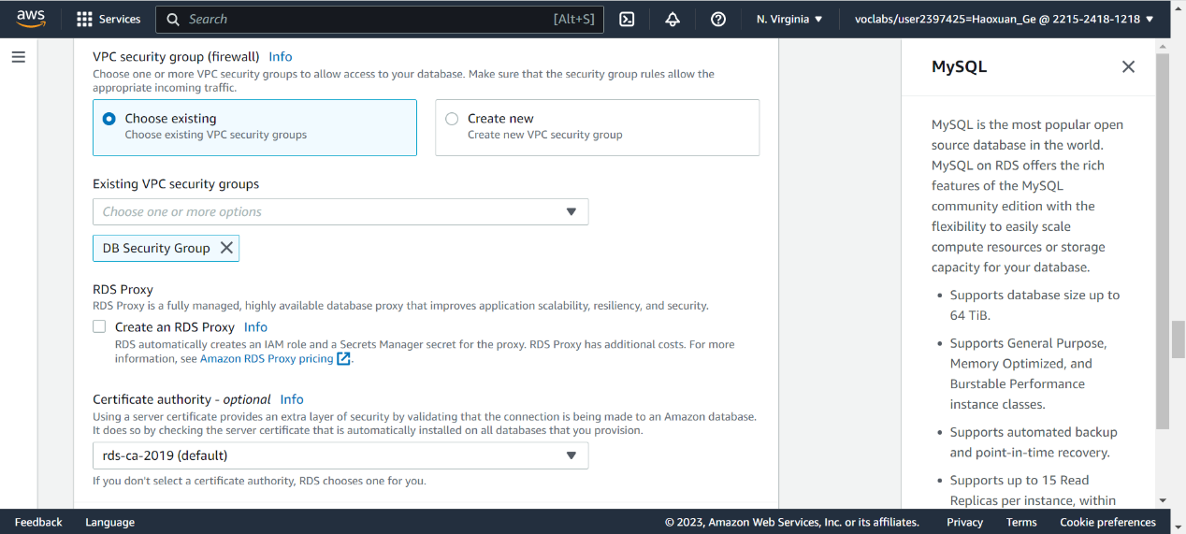

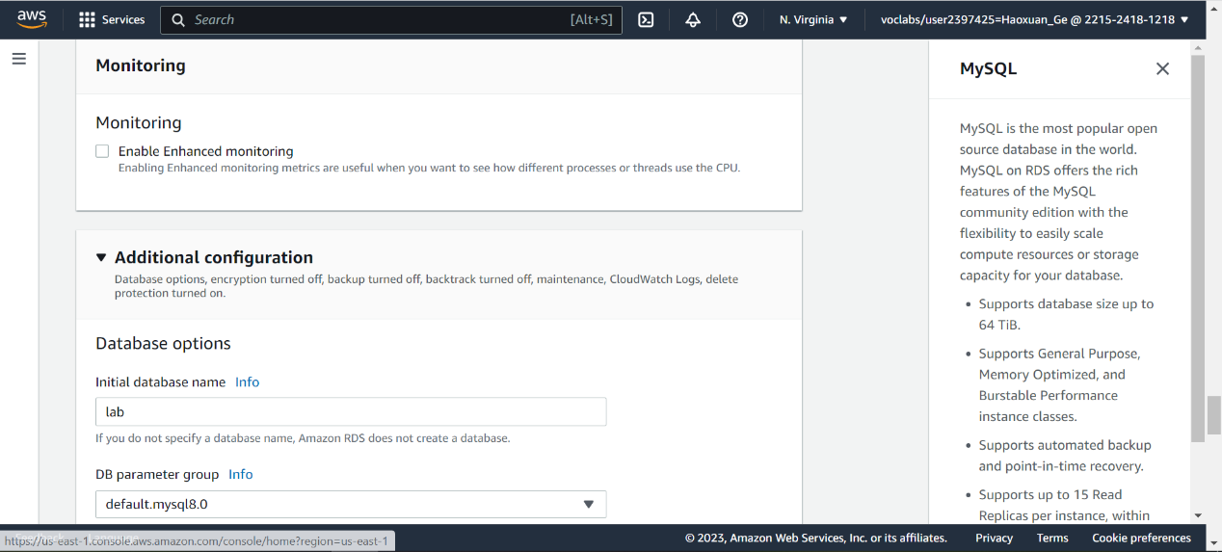

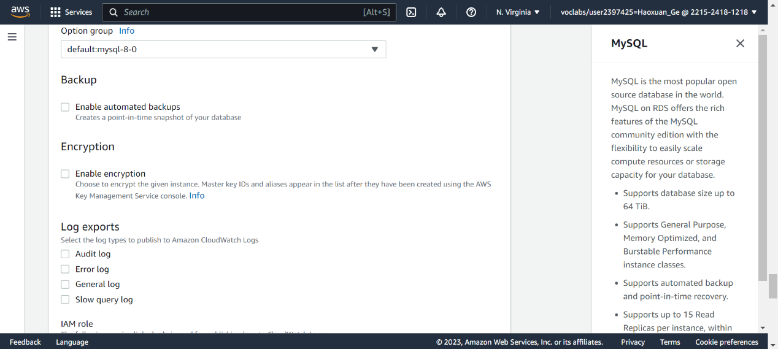

Copy the endpoint

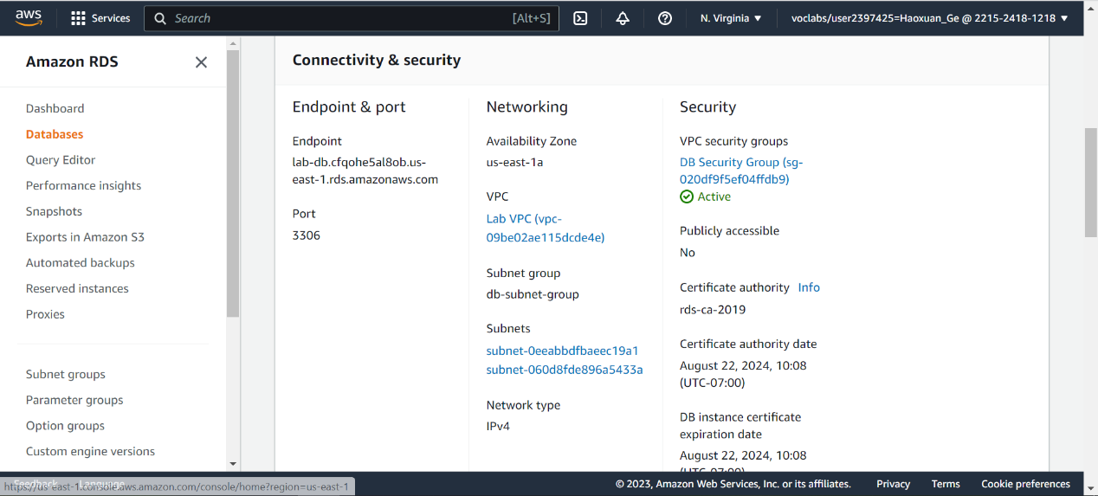

Download webserver address…copy to browser

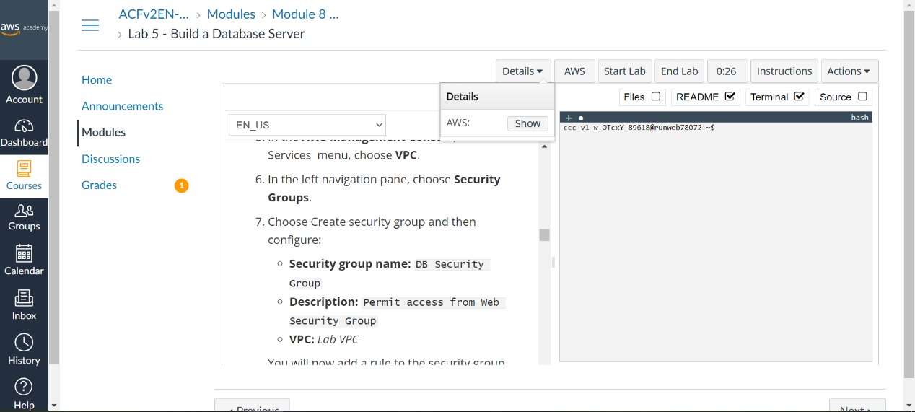

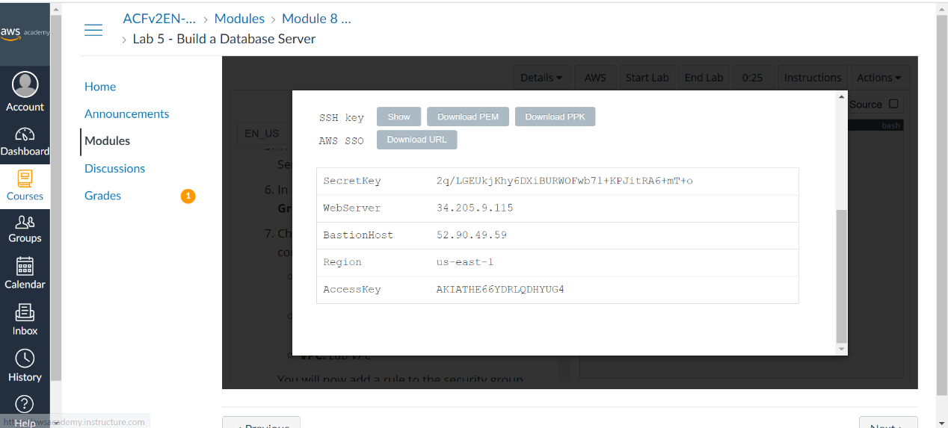

Guess what…district laptop refuses to pass this address in the browser, so…

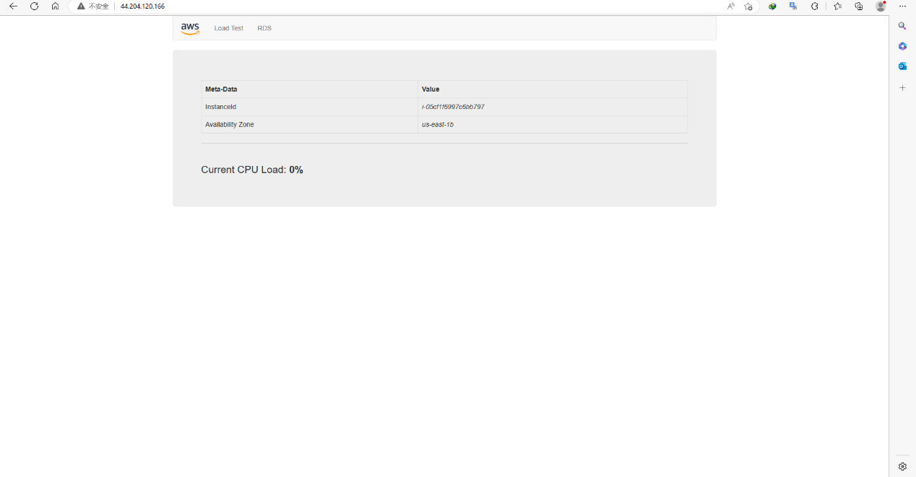

Clicks RDS and config it, then an address book shown

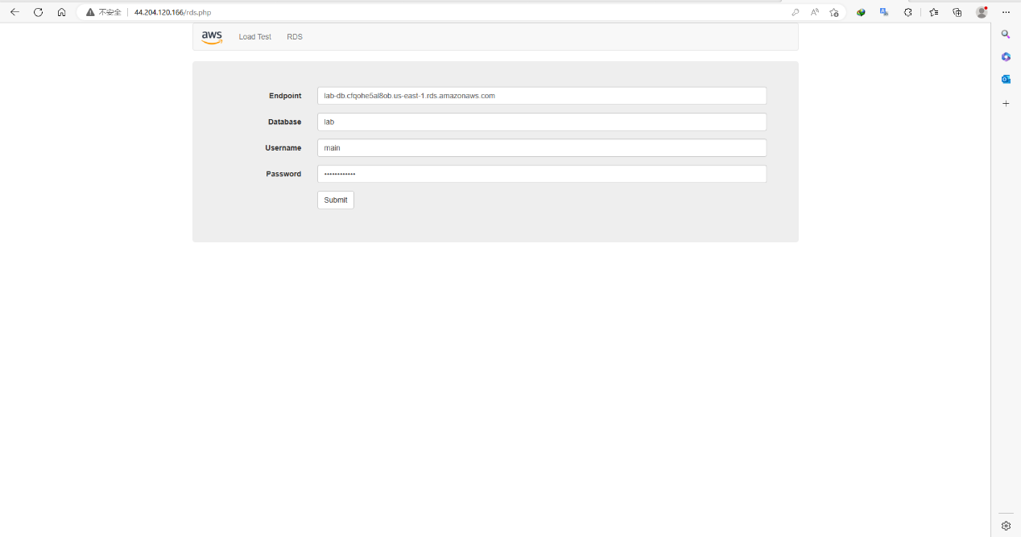

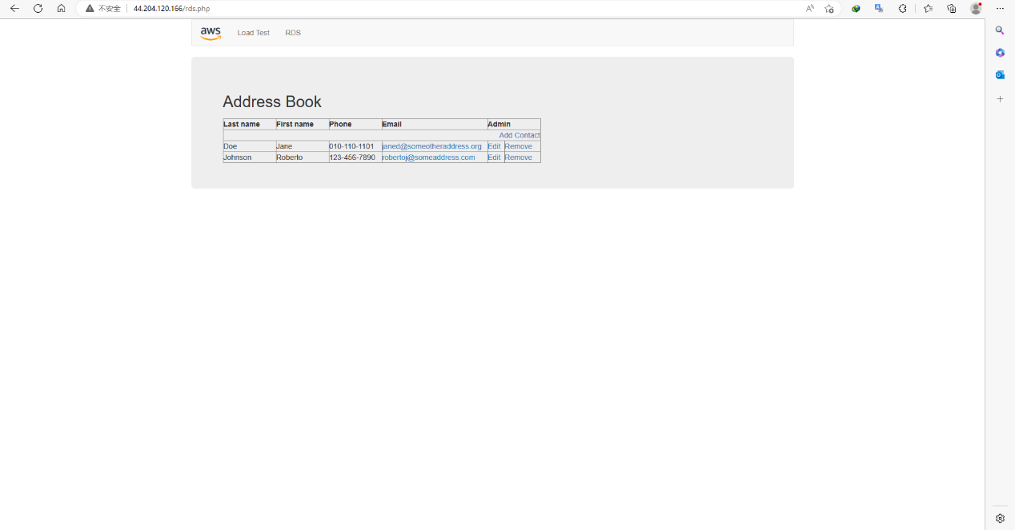

Lab 5 end

Lab 6:

Create an Amazon Machine Image (AMI) from a running instance.

Create a load balancer.

Create a launch configuration and an Auto Scaling group.

Automatically scale new instances within a private subnet

Create Amazon CloudWatch alarms and monitor performance of your infrastructure.

Enter instance check if there is 2 already

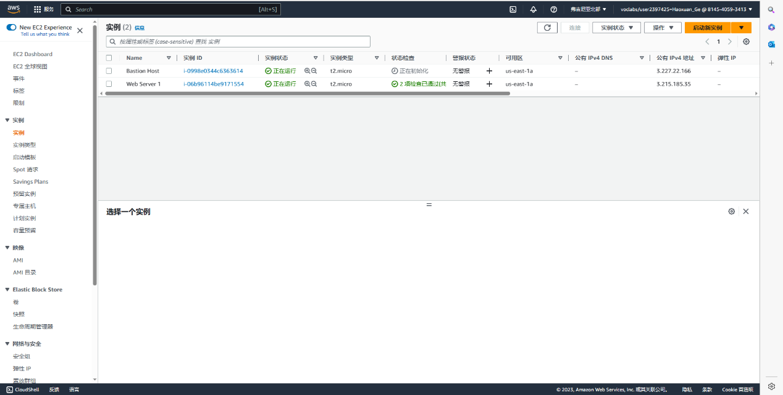

Jump to target group on left column below and create a new one

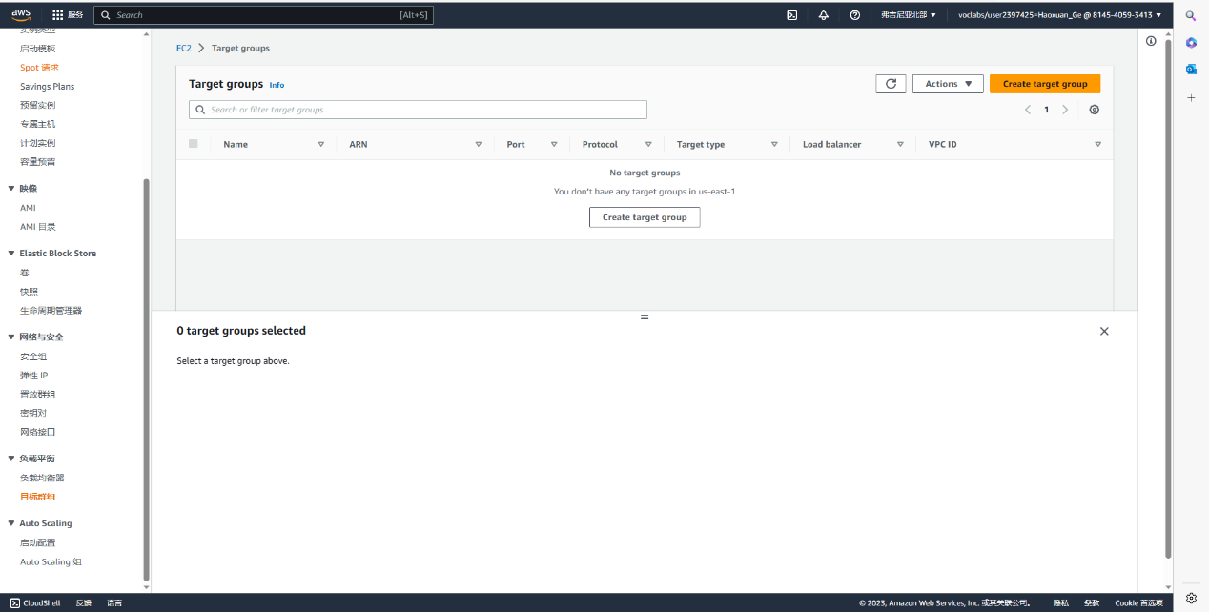

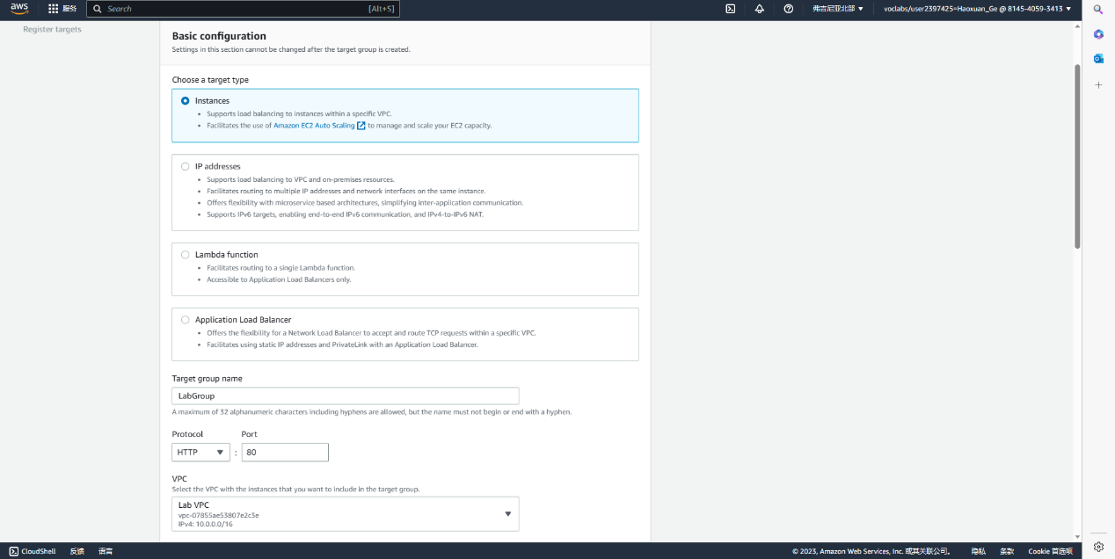 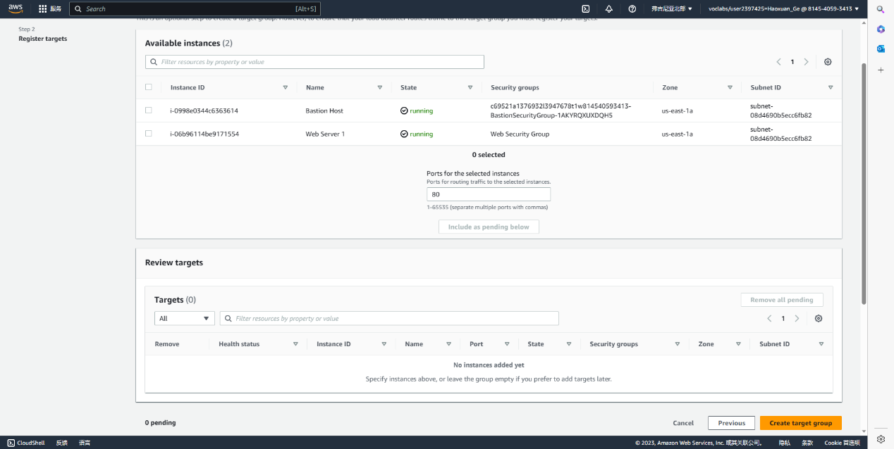

Enter load balancer, also left column, create one

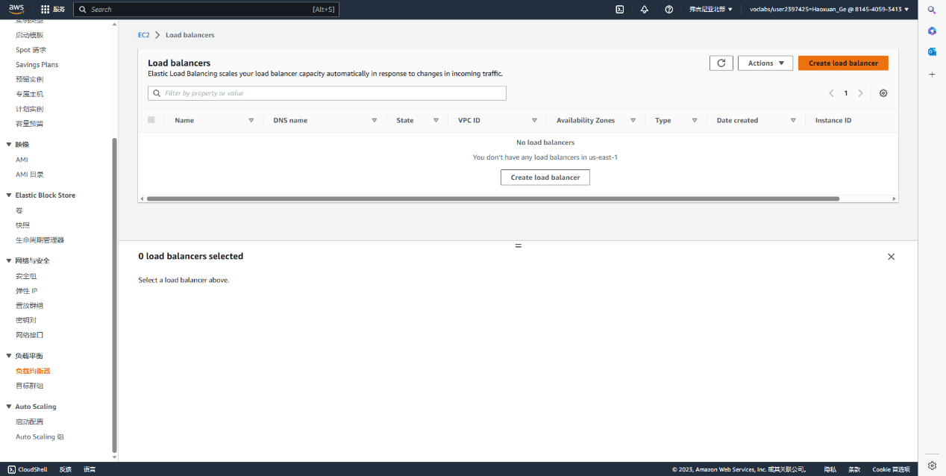

First one

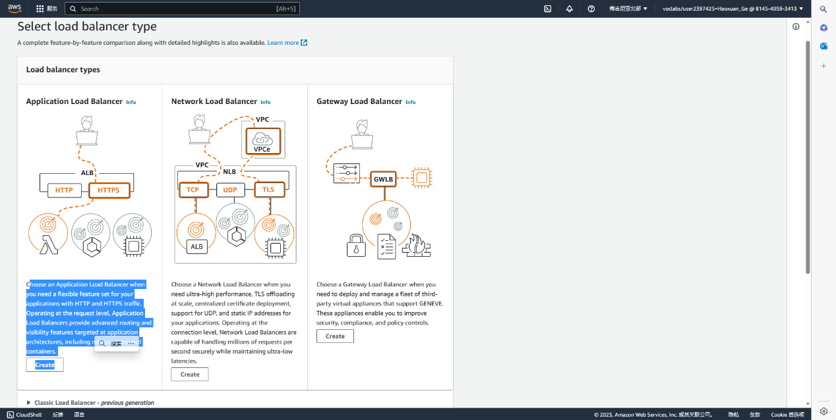

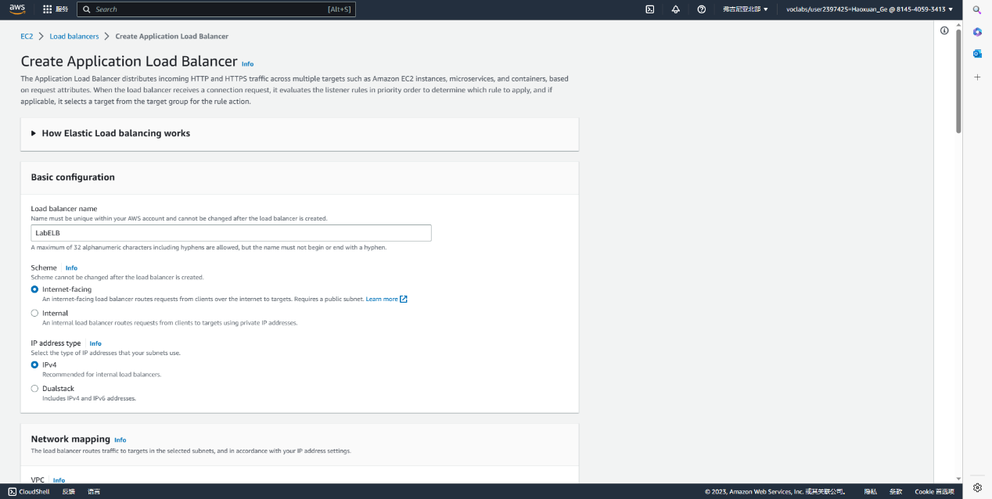

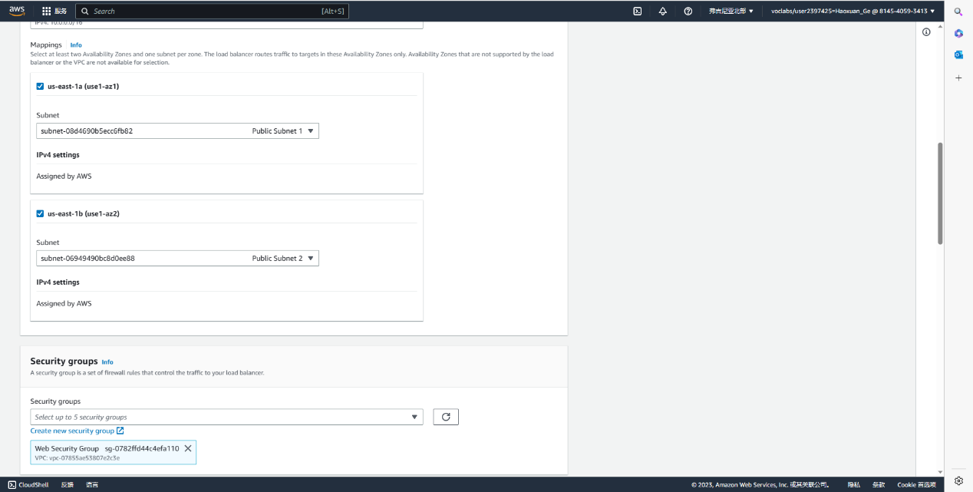

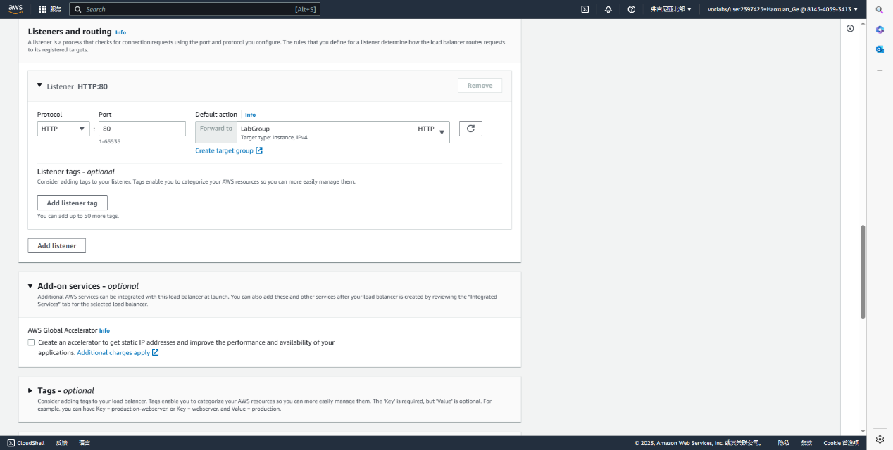

Create a Launch Configuration and an Auto Scaling Group

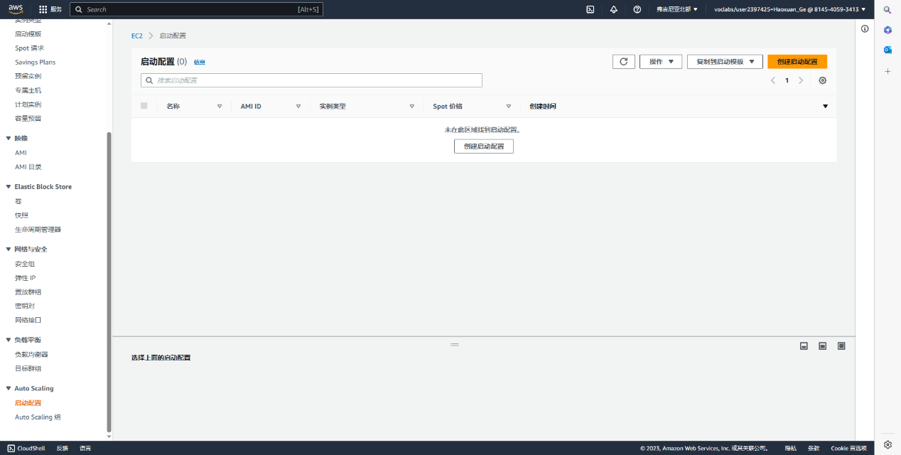

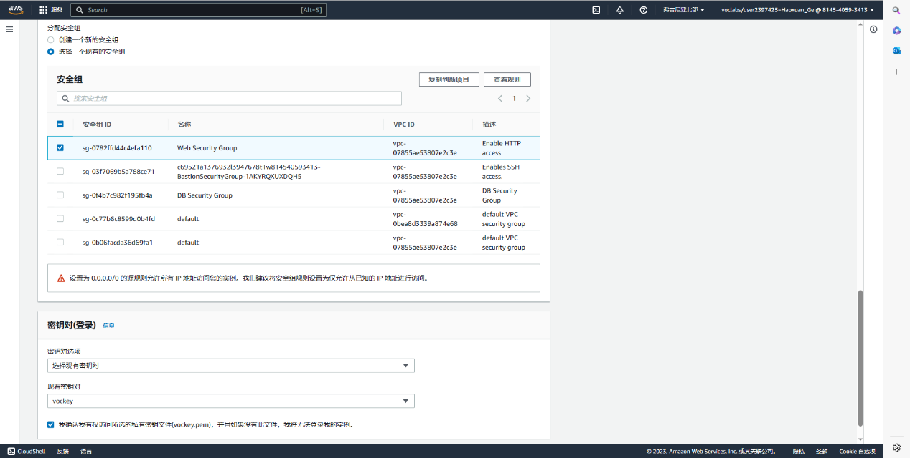

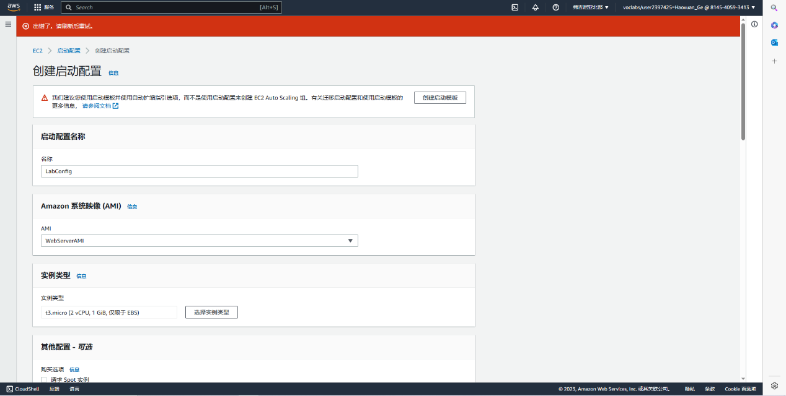

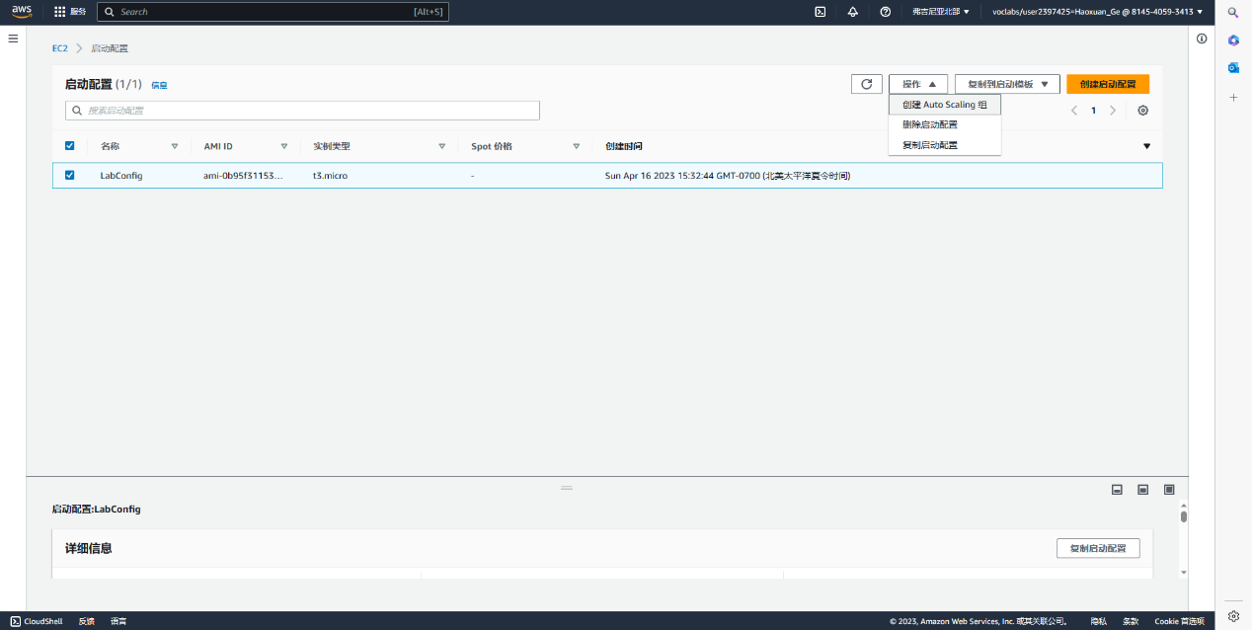

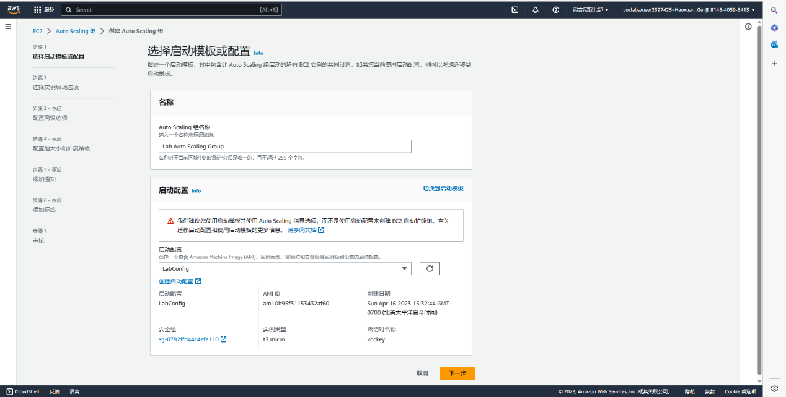

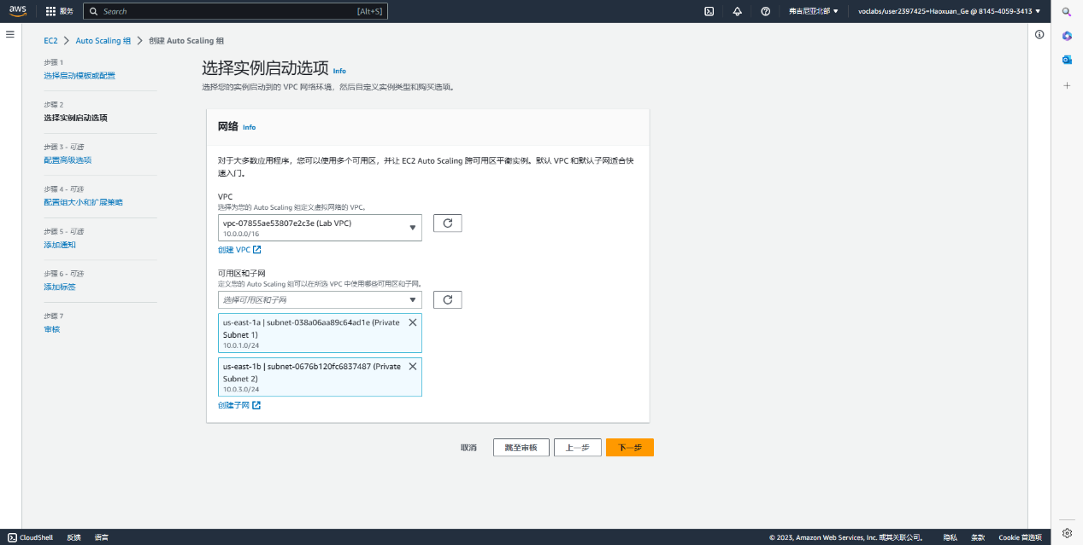

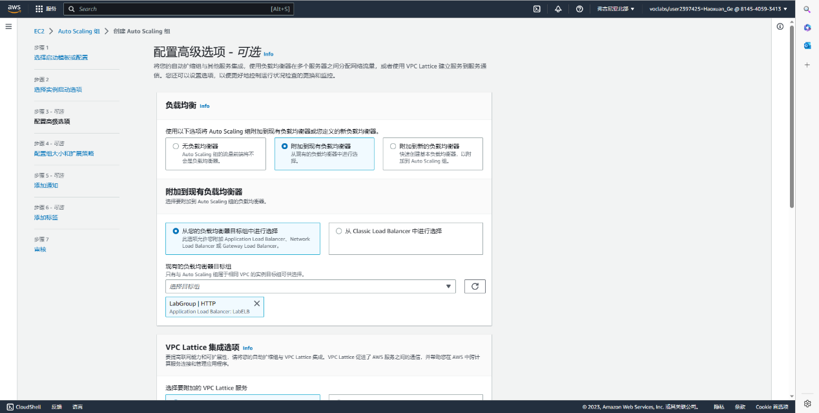 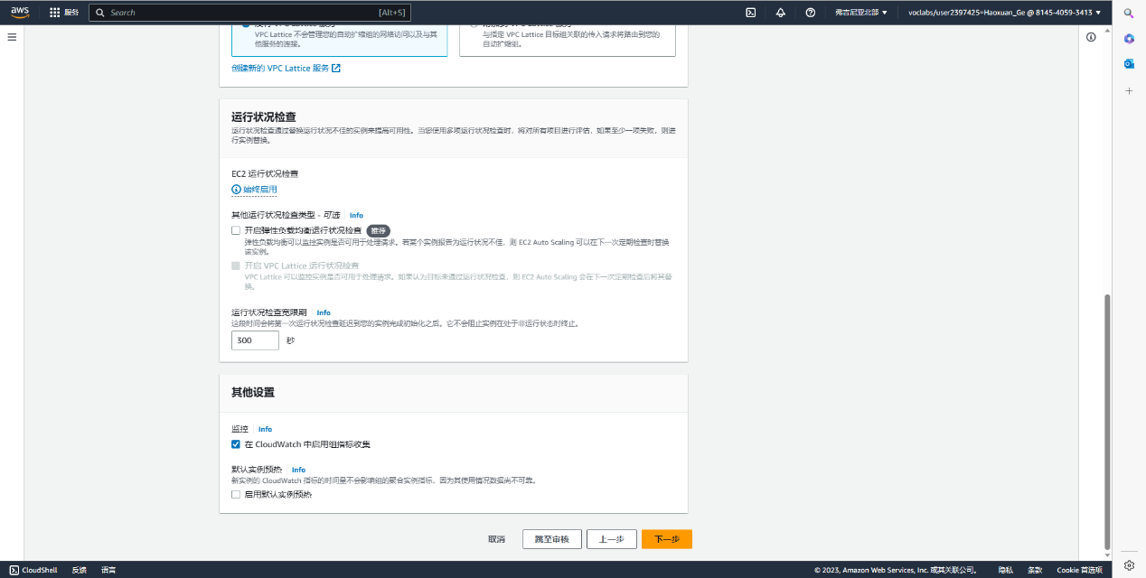 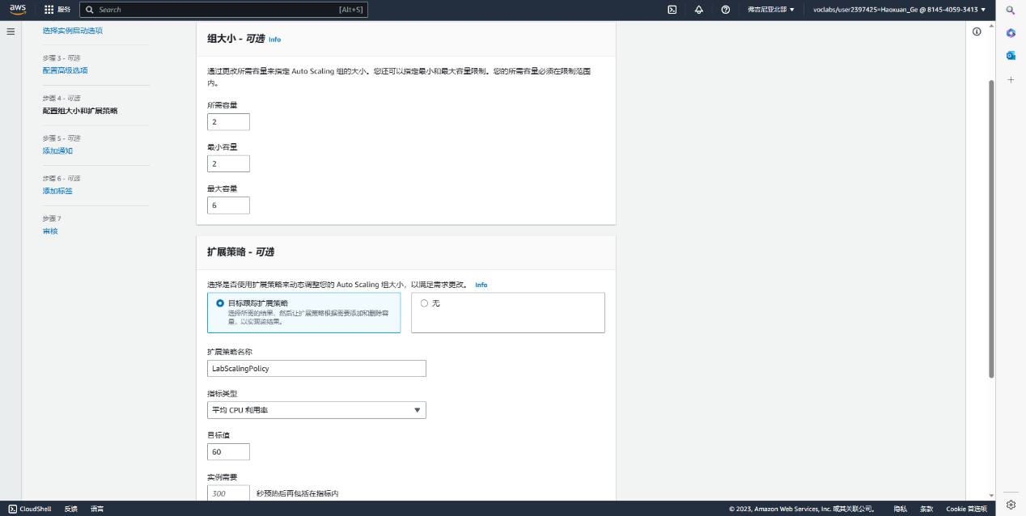

Tag

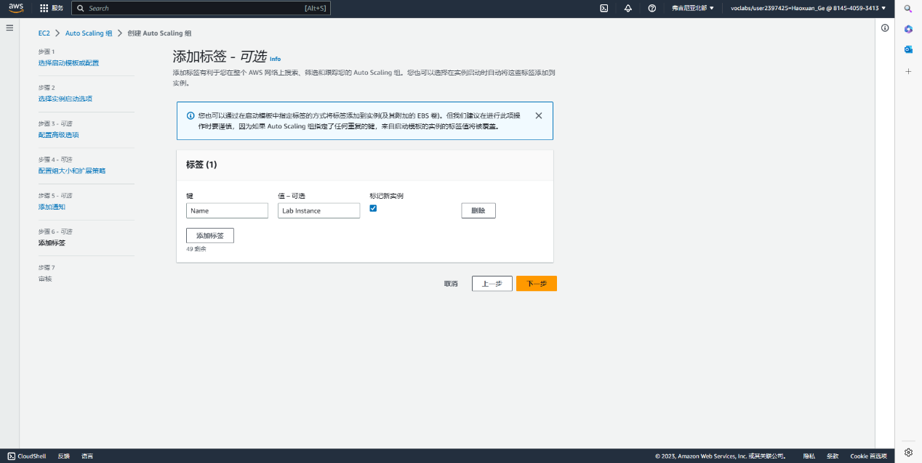

Final check

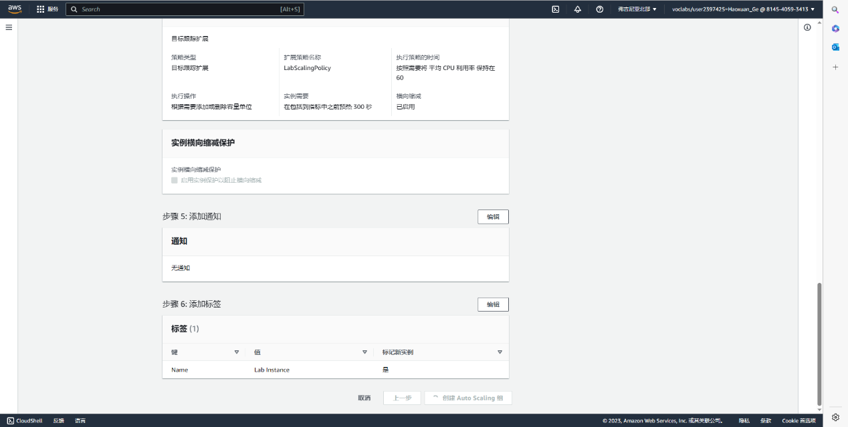

Back to instances, finding that there is 2 more lab instance

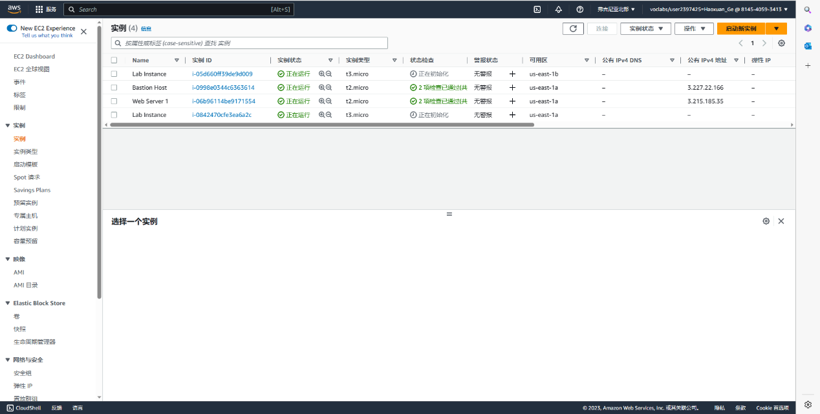

Both targets in targets group is healthy

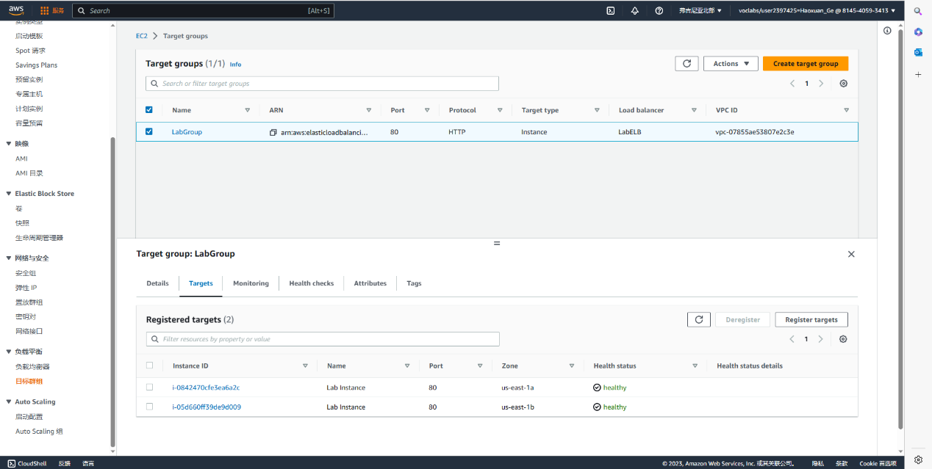

Copy DNS name in load balancer to browser(delete “A record”)

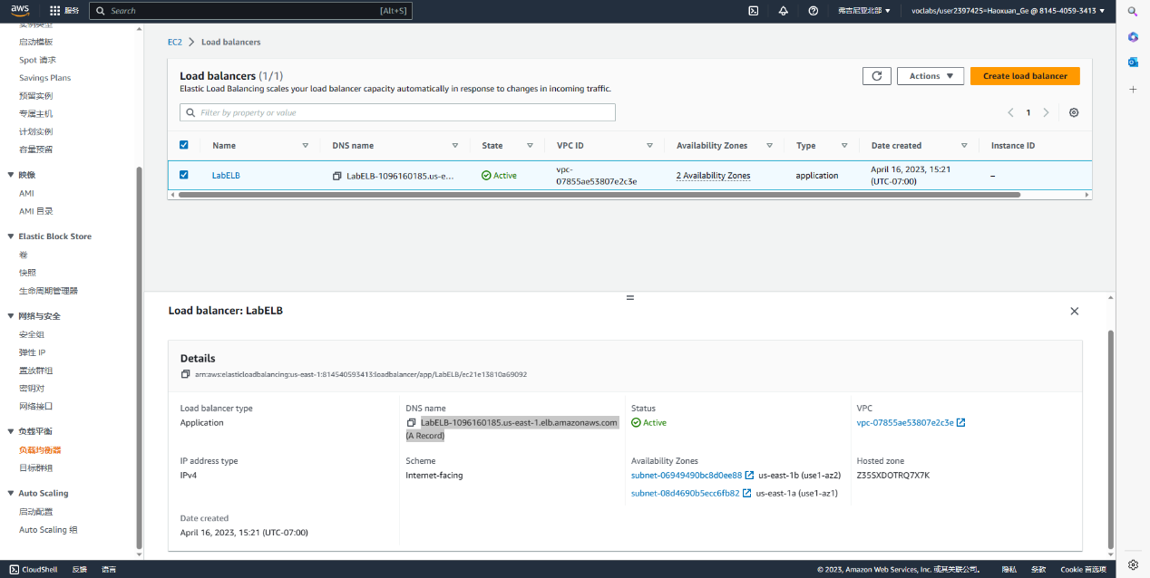

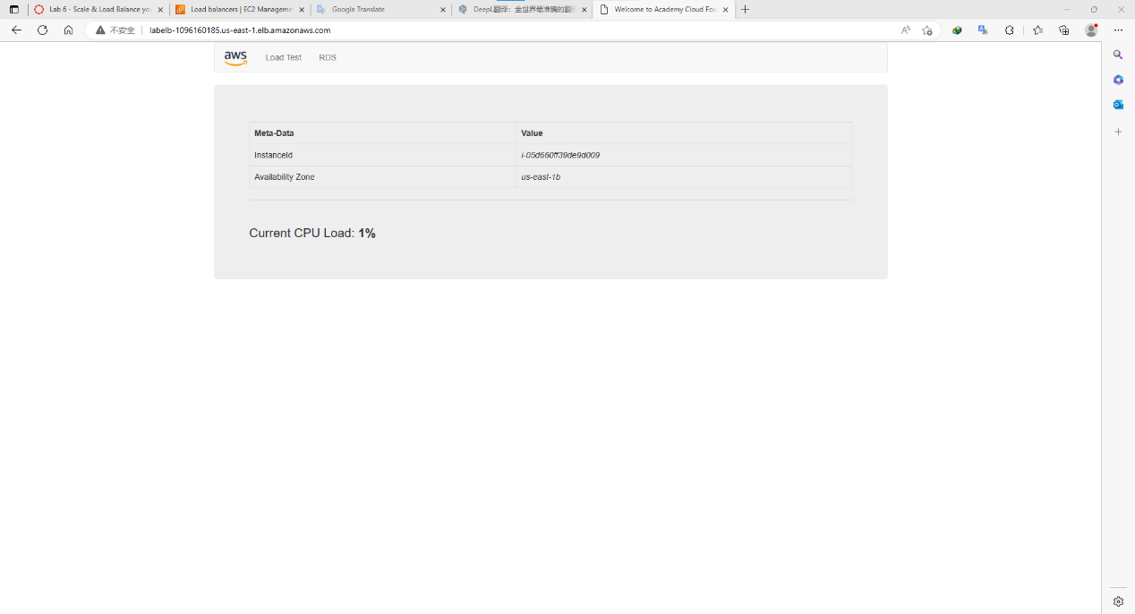

Enter CloudWatch, finding that there is no alarm right now

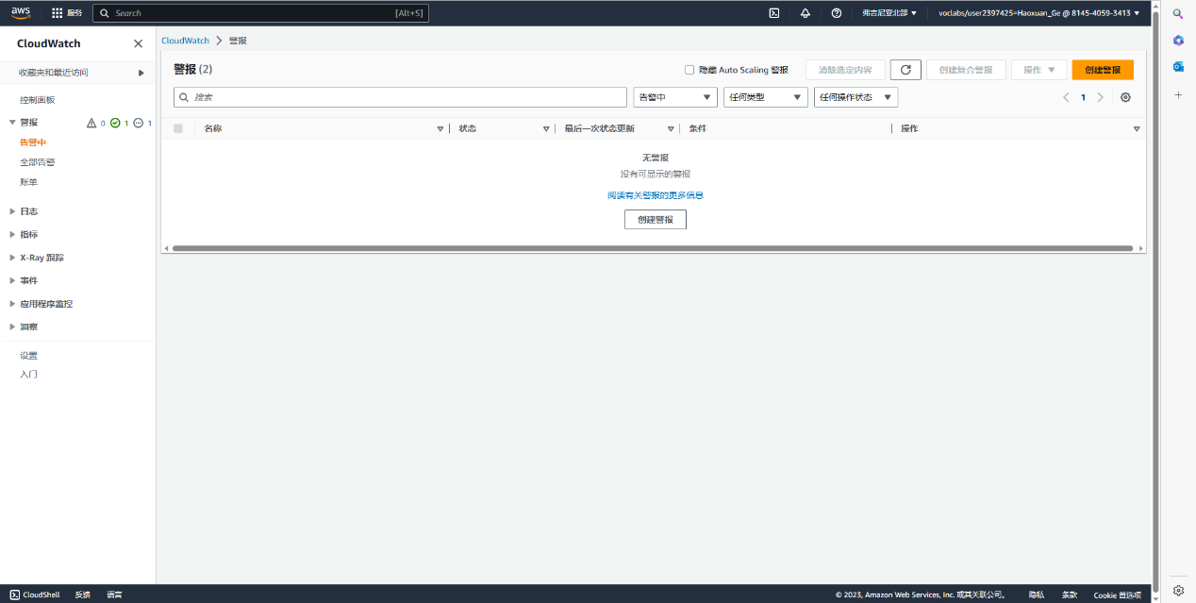

Back to auto scaling group, edit Lab Scaling Policy

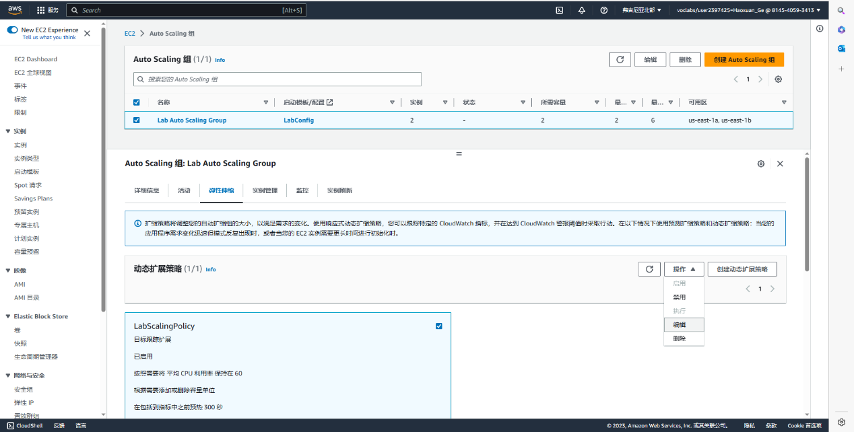

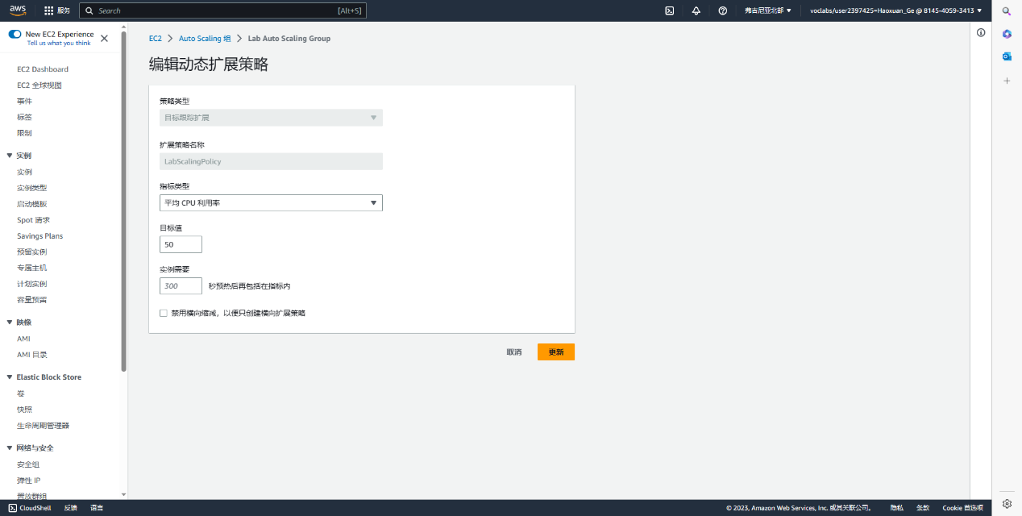

Back to CloudWatch, finding that 1 alarm is warning, but other one just ok

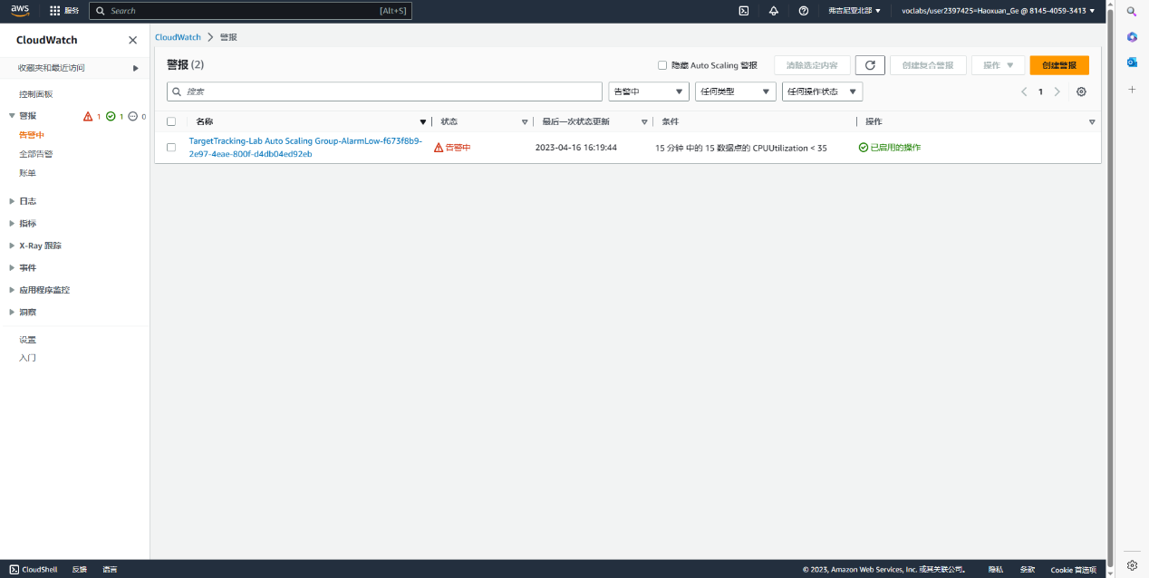

Back to instance, 2 more instance is running

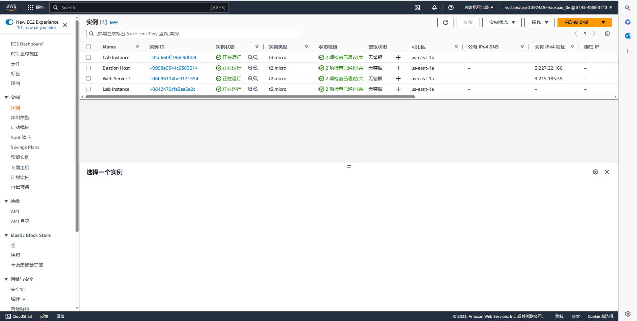

Terminate Web Server 1

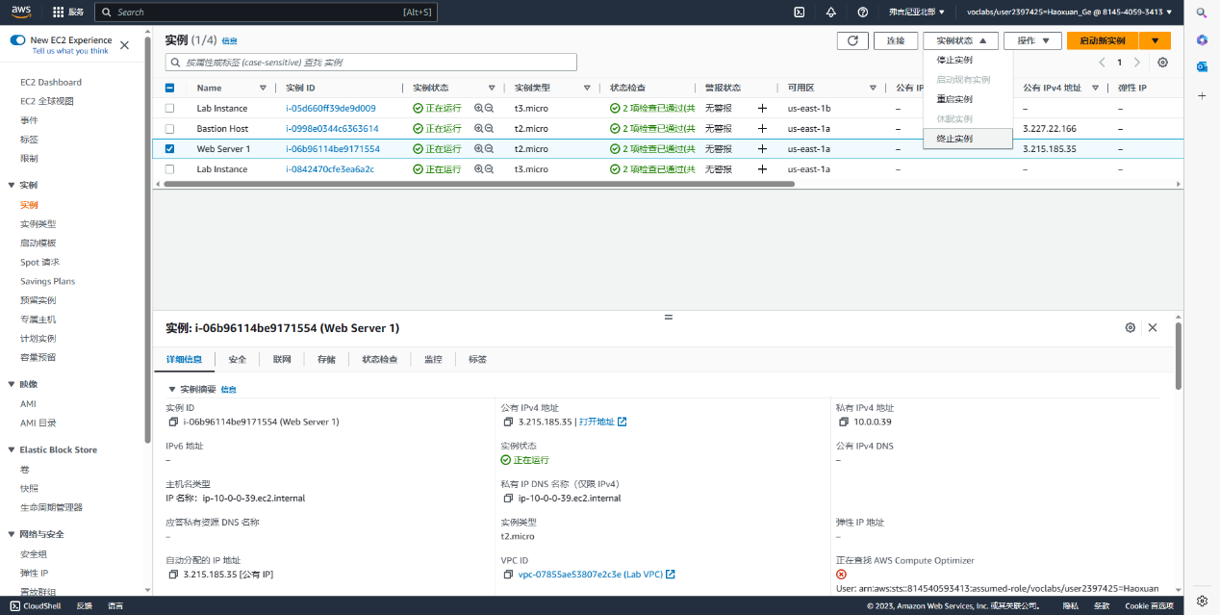

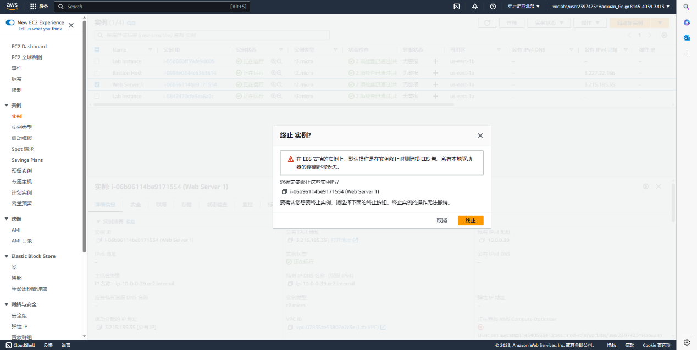

Lab 6 end

Problem:

I have to say that the laptop in the school district can't download putty, and can't open the link of the public ip, and the progress can't be saved, I have to redo lab 4 and lab 5 on my home computer...

When create database in lab 5, In the deployment option, must switch to multi-AZ DB instance, which is the second one. The first one is selected by default, which makes it impossible to choose burstable classes in the DB instance class. The tutorial only vaguely introduces it but does not mention it.

Lab 8

MPLS (Multiprotocol Label Switching)

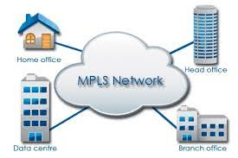

Multiprotocol Label Switching

Background:

In chaotic network routing, the router will send a data packet to the destination, which is determined according to the routing table, and the data packet will be automatically sent to the shortest path in the routing table, but if using mpls routing, the router will use other devices The label determines the routing direction, which will greatly increase the speed, because the data packet does not need to be mixed with other data packets for transmission. The regular network transmission may be the third layer or the second layer, but mpls is different. It uses the 2.5 layer, which is Data packets are transmitted between networks based on data links, Layer 2 LANs or point-to-point WANs. Layer 3 uses the IP protocol for Internet-wide addressing and routing.

Although the high speed of long-distance transmission sounds good, the disadvantages of mpls are also obvious. When the transmission distance is long, it usually requires high cost and maintenance fees. Moreover, the interaction between mpls and the cloud is not good. Transfer to the headquarters to the cloud instead of directly connecting to the cloud. Similar to mpls is SD-WAN, which is a software-defined wide area network. Generally speaking, SD-WAN has a higher priority than mpls because it has a lower cost

Diagram:

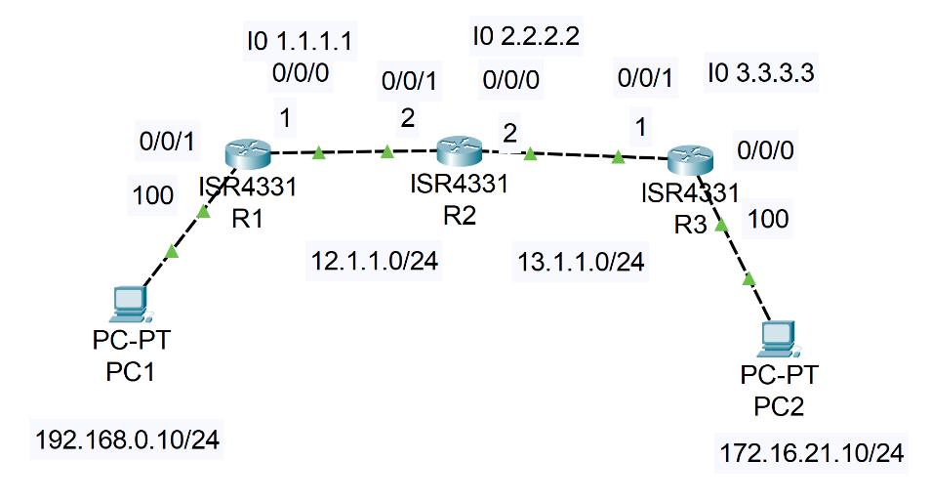

Configuration:

R1:

hostname R1

!

boot-start-marker

boot-end-marker

!

!

vrf definition Mgmt-intf

!

address-family ipv4

exit-address-family

!

address-family ipv6

--More--

*Jun 6 18:48:03.070: %SYS-5-CONFIG_I: Configured from console exit-address-family

!

!

no aaa new-model

!

!

!

!

!

!

!

no ip domain lookup

!

!

!

!

!

!

!

!

!

!

subscriber templating

!

!

!

!

vtp domain cisco

vtp mode transparent

mpls label protocol ldp

mpls label range 20 30

!

!

multilink bundle-name authenticated

!

!

!

!

!

!

!

license udi pid ISR4321/K9 sn FDO220523GF

license boot level appxk9

no license smart enable

diagnostic bootup level minimal

!

spanning-tree extend system-id

!

!

!

!

redundancy

mode none

!

!

!

!

!

!

!

!

!

!

!

interface Loopback0

ip address 1.1.1.1 255.255.255.0

!

interface GigabitEthernet0/0/0

ip address 12.1.1.1 255.255.255.0

negotiation auto

mpls ip

!

interface GigabitEthernet0/0/1

ip address 192.168.0.100 255.255.255.0

negotiation auto

mpls ip

!

interface Serial0/1/0

no ip address

shutdown

!

interface Serial0/1/1

no ip address

shutdown

!

interface GigabitEthernet0/2/0

no ip address

shutdown

negotiation auto

!

interface GigabitEthernet0/2/1

no ip address

shutdown

negotiation auto

!

interface GigabitEthernet0

vrf forwarding Mgmt-intf

no ip address

shutdown

negotiation auto

!

router ospf 10

router-id 1.1.1.1

network 1.1.1.1 0.0.0.0 area 0

network 12.1.1.0 0.0.0.255 area 0

network 192.168.0.0 0.0.0.255 area 0

!

ip forward-protocol nd

ip http server

ip http authentication local

ip http secure-server

ip tftp source-interface GigabitEthernet0

!

!

!

!

mpls ldp router-id Loopback0 force

!

!

control-plane

!

!

line con 0

transport input none

stopbits 1

line aux 0

stopbits 1

line vty 0 4

login

!

wsma agent exec

!

wsma agent config

!

wsma agent filesys

!

wsma agent notify

!

!

End

R2

hostname R2

!

boot-start-marker

boot-end-marker

!

!

vrf definition Mgmt-intf

!

address-family ipv4

exit-address-family

!

address-family ipv6

exit-address-family

!

!

no aaa new-model

!

!

!

!

!

!

!

!

!

!

login on-success log

!

!

!

!

!

!

!

subscriber templating

!

!

!

!

vtp domain cisco

vtp mode transparent

mpls label protocol ldp

mpls label range 60 90

multilink bundle-name authenticated

!

!

!

!

crypto pki trustpoint TP-self-signed-2189345785

enrollment selfsigned

subject-name cn=IOS-Self-Signed-Certificate-2189345785

revocation-check none

rsakeypair TP-self-signed-2189345785

!

!

crypto pki certificate chain TP-self-signed-2189345785

certificate self-signed 01

30820330 30820218 A0030201 02020101 300D0609 2A864886 F70D0101 05050030

31312F30 2D060355 04031326 494F532D 53656C66 2D536967 6E65642D 43657274

69666963 6174652D 32313839 33343537 3835301E 170D3233 30363036 31373438

31355A17 0D333030 31303130 30303030 305A3031 312F302D 06035504 03132649

4F532D53 656C662D 5369676E 65642D43 65727469 66696361 74652D32 31383933

34353738 35308201 22300D06 092A8648 86F70D01 01010500 0382010F 00308201

0A028201 0100DC56 626B6F15 C4D5713A 04E6FA0F 493D2096 4DEFCDF3 24374D3E

9A63CFBF B1EE2AAE 86BE7C78 7B77E111 A5E90321 A473FC94 0F4CBC50 6307FE29

1E9395B4 76DE2FD5 882F2C8E A16CDBB3 E342D482 88038E60 1D78D5D6 BBCE2428

8D75D97A 6FB96560 38BA42B4 C654153D A0AB7185 56492AF0 6983C37C 34A2F360

C9C7C5D0 D4A95DCA 4C37CCEE 0C9F711E E7CEB57D 7264F897 CF9B5D9D CEF5CC1A

ABDDA5B0 C9189BAB 51CA683F 38568F93 D200E642 BA952148 292C079E 0FEF587A

9140376C 15E3AB38 E5DF221B A548D893 9422FF32 466B44B9 B24FCD48 F8D167C7

640BC5A7 085030D4 4306764F 7254E1D1 1AD6C1EE 86C8EC79 597D00B8 CFCFD88F

785DE563 9FBF0203 010001A3 53305130 0F060355 1D130101 FF040530 030101FF

301F0603 551D2304 18301680 142BDA45 0077675C A58B4A0F 6FF0B807 EA295E09

D1301D06 03551D0E 04160414 2BDA4500 77675CA5 8B4A0F6F F0B807EA 295E09D1

300D0609 2A864886 F70D0101 05050003 82010100 4A86E97D 7DA6060D A1A80970

4711228D DCFE1026 CA78AA16 6EA2364E C03C2A29 A8E3F6AE 63EA340A 357AA0AE

9B0CBB78 A47777F4 7DE8147D 551111C3 A2A8F991 9F44E321 7B8E75E9 22C3FF16

2CDBEA6B FD508E68 B64D32A2 2AA1B8B2 952AF05A D508C8C1 33C016B0 61B894EE

996E68A5 8616A036 D2AA7EFB B88F32B1 3531F5BB 3D2CB411 F73E0DF4 2C655186

E82C6E72 91FE82D6 D3B2E438 F23C3B37 ACA349E2 9980E212 488DB982 3F06094C

68AD6FC6 667DCD1D C9A70F39 8A70B9D1 6C7EECAA 27351E91 73B91111 C4F7FD27

A69AFDDC 94B1054C 49DCAA47 945C7F5B E9F0F1FC 1DF0B520 48A7243E E90BA117

FFEFCA06 DF2053FA 98A27757 7A2B1678 5D1025BB

quit

!

license udi pid ISR4321/K9 sn FDO21482DXE

license boot level appxk9

no license smart enable

diagnostic bootup level minimal

!

spanning-tree extend system-id

!

!

!

!

redundancy

mode none

!

!

!

!

!

!

!

!

!

!

!

interface Loopback0

ip address 2.2.2.2 255.255.255.0

!

interface GigabitEthernet0/0/0

ip address 13.1.1.2 255.255.255.0

negotiation auto

mpls ip

!

interface GigabitEthernet0/0/1

ip address 12.1.1.2 255.255.255.0

negotiation auto

mpls ip

!

interface Serial0/1/0

no ip address

shutdown

!

interface Serial0/1/1

no ip address

shutdown

!

interface GigabitEthernet0/2/0

no ip address

shutdown

negotiation auto

!

interface GigabitEthernet0/2/1

no ip address

shutdown

negotiation auto

!

interface GigabitEthernet0

vrf forwarding Mgmt-intf

no ip address

shutdown

negotiation auto

!

router ospf 10

router-id 2.2.2.2

network 2.2.2.2 0.0.0.0 area 0

network 12.1.1.0 0.0.0.255 area 0

network 13.1.1.0 0.0.0.255 area 0

!

ip forward-protocol nd

ip http server

ip http authentication local

ip http secure-server

ip tftp source-interface GigabitEthernet0

!

!

!

!

mpls ldp router-id Loopback0 force

!

!

control-plane

!

!

line con 0

transport input none

stopbits 1

line aux 0

stopbits 1

line vty 0 4

login

!

!

!

!

!

!

End

R3:

hostname R3

!

boot-start-marker

boot-end-marker

!

!

vrf definition Mgmt-intf

!

address-family ipv4

exit-address-family

!

address-family ipv6

exit-address-family

!

!

no aaa new-model

!

!

!

!

!

!

!

!

!

!

login on-success log

!

!

!

!

!

!

!

subscriber templating

!

!

!

!

vtp domain cisco

vtp mode transparent

mpls label protocol ldp

mpls label range 100 120

multilink bundle-name authenticated

!

!

!

!

crypto pki trustpoint TP-self-signed-2557841031

enrollment selfsigned

subject-name cn=IOS-Self-Signed-Certificate-2557841031

revocation-check none

rsakeypair TP-self-signed-2557841031

!

!

crypto pki certificate chain TP-self-signed-2557841031

certificate self-signed 01

30820330 30820218 A0030201 02020101 300D0609 2A864886 F70D0101 05050030

31312F30 2D060355 04031326 494F532D 53656C66 2D536967 6E65642D 43657274

69666963 6174652D 32353537 38343130 3331301E 170D3233 30363036 31373234

34375A17 0D333030 31303130 30303030 305A3031 312F302D 06035504 03132649

4F532D53 656C662D 5369676E 65642D43 65727469 66696361 74652D32 35353738

34313033 31308201 22300D06 092A8648 86F70D01 01010500 0382010F 00308201

0A028201 01009D2A A302019C 0365F266 5AB12A75 0DBC0A7E 98E124DB 2B332400

436314D2 9F472538 9A300AC2 51D4B4EE 3ACDEA13 D7E5AD8D 76BDBCF0 5D11A184

078BB534 897059FD 9963A93C 505F0847 400B0719 B14F6CDA FC378C73 57B4D956

F1A4C75D F01BC438 BABDC6D2 1F4714F8 D93B6300 003B70F8 12F2B8AF 2CB0DE5E

2CA3343C EDC08EB9 18273203 59104090 F9938DF4 B88B5359 CF8D2856 1616E278

204FADC9 934415AE 90FC34F6 A6FB186B 147D15BF C13EBEFE 35875A30 EDF2C57A

EF2E676F EC94CE20 64B3549E 6595876B D9F41A45 D330D0E9 10167F6F 7ECEF96A

5324AB9E 2B0F5519 C5488BF2 E273CFD0 99D48B3D C23FCAE4 16ECCB67 D43F33E5

5FC84EC4 BA8F0203 010001A3 53305130 0F060355 1D130101 FF040530 030101FF

301F0603 551D2304 18301680 14E4750A FD202C45 02D77B79 8EF0BD39 63A1A06A

30301D06 03551D0E 04160414 E4750AFD 202C4502 D77B798E F0BD3963 A1A06A30

300D0609 2A864886 F70D0101 05050003 82010100 2143A416 4E6569B0 BC8FB2DD

DC818E48 419EF16A BA55A7BA 75F30977 7454C42F F3F5CB32 4FBE9AA8 6191F089

2F72579B 3D093069 7B2E737D C67742F3 A32361AA AB59B877 45920538 DBBCABCD

707B6785 95354630 BA31A64A CD4477BB 9F990B9E B1590A88 7DC93CFC 763FDFAF

F9855FCA 564ED126 D0DA84D1 B05E4009 036C62FD BC07F171 03D23AB2 EF580D91

BD957535 3CCFC8E0 85BCAB96 0445F033 D2135948 311D9C90 07A66778 754A0218

B36652AE EE921E34 6FE5EE3A DDFB4878 9007F061 D91168D4 BFBA20C6 17068B1A

17292D5C CA1B6C7A F8906ED5 6AB56D75 27724A32 6AE99878 8C6C4554 554DF068

49E0FC36 77AC55F8 C8CA6CD6 107D345E 2829A7AD

quit

!

license udi pid ISR4321/K9 sn FDO21500G1N

license boot level appxk9

no license smart enable

diagnostic bootup level minimal

!

spanning-tree extend system-id

!

!

!

!

redundancy

mode none

!

!

!

!

!

!

!

!

!

!

!

interface Loopback0

ip address 3.3.3.3 255.255.255.0

!

interface GigabitEthernet0/0/0

ip address 172.16.21.100 255.255.255.0

negotiation auto

mpls ip

!

interface GigabitEthernet0/0/1

ip address 13.1.1.1 255.255.255.0

negotiation auto

mpls ip

!

interface Serial0/1/0

no ip address

shutdown

!

interface Serial0/1/1

no ip address

shutdown

!

interface GigabitEthernet0/2/0

no ip address

shutdown

negotiation auto

!

interface GigabitEthernet0/2/1

no ip address

shutdown

negotiation auto

!

interface GigabitEthernet0

vrf forwarding Mgmt-intf

no ip address

shutdown

negotiation auto

!

router ospf 10

network 3.3.3.3 0.0.0.0 area 0

network 13.1.1.0 0.0.0.255 area 0

network 172.16.21.0 0.0.0.255 area 0

!

ip forward-protocol nd

ip http server

ip http authentication local

ip http secure-server

ip tftp source-interface GigabitEthernet0

!

!

!

!

mpls ldp router-id Loopback0 force

!

!

control-plane

!

!

line con 0

transport input none

stopbits 1

line aux 0

stopbits 1

line vty 0 4

login

!

!

!

!

!

!

end

Problem:

The command about mpls is not working, because the license is not enabled, enter (config)#license boot level appxk9 and reboot

Although mpls is switch-based, it can actually be implemented without a switch

Conclusion:

Like Derek said, mpls is basically just one instruction, but I actually realized that mpls is a more complicated concept, with a kind of vpn added to it, this kind of vpn is not a vpn in the traditional sense, it's hard to explain clearly, the main purpose of this kind of VPN is to avoid a large amount of external traffic, not to encrypt data. Of course, it also has the function of encrypting data, but it needs to configure mpls for each device on the path, and if the scope involved is too large , this does not use ospf as the cornerstone, it may also need vrf, bgp and the like, and it also needs a lot of loopbacks, although I don’t know what that meaning is